AI Attendee Feedback & Sentiment Analyzer
Summary
The AI Attendee Feedback & Sentiment Analyzer is a backend service built with FastAPI and PostgreSQL that transforms raw attendee feedback into actionable insights for event organizers. By leveraging an external LLM (Gemini API), the system summarizes sentiment, highlights positives, and common complaints while maintaining robustness, testability, and cost efficiency through caching and strict validation.
This service demonstrates:
- Clean REST API design
- Strong validation and error handling
- Thoughtful database modeling
- External AI integration with resilience
- Production-ready Docker-based setup

Table of Contents
1. Problem Understanding & Assumptions
2. Functional & Non-Functional Requirements
3. High-Level Architecture
4. System Design Decisions
5. Database Design (ER Diagram)
6. End-to-End Workflow
7. API Design
8. Project Structure
9. Environment & Deployment Setup
10. Testing Strategy
11. Error Handling & Resilience
12. Limitations & Future Enhancements

Problem Understanding & Assumptions
Problem Statement
Event organizers frequently collect qualitative feedback, but manual analysis of free text responses is time-consuming and inconsistent. The goal is to automatically analyze attendee feedback, extract sentiment and insights, and expose them through a clean REST API.
Core Use Case
AI sentiment analysis of event feedback, triggered on demand by organizers.
Key Assumptions
- Feedback forms are created by trusted organizers
- Authentication & authorization are out of scope
- One feedback form corresponds to one event
- Attendees may submit multiple responses per form
- Sentiment analysis is manually triggered
- AI analysis results are cached to reduce cost
- External AI API availability is not guaranteed

Functional & Non-Functional Requirements
Functional Requirements
- Create, update, and delete feedback forms
- Accept multiple feedback responses per form
- Validate ratings and comments strictly
- Trigger AI sentiment analysis on demand
- Cache and retrieve analysis results
Non-Functional Requirements
- High reliability despite external API failures
- Clear and consistent API error responses
- Database integrity with cascading deletes
- Testability with mocked external services
- Containerized local development

High-Level Architecture
Component Overview
Components:
- FastAPI Application (API Layer)
- PostgreSQL (Persistence Layer)
- Gemini API (External AI Service)
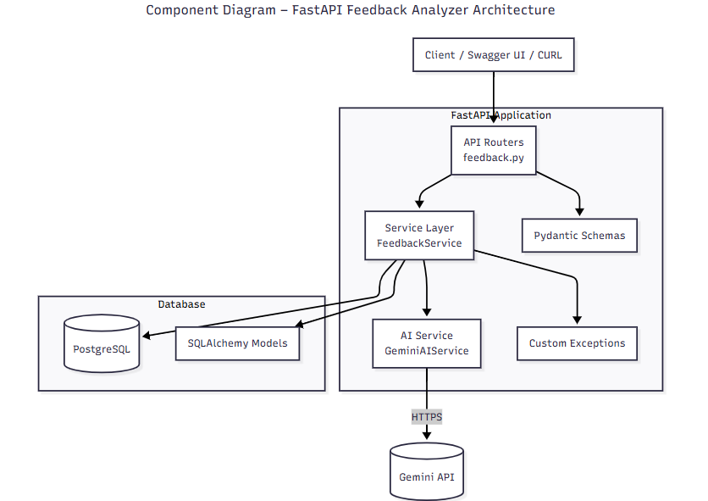
Responsibilities:
- API Layer: Validation, routing, orchestration
- Service Layer: Business logic & AI integration
- Database: Persistent storage & caching
- External AI: Natural language understanding

System Design Decisions
Why Cache AI Results?
- AI calls are expensive and slow
- Analysis results rarely change
- Improves performance and predictability
External API Strategy
- Timeout (30s)
- Retry with exponential backoff
- Graceful degradation on failures

Database Design
1. feedback_forms
2. feedback_responses
3. sentiment_analyses
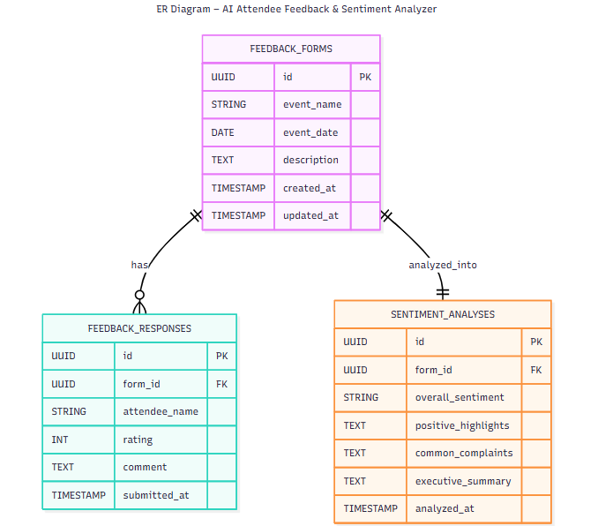
Design:
- One-to-many: forms → responses
- One-to-one: forms → analysis
- Cascading deletes ensure data consistency

End-to-End Workflow
Workflow Steps
- Organizer creates a feedback form
- Attendees submit feedback responses
- Organizer triggers sentiment analysis
- System aggregates responses
- Gemini API analyzes feedback
- Results are parsed and cached
- Cached analysis is served on request
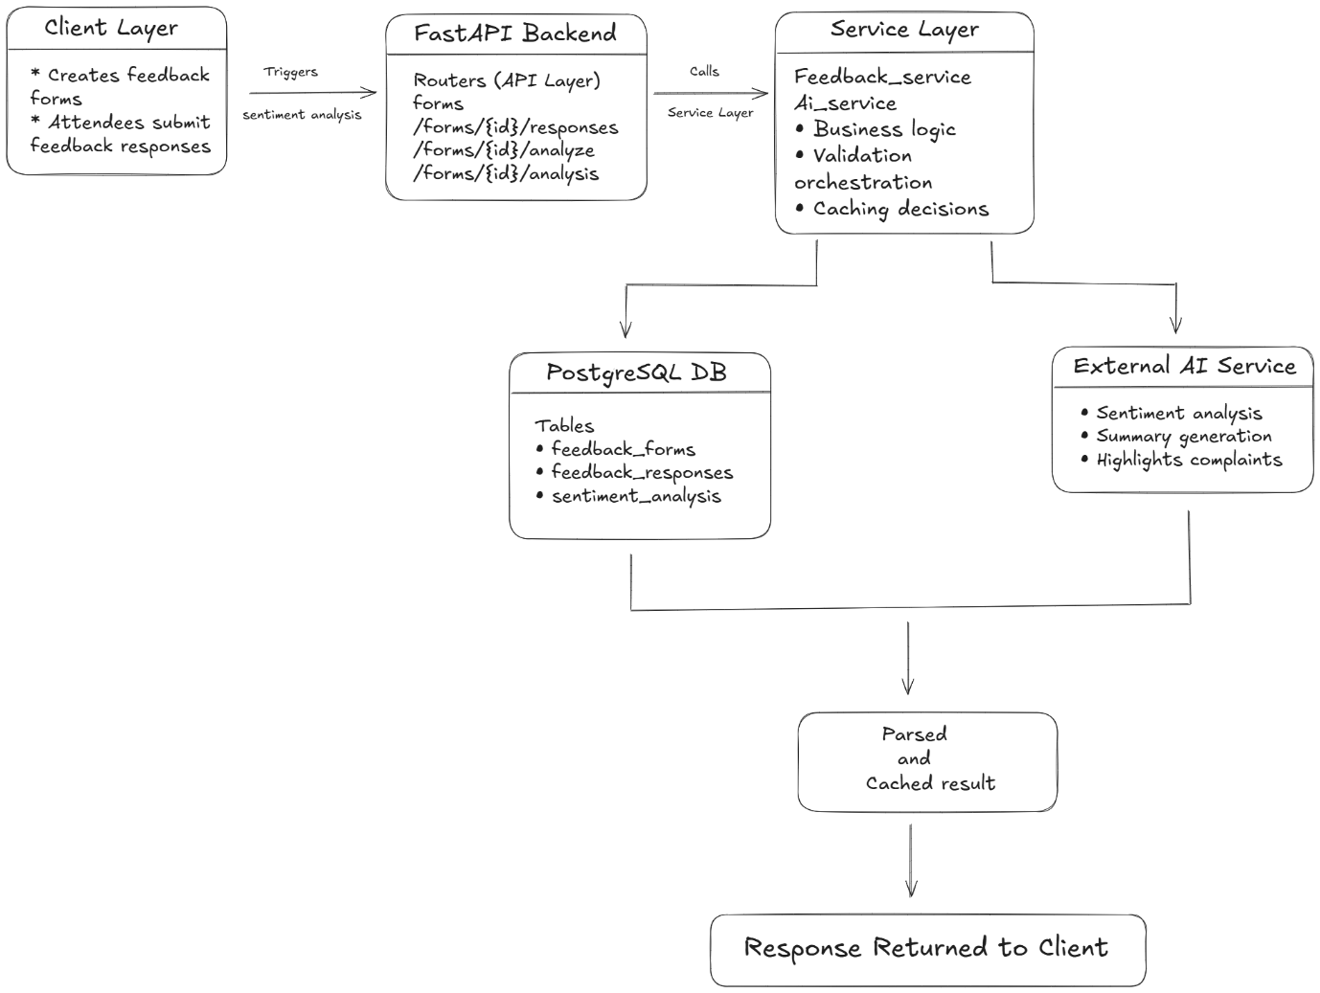

API Design
API Principles
- RESTful endpoints
- Predictable HTTP status codes
- JSON-only communication
Key Endpoints
Method | Endpoint | Description
POST | /api/v1/forms | Create feedback form
POST | /api/v1/forms/{id}/responses | Submit feedback
POST | /api/v1/forms/{id}/analyze | Trigger AI analysis
GET | /api/v1/forms/{id}/analysis | Fetch analysis
PUT | /api/v1/forms/{id} | Update form
DELETE | /api/v1/forms/{id} | Delete form & data

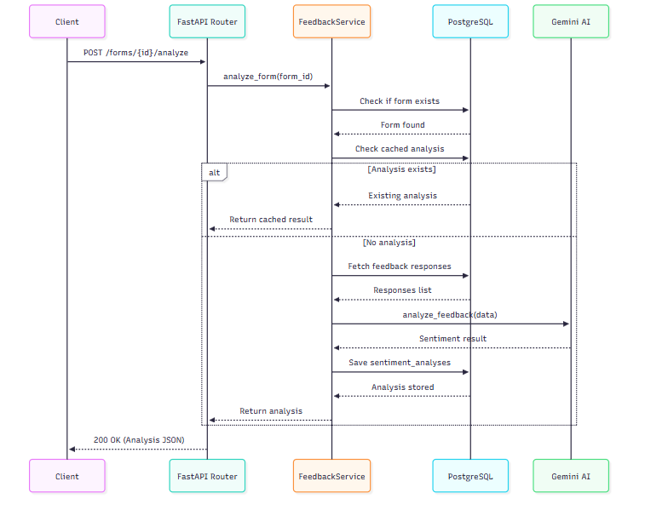

Project Structure
feedback-analyzer/
├── app/
│ ├── main.py # FastAPI entry point
│ ├── database.py # DB session & engine
│ ├── models.py # ORM models
│ ├── schemas.py # Pydantic schemas
│ ├── routers/ # API routes
│ ├── services/ # Business & AI logic
│ └── utils/ # Exceptions & helpers
├── tests/ # Unit & integration tests
├── docker-compose.yml
├── Dockerfile
├── requirements.txt
└── README.md

Environment & Deployment Setup
Local Development
- Dockerized PostgreSQL
- Python virtual environment
- .env-driven configuration
Production Considerations
- Use managed PostgreSQL (cloud provider)
- Add API authentication
- Centralized logging
- Rate limiting & monitoring

Testing Strategy
Test Types
- Unit Tests: Service logic & validation
- Integration Tests: API + DB interaction
- Mocked AI Calls: Deterministic testing
Tools
- Pytest
- HTTPX
- Pytest-asyncio

Error Handling & Resilience
Handled Scenarios
- Invalid UUIDs
- Missing resources
- Validation failures
- Database outages
- External AI timeouts
Standard Error Format
{ "detail": “error message" }

Limitations & Future Enhancements
Current Limitations
- No authentication or role management
- Single-language sentiment analysis
- Manual analysis trigger only
Future Enhancements
- OAuth2 / JWT authentication
- Multi-language sentiment support
- Automatic re-analysis triggers
- Dashboard & analytics UI
- Background task processing

