Test_services.py
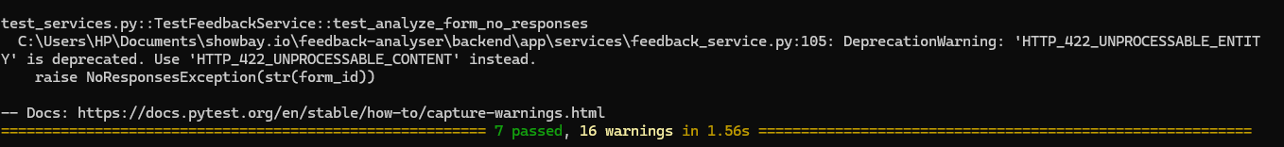

Test_api.py

FEEDBACKFORM BY EVENT ORGANIZERS
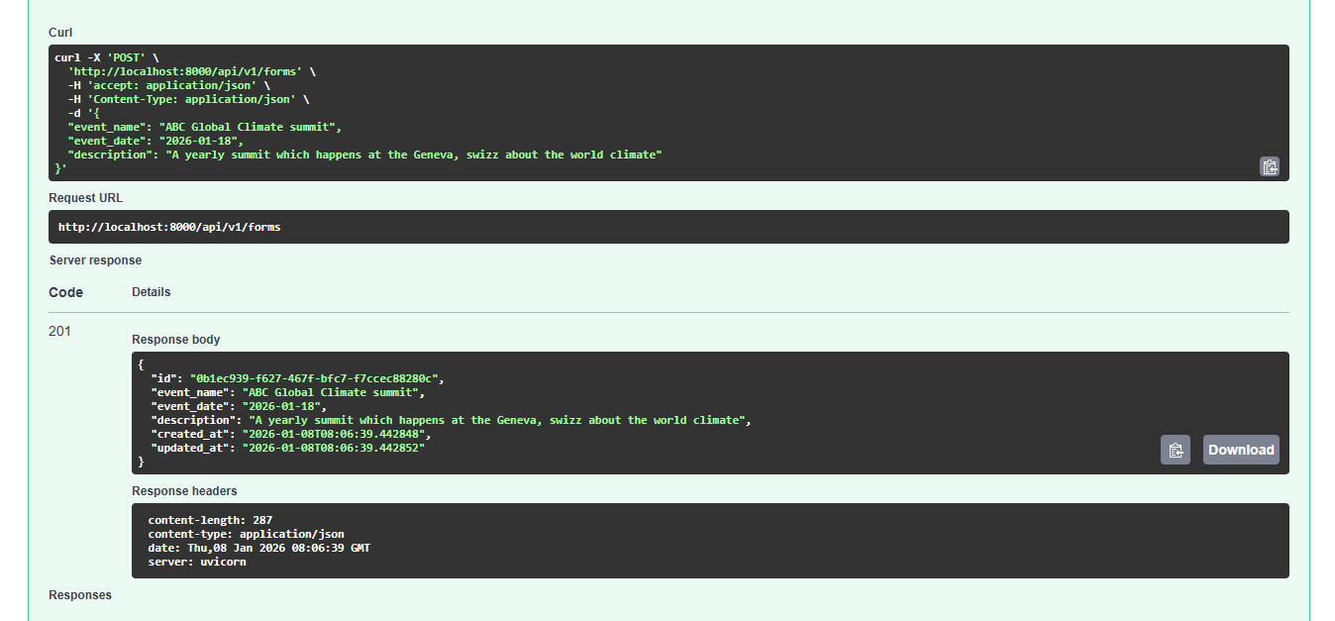
SUBMIT FEEDBACK FORM
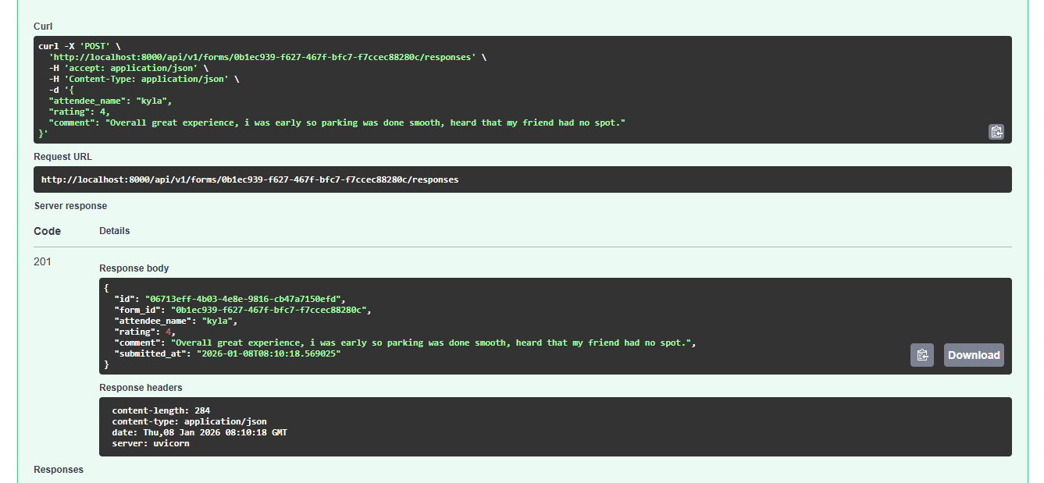

AI FEEDBACK ANALYSIS RESPONSE
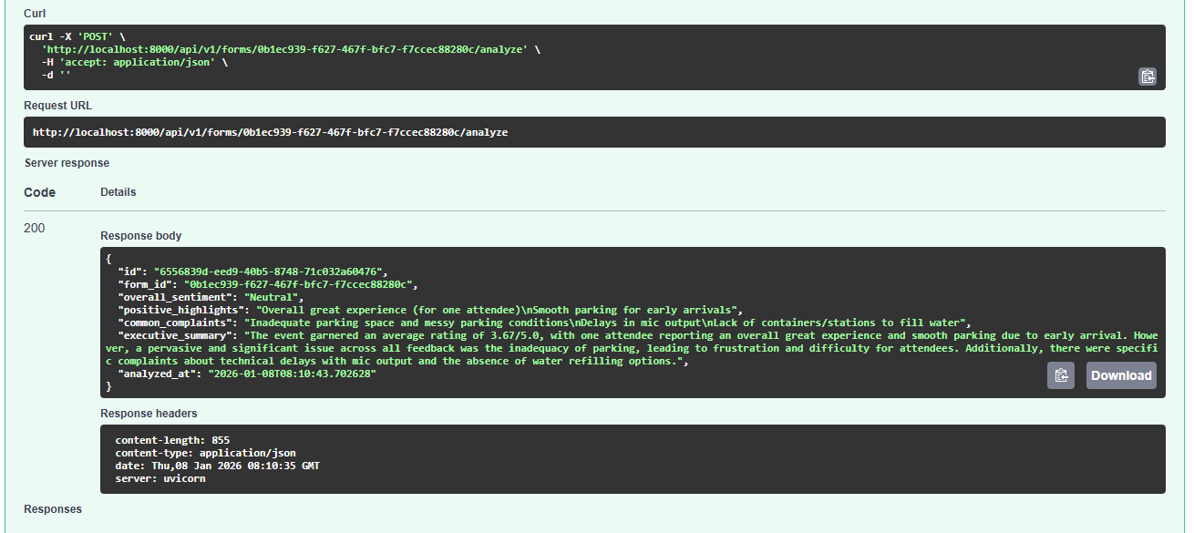

PARSED ANALYSED SUMMARY
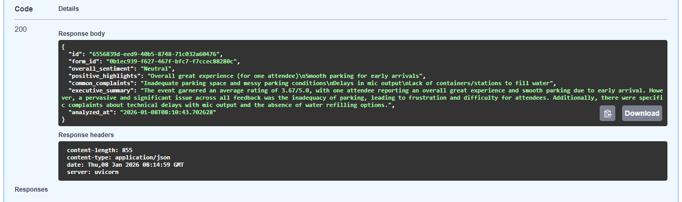

UPDATE FORM DATE
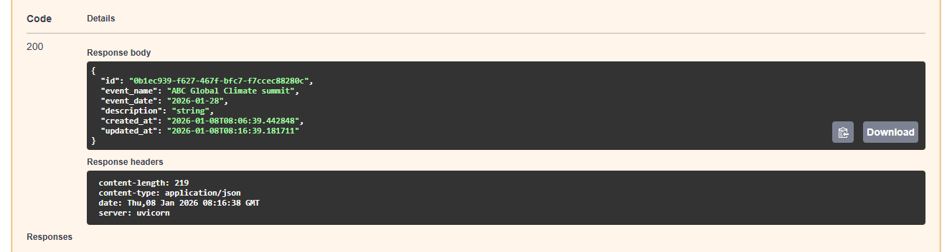

DELETE THE FORM AFTER THE EVENT AND ANALYSIS IS ENDED
