**PREDICTION OF STRUCTURAL COLLAPSE(**MORTALITY**)**

Here we will construct a model that is able to accurately predict whether a building gets collapse or not based on various parameters like depth of the building, height of the building, age of the building, rainfall per annum, temperature, and magnitude of the earthquake. This prediction is done by using Logistic Regression. The output of the project is whether the building collapses or not. With the help of our work, we will be predicting the collapse of the building and analysing the factors which strongly affect the failure. This prediction will give suggestions based on the result obtained which level of attribute can lead to a failure.

Predicting the collapse of the monument by satellite images and obtaining the result in a binary value

* Will the monument collapse? or not (only by analyzing the current image)

**APPROACH (**Machine learning algorithm)

**CLIMATIC CONDITIONS (**Logistic Regression Model (supervised ML)**)**

Logistic Regression Model is a supervised learning classification algorithm used to predict the probability of a target variable.

*Temperature,

*Rainfall per annum,

*Depth,

*Age,

*Height,

*Magnitude

A predictive analysis which explains the relationship between one dependent binary variable and one or more nominal, ordinary, interval or ratio-level independent variable.

C4.5 (STATISTICAL CLASSIFIER) https://en.wikipedia.org/wiki/C4.5_algorithm decision tree learning algorithm is used to predict damage in reinforced concrete buildings in future earthquake scenarios.

Reinforced concrete buildings are modelled as single-degree-of freedom systems and various time-history nonlinear analyses are performed to create a dataset of damage indices. Subsequently, two decision trees are trained using the qualitative interpretations of those indices. The first decision tree determines whether damage occurs in an RC building. Consequently, the second decision tree predicts the severity of damage as repairable, beyond repair, or collapse.

**PROPOSED METHOD**

Step 1- Collection of Dataset

The dataset is a collection of related sets of information that is composed of separate elements but can be manipulated as a unit by a computer. For this project, the dataset is prepared manually. To create a machine learning model, the first thing required is a dataset as a machine learning model completely works on data. The collected data for a particular problem in a proper format is known as the dataset.

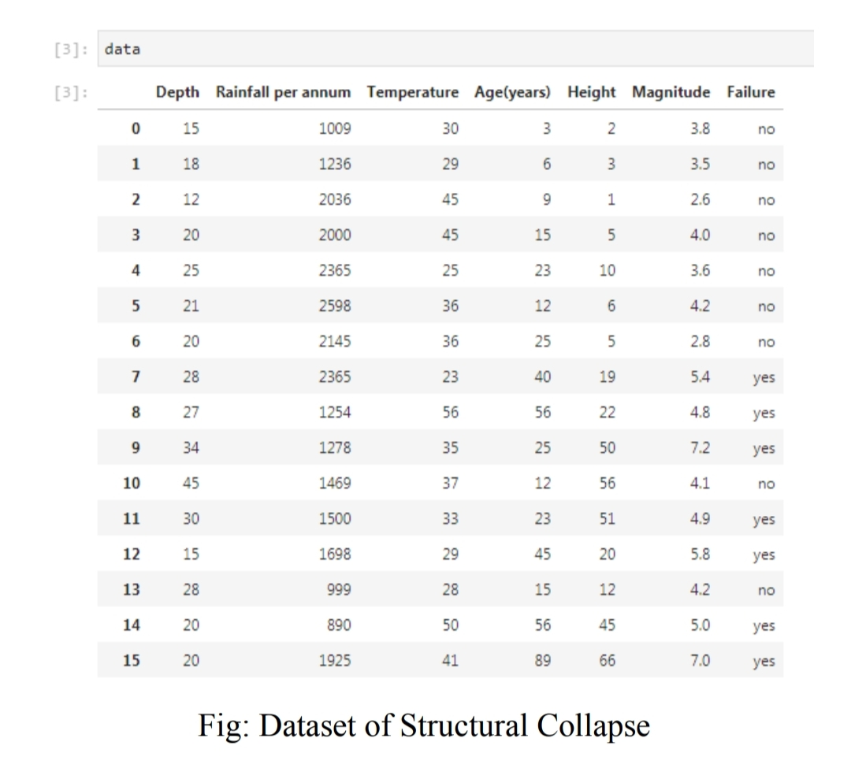

Step 2 - Importing Libraries and splitting the dataset **(python)**

*pandas,

*numpy,

*matplotlib

Step 3 - Checking the null values

Checking for the availability of all lines of data.

Step 4- Train and Split Dataset

Now we need to split our dataset into two sets a Training set and a Test set. We will train our machine learning models on our training set, i.e., our machine learning models will try to understand any correlations in our training set and then we will test the models on our test set to check how accurately it can predict. Assuming that your test set meets the preceding two conditions, your goal is to create a model that generalizes well to new data. Our test set serves as a proxy for new data. For example, the following figure. Notice that the model learned for the training data is very simple. This model doesn't do a perfect job prediction are wrong. However, this model does about as well on the test data as it does on the training data. In other words, this simple model does not overfit the training data. Validating the trained model against test data. Never train on test data. If you are seeing surprisingly good results on your evaluation metrics, it might be a sign that you are accidentally set.

Step 5- Normalize the data

Before we do the fit, let’s normalize the data so that the data is centered around the mean and has unit standard deviation. Normalization of the data can be done by the sklearn Standard Scaler. Data is pre-processes before it is used for analysis and prediction

Step 6- Visualization

Fit the model to selected supervised data by using the matplotlib library for visualizing the independent variables and dependent variables. X label represents the year and the Y label represents the economic damage occurs in each state.

Step 7- Model fitting and prediction

Fit the model into the decision tree algorithm by training the model by the supervised learning. Predicting the result by using Logistic Regression technique and the decision tree regression algorithm.

**RESULTS AND DISCUSSION**

**Prediction**: It is used to predict the accurate results. To calculate the accurate result in the code there are some calculations given in the code. Fig: Predicted value Accuracy is one metric for evaluating the classification models. Informally, accuracy is the fraction of predictions our model got right. **Accuracy** comes out to 0.91, or 91% (91 correct predictions out of 100 total examples). Actually, let's do a closer analysis of positives and negatives to gain more insight into our model's performance.