Migration Customer Assessment

Transformation Success Engineers

Purpose of this document is to guide TSE’s through the process of attaining, understanding and highlighting the Readiness of customers to perform the PC → CC Migration with the following goals:

- Understand the best feasible date for customers to begin their migration sprint with an understanding of the following:
  - Renewal Dates / Active RFP’s
  - Product Parity Blockers
  - Product Feature Request (T1 accounts only)
  - Customer dependencies (Customer resources, change freezes etc)
- Understand the outstanding hard blockers in the product and collate them for Product Management

These items will be logged in the following TSE Field Assessment Tracker

This assessment is intended to be undertaken with the knowledge already known on the accounts unless there is already existing dialogue with the customer around blockers and the planning and execution of the upgrade. Customer readiness is predominantly going to be evaluated based on the data from the following sources and conferring with internal field teams (DC,SC,CSS,AM,EE PS,CSE,CSM etc) and this guide will explain how to attain and populate this data in the TSE Field Assessment Tracker

- Upgrade Customers Telemetry
- Prisma Cloud Support Portals
- COE Tracker Log

The Customer Readiness Assessment Process Simplified:

- Upgrade Customer Telemetry Data to understand the Hard Blockers
- Use Oppty to find Customer Stack details in Prisma Cloud and verify/ add context with additional visibility in Prisma Cloud Support Portal Portals
- Validate any other Customer Blockers raised in COE Tracker
- Confirm with other “technical” stakeholders close to account if you do not already have up to date knowledge and documentation on the account blockers

Upgrade Telemetry

- Create your own Filter View in the List_of_Customers tab so you don’t change other people's/master views

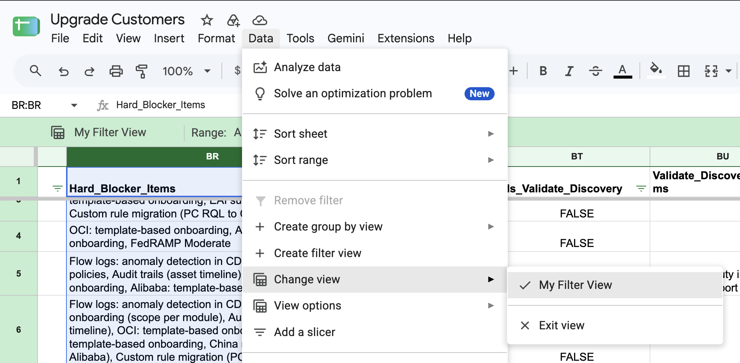

Prisma Cloud Support Portals

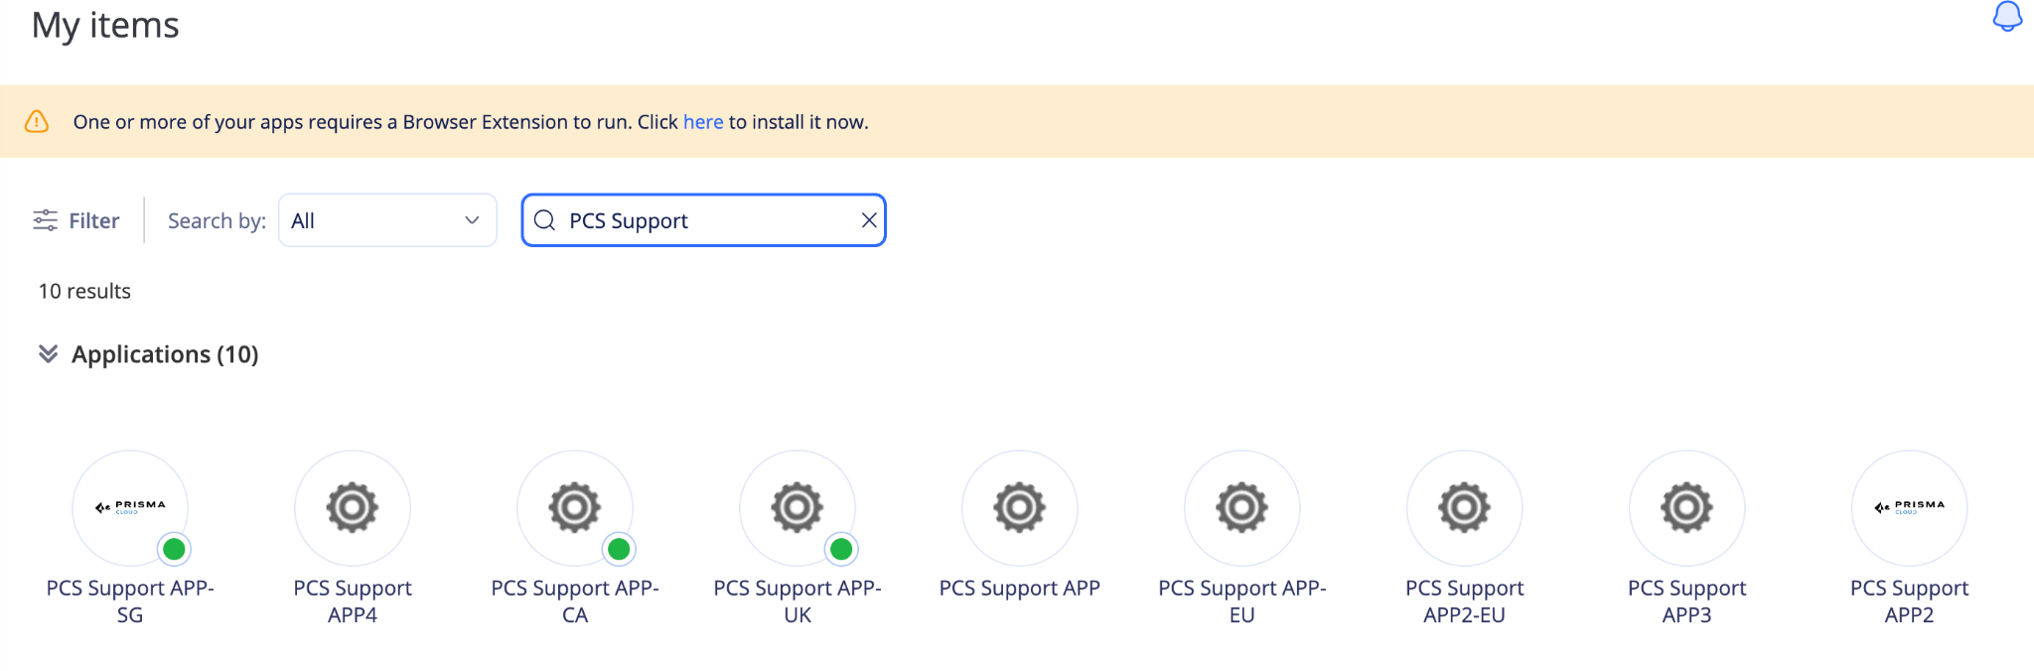

Custom Policies

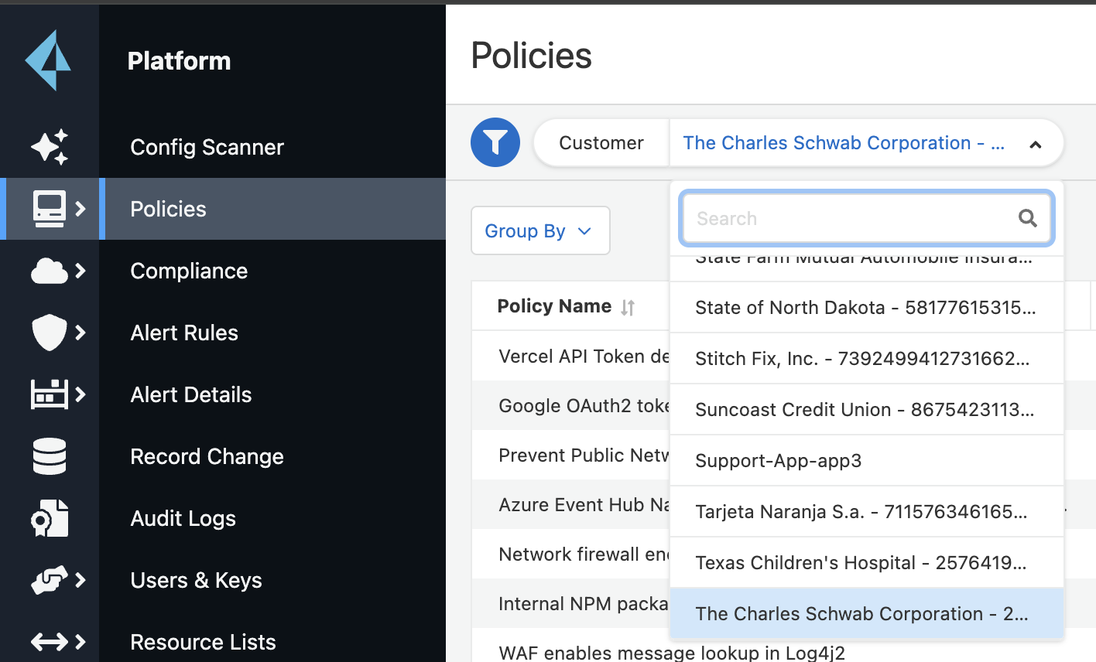

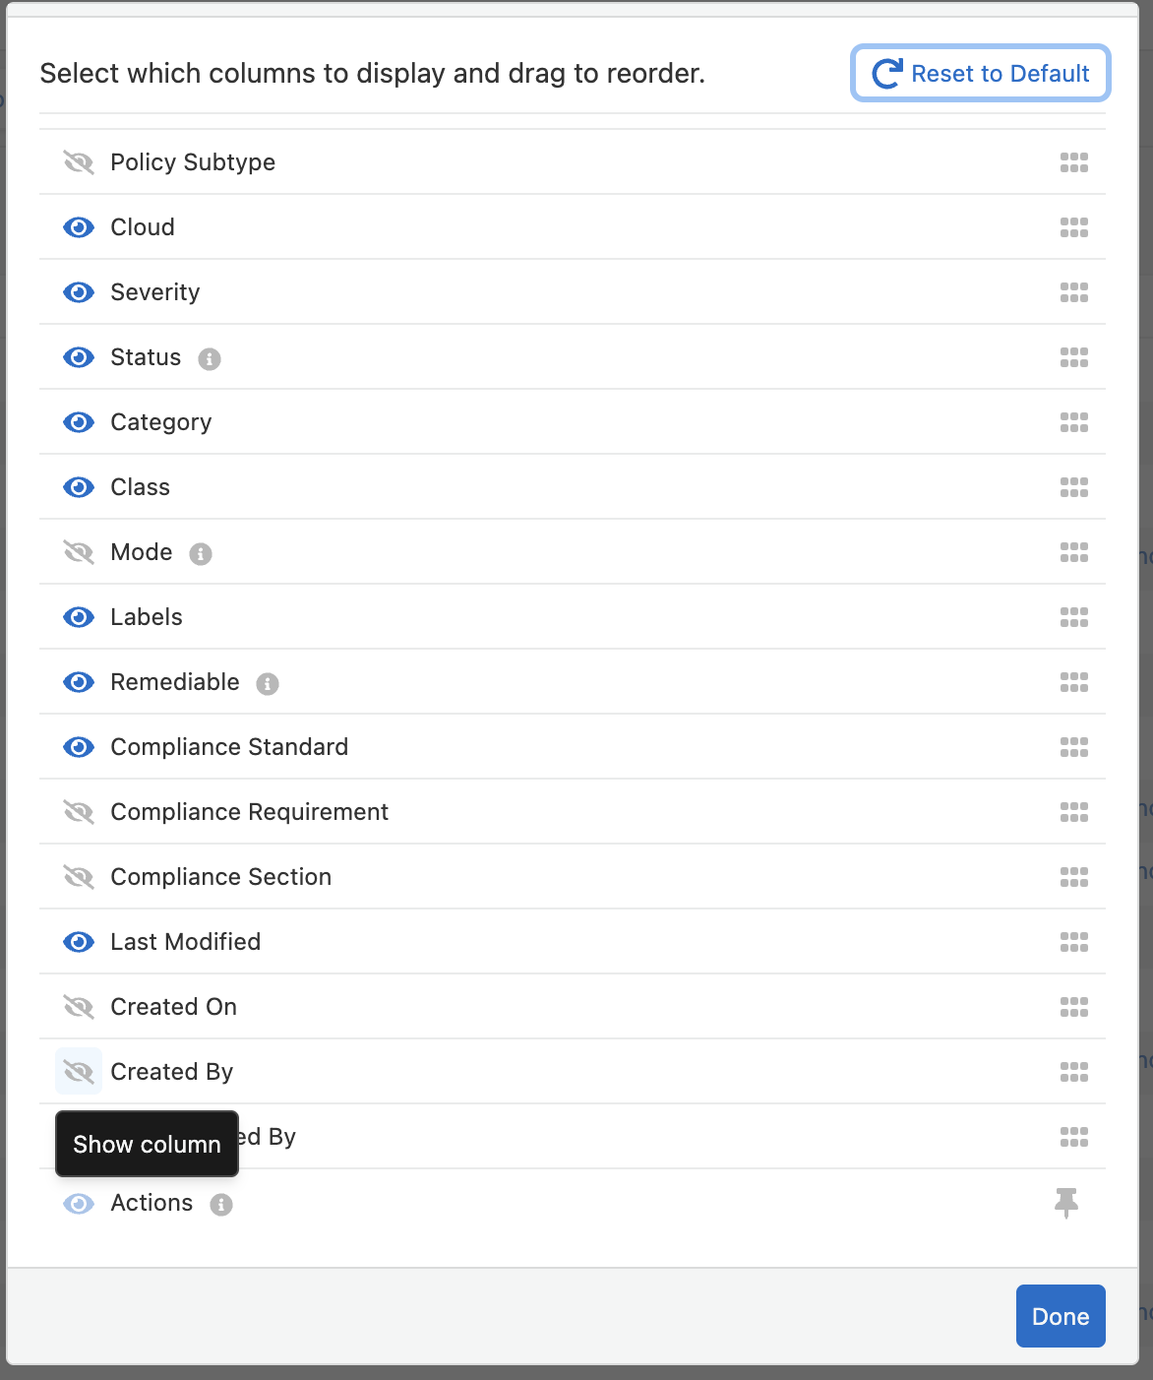

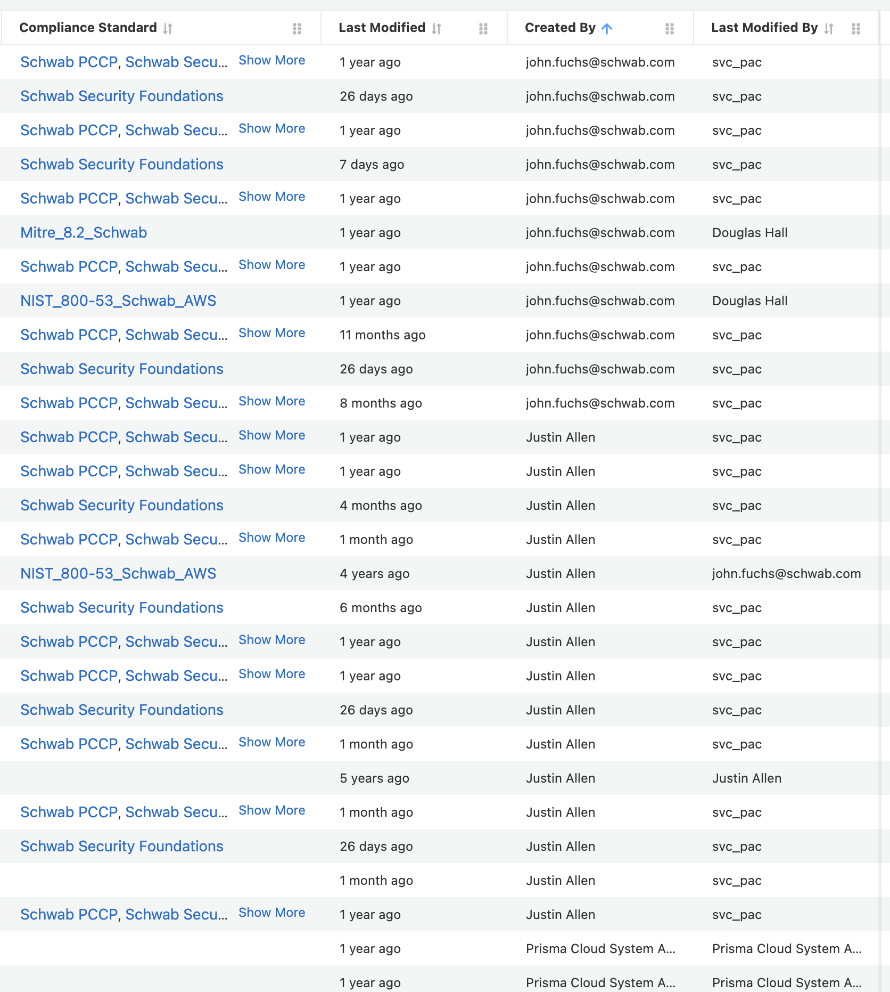

COE Tracker Log

