Cortex Cloud Enterprise Architecture Good, Better, Best

Prepared by: Global Transformation Success
Gareth Baruch

Technical Paper

Purpose of This Guide 1
Audience 2
Cortex Cloud Platform Maturity Model 3
Core Architecture States 3
Capability Summary by Domain 3
Good Architecture: Foundational Visibility 4
Development Guidance 4
Architecture Overview 4
Connectivity Flows 5
Posture Management 5
Architecture Overview 5
Reasoning for the “Good State” 6
Key Capabilities 6
Architecture Considerations 6
Limitations and Triggers for the Next State 6
Runtime Protection 7
Architecture Overview 7
Reasoning for the “Good State” 7
Key Capabilities 7
Architecture Considerations 7
Limitations and Triggers for the Next State 7
Application Security 8
Architecture Overview 8
Reasoning for the “Good State” 8
Key Capabilities 8
Architecture Considerations 8
Limitations and Triggers for the Next State 8
Data Security Posture Management 9
Architecture Overview 9
Reasoning for the “Good State” 9
Key Capabilities 9
Architecture Considerations 9
Limitations and Triggers for the Next State 9
Better Architecture: Context and Enforcement 10
Development Guidance 10
Architecture Overview 10
Connectivity Flows 11
Posture Management 12
Architecture Overview 12
Reasoning for the “Better State” 12
Key Capabilities 12
Architecture Considerations 12
Limitations and Triggers for the Next State 12
Runtime Protection 13
Architecture Overview 13
Reasoning for the “Better State” 13
Key Capabilities 13
Architecture Considerations 13
Limitations and Triggers for the Next State 14
Application Security 15
Architecture Overview 15
Reasoning for the “Better State” 15
Key Capabilities 15
Architecture Considerations 15
Limitations and Triggers for the Next State 15
Data Security Posture Management 16
Architecture Overview 16
Reasoning for the “Better State” 16
Key Capabilities 16
Architecture Considerations 16
Limitations and Triggers for the Next State 16
Best Architecture: Unified and Automated 17
Development Guidance 17
Architecture Overview 17
Connectivity Flows 18
Posture Management 19
Architecture Overview 19
Reasoning for the “Best State” 19
Key Capabilities 19
Architecture Considerations 19
Limitations and Triggers for the Next State 19
Runtime Protection 20
Architecture Overview 20
Reasoning for the “Best State” 20
Key Capabilities 20
Architecture Considerations 20
Limitations and Triggers for the Next State 20
Application Security 21
Architecture Overview 21
Reasoning for the “Best State” 21
Key Capabilities 21
Architecture Considerations 21
Limitations and Triggers for the Next State 21
Data Security Posture Management 22
Architecture Overview 22
Reasoning for the “Best State” 22
Key Capabilities 22
Architecture Considerations 22
Limitations and Triggers for the Next State 22

Purpose of This Guide

This document defines a three-state maturity model (Good, Better, Best) for delivering a Cloud-Native Application Protection Platform (CNAPP) across [Customer Name]'s cloud estate. For each state, it describes the target architecture for Posture Management, Runtime Protection, Application Security and, optionally, Data Security Posture Management (DSPM). It also explains the reasoning for each state so that stakeholders agree on a starting point, a target state and the triggers for moving between them.
The architecture is vendor-agnostic and is aligned to public standards. An optional appendix maps each capability to Palo Alto Networks products.

This Technical Paper:

• To guide customers in architecting Cortex Cloud effectively and building a highly successful and automated platform.
• Providing formal process documentation for the structured creation, definition and maturation of crucial organizational components, such as:

- Public cloud accounts, subscriptions and projects: [AWS / Azure / Google Cloud, to be confirmed]
- Managed and self-managed Kubernetes clusters: [EKS / AKS / GKE / OpenShift, to be confirmed]
- Virtual machines, containers and serverless functions running production workloads
- Source code management and CI/CD platforms: [GitHub / GitLab / Azure DevOps / Jenkins, to be confirmed]
- Container registries and infrastructure-as-code (IaC) repositories
- Cloud data stores (object storage, managed databases), where DSPM is in scope
- Integration with existing ticketing (ITSM), SIEM and identity provider platforms
• Offering guidance for defining and maturing enterprise level architecture that can support the customers evolving environment and support the adoption of a mature CNAPP platform.

In essence, this technical paper is an architecture design document, designed to help organizations transition to a more mature security focused solution leveraging Cortex Cloud and all its core functionality.

Audience

This technical paper is for those individuals who are involved in defining, enforcing and maintaining security, compliance and operational standards within the Cortex Cloud environment.

- Chief Information Security Officer (CISO) and security leadership: target state and investment priorities
- Cloud security architects: design decisions and integration patterns
- Platform engineering, DevOps and application owners: pipeline and workload impact
- Security operations (SOC): alert, detection and response integration
- Governance, risk and compliance (GRC): framework coverage and evidence

In this technical paper, it is assumed the reader is familiar with the basic concepts of cloud native solutions, applications, networking, virtualization, security operations, IT infrastructure, and cloud architecture.

Cortex Cloud Platform Maturity Model

Each state builds on the previous one. Good establishes broad visibility with low deployment effort. Better adds context and enforcement. Best unifies all signals into a single risk model and automates remediation and response. Organisations do not need to reach the same state in every domain at the same time. A common pattern is to reach Better in Posture Management while Application Security is still at Good.

Core Architecture States
State | Theme | Outcome
Good | Foundational visibility | See everything, measure against benchmarks, and route findings to owners.
Better | Context and enforcement | Prioritise by real risk, protect critical workloads in real time, and stop issues in the pipeline.
Best | Unified and automated | Correlate code, cloud, identity, data and runtime into attack paths, then fix at the source automatically.

Capability Summary by Domain
Domain | Good | Better | Best
Posture Management | Organisation-wide CSPM, asset inventory, CIS benchmark compliance | Adds CIEM, KSPM, agentless vulnerability context and risk-based prioritisation | Attack path analysis, code-to-cloud ownership, remediation as code
Runtime Protection | Agentless workload scanning and cloud audit log threat detection | Runtime agents on critical workloads, admission control, SIEM integration | Agent coverage on all production workloads, Cloud Detection and Response (CDR), automated containment
Application Security | IaC, secrets and software composition analysis (SCA) in repositories (report only) | Enforced CI/CD policy gates, image scanning, SBOM, pipeline posture | Application Security Posture Management (ASPM), provenance verification, automated fix pull requests
DSPM | Discover and classify sensitive data in cloud data stores | Correlate data sensitivity with exposure and identity access | Data access monitoring and data-aware attack paths
Outpost scanning (regulated) | Standard outpost where content must stay in customer accounts | Custom outpost: own network, inspected egress, enterprise identities | Regional outposts as code per jurisdiction, no-egress enclaves

Good Architecture: Foundational Visibility

Development Guidance
The Good state gives the security team complete, continuous visibility of the cloud estate with minimal change to workloads or developer workflows. All collections are API-based or agentless, so you deploy it at the organisation level in days rather than months. Findings are measured against recognised benchmarks and routed to the owning teams.

Architecture Overview
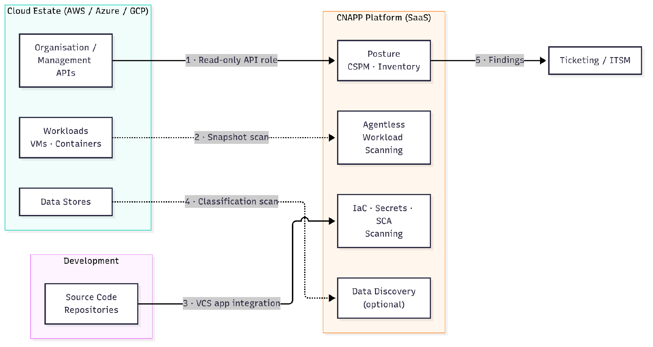
Figure 1. Good architecture: API-based and agentless collection

Connectivity Flows
Important: These are generic patterns; confirm product-specific endpoints during detailed design.

# | Source | Destination | Protocol / Port | Direction | Authentication | Purpose
1 | Cortex Cloud platform | Cloud organisation / management APIs | HTTPS, TCP 443 | Outbound from SaaS to provider API | Cross-account read-only role or service principal | Configuration and inventory collection
2 | Cortex Cloud platform | Workload disk snapshots | Provider API, HTTPS, TCP 443 | Outbound from SaaS to provider API | Role with snapshot permissions | Agentless vulnerability and malware scanning
3 | Source code repositories | Cortex Cloud platform | HTTPS, TCP 443 | Webhook / app integration | OAuth application or access token | IaC, secrets and SCA scanning
4 | Cortex Cloud platform | Cloud data stores | Provider API, HTTPS, TCP 443 | Outbound from SaaS to provider API | Role with scoped read permissions | Data discovery and classification (optional)
5 | Cortex Cloud platform | Ticketing / ITSM | HTTPS, TCP 443 | Outbound from SaaS | API token | Finding notification and tracking

Posture Management

Architecture Overview
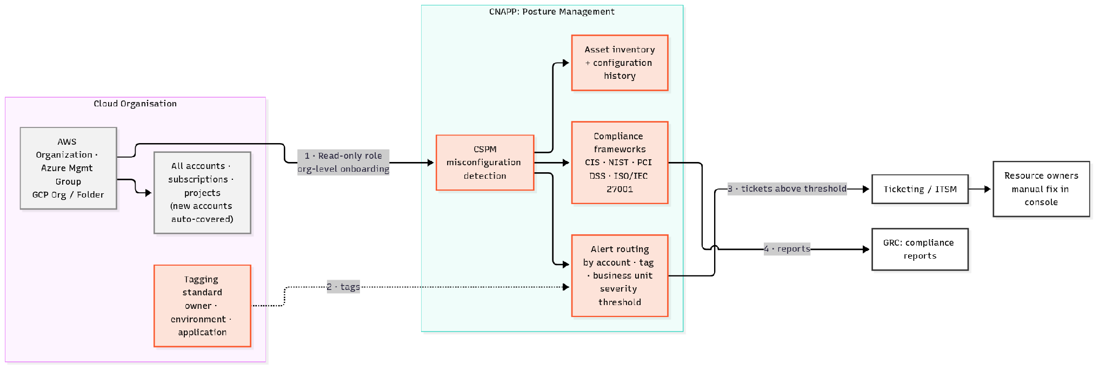
Figure 2. Posture Management: Good state architecture

Reasoning for the “Good State”
Misconfigured and unmanaged resources create critical exposure that security teams cannot address until they achieve full visibility, making a complete, continuous inventory the primary priority. Establishing organization-level onboarding with a read-only role delivers seamless coverage across every account—including newly created ones—without requiring workload alterations or developer involvement. With visibility established, benchmarking against provider-specific CIS Foundations Benchmarks [S4] and the CSA Cloud Controls Matrix [S5] provides an objective, prescriptive baseline to systematically evaluate and maintain cloud security posture.

Key Capabilities
Cloud Security Posture Management (CSPM) delivers comprehensive visibility across all accounts, subscriptions, and projects by maintaining a continuous asset inventory that tracks detailed resource configuration history. Organizations can evaluate their environments against out-of-the-box compliance frameworks—such as CIS, NIST, PCI DSS, and ISO/IEC 27001—while generating automated audit reports. Furthermore, actionable risk remediation is streamlined through intelligent alert routing, which directs findings straight into ticketing systems based on account, resource tag, or business unit.

Architecture Considerations
To ensure seamless coverage from day one, onboard integrations at the organization, management group, or folder level so that newly provisioned accounts are included automatically. Leveraging a read-only role establishes essential visibility while deliberately deferring remediation permissions to a more mature "Better" operating state. In parallel, defining a standardized resource tagging taxonomy—capturing attributes such as owner, environment, and application—lays the operational groundwork for accurate alert routing and prioritization. Finally, establishing an agreed alert severity threshold for automated ticket creation ensures security posture stays actionable without flooding resource owners with operational noise.

Limitations and Triggers for the Next State
At this stage, findings are prioritized solely by severity rather than exploitability, burdening teams with high alert volumes that lack critical environmental context. Furthermore, identity permissions remain unanalyzed, leaving over-privileged roles and entitlement risks completely hidden. Because remediation is entirely manual, organizations should plan their transition to the "Better" maturity state when open-finding counts plateau or when operational teams begin disputing triage priorities.

Federal and Government Sensitive Compliance Considerations
Federal agencies and regulated public-sector customers often require a FedRAMP-authorised service, US-only data handling and customer-owned scanning. In the Good state, meet this with a FedRAMP tenant and a standard outpost.
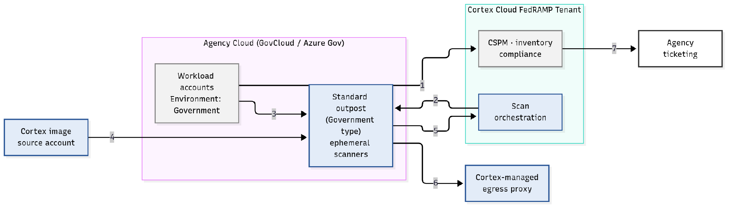
Figure 3. Posture Management: Good state, Federal and Government variant (standard outpost)
# | Source | Destination | Protocol / Port | Direction | Authentication | Purpose
1 | Cortex FedRAMP tenant | Workload accounts | Cloud provider APIs, HTTPS 443 | Outbound from tenant | Read-only cross-account role | CSPM and inventory (Government environment onboarding [S39])
2 | Scan orchestration | Outpost | Cloud provider APIs | Tenant to outpost | Federated identity trust | Launch scanner VMs [S41]
3 | Workload accounts | Outpost scanners | In-region provider APIs | Within agency cloud, same region | Outpost IAM roles | Disk, registry, serverless and DSPM scans [S43], processed in-region [S41]
4 | Cortex image-source accounts (AWS GovCloud 622687710055; Azure Gov Prod subscription 79a60f94-884a-4118-93e1-51c21de34a85 and gallery) | Outpost | Image pulled by outpost | Into outpost | Egress allowed to image source | Hardened scanner boot image, no customer data [S41]
5 | Outpost | Scan orchestration | Encrypted cloud-native storage | Outpost to tenant | Outpost roles | Operational data and scan results (metadata), never raw customer data [S41]
6 | Outpost scanners | Cortex-managed egress proxy | Managed by Cortex Cloud | Outbound | Managed | Default outpost networking [S42]
7 | Cortex FedRAMP tenant | Agency ticketing | HTTPS 443 | Outbound from tenant | API token | Findings to owners

Runtime Protection

Architecture Overview
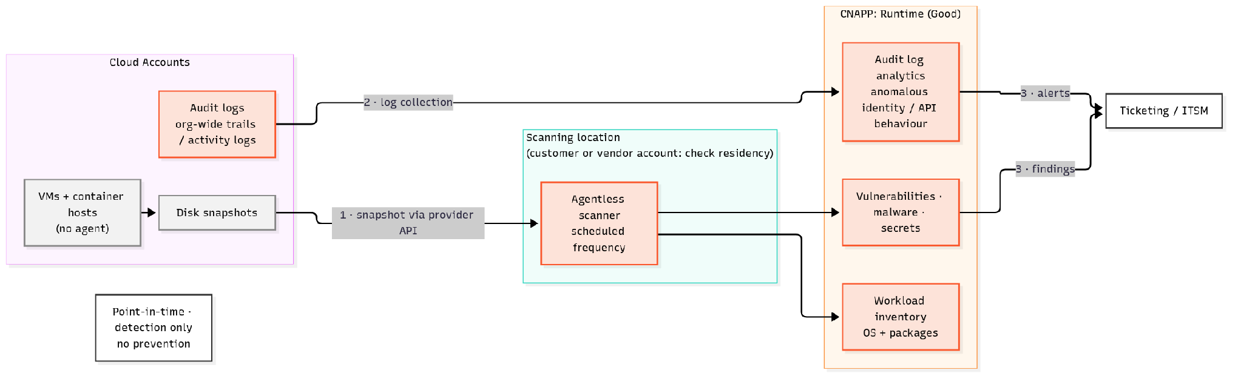
Figure 3. Runtime Protection: Good state architecture

Reasoning for the “Good State”

Key Capabilities

Architecture Considerations

Limitations and Triggers for the Next State

Application Security

Architecture Overview
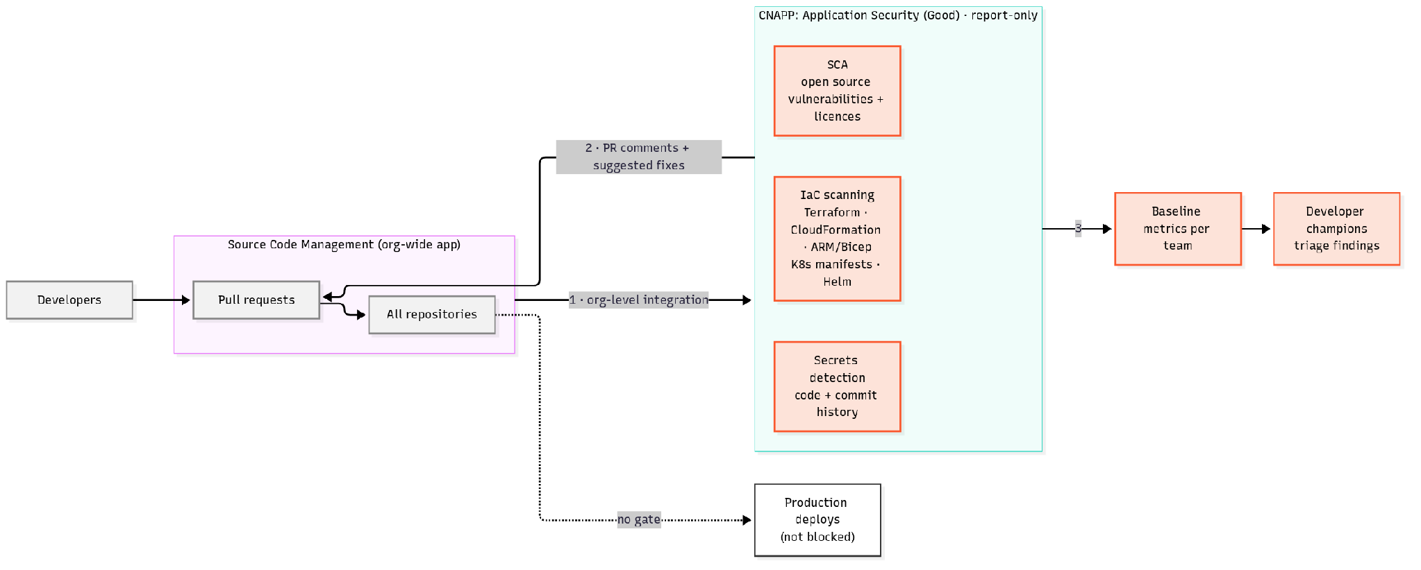
Figure 4. Application Security: Good state architecture

Reasoning for the “Good State”

Key Capabilities

Architecture Considerations

Limitations and Triggers for the Next State

Data Security Posture Management

Architecture Overview
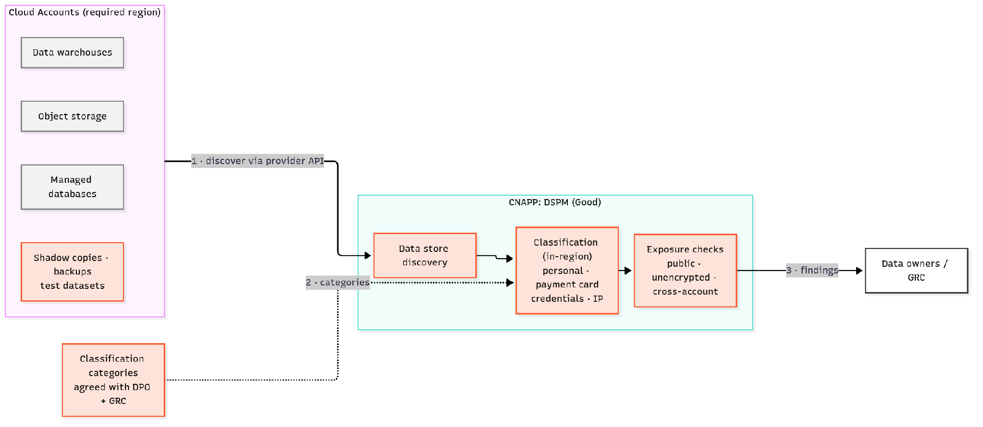
Figure 5. Data Security Posture Management: Good state architecture

Reasoning for the “Good State”

Key Capabilities

Architecture Considerations

Limitations and Triggers for the Next State

Better Architecture: Context and Enforcement

Development Guidance
The Better state turns visibility into prioritised action. It adds identity and Kubernetes context to posture, real-time protection on critical workloads, and enforced security gates in the CI/CD pipeline. CNAPP alerts flow into the SOC so that cloud threats are handled with the same process as other incidents.

Architecture Overview
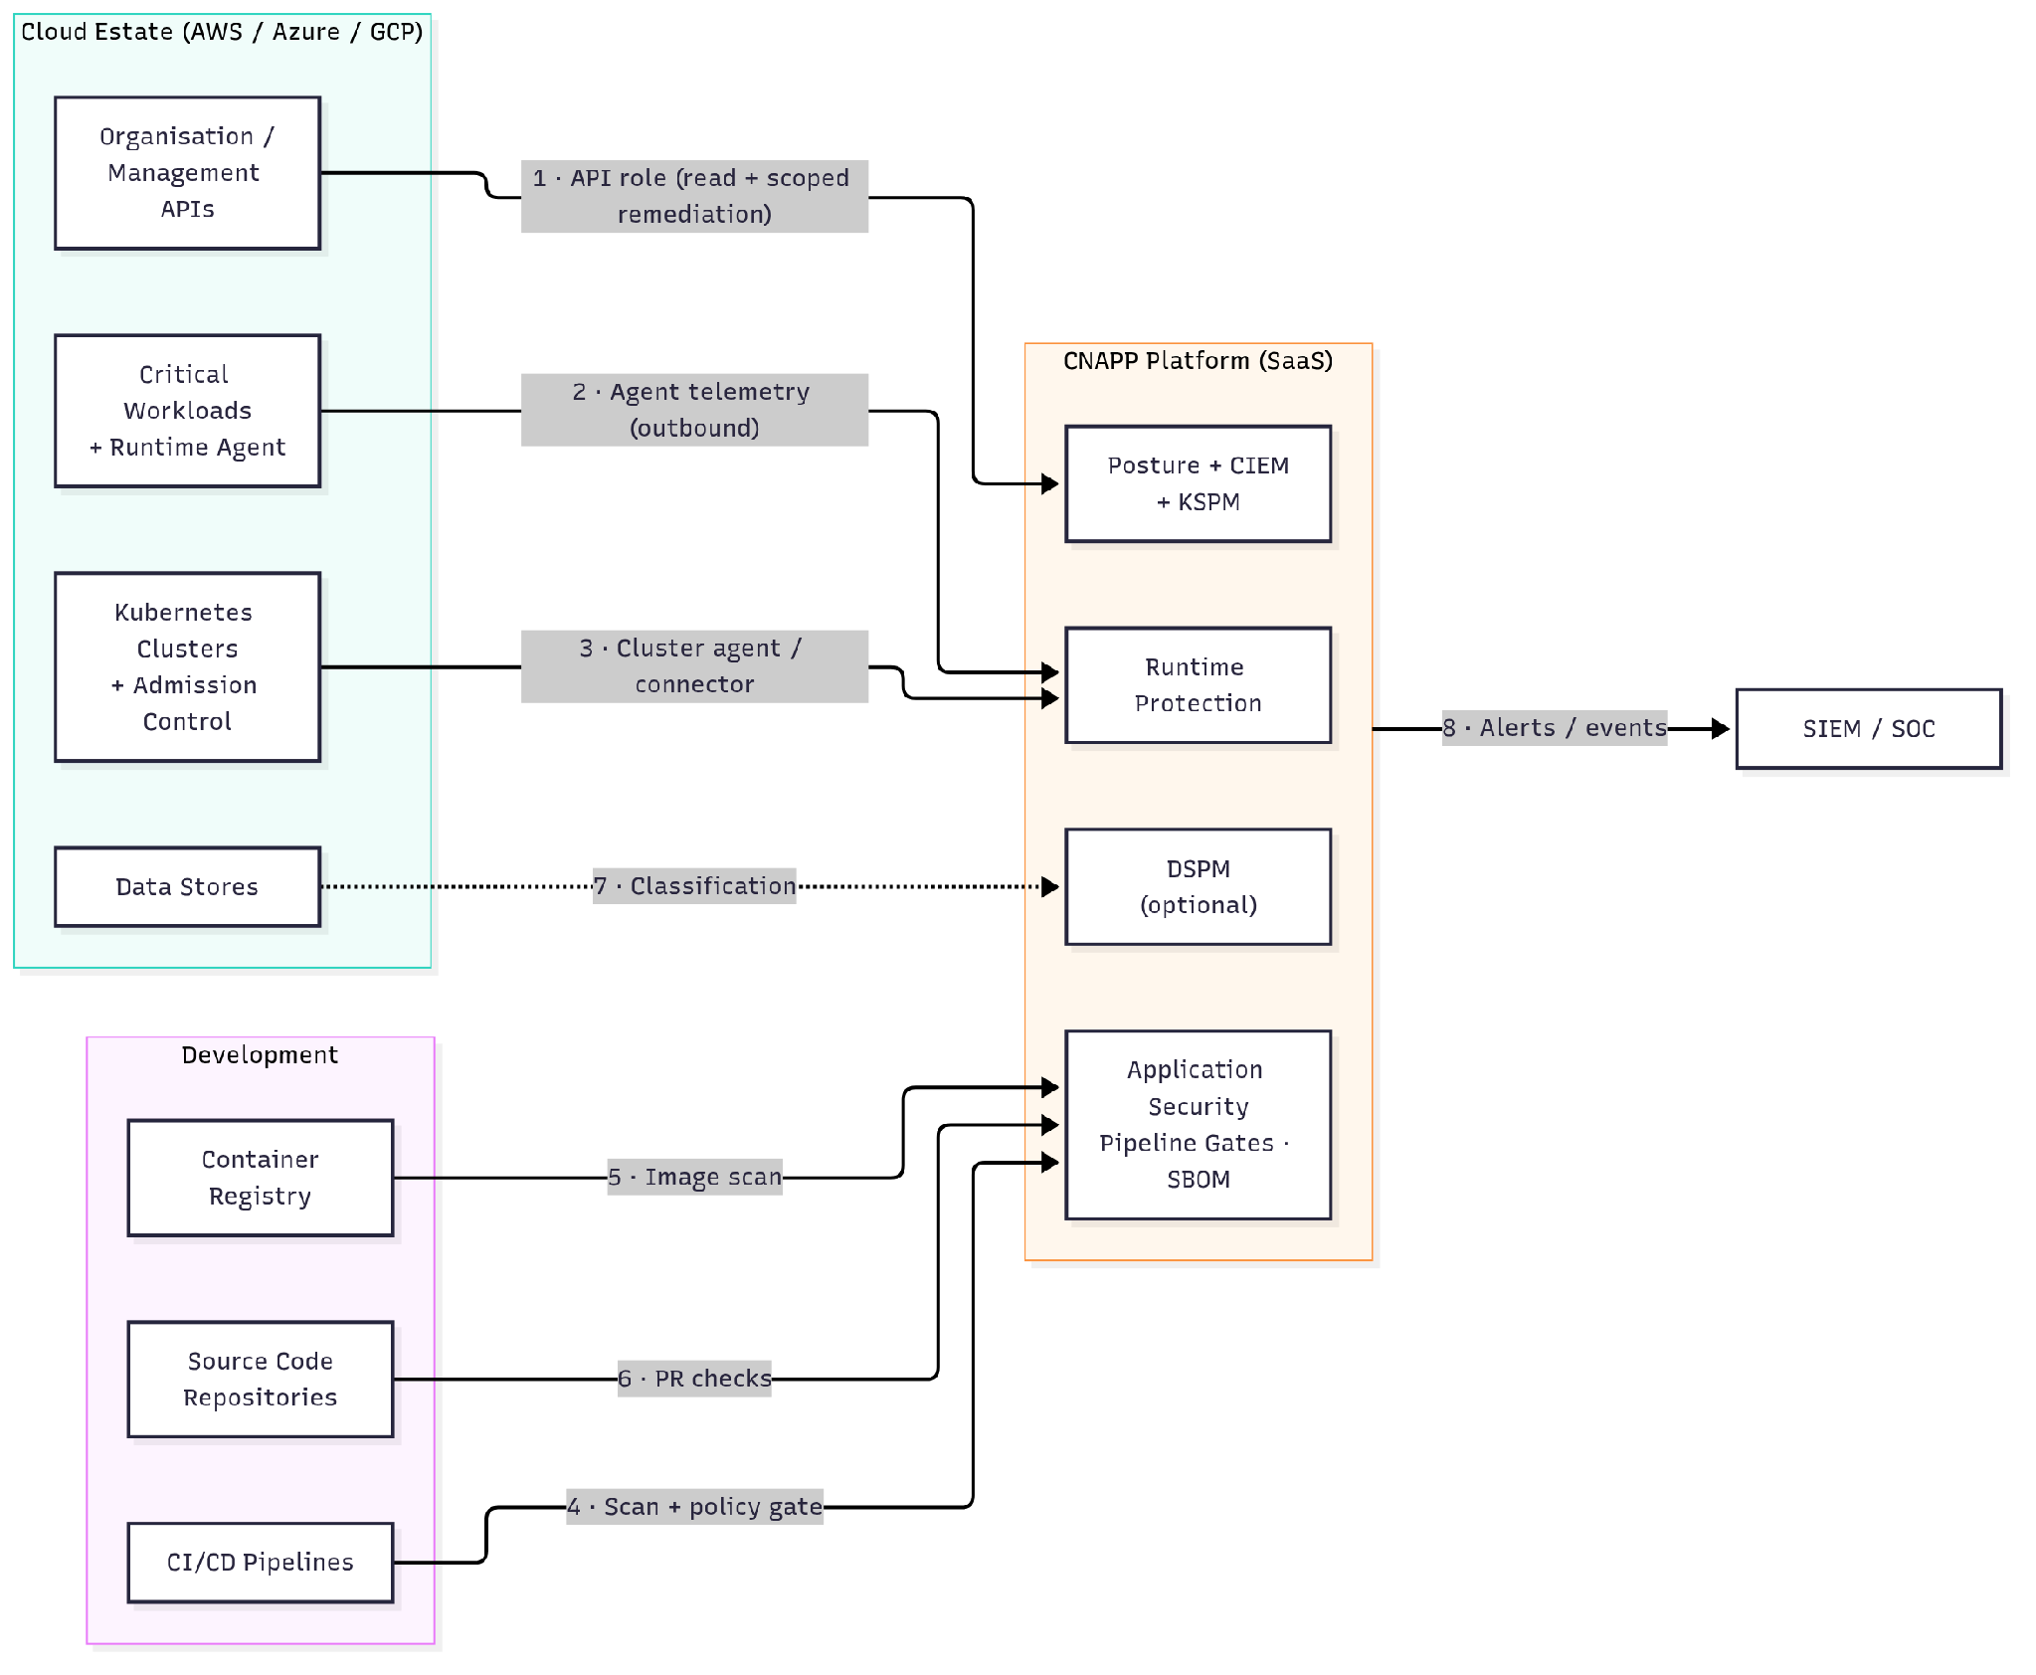
Figure 6. Better architecture: identity context, runtime agents and pipeline enforcement

Connectivity Flows
Important: These are generic patterns; confirm product-specific endpoints during detailed design.

# | Source | Destination | Protocol / Port | Direction | Authentication | Purpose
1 | Cortex Cloud platform | Cloud organisation / management APIs | HTTPS, TCP 443 | Outbound from SaaS to provider API | Role with read and scoped remediation permissions | Posture, CIEM and guided remediation
2 | Runtime agent (critical workloads) | CNAPP platform | HTTPS/TLS, TCP 443 | Outbound from workload | Agent certificate / token | Runtime telemetry and policy rules
3 | Kubernetes cluster agent / connector | Cortex Cloud platform | HTTPS/TLS, TCP 443 | Outbound from cluster | Cluster registration token | KSPM, runtime and admission control
4 | CI/CD pipelines | CNAPP platform | HTTPS, TCP 443 | Outbound from pipeline runner | API key / OIDC | Scan and policy gate decision
5 | Cortex Cloud platform | Container registry | HTTPS, TCP 443 | Outbound from SaaS (or scanner in customer network) | Registry credentials / role | Image vulnerability scanning
6 | Source code repositories | Cortex Cloud platform | HTTPS, TCP 443 | Webhook / app integration | OAuth application | Pull request checks
7 | Cortex Cloud platform | Cloud data stores | Provider API, HTTPS, TCP 443 | Outbound from SaaS | Role with scoped read permissions | Classification (optional)
8 | Cortex Cloud platform | SIEM / SOC | HTTPS, TCP 443 (or syslog over TLS, TCP 6514) | Outbound from SaaS | API token / certificate | Alert and event forwarding

Posture Management

Architecture Overview
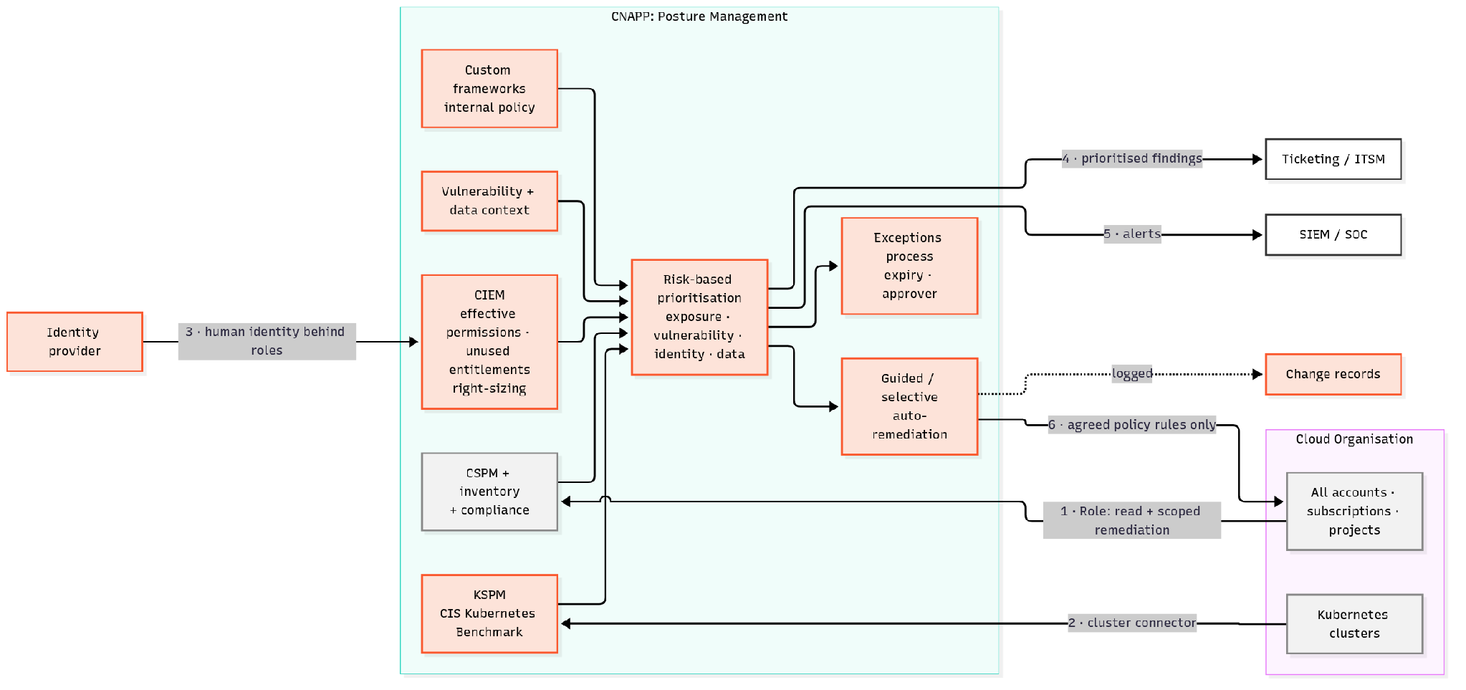
Figure 7. Posture Management: Better state architecture

Reasoning for the “Better State”

Key Capabilities

Architecture Considerations

Limitations and Triggers for the Next State

Runtime Protection

Architecture Overview
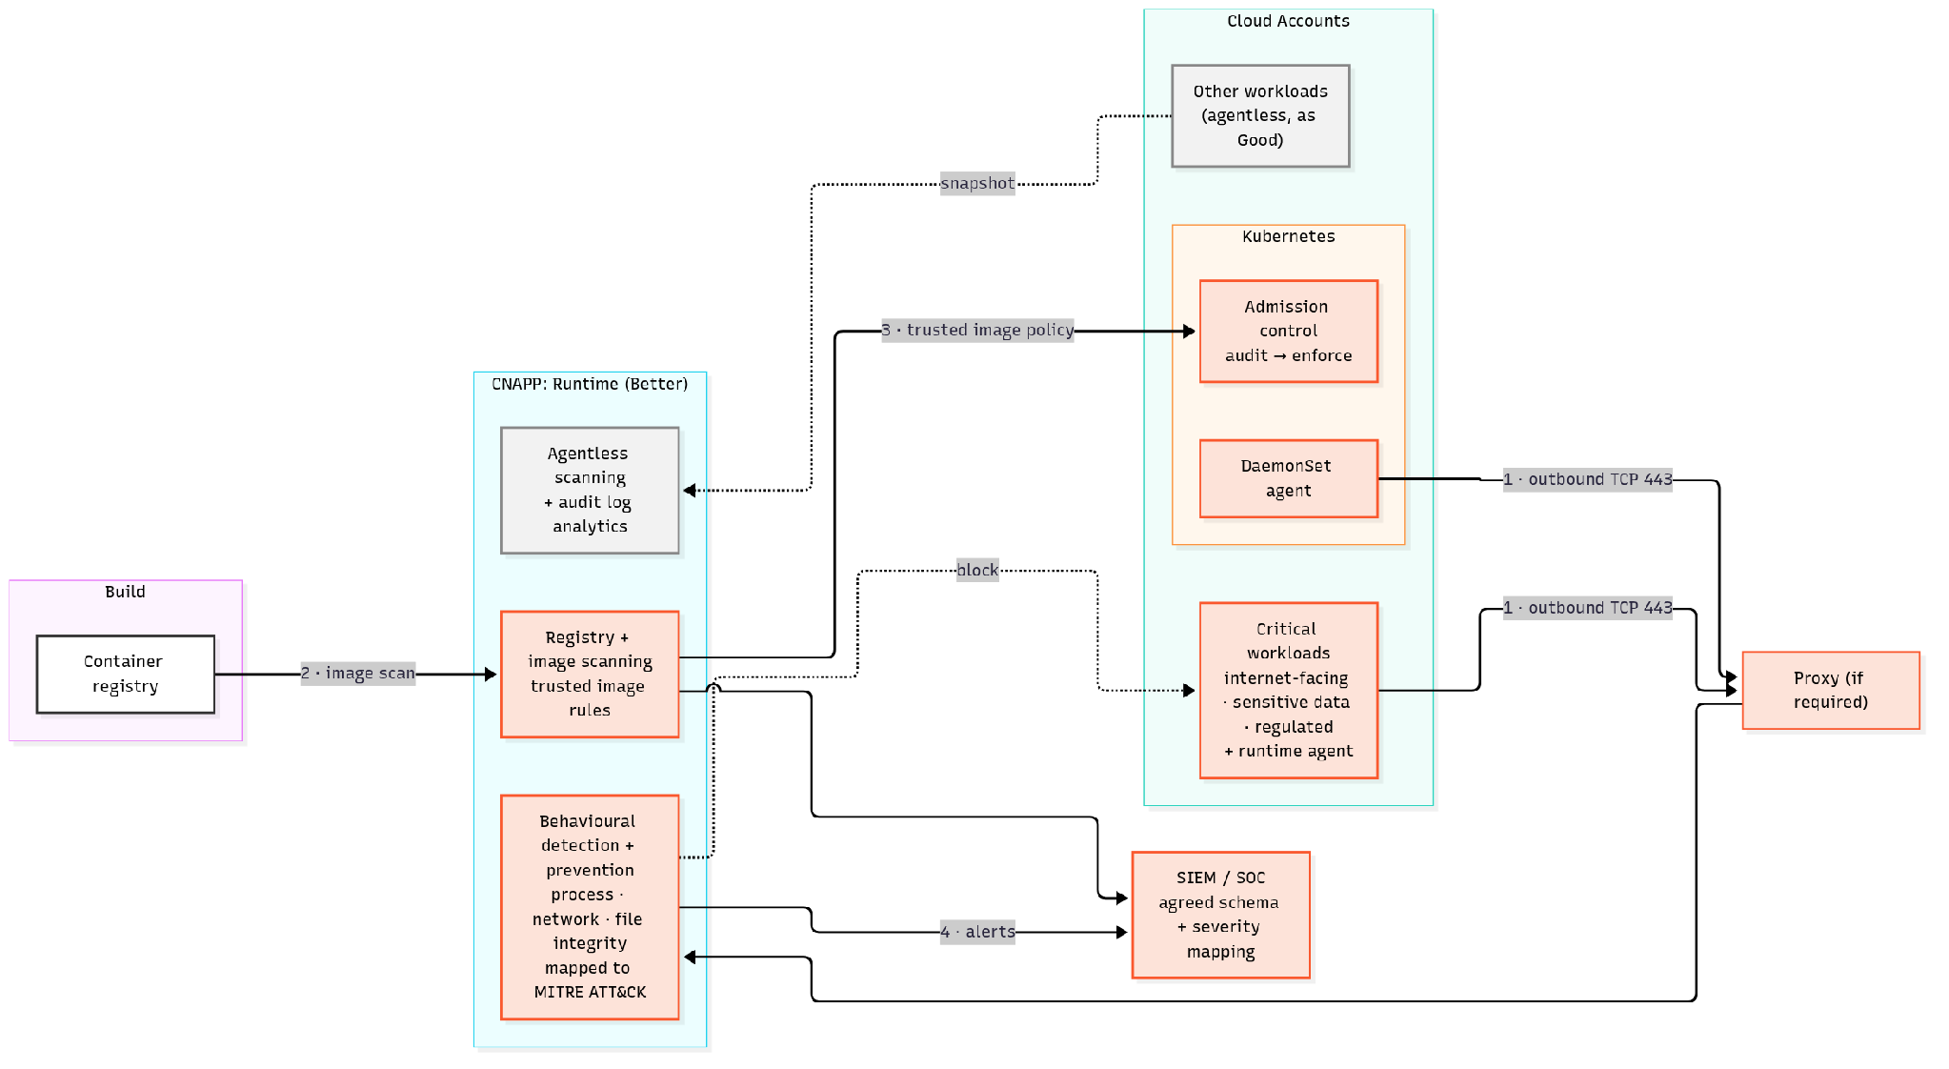
Figure 8. Runtime Protection: Better state architecture

Reasoning for the “Better State”

Key Capabilities

Architecture Considerations

Limitations and Triggers for the Next State

Application Security

Architecture Overview
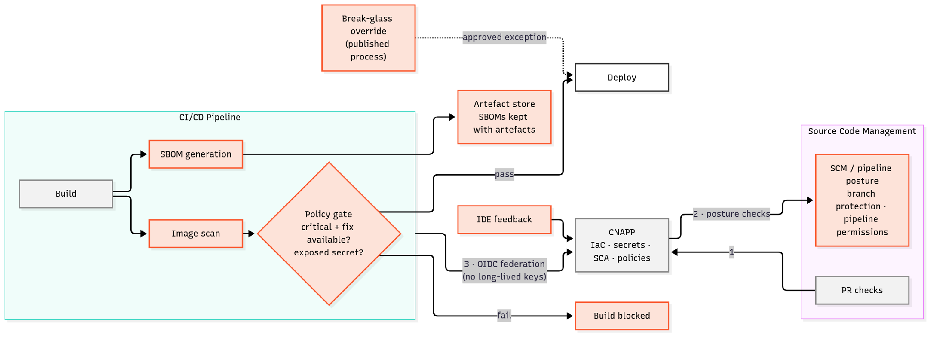
Figure 9. Application Security: Better state architecture

Reasoning for the “Better State”

Key Capabilities

Architecture Considerations

Limitations and Triggers for the Next State

Data Security Posture Management

Architecture Overview
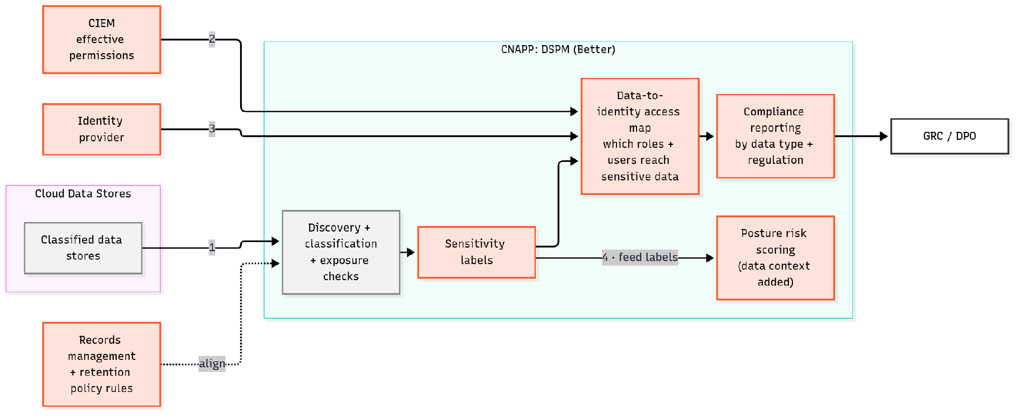
Figure 10. Data Security Posture Management: Better state architecture

Reasoning for the “Better State”

Key Capabilities

Architecture Considerations

Limitations and Triggers for the Next State

Best Architecture: Unified and Automated

Development Guidance
The Best state treats code, cloud configuration, identity, data and runtime as one connected risk model. Attack paths are calculated across all signals, every risk is traced to its owner and source code, and remediation and response are automated where confidence is high. The CNAPP platform and the SOC operate as one workflow.

Architecture Overview
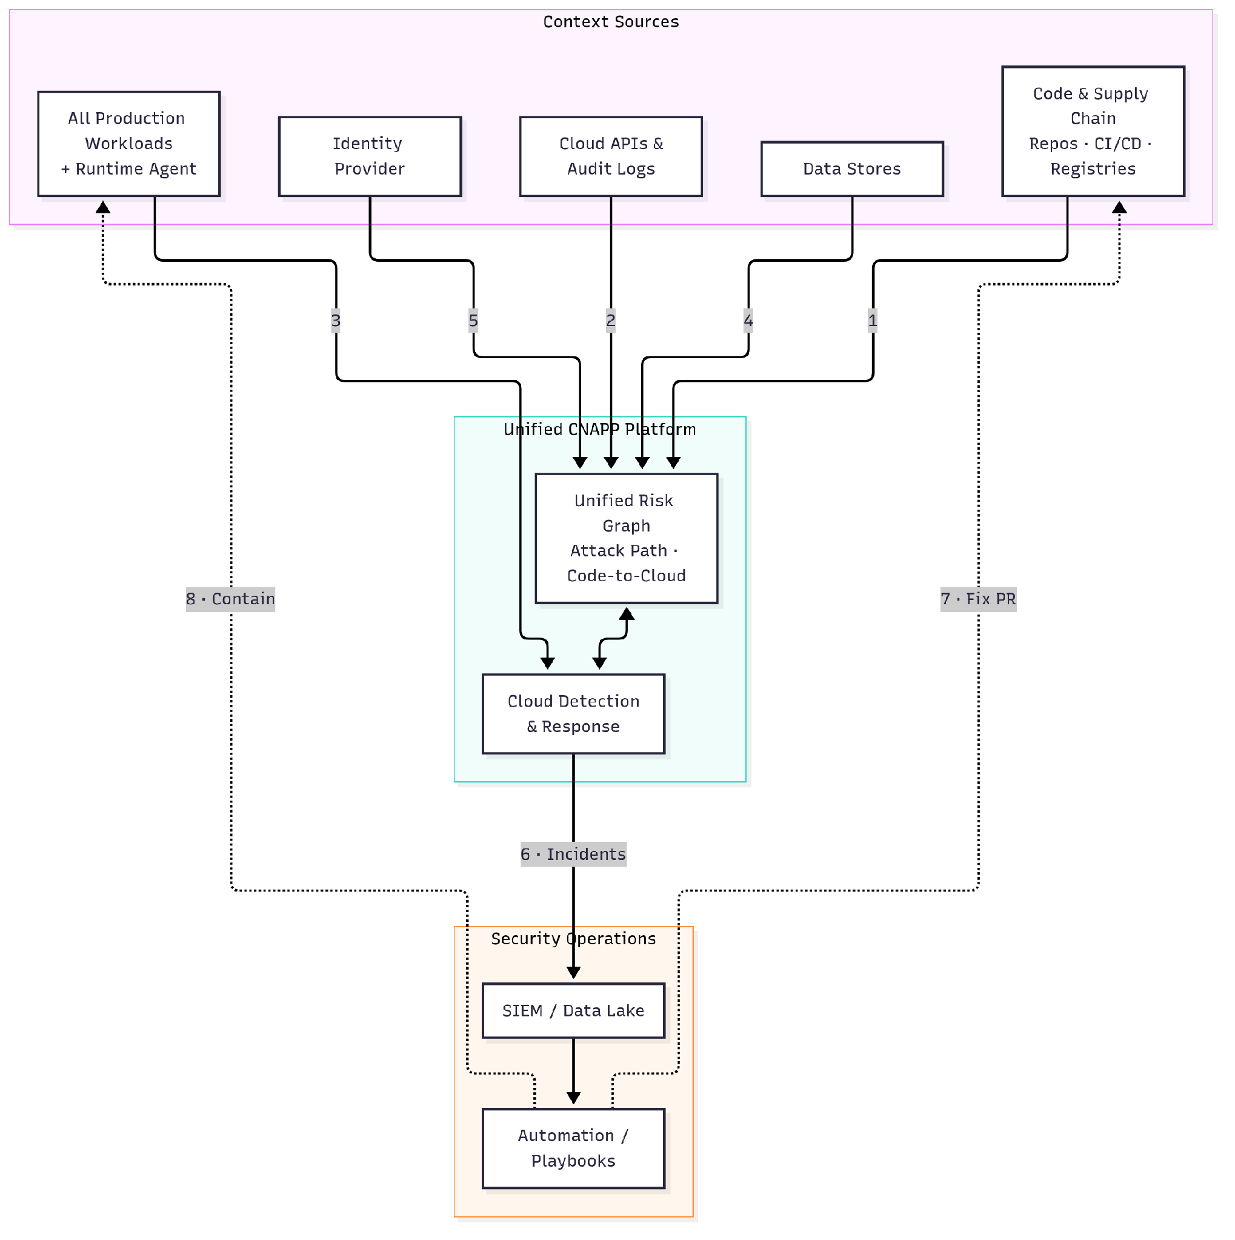
Figure 11. Best architecture: unified risk graph, CDR and automated response

Connectivity Flows
Important: These are generic patterns; confirm product-specific endpoints during detailed design.

# | Source | Destination | Protocol / Port | Direction | Authentication | Purpose
1 | Repositories, CI/CD, registries | Cortex Cloud platform | HTTPS, TCP 443 | App integration / pipeline outbound | OAuth application / OIDC | Code, pipeline and provenance context
2 | Cortex Cloud platform | Cloud APIs and audit logs | HTTPS, TCP 443 (or provider log streaming) | Outbound from SaaS / provider push | Cross-account role | Posture and audit event collection
3 | Runtime agents (all production workloads) | Cortex Cloud platform | HTTPS/TLS, TCP 443 | Outbound from workload | Agent certificate / token | Runtime telemetry for CDR
4 | Cortex Cloud platform | Cloud data stores | Provider API, HTTPS, TCP 443 | Outbound from SaaS | Role with scoped read permissions | Data context and access monitoring
5 | Identity provider | Cortex Cloud platform | HTTPS, TCP 443 | API integration | OAuth / SCIM | Human identity context
6 | Cortex Cloud platform (CDR) | SIEM / data lake | HTTPS, TCP 443 | Outbound from SaaS (or native platform) | API token | Correlated incidents
7 | Automation / playbooks | Source code repositories | HTTPS, TCP 443 | Outbound from automation platform | OAuth application | Automated fix pull requests
8 | Automation / playbooks | Workloads (via agent or provider API) | HTTPS, TCP 443 | Outbound from automation platform | Role / agent channel | Containment (isolate, stop, revoke)

Posture Management

Architecture Overview
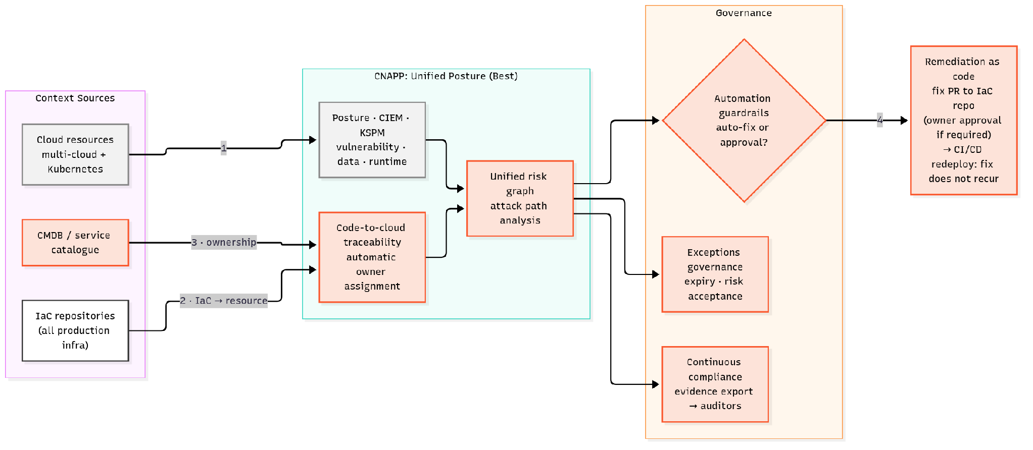
Figure 12. Posture Management: Best state architecture

Reasoning for the “Best State”

Key Capabilities

Architecture Considerations

Limitations and Triggers for the Next State

Runtime Protection

Architecture Overview
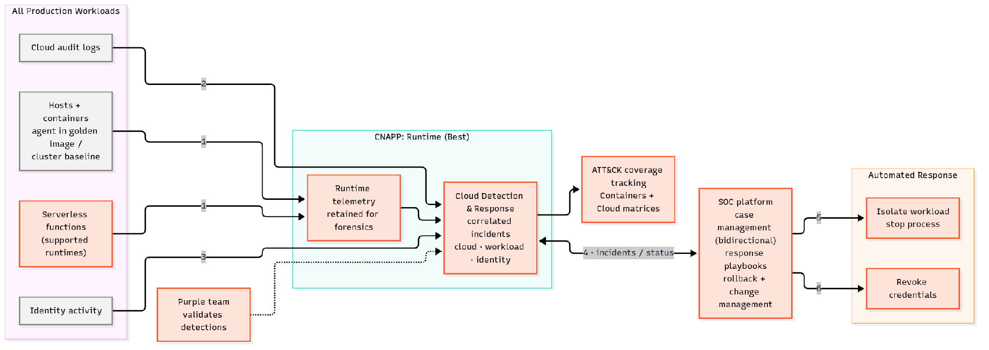
Figure 13. Runtime Protection: Best state architecture

Reasoning for the “Best State”

Key Capabilities

Architecture Considerations

Limitations and Triggers for the Next State

Application Security

Architecture Overview
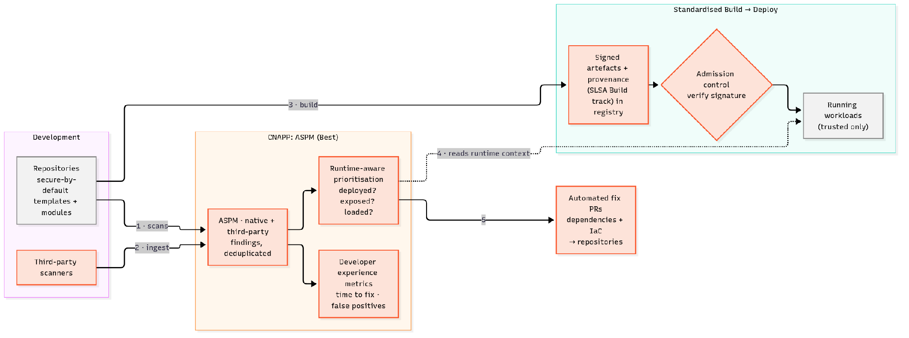
Figure 14. Application Security: Best state architecture

Reasoning for the “Best State”

Key Capabilities

Architecture Considerations

Limitations and Triggers for the Next State

Data Security Posture Management

Architecture Overview
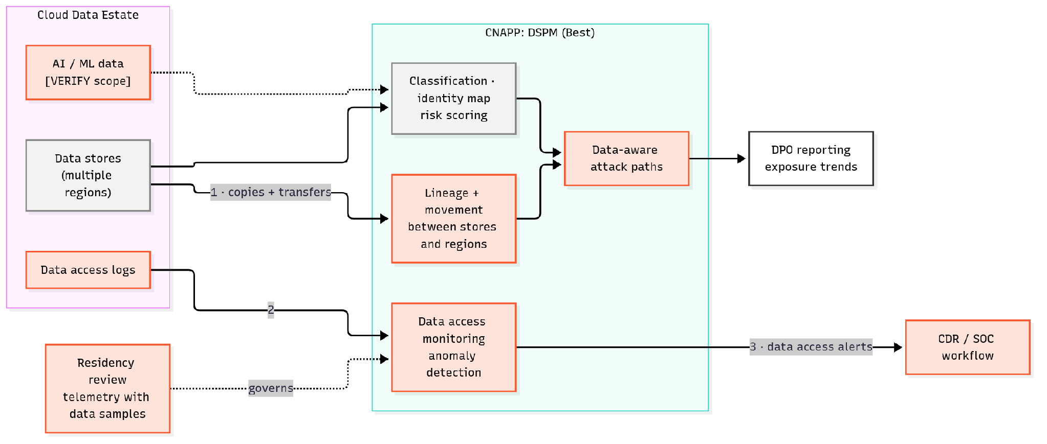
Figure 15. Data Security Posture Management: Best state architecture

Reasoning for the “Best State”

Key Capabilities

Architecture Considerations

Limitations and Triggers for the Next State

References
ID | Title | Publisher | Date | URL
S1 | NIST SP 800-190, Application Container Security Guide | NIST | September 2017 | https://csrc.nist.gov/pubs/sp/800/190/final
S2 | NIST SP 800-207, Zero Trust Architecture | NIST | August 2020 | https://csrc.nist.gov/pubs/sp/800/207/final
S3 | NIST SP 800-218, Secure Software Development Framework (SSDF) Version 1.1 | NIST | February 2022 | https://csrc.nist.gov/pubs/sp/800/218/final
S4 | CIS Benchmarks (AWS Foundations, Microsoft Azure Foundations, Google Cloud Platform Foundation, Kubernetes) | Center for Internet Security | Accessed November 2026 | https://www.cisecurity.org/cis-benchmarks
S5 | Cloud Controls Matrix (CCM) v4.1 | Cloud Security Alliance | Accessed November 2026 | https://cloudsecurityalliance.org/research/cloud-controls-matrix
S6 | MITRE ATT&CK Containers Matrix | MITRE | Accessed November 2026 | https://attack.mitre.org/matrices/enterprise/containers/
S7 | OWASP Top 10 CI/CD Security Risks | OWASP | Accessed November 2026 | https://owasp.org/www-project-top-10-ci-cd-security-risks/
S8 | SLSA Specification v1.2 | OpenSSF | Accessed November 2026 | https://slsa.dev/spec/v1.2/
S9 | Cortex Cloud product overview | Palo Alto Networks | Accessed November 2026 | https://www.paloaltonetworks.com/cortex/cloud
S10 | Cortex Cloud Documentation | Palo Alto Networks | Accessed November 2026 | https://cortex-docs.paloaltonetworks.com/cortex-cloud-docs/readme.md
S11 | ADS capabilities | Palo Alto Networks | Accessed November 2026 | https://cortex-docs.paloaltonetworks.com/cortex-cloud-runtime-security/agentless-disk-scanning/agentless-disk-scanning/ads-capabilities
S12 | ADS scan modes | Palo Alto Networks | Accessed November 2026 | https://cortex-docs.paloaltonetworks.com/cortex-cloud-runtime-security/agentless-disk-scanning/agentless-disk-scanning/ads-scan-modes
S13 | Onboard the Kubernetes Connector | Palo Alto Networks | Accessed November 2026 | https://cortex-docs.paloaltonetworks.com/cortex-cloud-runtime-security/onboard-and-configure/deployment-steps-and-checklist/onboard-the-kubernetes-connector
S14 | Serverless function runtime security (Cortex XSIAM) | Palo Alto Networks | Accessed November 2026 | https://cortex-docs.paloaltonetworks.com/cortex-xsiam/cloud-security/overview-1
S15 | Kubernetes platforms supported (Cortex XDR agent) | Palo Alto Networks | Accessed November 2026 | https://cortex-docs.paloaltonetworks.com/compatibility-matrix/where-can-i-install-the-cortex-xdr-agent/kubernetes-platforms-supported
S16 | Web and API Security (WAAS) | Palo Alto Networks | Accessed November 2026 | https://cortex-docs.paloaltonetworks.com/cortex-xsiam/cloud-security/overview
S17 | Onboard version control systems | Palo Alto Networks | Accessed November 2026 | https://cortex-docs.paloaltonetworks.com/application-security/application-security/onboard-data-sources/onboard-version-control-systems
S18 | Pull request scan workflow | Palo Alto Networks | Accessed November 2026 | https://cortex-docs.paloaltonetworks.com/application-security/code-security/application-security-scans-management/manage-scans-through-the-tenant-ui/pull-request-scans/pull-request-scan-workflow
S19 | Application Security Cortex CLI | Palo Alto Networks | Accessed November 2026 | https://cortex-docs.paloaltonetworks.com/application-security/code-security/application-security-cli
S20 | Create an automation rule (Cortex Cloud) | Palo Alto Networks | Accessed November 2026 | https://cortex-docs.paloaltonetworks.com/cortex-cloud-runtime-security/cases-and-issues/investigation-and-response/automation/create-an-automation-rule
S21 | CLI pipeline code snippets | Palo Alto Networks | Accessed November 2026 | https://cortex-docs.paloaltonetworks.com/application-security/application-security/onboard-data-sources/cli-pipeline-code-snippets
S22 | GitHub Actions integration | Palo Alto Networks | Accessed November 2026 | https://cortex-docs.paloaltonetworks.com/application-security/application-security/onboard-data-sources/integrate-ci-tools/github-actions
S23 | Ingest third-party data sources | Palo Alto Networks | Accessed November 2026 | https://cortex-docs.paloaltonetworks.com/application-security/application-security/onboard-data-sources/ingest-third-party-data-sources
S24 | Code-to-Cloud: core components and mechanisms | Palo Alto Networks | Accessed November 2026 | https://cortex-docs.paloaltonetworks.com/application-security/application-security-posture-management-aspm/code-to-cloud/core-components-and-mechanisms
S25 | Remediate multiple CVEs with single-fix | Palo Alto Networks | Accessed November 2026 | https://cortex-docs.paloaltonetworks.com/application-security/code-security/code-security-scanners/software-composition-analysis-sca-scanners/software-composition-analysis-sca-vulnerability-issues/investigate-and-remediate-cve-vulnerability-issues/remediate-multiple-cves-with-single-fix
S26 | AppSec Objectives with Agentix | Palo Alto Networks | Accessed November 2026 | https://cortex-docs.paloaltonetworks.com/application-security/application-security/appsec-objectives-with-agentix
S27 | Automation in Cortex AgentiX | Palo Alto Networks | Accessed November 2026 | https://cortex-docs.paloaltonetworks.com/cortex-agentix/configure-cortex-agentix/automations/automation-in-cortex-agentix
S28 | Cortex AgentiX product overview | Palo Alto Networks | Accessed November 2026 | https://www.paloaltonetworks.com/cortex/agentix
S29 | Registry scanning (Cortex XSIAM) | Palo Alto Networks | Accessed November 2026 | https://cortex-docs.paloaltonetworks.com/cortex-xsiam/cloud-security/container-registry-scanning
S30 | Supported container registry integrations | Palo Alto Networks | Accessed November 2026 | https://cortex-docs.paloaltonetworks.com/cortex-xsiam/cloud-security/container-registry-scanning/supported-container-registry-integrations
S31 | Enable access to required PANW resources | Palo Alto Networks | Accessed November 2026 | https://cortex-docs.paloaltonetworks.com/cortex-cloud-runtime-security/onboard-and-configure/deployment-steps-and-checklist/activate-cortex-cloud/enable-access-to-required-panw-resources
S32 | Agentic Response (Preview) | Palo Alto Networks | Accessed November 2026 | https://cortex-docs.paloaltonetworks.com/cortex-agentix/configure-cortex-agentix/automations/agentic-response-preview
S33 | Dispatch an agent on a case | Palo Alto Networks | Accessed November 2026 | https://cortex-docs.paloaltonetworks.com/cortex-cloud-runtime-security/cases-and-issues/analyze-and-resolve-cases/additional-case-actions/dispatch-an-agent-on-a-case
S34 | Playbooks and Agentic Playbook Builder (Cortex Cloud) | Palo Alto Networks | Accessed November 2026 | https://cortex-docs.paloaltonetworks.com/cortex-cloud-runtime-security/cases-and-issues/investigation-and-response/automation/playbooks
S35 | Cortex MCP server (Cortex XSIAM) | Palo Alto Networks | Accessed November 2026 | https://cortex-docs.paloaltonetworks.com/cortex-xsiam/configure-cortex-xsiam/cortex-mcp-server
S36 | Cortex Agentic Assistant Agents permissions (Cortex XSIAM) | Palo Alto Networks | Accessed November 2026 | https://cortex-docs.paloaltonetworks.com/cortex-xsiam/reference-and-developer-docs/role-based-access-control/cortex-agentic-assistant-permissions/cortex-agentic-assistant-agents
S37 | Cortex Cloud federal compliance | Palo Alto Networks | Accessed November 2026 | https://cortex-docs.paloaltonetworks.com/cortex-cloud-posture-management/onboard-and-configure/deployment-steps-and-checklist/fedramp-overview/cortex-cloud-federal-compliance
S38 | FedRAMP limitations and supported regions | Palo Alto Networks | Accessed November 2026 | https://cortex-docs.paloaltonetworks.com/cortex-cloud-posture-management/onboard-and-configure/deployment-steps-and-checklist/fedramp-overview/limitations-and-supported-regions
S39 | FedRAMP onboarding and configuration | Palo Alto Networks | Accessed November 2026 | https://cortex-docs.paloaltonetworks.com/cortex-cloud-posture-management/onboard-and-configure/deployment-steps-and-checklist/fedramp-overview/onoarding-and-configuration
S40 | FedRAMP and the US Federal Government required resources | Palo Alto Networks | Accessed November 2026 | https://cortex-docs.paloaltonetworks.com/cortex-cloud-posture-management/onboard-and-configure/deployment-steps-and-checklist/activate-cortex-cloud/enable-access-to-required-panw-resources/fedramp-and-the-us-federal-government-required-resources
S41 | Outpost fundamentals and planning | Palo Alto Networks | Accessed November 2026 | https://cortex-docs.paloaltonetworks.com/cortex-cloud-posture-management/onboard-and-configure/deployment-steps-and-checklist/cloud-service-provider-csp-onboarding/outpost-onboarding/outpost-fundamentals-and-planning
S42 | Outpost networking options | Palo Alto Networks | Accessed November 2026 | https://cortex-docs.paloaltonetworks.com/cortex-cloud-posture-management/onboard-and-configure/deployment-steps-and-checklist/cloud-service-provider-csp-onboarding/outpost-onboarding/working-with-custom-outposts/custom-outpost-concepts/outpost-networking-options
S43 | What Cortex creates in a custom outpost | Palo Alto Networks | Accessed November 2026 | https://cortex-docs.paloaltonetworks.com/cortex-cloud-posture-management/onboard-and-configure/deployment-steps-and-checklist/cloud-service-provider-csp-onboarding/outpost-onboarding/working-with-custom-outposts/custom-outpost-concepts/what-cortex-creates-in-a-custom-outpost
S44 | Transporter over Broker VM | Palo Alto Networks | Accessed November 2026 | https://cortex-docs.paloaltonetworks.com/application-security/application-security/onboard-data-sources/transporter-over-broker-vm
S45 | Set up a Transporter applet on Broker VM | Palo Alto Networks | Accessed November 2026 | https://cortex-docs.paloaltonetworks.com/application-security/application-security/onboard-data-sources/transporter-over-broker-vm/set-up-a-transporter-applet-on-broker-vm
S46 | Set up a Transporter on your VCS | Palo Alto Networks | Accessed November 2026 | https://cortex-docs.paloaltonetworks.com/application-security/application-security/onboard-data-sources/transporter-over-broker-vm/set-up-a-transporter-on-your-vcs
S47 | Onboard GitHub Enterprise (On-Prem) | Palo Alto Networks | Accessed November 2026 | https://cortex-docs.paloaltonetworks.com/application-security/application-security/onboard-data-sources/onboard-version-control-systems/github-enterprise-on-prem/onboard-github-enterprise-on-prem
S48 | Set up and configure Broker VM | Palo Alto Networks | Accessed November 2026 | https://cortex-docs.paloaltonetworks.com/cortex-cloud-posture-management/data-management/broker-vm/set-up-and-configure-broker-vm
S49 | Broker VM High Availability Cluster | Palo Alto Networks | Accessed November 2026 | https://cortex-docs.paloaltonetworks.com/cortex-cloud-posture-management/data-management/broker-vm/broker-vm-high-availability-cluster
S50 | Activate Registry Scanner (Broker VM) | Palo Alto Networks | Accessed November 2026 | https://cortex-docs.paloaltonetworks.com/cortex-cloud-runtime-security/cortex-cloud-data-sources-and-connectors/generic-on-premise-data-collectors/broker-vm-data-collector-applets/activate-registry-scanner
S51 | What is the Broker VM? | Palo Alto Networks | Accessed November 2026 | https://cortex-docs.paloaltonetworks.com/cortex-cloud-posture-management/data-management/broker-vm/what-is-the-broker-vm
S52 | Amazon Web Services (AWS) outpost permissions | Palo Alto Networks | Accessed November 2026 | https://cortex-docs.paloaltonetworks.com/cortex-cloud-posture-management/onboard-and-configure/deployment-steps-and-checklist/cloud-service-provider-csp-onboarding/outpost-onboarding/outpost-cloud-service-provider-csp-permissions/amazon-web-services-aws-outpost-permissions
S53 | Microsoft Azure outpost permissions | Palo Alto Networks | Accessed November 2026 | https://cortex-docs.paloaltonetworks.com/cortex-cloud-posture-management/onboard-and-configure/deployment-steps-and-checklist/cloud-service-provider-csp-onboarding/outpost-onboarding/outpost-cloud-service-provider-csp-permissions/microsoft-azure-outpost-permissions
S54 | Google Cloud Platform (GCP) outpost permissions | Palo Alto Networks | Accessed November 2026 | https://cortex-docs.paloaltonetworks.com/cortex-cloud-posture-management/onboard-and-configure/deployment-steps-and-checklist/cloud-service-provider-csp-onboarding/outpost-onboarding/outpost-cloud-service-provider-csp-permissions/google-cloud-platform-gcp-outpost-permissions
S55 | Create a standard outpost | Palo Alto Networks | Accessed November 2026 | https://cortex-docs.paloaltonetworks.com/cortex-cloud-posture-management/onboard-and-configure/deployment-steps-and-checklist/cloud-service-provider-csp-onboarding/outpost-onboarding/working-with-standard-outposts/create-a-standard-outpost
S56 | Plan your custom outpost | Palo Alto Networks | Accessed November 2026 | https://cortex-docs.paloaltonetworks.com/cortex-cloud-posture-management/onboard-and-configure/deployment-steps-and-checklist/cloud-service-provider-csp-onboarding/outpost-onboarding/working-with-custom-outposts/plan-your-custom-outpost
S57 | Prerequisites for bringing your own app registration (BYOA) | Palo Alto Networks | Accessed November 2026 | https://cortex-docs.paloaltonetworks.com/cortex-cloud-posture-management/onboard-and-configure/deployment-steps-and-checklist/cloud-service-provider-csp-onboarding/outpost-onboarding/working-with-custom-outposts/bring-your-own-azure-app-registration-byoa/prerequisites-for-bringing-your-own-app-registration
S58 | Outbound allow-list reference (custom networking) | Palo Alto Networks | Accessed November 2026 | https://cortex-docs.paloaltonetworks.com/cortex-cloud-posture-management/onboard-and-configure/deployment-steps-and-checklist/cloud-service-provider-csp-onboarding/outpost-onboarding/working-with-custom-outposts/custom-networking-byon/outbound-allow-list-reference
S59 | Custom networking prerequisites | Palo Alto Networks | Accessed November 2026 | https://cortex-docs.paloaltonetworks.com/cortex-cloud-posture-management/onboard-and-configure/deployment-steps-and-checklist/cloud-service-provider-csp-onboarding/outpost-onboarding/working-with-custom-outposts/custom-networking-byon/custom-networking-prerequisites
S60 | Amazon Web Services (AWS) provider permissions | Palo Alto Networks | Accessed November 2026 | https://cortex-docs.paloaltonetworks.com/cortex-cloud-posture-management/onboard-and-configure/deployment-steps-and-checklist/cloud-service-provider-csp-onboarding/amazon-web-services-cloud-onboarding/amazon-web-services-aws-provider-permissions
S61 | Microsoft Azure provider permissions | Palo Alto Networks | Accessed November 2026 | https://cortex-docs.paloaltonetworks.com/cortex-cloud-posture-management/onboard-and-configure/deployment-steps-and-checklist/cloud-service-provider-csp-onboarding/microsoft-azure-cloud-onboarding/microsoft-azure-provider-permissions
S62 | Google Cloud Platform (GCP) provider permissions | Palo Alto Networks | Accessed November 2026 | https://cortex-docs.paloaltonetworks.com/cortex-cloud-posture-management/onboard-and-configure/deployment-steps-and-checklist/cloud-service-provider-csp-onboarding/google-cloud-platform-cloud-onboarding/google-cloud-platform-gcp-provider-permissions
S63 | Regulation (EU) 2016/679 (General Data Protection Regulation) | EUR-Lex | 2016 | https://eur-lex.europa.eu/eli/reg/2016/679/oj
S64 | Regulation (EU) 2022/2554 (Digital Operational Resilience Act) | EUR-Lex | 2022 | https://eur-lex.europa.eu/eli/reg/2022/2554/oj
S65 | Directive (EU) 2022/2555 (NIS2 Directive) | EUR-Lex | 2022 | https://eur-lex.europa.eu/eli/dir/2022/2555/oj
S66 | 45 CFR Part 164, Subpart C (HIPAA Security Rule) | Electronic Code of Federal Regulations | Accessed November 2026 | https://www.ecfr.gov/current/title-45/subtitle-A/subchapter-C/part-164/subpart-C
S67 | PCI DSS document library | PCI Security Standards Council | Accessed November 2026 | https://www.pcisecuritystandards.org/document_library/
S68 | Cortex Cloud Identity Security functionality | Palo Alto Networks | Accessed November 2026 | https://cortex-docs.paloaltonetworks.com/cortex-cloud-posture-management/cortex-cloud-identity-security/cortex-cloud-identity-security-functionality

