# **HOST**

1. Establishment of Parameters and Keys

(Private, Public, and Session Key)

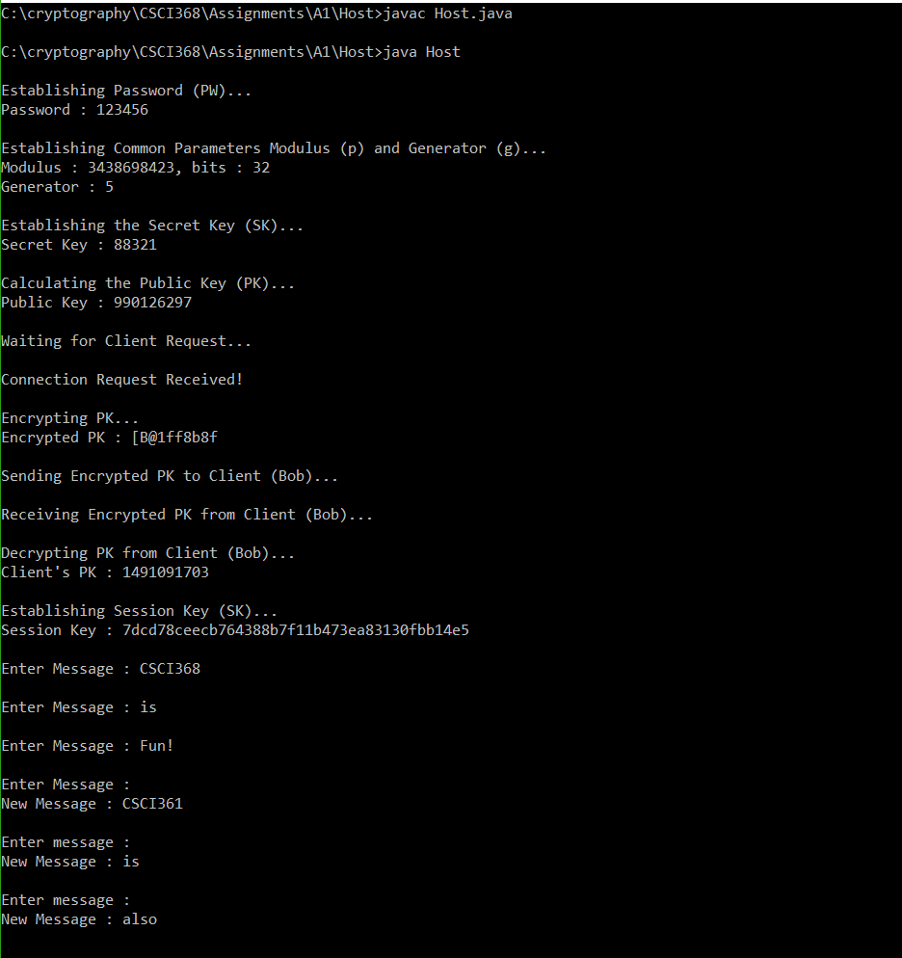

# Message Session

# 

# **CLIENT**

1. Establishment of Parameters and Keys

(Private, Public, and Session Key)

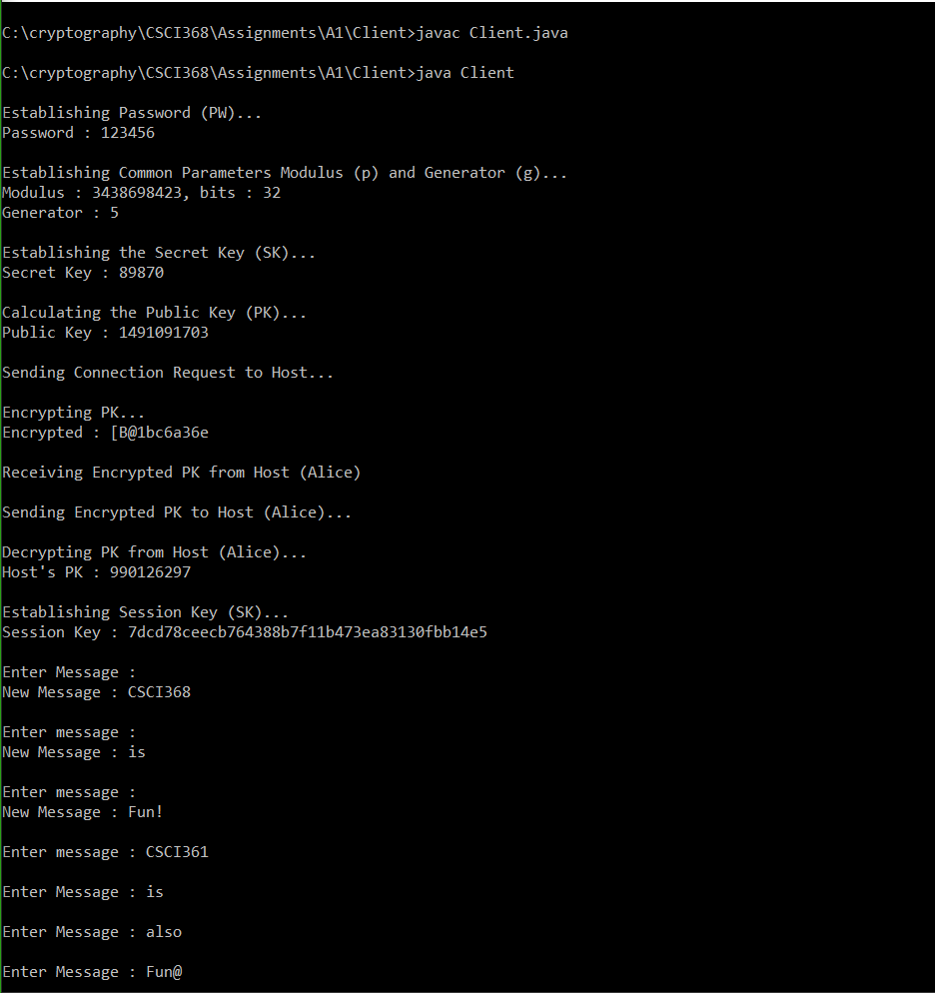

# Message Session

