Project - 1

Project Title: Weather Data Analysis (Entry Level)

Objective: Conduct basic data analytics and visualization on the Weather Data Set to gain insights. No machine learning is required for this entry-level project, and tools such as PowerBI, Tableau, or any preferred tool can be used for analysis and visualization.

Tasks:

1. Descriptive statistics:

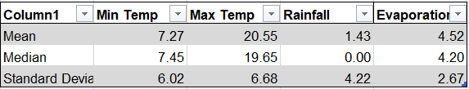

1. Time Series Visualization:
2. Correlation Analysis:

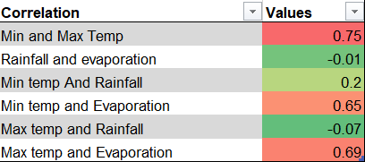

1. Rainfall Distribution:

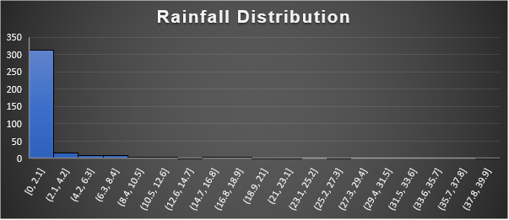

1. Seasonal Analysis: