Birdy — A Physical Voice for Understanding Birdsong
Working draft — internal research note · 2026-08-01

Abstract. Birdy is a research programme and an interactive installation. It treats birdsong as learnable structure. Its voice is a physical model of the avian syrinx, fitted to field recordings by gesture inversion. Its memory is a measurement-only corpus: the harvest decodes each recording, describes it as numbers, and deletes the audio. Its map is a 3-D galaxy with one point per measured syllable. Its claim to translation is narrow on purpose. The system does functional decoding: call type to documented behavioural function, with confidence labels. Playback experiments are the only proof of meaning the field accepts, so the app labels everything else as what it is. This note describes the instrument, the design choices and their reasons, the pipeline, and the evidence. It reports what works: a learned syllable embedding that lifts species placement by up to +13.3 points, a bit-identical parallel learn, a measured fricative synthesis path, and a session-quality gate at AUC 0.953. It reports at equal length what does not work: the fit objective does not track audible distortion, recorder invariance does not come from loss engineering, and the corpus is too shallow for song grammar. Negative results stay in the record. That is the method, not an apology.

Keywords. birdsong, syrinx model, gesture inversion, contrastive embedding, bioacoustics, confidence labels

Contents
1 The premise: what translating birdsong can honestly mean
2 Design choices and why
3 Comparison with other approaches
4 The pipeline, end to end
5 Results: what works (measured)
6 Limitations: what does not work (measured)
7 The unknown-bird pipeline
8 Roadmap
9 References

1. The premise: what translating birdsong can honestly mean
In plain terms. A great tit does not improvise. It owns a small set of calls. One of them is a sentence: three notes that mean “scan for danger”, then one note that means “come here”. Played in that order, other tits do both. Played backwards, they do nothing. Birdsong is structure that a machine can learn. But a machine cannot yet say what an unheard call means. The only accepted proof of meaning is a playback experiment: play the sound to a bird and watch what the bird does. Birdy builds on both halves of that fact. It learns the structure aggressively, and it labels the meaning honestly.
The field's own position has three parts^{[1]}. Machine learning today can characterize repertoires: find the units and their structure. It can functionally decode: link signals to context and behaviour. It cannot translate into propositional human language. That requires playback experiments, and those exist for only a handful of systems. An ethological asymmetry sharpens the point. Bird song has rich syntax but weak or no referential meaning. Bird calls carry meaning but little syntax (docs/03 §3.1)^{[36]}. The defensible product is therefore functional translation: call type to documented behavioural function, species, individual identity, urgency, each with a confidence label. Word-for-word translation is marketing, and the app says so in its own interface.
The studied vocabularies behind the language set are real. The Japanese great tit composes ABC–D: ABC means “scan for danger”, D means “approach”, and the reversed order elicits nothing^{[2]}. The Siberian jay's alarm calls encode predator behaviour rather than predator species^{[3]}. The chickadee's chick-a-dee call has four note types, a strict A→B→C→D order, and a D-count that scales with threat^{[4]}. The nightingale delivers 180–200 song types in rule-governed order^{[5]}. The Bengalese finch sings a finite-state syntax^{[6]}. This literature-anchored set is what Birdy calls a documented function. Everything else is labelled as what it is.
Why a physical synthesiser. Two reasons anchor the design, one scientific and one legal. Scientifically, a procedural model of the syrinx is a falsifiable theory of the bird. Its parameters — air-sac pressure, syringeal tension, tract geometry — are physiological claims. The model class has passed the strongest realism tests available. Synthetic song from it drives song premotor neurons indistinguishably from real song^{[10]}, and wild territorial sparrows respond to it as they do to a real rival^{[15]}. Legally, it is the app's only clean voice. xeno-canto recordings carry per-file Creative Commons licences, largely non-commercial, so Birdy retains and ships no audio at all. The harvest decodes each recording, describes it as numbers, and deletes it (docs/09 §9.4, AGENTS.md)^{[39,52]}. Every sound the app makes is synthesized from fitted parameters. Every point in its galaxy is a measurement, not a file.

2. Design choices and why
In plain terms. Five choices carry the system: a physical voice, a corpus without audio, a network that scores but never sings, two feature spaces with a bridge between them, and a label on every claim. Each choice has a stated reason. Each has a measured consequence later in this note. Table 1 maps every technique to the place where it runs.

2.1 A physical syrinx as the voice
Birds do not sing with a larynx. At the bottom of the windpipe sits the syrinx: soft membranes that vibrate in the airstream like a reed. The bird has two control knobs. Air-sac pressure sets how hard it blows, roughly loudness. Syringeal tension sets how tight the membranes are, roughly pitch. A two-equation model of that reed, driven by those two knobs, is realistic enough to fool the auditory neurons of a listening bird. Birdy's voice is that model, plus the physics of the tube above it. The source is the low-dimensional Mindlin–Laje flapping oscillator^{[7,9]}, integrated as two first-order equations (docs/08 §8.1)^{[38]}:
(1)
Here α is the air-sac pressure and β the syringeal tension that sets the fundamental frequency. g is a pure time-scale: rescaling time by g leaves the equations unchanged. Each syllable gets its own g, chosen to place its median pitch in the well-behaved region of the model:
(2)
Φ was measured once on a calibration sweep; the value above is measured, not fitted^{[13]}. The bifurcation that births the oscillation decides the timbre. At high tension a Hopf bifurcation produces tonal, whistle-like notes. At low tension a saddle-node on a limit cycle produces pulse-like, harmonically dense sounds^{[11]}. The spectral content index is a function of tension alone, so the model's γ-scale — not its filters — is the tonal-to-rich axis (docs/08 §8.1a). The integrator is deliberately plain: forward Euler at 16× oversampling at 48 kHz. RK4 agrees to within 2 % of F0, so Euler is what ships (docs/08 §8.1).
The vocal tract is not cosmetic. Pure-tone birdsong is a filter effect: the tract suppresses harmonics, proven by heliox experiments^{[17,18]}. Songbirds also retune the oropharyngeal cavity actively, tracking the fundamental from 1.5 to 5 kHz within a single syllable^{[20]}. So one resonance follows the instantaneous f0. A tracking resonance alone would make every spectrum pitch-invariant: two species at the same pitch would become the same instrument. The part that does not move is the trachea. It is a tube closed at the syrinx, and it resonates as a stopped quarter-wave pipe at the odd harmonics of one body-fixed frequency:
(3)
The measured agreement is close: eastern towhee resonances at ~2.0 and ~5.5 kHz against 1.88 and 5.67 kHz predicted for its 45 mm trachea^{[19]}. Birdy measures f₁ per species from the harvest itself. Pitch-dependent structure averages away, so only body-fixed resonances survive. The comb ships only where the resynthesis scores better with it: 10 of 22 species earned one on the original corpus (docs/08 §8.1a).
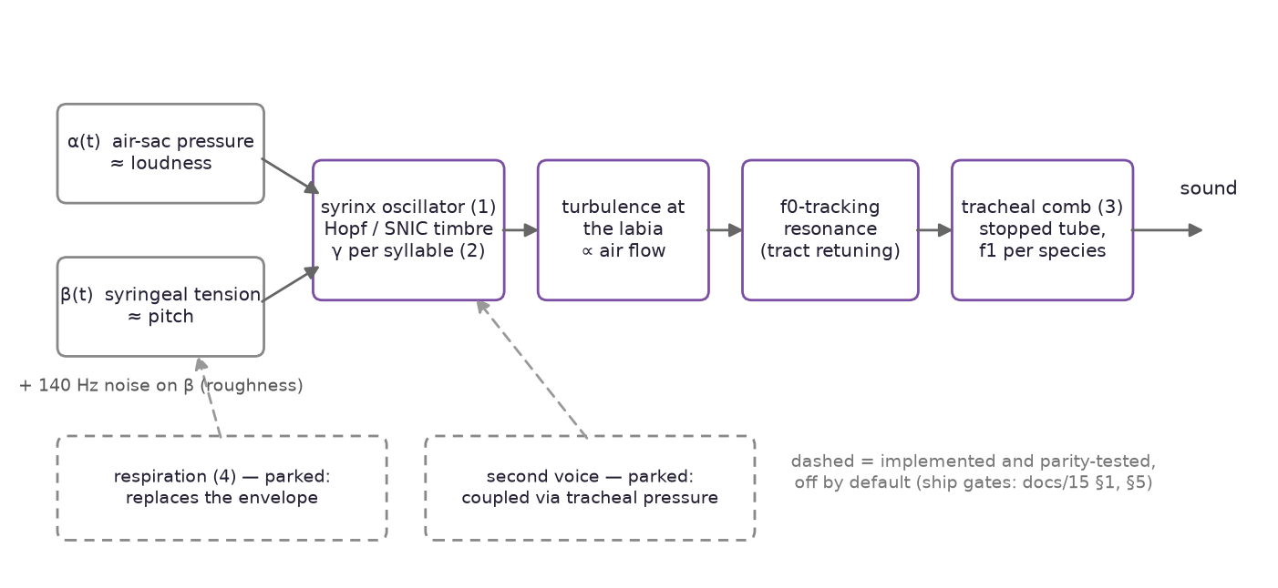
Figure 1 — The synthesis signal chain. Gesture contours drive the oscillator (eq. 1); texture and the two tract stages shape the result. The dashed blocks are implemented and parity-tested but off by default, because their hand-set defaults lost the pre-registered bake-offs. Sources: docs/08 §8.1, docs/15 §1, §5^{[38,45]}
Texture is physics too. Turbulence is added at the labia and scaled by air flow, so a silent bird does not hiss. Roughness perturbs β, the tension, not the output. The literature is specific here: matching the fundamental and the filters was not enough to drive selective forebrain neurons, noise on tension was required, and an intermediate amount scored best^{[9]}. The modulation sits at 140 Hz, inside the 80–250 Hz band that syringeal muscle can follow^{[34]}. The perturbation acts through the oscillator, so f0 and amplitude wobble arrive correlated, as they do in real song (rendition-to-rendition R² ≈ 0.03)^{[33]}. All noise is a seeded xorshift32 stream, so “the same turbulence” is a testable claim on both sides of the contract (docs/08 §8.1a).
Extensions, measured and mostly parked. Two structural extensions are implemented and parity-tested, but off by default. The respiratory oscillator^{[16]} replaces the hand-designed envelope with two-state air-sac dynamics (docs/15 §1)^{[45]}:
(4)
A Heaviside conductance asymmetry between inflow and outflow lets attack shape and cross-syllable memory emerge instead of being designed. The hand-set default is a wash on the pre-registered bake-off: median cosine 0.343 → 0.336, placement 17/81 → 20/81. It stays off until the per-species fit wins. The two-voice extension couples the syrinx's two sides through the shared tracheal pressure^{[8]}, and it is parked for the same reason: 0.343 → 0.294 with the hand-set default. Both refutations stay in the record, per the project's rule that a negative result is a deliverable.
Why this voice at all. The validation lineage is strong. The model class fools HVC auditory neurons^{[10]} and runs as a real-time neural prosthesis^{[21]}. The decisive test is playback: in 256 tests across 26 wild rufous-collared sparrows at 15 sites, territorial responses to synthetic song did not differ significantly from responses to real song, and heterospecific song evoked none^{[15]}. Automatic gesture inversion from real audio is likewise published^{[14]}. A generative audio model would trade all of this for raw sample quality the field itself admits it cannot measure (docs/09 §9.6). The synthesiser stays physical; learned components analyse and score, they never generate.

2.2 A measurement-only corpus
No audio is ever retained or shipped. The decode → describe → delete loop is load-bearing for licensing. One owner-sanctioned exception exists: a local training cache under pipeline/out/audio-cache/, gitignored and deleted at phase end, which never feeds the app (AGENTS.md)^{[52]}. What a syllable leaves behind is two measurements. The first is a 28-dimensional descriptor: 13 MFCC means, 13 MFCC standard deviations, mean log₂ spectral centroid, and mean spectral flatness. It is computed under an exact frame-level contract — 48 kHz mono, 1024/512 Hann frames — that the browser re-implements sample for sample (docs/08 §8.2)^{[38]}. The second is a fixed 32×23 log-mel patch: 736 numbers, log-magnitude only, no phase, resampled onto the syllable's own duration. A patch cannot be turned back into recognisable audio, so the licensing property holds while a spectral fingerprint survives (docs/09 §9.3, docs/17 §17)^{[39,47]}.

2.3 A critic that scores, never sings
The critic is a small convolutional network over the log-mel patch: 4 conv layers, spectral normalisation, about 1–3 M parameters. It trains with three heads on a shared trunk (docs/09 §9.2b). A realism logit separates real patches from renders of the current fit. A species classifier reads the harvest labels. A contrastive head trains with an NT-Xent loss: two augmented views of the same syllable embed close, different syllables embed apart:
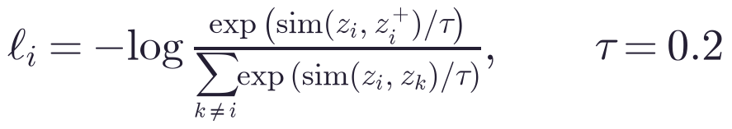 (5)
Augmentations are time stretches, gain changes, and added noise — never pitch shifts, which are genuinely type-diagnostic. Whole species are held out of training, so realism and novelty are measured on birds the network never saw. The current critic trained on 2 686 species, with 895 held out entirely. It scores realism AUC 1.000 on held-out species and species accuracy 0.730 over 2 686 classes (chance 0.0004). Its novelty ROC is 0.846, flagging 32.2 % of unheard species' syllables at a chosen 5 % false-positive rate (docs/16 §16.2)^{[46]}. The 32-d embedding is the deliverable. The realism logit, as section 6 records, is a refuted objective. The rule behind this choice: learned components analyse and score, they never generate. A generator would need its own honesty story; a scorer inherits the physical synth's story for free.

2.4 Two feature spaces and a bridge
Two feature spaces coexist. The hand-written 28-d descriptor is what the browser can compute live. The critic's 32-d embedding is what the galaxy is clustered in. No torch ships to the browser, so a bridge maps the first space into the second: random Fourier features approximating an RBF kernel, then a closed-form ridge regression, fitted on (descriptor, embedding) pairs of the store with knobs chosen on held-out recordings (docs/11 §11.3)^{[41]}:
(6)
The bridge ships as plain numbers: D = 2048 features, σ = 4, λ = 1 on the reference fit. The map is gated: a median mapped-vs-true cosine below 0.8 on held-out recordings ships accepted: false, and the browser stays on the 28-d path. On the debug build the gate passes at 0.962. The honest knot-level agreement is 0.61 raw, 0.91 tie-adjusted, and 0.78 at species level — section 6 decomposes why the raw number undersells the map (docs/20)^{[50]}. A linear ridge was the original honest choice. It broke at 0.7997, below the gate, when the embedding grew finer. The refutation is recorded in place (docs/11 §11.3).
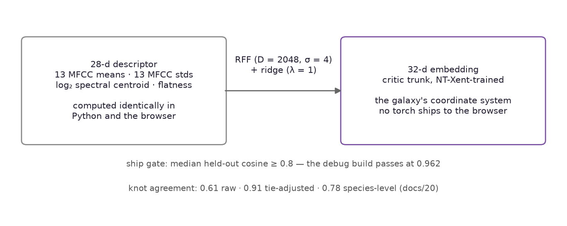
Figure 2 — Two feature spaces and the bridge. The browser computes only the 28-d descriptor; the galaxy lives in the critic's 32-d embedding; the RFF ridge bridge (eq. 6) maps one into the other behind a ship gate. Sources: docs/11 §11.3, docs/20 §20.1^{[41,50]}

2.5 The honesty layer
The browser runs the same syrinx model in an AudioWorklet and the same feature extractor on the mic. The two renderers are verified sample for sample against each other: 18/18 parity fixtures, worst divergence at float32 rounding (docs/08 §8.1a, HANDOFF)^{[38,51]}. Live audio is standardised, bridged into the galaxy's space, and turned into cluster activations by a softmax over centroid cosines with ~120 ms smoothing (docs/08 §8.2). The honesty rule (docs/08 §8.5) is a product requirement, not a nicety. Every rendered phrase carries its confidence: experimental (playback-verified), documented (in the literature), inferred (plausible, not established), invented (a designed mapping, always labelled as such). Anything the system flags as new is “unlabelled: real acoustics, no documented function”, because detecting that a sound is new is not knowing what it means^{[38]}.
component | technique | where it runs | source | why it is there
voice source | Mindlin–Laje flapping oscillator (eq. 1) | AudioWorklet synth + Python fit | docs/08 §8.1 | physiological, bird-validated, real-time
time scale | per-syllable γ, f0 = g·Φ (eq. 2) | fit + synth | docs/08 §8.1 | measured Φ(0.1, 1) = 0.17061, not fitted
tract | f0-tracking resonance + stopped-tube comb (eq. 3) | synth | docs/08 §8.1a | pure tone is a filter effect; comb ships only where it wins (10/22)
roughness | 140 Hz noise on β | synth | docs/08 §8.1a | tension noise drives forebrain neurons; intermediate amount best
fricatives | turbulence routed to fitted formants | synth, per type | docs/16 §16.7 | chip notes are shaped noise; ships where it beats the tonal fit
respiration | air-sac oscillator (eq. 4) | parked (off by default) | docs/15 §1 | hand-set default is a wash; waits for the per-species fit
two voices | pair coupled via tracheal pressure | parked (off by default) | docs/15 §5 | hand-set default regresses (0.343 → 0.294)
descriptor | 28-d: 13 MFCC means + 13 stds + centroid + flatness | harvest, fit, browser | docs/08 §8.2 | computable identically in Python and the browser
spectral fingerprint | 32×23 log-mel patch | store, critic | docs/09 §9.3 | not invertible to audio; the licensing property holds
critic | 3-head CNN: realism, species, contrastive | pipeline | docs/09 §9.2b | scores and types; never generates
contrastive loss | NT-Xent, τ = 0.2 (eq. 5) | critic training | docs/09 §9.2b | same syllable close, different syllables apart
galaxy space | critic 32-d embedding | build, galaxy | docs/09 §9.7 | +13.3 pts placement over the hand-weighted vector
browser bridge | RFF + ridge (eq. 6) | build fits it, browser applies it | docs/11 §11.3 | no torch in the browser; gated at 0.8
fit objective | descriptor cosine (eq. 7) | inversion, ship gates | docs/08 §8.2, docs/19 | cluster-safe; audibly blind (section 6)
session gate | off-manifold 5-NN distance | browser live path | docs/20 §20.3.2 | AUC 0.953; computable from the 28-d side alone
grammar | first-order + Kneser–Ney backoff | build, app sequences | docs/18 | unseen tail +1.90 / +2.32 nats; seen side bit-identical
song baseline | bag-of-types | build | docs/18 P2 | the bar any learned song encoder must beat
novel-species hint | Perch 2.0 top-3 (ONNX, offline) | pipeline only | docs/13 | metadata, never typing ground truth

Table 1 — Where the system uses what. Every technique, the place it runs, the note that defines it, and the reason it is there. Parked rows are implemented and parity-tested but ship off by default.

3. Comparison with other approaches
In plain terms. Birdy sits in a landscape of bioacoustic tools. Some classify, some embed, some map, some generate. None of them is a voice. Table 2 puts the approaches side by side on the properties this project cares about. A cell says “not documented” where the project's own references do not answer the question. The comparison claims nothing beyond the cited sources.
approach | what it is | generates sound | interpretable | offline in browser | licence-clean | confidence labels | bird-validated
BirdNET [26] | species classifier on spectrograms | no | no | not documented | no — CC BY-NC-SA, non-commercial | not documented | not documented
Perch 2.0 [25] | 14 597-species embedding model | no | no | no — 409 MB ONNX; runs offline in the pipeline only | yes — Apache 2.0 | no | not documented
Google Bird Sounds [24] | t-SNE map of thousands of recordings | no | no | yes — web experiment | yes — Apache 2.0 | no | no
Sainburg et al. [22] | VAE latent space across species | no | latent, not physiological | not documented | not documented | no | not documented
Goffinet et al. [23] | learned low-d features for individual and group differences | no | no | not documented | not documented | no | not documented
generative audio models [39] | waveform generators | yes | no | no | training-data licences unclear | no | no
Birdy (this work) | physical syrinx + measurement-only corpus | yes | yes — physiological parameters | yes | yes — no audio retained | yes — four levels | yes — playback-tested [10, 15]

Table 2 — Approaches side by side. Bracketed numbers resolve to the References section. “Not documented” means the project's references do not answer the cell; the table claims nothing beyond its sources.
What Birdy takes, and what it declines. The galaxy's prior art is open source: the t-SNE bird map, the VAE latent space, and the learned feature spaces showed that vocal repertoires have navigable geometry^{[24,22,23]}. Perch 2.0 gives novel syllables a second opinion — as metadata, never as identity^{[25]}. BirdNET's non-commercial licence excludes it from the app^{[26]}. A generative audio model would trade interpretability, the honesty labels, and the bird-validated realism evidence for sample quality the field cannot yet measure (docs/09 §9.6)^{[39]}. On the documented cells of Table 2, no listed approach combines Birdy's specific triple: a bird-validated physical voice, a corpus that keeps no audio, and a confidence label on every claim.

4. The pipeline, end to end
In plain terms. The pipeline is a conveyor belt with five stations. Recordings come in, are measured, and are destroyed. Only numbers survive. A clustering step decides which sounds are the same sound: a syllable type. A fitting step searches the synthesiser's knobs until the render of each type matches the measurements as closely as possible. The critic's internal representation becomes the coordinate system of a 3-D map: the galaxy. The browser replays all of it with no server and no neural network, and it labels every claim it makes.
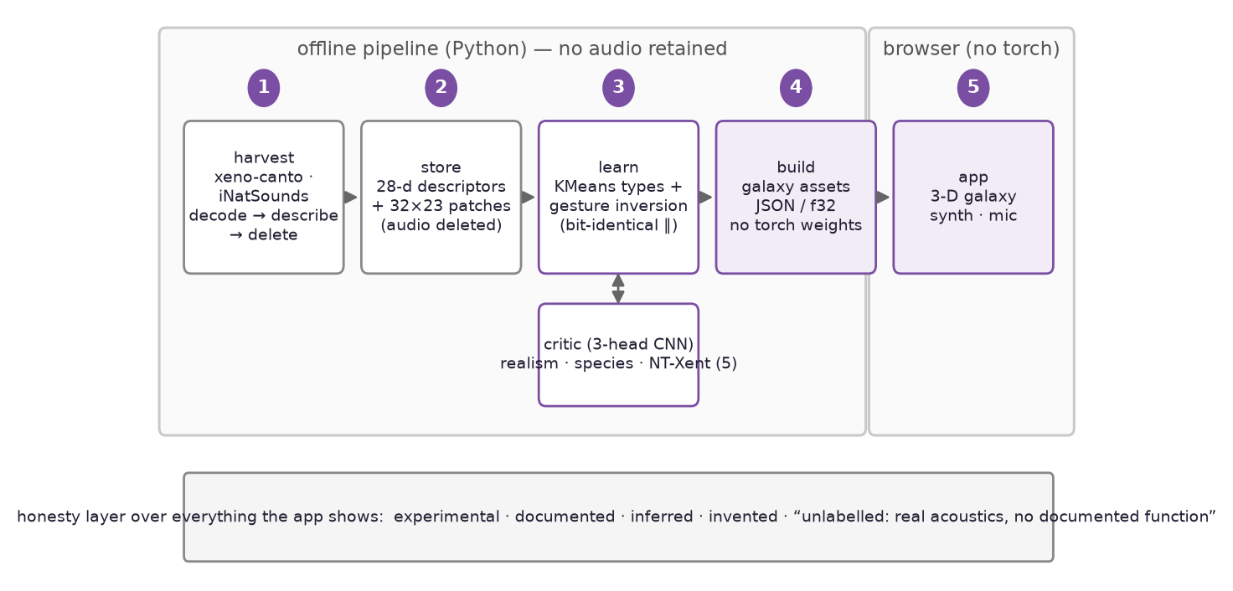
Figure 3 — Architecture. Stations 1–4 run offline in Python; the harvest keeps only descriptors and log-mel patches. Station 5 is the browser: static assets only, no torch, no Python. The honesty band labels every claim the app shows. Sources: docs/06 §6.1, docs/08 §8.3^{[37,38]}

4.1 Harvest: decode → describe → delete
The harvest downloads a recording, decodes it, measures every syllable, and deletes the file. What stays is the descriptor and the patch of section 2.2. The largest ingest to date is iNatSounds 2024, in one pass: 6 453 recordings, 2 513 minutes, 226 264 syllables, 3 811 species, zero failures (docs/16 §16.1)^{[46]}.

4.2 Learn: types and gestures
Syllable identity was once decided by seven hand-weighted numbers with guessed weights. It is now KMeans clustering in the critic's 32-d embedding, with the cluster count chosen by silhouette (docs/09 §9.2b, §9.7). Each type is then fitted by gesture inversion: a coordinate descent over ~16 axes of the synthesiser's parameter vector, in three passes. The score against the reference observation is the descriptor cosine, the number every fit gate in the project reads:
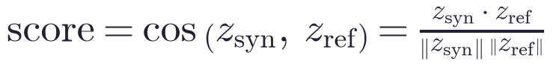 (7)
z is the standardised 28-d descriptor in the harvest population frame. Section 6 is largely about what is wrong with this objective. It remains the optimiser because its failure is bounded and cluster-safe (docs/19 §19.5). The learn is parallel and streaming: per-species fits in a fork pool after one GPU embedding pass, checkpointed every 100 species. It is verified bit-identical to the serial fit (docs/16 §16.3)^{[46]}. Rhythm is measured, not invented: 26 897 per-transition gaps extracted with the grammar (docs/18)^{[48]}.

4.3 Build: the galaxy as static assets
The build renders every fitted type, places every measured syllable, and writes static assets: JSON and f32, no torch weights. The galaxy is a precomputed 3-D point cloud with one point per measured syllable, plus renders of measured realisations. Hand-set jitter survives only where no measurements exist, and it is labelled “invented” (docs/10 §10.1)^{[40]}.

4.4 The app: replay with no server
The app is a static site. It loads the assets, synthesises in an AudioWorklet, and analyses the mic. It never calls a Python process. The session gate of section 5 watches the live path: an off-manifold 5-NN distance, computable from the 28-d side alone, flags sessions that sit off everything the galaxy knows (docs/20 §20.3.2)^{[50]}.
Corpus growth, for scale. The measurement stores behind this note:
store / phase | syllables | species | source
out/harvest (original) | 39 976 | 22 | docs/08 §8.1a
out/harvest-gan, first | 9 041 | 25 | docs/09 §9.7
out/harvest-gan at 40 k | 39 993 | 25 (13 after a fixed trim bug) | docs/09 §9.8
+ xccoverbl ingest | 39 874 | 121 | docs/14 §14.1
+ iNatSounds 2024 | 226 264 | 3 811 | docs/16 §16.1
200 k learn (parallel) | 187 078 typed | 2 423 fitted, 12 724 types | docs/16 §16.3

Table 3 — The measurement stores. Each row is a fixed corpus; every number in this note names the store it was measured on.
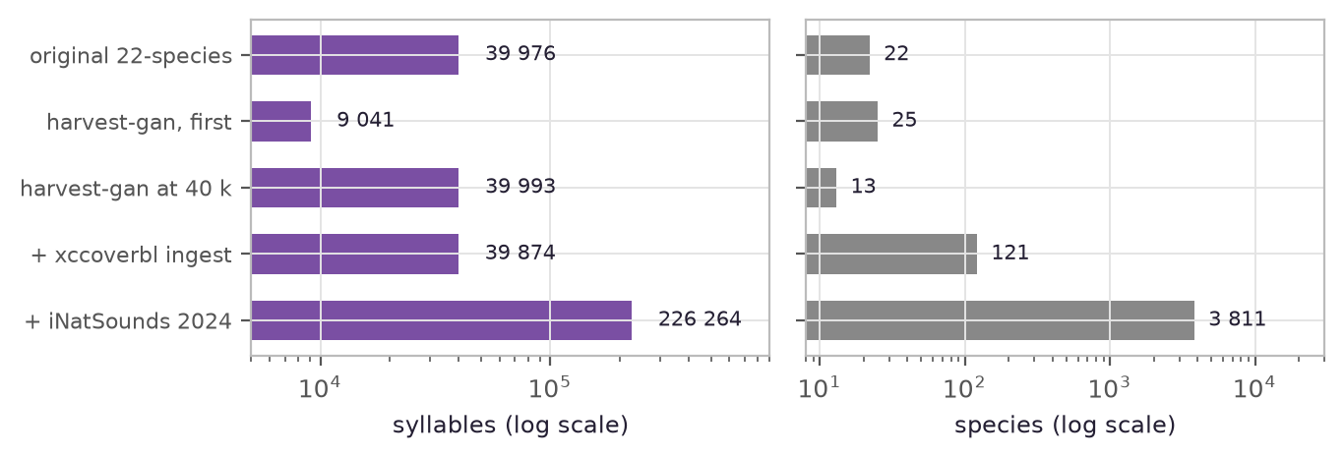
Figure 4 — Corpus growth. Syllables and species per store, log scales. The iNatSounds 2024 ingest multiplied the species count by 31; depth per species did not grow with it — section 6.3. Sources: docs/08 §8.1a, docs/09 §9.7–9.8, docs/14 §14.1, docs/16 §16.1^{[38,39,44,46]}

5. Results: what works (measured)
In plain terms. The good news, with receipts. Every claim below is a number the project measured on a fixed corpus. Most were pre-registered: the target was written down before the run. Where a number comes from the smaller debug corpus, the caption or the text says so.
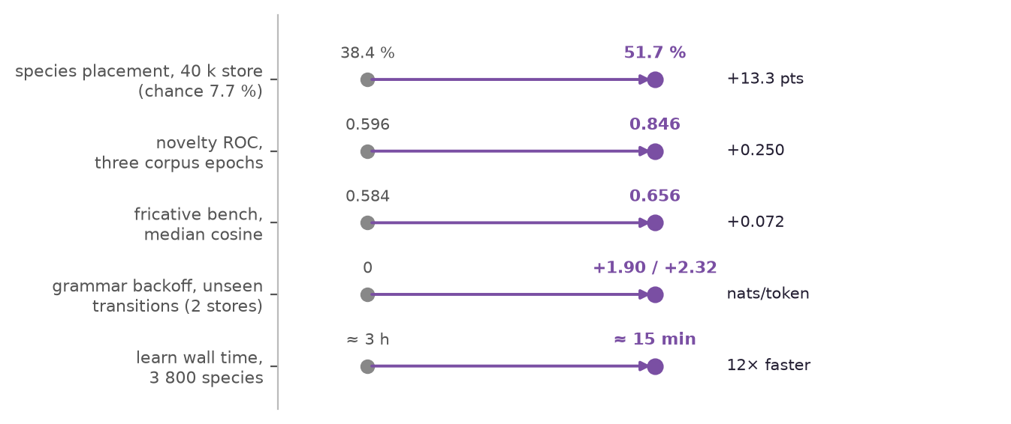
Figure 5 — Headline measured gains. Each row shows before and after, with units per row. Sources: docs/09 §9.8, docs/10 §10.3, docs/16 §16.2–16.3, §16.7, docs/18^{[39,40,46,48]}
The learned embedding is a clean win, twice. Typing syllables in the critic's 32-d embedding instead of the hand-weighted vector moved species placement from 26.6 % to 32.9 % on the 9 k store (chance 4.0 %). On the 40 k store it moved placement from 38.4 % to 51.7 % — a +13.3-point gain — against 7.7 % chance (13 species after the trim bug). The guardrail cosine held: 0.807 → 0.796. F0 error improved from 3.3 % to 2.2 %. Nothing regressed, on two independent stores (docs/09 §9.7, §9.8)^{[39]}. The same retrain epochs lifted novelty detection from ROC 0.596 to 0.846, and true-positive rate at 5 % FPR from 7.4 % to 32.2 %, across three corpus epochs (docs/10 §10.3, docs/11 §11.2, docs/16 §16.2)^{[40,41,46]}.
The learn is fast and exactly reproducible. Parallel per-species fitting is verified bit-identical to the serial fit. The 3 800-species learn went from a ~3 h serial pace to ~15 min on 16 workers. Checkpointing every 100 species came after two crash losses taught the lesson. The 200 k learn fitted 2 423 species into 12 724 types over 187 078 typed observations. All 2 423 fitted species carry recovered common names (docs/16 §16.3)^{[46]}.
The fricative path closed the biggest acoustic gap. Real chip notes are broadband bursts shaped by the tract: whispered vowels, not tones with hiss. The evidence was two species parked at the noise ceiling and still failing: Algerian nuthatch types scored cosine 0.16–0.60 with noise at 0.60–0.85. The fix routes turbulence around the f0-tracking band into the syllable's own fitted formant set, driven by the same pressure gesture as the tonal source. The bench median moved 0.584 → 0.656. End to end: 13 wins, 0 losses. The path ships per type only where the resynthesis beats the tonal fit. Syllables without the flag render bit-identically (docs/16 §16.7; HANDOFF 2026-07-30)^{[46,51]}.
The naturalness fit pass won where hand-set physics washed. A per-species coordinate search over the respiratory and two-voice parameter sets scored 12 680 types. Respiration won 445. Two-voice won 2 027 of 5 922 screened. The median cosine moved 0.650 → 0.6623, and the ship gate held everywhere (docs/16 §16.4). The documented one-tone re-fit shipped measured noise and rough texture on 14 of 15 authored calls, median gain +0.148 on the debug store of 37 species. The one holdout stayed pure: the gate doing its job. One caveat carries over from section 6: these gates read the cosine, and the bench has since shown that the cosine does not rank audible fit (docs/19 §19.3)^{[46,49]}.
Grammar repair, on pre-registered terms. The first-order model's one measured weakness was unseen-context transitions at −9.25 nats/token. A Kneser–Ney continuation backoff gained +1.90 and +2.32 nats/token on unseen-context transitions on the two debug stores. The seen side stayed bit-identical, with loss exactly 0.0000. The honest scope: 80 % of the unseen tail is seen-context, so the full-tail gain is +0.37 and +0.65 (docs/18)^{[48]}.
The session gate separates pathological recordings at AUC 0.953. Eight of 45 held-out recording sessions on the debug build carry 22.9 % of the galaxy map's flip loss, all xeno-canto. An off-manifold 5-NN distance — computable from the 28-d side alone, all the browser will ever have — separates them at AUC 0.953 (norm-deviation 0.922; the pre-registered two-signal combination adds nothing at 0.954; gate 0.9). A shipped cloud of 256 random anchors (28 kB) holds AUC ≥ 0.92. The lever gate failed its raw bar (+3.5 points vs +5), so the pre-registered fallback fired: it ships as an honesty gate — “this session is off everything the galaxy knows” — catching 5 of the 8 bad sessions including the three worst loss-carriers, with 3 clean false-flags all within 0.02 of the bad line (docs/20 §20.3.2)^{[50]}.
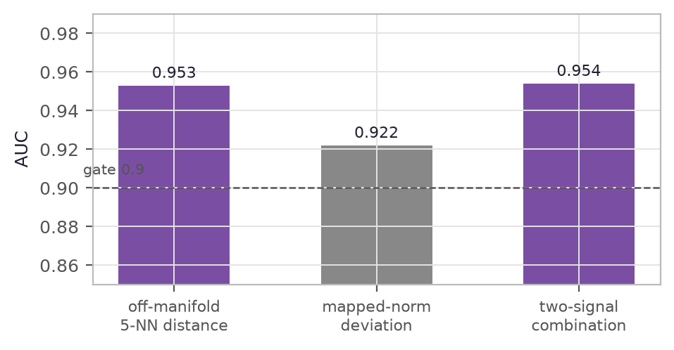
Figure 6 — Session-gate signal AUCs. AUC against the bad-session label (8 of 45 held-out sessions), end-to-end debug build (harvest-b100, 3 731 eval rows); the dashed line is the pre-registered adoption gate. Debug-scale measurement. Source: docs/20 §20.3.2^{[50]}
Song types fall out, with an honest control. Clustering run-collapsed type-id sequences by normalised edit distance found 50 song types over 13 of 35 species, placing 693 of 2 419 candidate bouts. A global-permutation control yields 0.2 % — one spurious type — at the shipped constants. The nightingale, the famous improviser, yields zero types over 275 candidate bouts: the noise category agrees with a century of field notes (docs/12)^{[42]}. Rhythm is measured everywhere the app plays sequences: 26 897 per-transition gaps (docs/18). And the two-renderer contract holds at 18/18 parity fixtures — the same syllable is the same samples in Python and in the browser (HANDOFF 2026-07-30)^{[48,51]}.

6. Limitations: what does not work (measured)
In plain terms. This section is the spine of the paper, and it is as long as the good news on purpose. Birdy's rule: a measurement that contradicts the plan is the deliverable. Every failure below has a number, a fixed corpus, and a written-down verdict. It stays in the record so nobody tries it again. Three big things do not work yet. The number the pipeline optimises is not the number a listener hears. The embedding organises by microphone before it organises by bird. The corpus is too shallow for song grammar to show up in it.

6.1 The objective does not measure the audible
Every fit decision in the pipeline is judged by the 28-d descriptor cosine: the inversion's gesture search, the respiration and two-voice ship gates, and the fricative routing. The spectral bench asked the obvious question nobody had asked: is a cosine gain an audible gain? It rendered 200 fitted types against their medoid members' cached audio and scored two independent spectral distances: mel-cepstral distortion and multi-resolution STFT error. The answer is no. The correlations sit at ≈ 0.1, with p-values that cannot reject zero, and the point estimates lean the wrong way (docs/19 §19.2)^{[49]}. This is not a bench artifact. The recomputed cosine matches the stored one at 0.921. The two distances agree with each other at 0.925: they measure something coherent, and the cosine does not measure it.
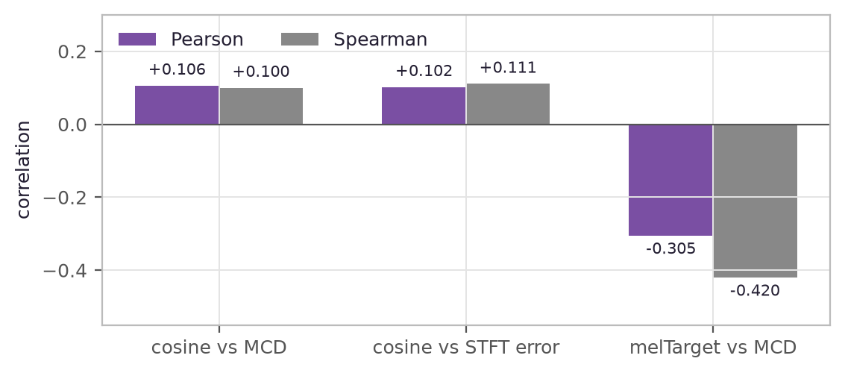
Figure 7 — The objective carries no information about audible distortion. The mel-path target does (signs correct: higher similarity ↔ lower distortion). n = 200 types, debug-100 store against the iNat cache. Source: docs/19 §19.2, §19.4^{[49]}
The mel-path target — time-resolved exp(−LSD) similarity to the type's measured mel trajectory — is the better measurement: Spearman −0.420 vs MCD where the cosine reads +0.100. It is the worse optimiser. At blend weight 1.0 the cosine guardrail collapses by 0.377. The n = 10 probe's 7/3 MCD win did not survive n = 80: 31 % win share against a 60 % gate, median ΔMCD exactly 0.0 dB, one type losing 0.12 cosine (docs/19 §19.4, §19.5). The honest state, verbatim: “measure spectrally, optimise descriptor-ly”. Gates are read on the bench. The inversion keeps climbing the cosine. An objective that is both remains unfound.
The learned alternative failed the same way, earlier and harder. A realism-trained critic is itself excellent: AUC 0.990–1.000 on entirely held-out species. Used as the fit objective, it is monotonically harmful in its weight. At w = 1 the cosine collapses 0.762 → 0.335 and placement drops to 17.3 %. The refutation replicated at 40 k: 38.4 % → 31.9 % at w = 0.5. Separating two distributions perfectly is not the same as having a gradient that points at the nearer one. The retained cosine guardrail is what made the gaming visible (docs/09 §9.7, §9.8)^{[39]}. A structurally better tract tells a similar story. A fixed waveguide with 32× the spectral freedom of the tracking band improved all three metrics at once on five species, and it was a regression over 22: 23.1 % → 22.2 % placement. It was later shown to have been rejected by badly defined types, not by the objective. It now wins on the gan store under learned typing (37.0 %) and pays for it in cosine, so it stays promising and unconfirmed (docs/08 §8.1c, docs/09 §9.7)^{[38,39]}.
The oldest open problem is species identity. On the original 22-species store, a resynthesis lands nearest its own species only 23.1 % of the time, against 4.5 % chance. Four hypotheses were tested and refuted in place (docs/08 §8.1a). The envelopes are not collapsed: the synth expresses 103 % of the real between-species spread and 106 % of the spectral detail, varied along different axes. There is a spectral tilt error, but correcting it exactly drops placement to 20.2 %. The harmonic structure is not missing: real syllables resolve to a mean of 2.2 partials. A time-resolved objective improves its own metric 36 % while placement falls 61.7 % → 43.2 %: the two objectives conflict. The ceiling is the descriptor and the filter chain's capacity, not the search.

6.2 The embedding organises by recorder before bird
The geometry battery scores how much a grouping organises the embedding: the same-label rate among a point's nearest neighbours, minus a permutation null:
 (8)
On the production embedding the strongest relation is source — which recorder, not which bird: recordist kNN lift +0.488 against species' +0.196 (docs/14 §14.4)^{[44]}. Every consumer of the embedding inherits that confound. The literature is unambiguous that invariance is a training-time problem^{[27,28,29]}, and Birdy swept it three times on pre-registered gates (docs/17)^{[47]}.
Loss engineering trades one for one with species. Channel-EQ simulation and Freq-MixStyle augmentation are perfectly species-safe, and they move recordist lift not at all (−0.7 % relative). The recordist-adversarial head does move it, and the trade is almost perfectly linear in log weight: −33 % recordist at w = 0.05 costs species accuracy −14.7 points. At w = 0.3 the embedding is destroyed: species accuracy 0.199, realism AUC 0.862. No swept weight buys the required −30 % recordist while holding species within the gates: recorder invariance costs species information at roughly one to one (docs/17 §17.3).
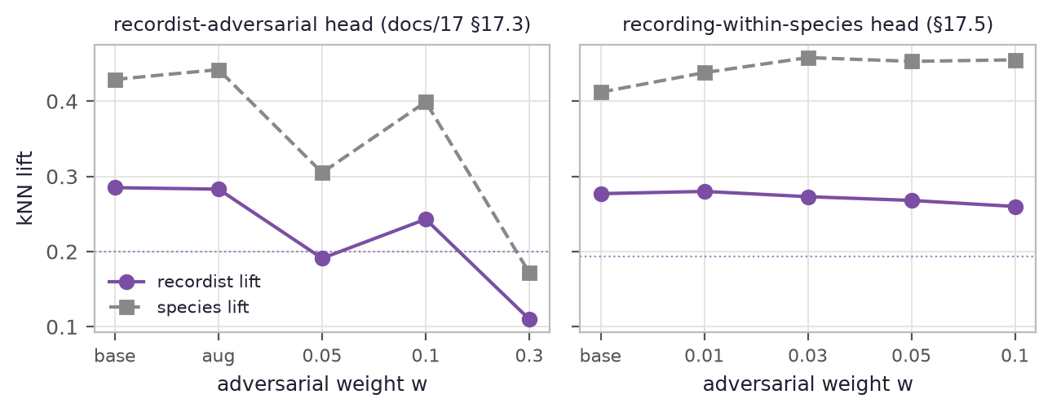
Figure 8 — Adversarial sweeps on the 37-species debug store (debug-scale). Left: the recordist head trades recordist lift for species lift ~1:1. Right: the recording-within-species head never touches species — and barely reaches the recordist (−6 % at w = 0.1 against the −30 % gate, dotted). Sources: docs/17 §17.3, §17.5^{[47]}
The species-safe factorization cannot reach the confound. Masking the adversarial softmax to recordings of the patch's own species fences species information out by construction. It works: species lift is flat to +10 % at every weight. But the target buys only −6 % against the −30 % gate. The recordist signal is carried between species — each species' recordings come from different people — where a species-factored head is forbidden to look (docs/17 §17.5).
Data helps, and the honest re-test shrank it. The AVEX direction^{[29]} held: merging two recording domains per species beat every loss. The first test was 12 species with a 3-species holdout. The pre-registered bigger re-test used 63 both-domain species with 16 held out, and it shrank every delta. The naive merge's +14.4 points became +3.6. The cross-domain contrastive mechanism's +13.4-point boost became +1.7, against a +10 gate: small-sample structure, the same lesson as the mel-weight probe. What survives at both scales is the ordering. More domains per species helps. The mechanism adds ≈ nothing on top. No loss term buys invariance cheaper than data (docs/17 §17.4, §17.6).
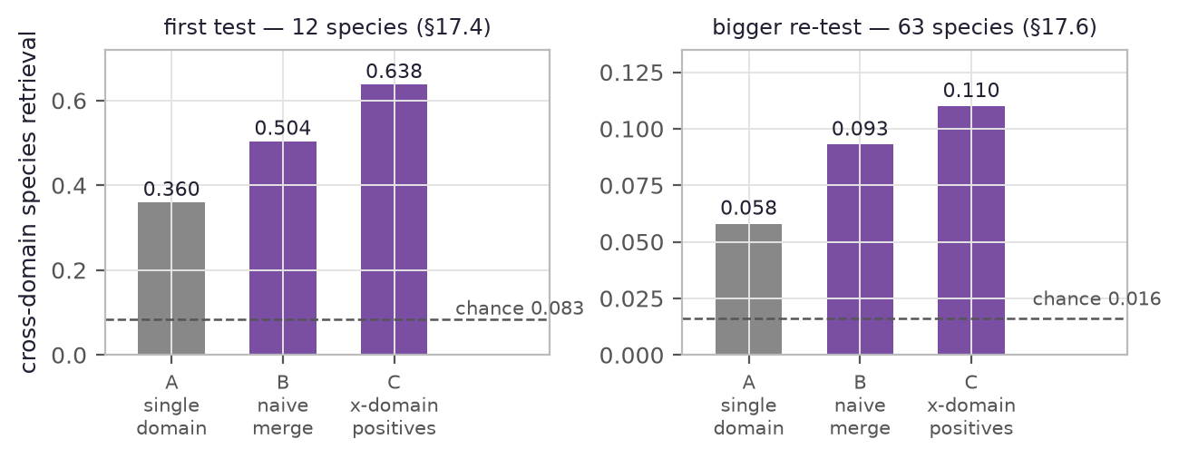
Figure 9 — Cross-domain species retrieval, three arms, two tests. Both debug-scale; absolute levels are only comparable arm-vs-arm within each panel. The naive merge (B) beats single-domain (A) in both. The contrastive mechanism (C) looked decisive at 12 species and added +1.7 points at 63. Sources: docs/17 §17.4, §17.6^{[47]}

6.3 Song structure starves at current depth
Birdsong is not first-order: repeat-count adaptation and partially observable structure are established^{[30,31]}. Birdy ran the pre-registered bake-off anyway: current first-order transitions against Jin–Kozhevnikov repeat-count and a hidden-state HMM, scored on held-out bout likelihood. M2 loses decisively: −0.348 nats/token, 0 of 30 species. M3 wins the rule: +0.422, 29 of 30. The decomposition then reverses the adoption. On the 90 % of held-out transitions seen in training, first-order is the best model: −1.525 against M3's −1.624. M3's entire advantage sits in the 10 % unseen tail: −9.25 against −4.16. That is a property of smoothing shape, not recovered hidden structure. Adopting a heavier model for a smoothing artifact is the wrong lesson; first-order stays (docs/18 P1)^{[48]}.
The song-level kernel failed both its gates. A weighted edit distance over (type, gap) sequences loses species lift to plain bag-of-types: +0.877 against +0.924 on the 37-species store, and +0.050 against +0.081 on debug-100. It also fails the recordist gate at +0.264. Within-species song structure exists — all 18 deep species separate their recordings — but it lives entirely in the token marginals: order and rhythm add nothing measurable at current depth. The reason is one number: only 12 of the debug-100 species have ≥ 20 bouts. The bar for any learned song encoder is now bag-of-types, after the depth harvest (docs/18 P2)^{[48]}.
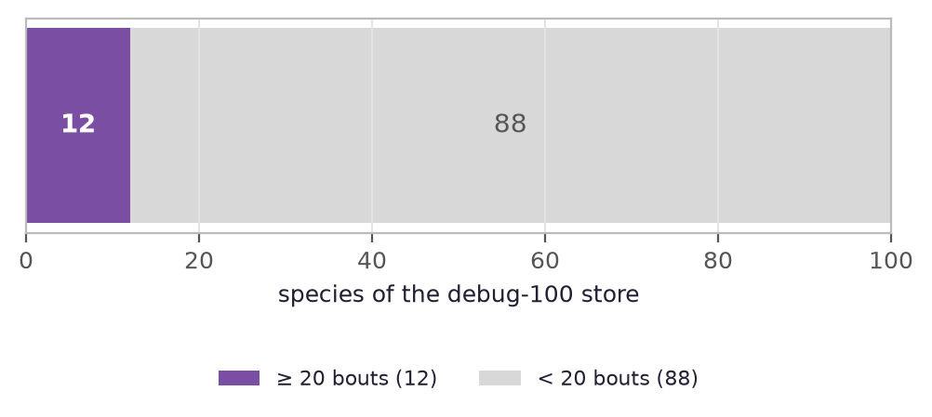
Figure 10 — Why syntax starves. Species of the debug-100 store with enough bouts for song-level structure (≥ 20 bouts after run-collapse). Debug-scale. Source: docs/18 (debug-100 cycle note)^{[48]}

6.4 Smaller refutations, kept on the record
The galaxy map's 0.61 is a metric problem, not a map problem. Decomposing the centroid-agreement loss over 3 731 held-out syllables: 76.4 % of it is boundary near-ties (74 % of all rows sit within margin 0.05; tie-adjusted agreement is 0.91, and 41 % of flips land on the runner-up knot). Genuine big-margin map failure is ~2 % of rows. No better map class can fix near-ties. The honest single-label claim is species-level agreement: 0.78 (docs/20 §20.1)^{[50]}.
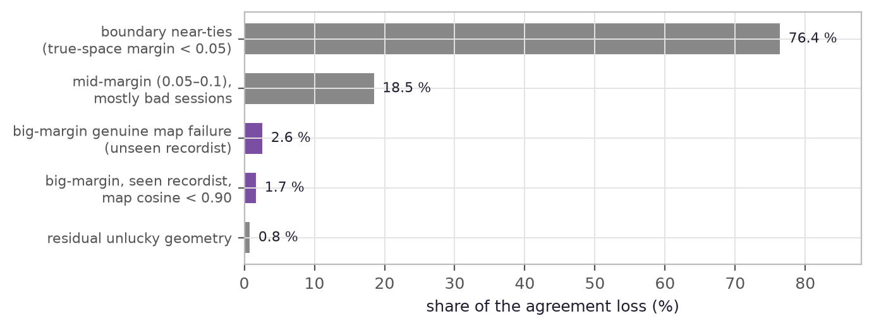
Figure 11 — Decomposition of the 38.6 % knot-agreement loss. 1 439 flips over 3 731 held-out syllables, debug build. Most of the “error” is the question being ill-posed at knot boundaries; genuine map failure is the two small violet bars. Source: docs/20 §20.1^{[50]}
Pruning bad sessions from the fit fails. Dropping the worst-quintile off-manifold sessions costs −0.006 and −0.015 eval cosine on the two debug stores, against a ≤ 0.005 allowance. The weird sessions are manifold coverage, and pruning them hurts the next unseen weird session. Gating is a live-path action only (docs/20 §20.3.1). The learned inverse failed its ship rule. An encoder predicting synthesis parameters from mel patches — trained on 150 k free rendered pairs — matched the coordinate descent on cosine (0.737 vs 0.734), but the pre-registered 2× speedup never existed on the hardware (0.2 s either way). It stays experimental, documented in place (docs/10 §10.5). Novelty thresholds do not transfer across harvest epochs. A threshold calibrated for 5 % false positives on the 9 k store flagged 29.8 % of the 47 k store. Recalibration is cheap and now automatic. The honest ROCs are reported per epoch — 0.596 → 0.786 → 0.846 — rather than the best one (docs/10 §10.3, docs/14 §14.3, docs/16 §16.2)^{[40,44,46]}.

7. The unknown-bird pipeline
In plain terms. What happens when a bird the system has never heard starts to sing? Not a guess, and not silence. The arrival is measured and compared against everything known. If it fits nothing, it is allowed to be new. It gathers with similar arrivals until enough of them agree to found a new knot in the galaxy. The label is exactly as honest as the situation deserves: real acoustics, no documented function. An external model may suggest which species it resembles. That suggestion is metadata, never identity.
The arrival pipeline is live end to end (docs/10 §10.3, §10.4; docs/16 §16.5)^{[40,46]}. At ingest, each new observation is embedded and scored against the calibrated novelty threshold — a chosen false-positive rate, not a discovered one. Known-looking syllables inherit the nearest type. In a relabel-recovery test, 97.4 % of relabelled syllables inherited a known type, and 65.2 % inherited the correct species' type. Misassignments go to similar-sounding types of other species: the detector prices acoustic neighbourhood, not taxonomy, and the wren counterexample proves it. Novel syllables are not force-assigned. Below quorum they stay unassigned. At quorum — ≥ 8 coherent pending points, 0.70 cosine radius, 0.75 cohesion floor — they found a new knot labelled “unheard syllable”, confidence unlabelled: real acoustics, no documented function.
A Perch 2.0 pass^{[25]} labels the novel-flagged syllables from the training cache. It runs as ONNX, offline, at ~48 ms per window. Its label reads “closest documented species (Perch 2.0 inference, unverified)” — metadata only, never typing ground truth; nothing in the learn path may read it. The store holds 23 697 novel syllables. 841 of them are honestly unlabelable, because their xeno-canto audio was deleted by design, and the pipeline says so rather than guessing. Structure above the syllable — sequence statistics, candidate song types for undocumented birds — inherits the same label all the way up (docs/18 P6)^{[48]}. Anything more confident than this pipeline is numerology, and the interface keeps saying so.

8. Roadmap
In plain terms. The next steps, in order, each with the number that would prove it. First: listen longer to fewer birds. Nearly every open problem — grammar, dialects, the bench — is starved by shallow coverage, not by missing machinery. Then re-run the bake-offs that depth was blocking. The metrology problem underneath everything stays open and named.
P0 — Depth harvest (in progress at this writing). 100 species × up to 30 recordings each, chosen for documented syntax cases, repertoire depth, and existing playback anchors. The harvest runs in 25-species batches, with the log read between batches (docs/18 P0; HANDOFF 2026-07-31)^{[48,51]}. This one action unblocks the grammar re-test, the song-level space, and the widening of the spectral bench. Nothing else on the roadmap does that.
P1 — Re-bake-off after depth. The first-order, Jin–Kozhevnikov, and POMM comparison runs again once the unseen-transition tail shrinks. Thin data is exactly where higher-order models starve, and M2's 0 of 30 says so. P2 — Song-level embedding. Bouts as points. The parameter-free kernel baseline already failed, so the bar any learned encoder must beat is bag-of-types (+0.924), with the recordist lift gate upstream (docs/18). P3 — CETI-style factorization^{[32]}: decompose each deep species' songs into independent axes — rhythm, tempo, ornamentation — toward per-species combinatorial alphabets, the strongest honest claim available without playback. P4 — Dialect and individual maps. With depth: same-species variants placed geographically, individuals separated where 10–16 bouts each exist — literature-proven sufficient (docs/18 P3–P4)^{[48]}.
The open problem, named. Underneath the roadmap sits metrology. The project optimises one number: the descriptor cosine, cluster-safe and audibly blind. It measures with another: MCD and STFT, audibly faithful and optimiser-hostile. It has refuted the learned third: the realism logit. “An objective that is both remains unfound.” Every future fit gate reads the bench. Every future objective candidate is pre-registered against it (docs/19 §19.5)^{[49]}. Structure first, meaning only from playback. That ordering is the roadmap's spine, and it does not move.

9. References
External literature and internal research notes, numbered in list order; in-text superscripts resolve here. Internal notes live in the repository's docs/ directory.
[1] Rutz, C. et al., “Using machine learning to decode animal communication”, Science 2023. DOI 10.1126/science.adg7314.
[2] Suzuki, T.N., Wheatcroft, D. & Griesser, M., “Experimental evidence for compositional syntax in bird calls”, Nature Communications 2016 (great tit ABC–D).
[3] Griesser, M., “Referential calls signal predator behavior in a group-living bird species”, Current Biology 2008 (Siberian jay).
[4] Freeberg, T.M. et al. 2003 — black-capped chickadee chick-a-dee call: four note types, strict A→B→C→D ordering, D-count scaling with threat.
[5] Hultsch, H. & Todt, D. — nightingale song-type organisation (~180–200 types per male, package organisation, countersinging rules); as reviewed in Birdy research notes docs/01 §1.1 and docs/03 §3.2.
[6] Okanoya, K. 2004; Katahira, K. et al. — finite-state song syntax of the Bengalese finch.
[7] Mindlin, G.B. & Laje, R., The Physics of Birdsong, Springer 2005.
[8] Laje, R. & Mindlin, G.B., “Source–source and source–filter coupling in birdsong production”, Physical Review E 72:036218 (2005).
[9] Amador, A. & Mindlin, G.B., “Low-dimensional dynamics of birdsong production and imitation”, Frontiers in Neuroscience 15:647978 (2021).
[10] Amador, A., Perl, Y.S., Mindlin, G.B. & Margoliash, D., “Elemental gesture dynamics are encoded by song premotor cortical neurons”, Nature 2013 — synthetic song from the low-dimensional model drives HVC neurons indistinguishably from real song.
[11] Sitt, J.D., Amador, A., Goller, F. & Mindlin, G.B., “Dynamical origin of spectrally rich vocalizations in birdsong”, Physical Review E 78:011905 (2008).
[12] Sitt, J.D. et al., “Physiologically driven avian vocal synthesizer”, Physical Review E 81:031927 (2010).
[13] Perl, Y.S., Arneodo, E.M., Amador, A., Goller, F. & Mindlin, G.B., Physical Review E 84:051909 (2011) — χ²(γ) fit over 28 segments → γ = 24 000.
[14] Boari, S., Perl, Y.S., Amador, A., Margoliash, D. & Mindlin, G.B., “Automatic reconstruction of physiological gestures used in a model of birdsong production”, Journal of Neurophysiology 114:2912 (2015).
[15] Bistel, A., Amador, A. & Mindlin, G.B., “Response of wild songbirds to songs synthesized with a low-dimensional model”, Physical Review E 109:054410 (2024) — 256 playback tests, 26 wild rufous-collared sparrows, 15 sites: no significant difference between responses to real and synthetic song.
[16] Fainstein, D., Goller, F. & Mindlin, G.B., “Nonlinear biomechanical resonances in birdsong”, arXiv:2509.11019 (2025).
[17] Nowicki, S., “Vocal tract resonances in oscine bird sound production: evidence from birdsongs in a helium atmosphere”, Nature 325:53 (1987).
[18] Beckers, G.J.L., Suthers, R.A. & ten Cate, C., “Pure-tone birdsong by resonance filtering of harmonic overtones”, PNAS 2003.
[19] Nelson, B.S., Beckers, G.J.L. & Suthers, R.A., “Vocal tract filtering and sound radiation in a songbird”, Journal of Experimental Biology 208:297 (2005).
[20] Riede, T., Suthers, R.A., Fletcher, N.H. & Blevins, W.E., “Songbirds tune their vocal tract to the fundamental frequency of their song”, PNAS 103:5543 (2006).
[21] Arneodo, E.M. et al., PLOS Computational Biology 2012 — the low-dimensional syrinx model running as a real-time neural prosthesis.
[22] Sainburg, T., Thielk, M. & Gentner, T.Q., “Finding, visualizing, and quantifying latent structure across diverse animal vocal repertoires”, PLOS Computational Biology 2020.
[23] Goffinet, J. et al., “Low-dimensional learned feature spaces quantify individual and group differences in vocal repertoires”, eLife 2021.
[24] McDonald, K., Tan, M. & Mann, Y., Google Creative Lab “Bird Sounds” experiment, 2016 (Apache 2.0) — t-SNE map of thousands of bird recordings.
[25] Google Perch / Perch 2.0, arXiv:2508.04665 (2025), Apache 2.0 — 14 597-species bioacoustic embedding model.
[26] BirdNET, Cornell Lab of Ornithology (CC BY-NC-SA, non-commercial).
[27] Moummad, I. et al., domain-invariant contrastive learning for bioacoustics, arXiv:2409.08589.
[28] Morocutti, F. et al., impulse-response augmentation + Freq-MixStyle for device-invariant audio classification, arXiv:2305.07499.
[29] AVEX — corpus diversity over architecture for bioacoustic embeddings, arXiv:2508.11845.
[30] Jin, D.Z. & Kozhevnikov, A.A. 2011 — repeat-count-dependent transition structure in Bengalese finch song.
[31] Lu, K. et al. 2025 — partially observable Markov models beat HMMs on Bengalese finch song; as cited in Birdy research notes docs/18.
[32] Sharma, P. et al. 2024 (Project CETI) — sperm-whale codas factorized into a combinatorial 156-unit alphabet; as cited in Birdy research notes docs/18 P3.
[33] Chen, R. et al., PLOS ONE 2013 — rendition-to-rendition f0 and amplitude near-uncorrelated (R² ≈ 0.03).
[34] Riede, T. & Goller, F., “Peripheral mechanisms for vocal production in birds” — modulation below 80 Hz is respiratory, 80–250 Hz syringeal.
[35] Birdy research notes, docs/02-procedural-voice-engine.md.
[36] Birdy research notes, docs/03-decoding-science.md.
[37] Birdy research notes, docs/06-architecture.md.
[38] Birdy research notes, docs/08-implementation.md (normative contract).
[39] Birdy research notes, docs/09-learned-objective-plan.md.
[40] Birdy research notes, docs/10-real-data-galaxy.md.
[41] Birdy research notes, docs/11-critic-47k-map-coverage.md.
[42] Birdy research notes, docs/12-song-level-types.md.
[43] Birdy research notes, docs/13-sources-and-complexification.md.
[44] Birdy research notes, docs/14-xccoverbl-ingest.md.
[45] Birdy research notes, docs/15-synth-extensions-math.md.
[46] Birdy research notes, docs/16-inat-critic-naturalness.md.
[47] Birdy research notes, docs/17-source-invariance.md.
[48] Birdy research notes, docs/18-syntax-roadmap.md.
[49] Birdy research notes, docs/19-spectral-bench.md.
[50] Birdy research notes, docs/20-spacemap-agreement.md.
[51] Birdy session handoff, HANDOFF.md (2026-07-30 and 2026-07-31 entries).
[52] Birdy repository conventions, AGENTS.md.

