Yogi Bear

# Shafaqat Iqbal PMR75l

Description of the task – Yogi Bear :

Yogi Bear wants to collect all the picnic baskets in the forest of the Yellowstone National Park. This park contains mountains and trees, that are obstacles for Yogi. Besides the obstacles, there are rangers, who make it harder for Yogi to collect the baskets. Rangers can move only horizontally or vertically in the park. If a ranger gets too close (one unit distance) to Yogi, then Yogi loses one life. (It is up to you to define the unit, but it should be at least that wide, as the sprite of Yogi.) If Yogi still has at least one life from the original three, then he spawns at the entrance of the park.

During the adventures of Yogi, the game counts the number of picnic baskets, that Yogi collected. If all the baskets are collected, then load a new game level, or generate one. If Yogi loses all his lives, then show a popup message box, where the player can type his name and save it to the database. Create a menu item, which displays a high score table of the players for the 10 best scores. Also, create a menu item which restarts the game.

UML Diagram:

# Testing:

Test1:

Checking the collection before and after  
Before:

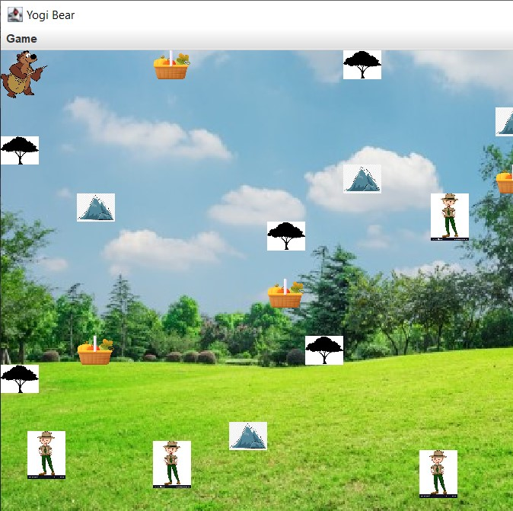

After:

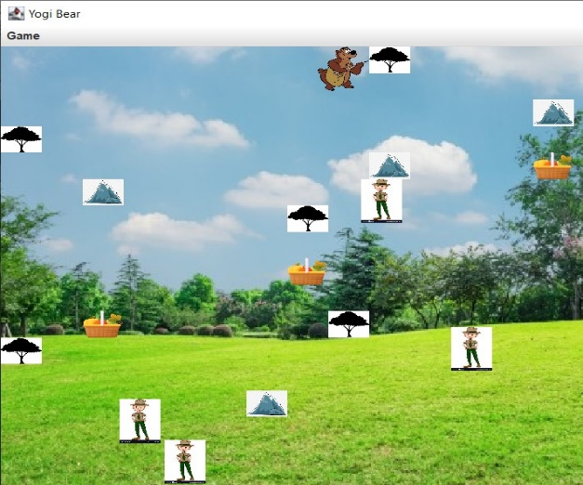

Test2: Cannot go passing Mountains

Before:



After:

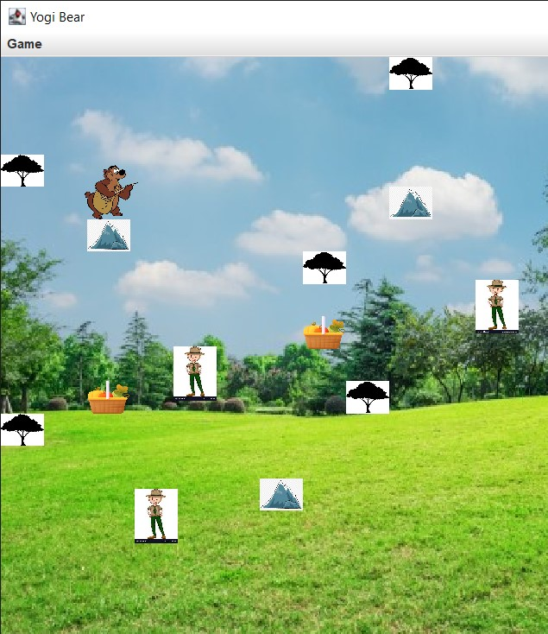

Test3: Cannot go passing the Trees:

Before



After:

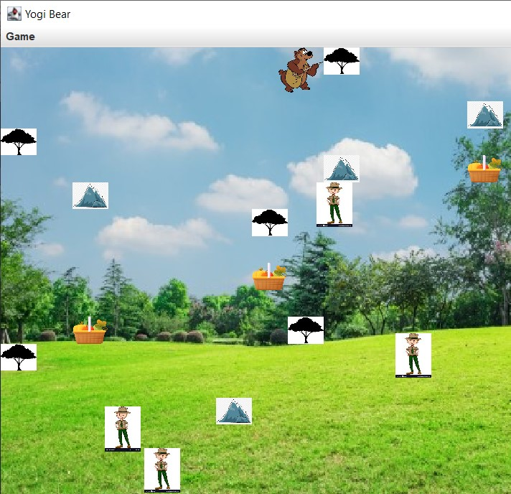

Test4: You have 3 lives in general, You collide with Ranger you use your one life:

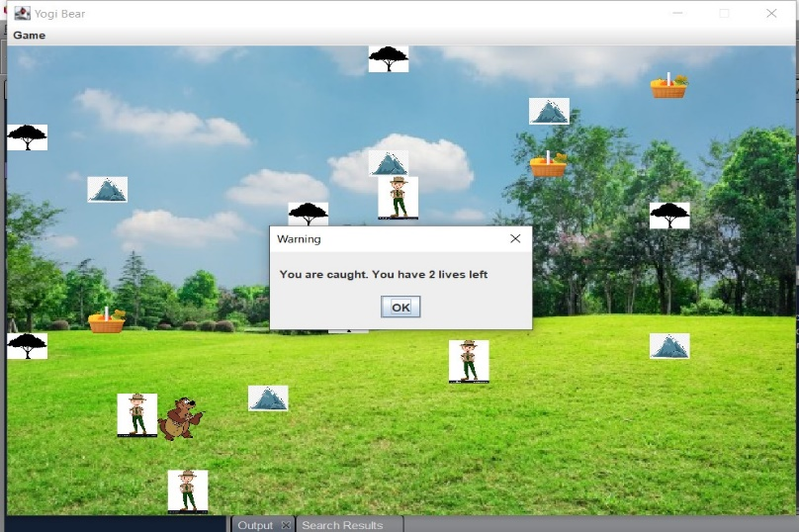

Test5: When you lose all three lives, game is over and your name is asked for your score to be stored in Database.

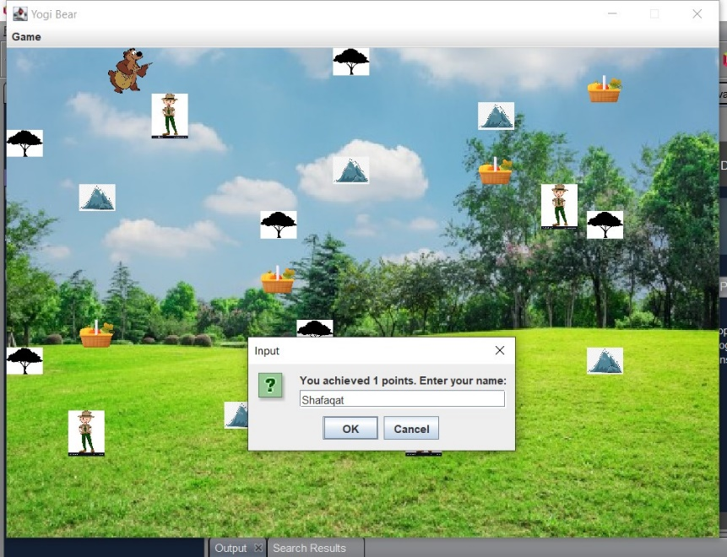

Test6: If you collect all baskets , you move on to next level.

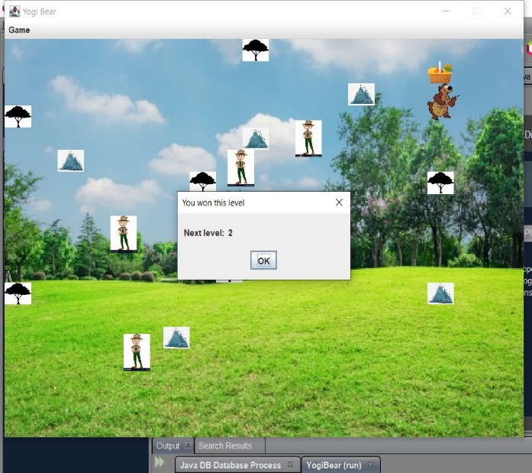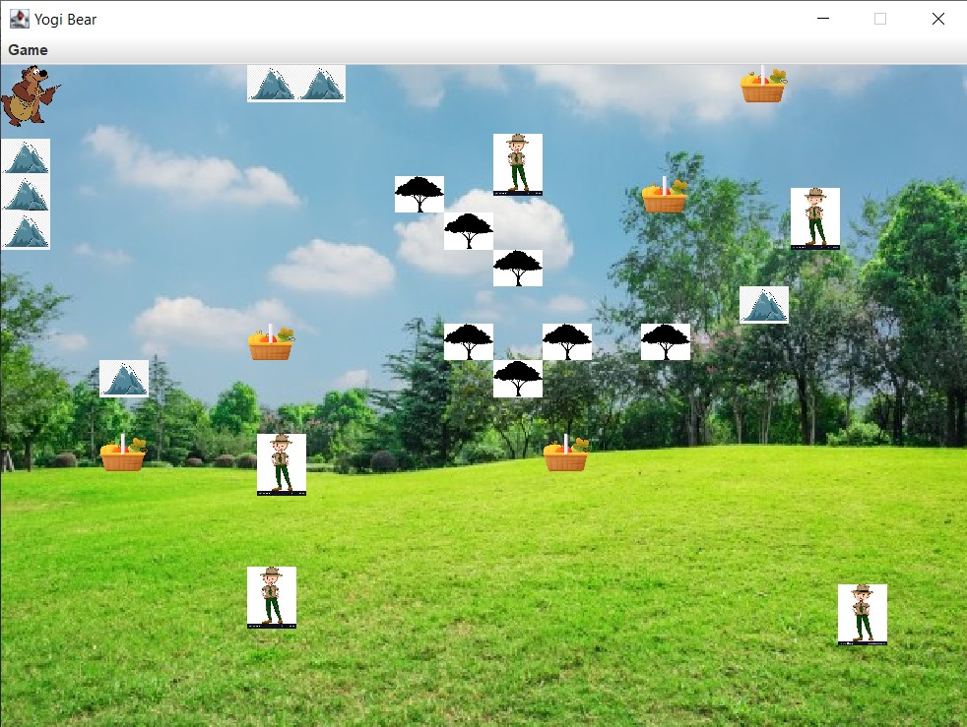

Test7: high score stored in database