Resume

Richa Sharma


Address: B-129, Aditya Puram, Opposite D.D. Nagar, Gwalior, M.P. 474005 Contact No.: +91-7828888977 Email ID: richasharma2920@gmail.com
CAREER OBJECTIVE

- Working in a professional environment that will enhance my professional and personal skills.
- Coordinating and controlling the various activities of school curriculum.
- Preparing students for cultural activities.
- Planning of lecture schedule and ensuring its smooth execution.
- Monitoring course progress according to the module plan.
- Keeping professional attitude towards work.
- Can motivate weak students to do hard work.
EXPERIENCE
- TSS International School, Morena - Designation: P.G.T (Economics) August 2022 - Present
- MORNING STAR SCHOOL, Gwalior- Designation: T.G.T. (Social Science) from July 2013 to July 2022.
- CENTRAL ACADEMY SCHOOL, Gwalior- Designation: T.G.T. (Social Science) from July 2008 to July 2013.
- J.S. PUBLIC SCHOOL, Morena- Designation: T.G.T. from July 1999 to May 2008.

PROFESSIONAL STUDIES’ ACHIEVEMENTS
- M.A. (Economics) with 1st Division from Jiwaji University.
- M.H.Sc. (Child Development) from Jiwaji University- 3rd Rank in the university.
- Featured in merit list of 12th class, M.P. Board.
- Diploma in Vocal & Kathak Dance.
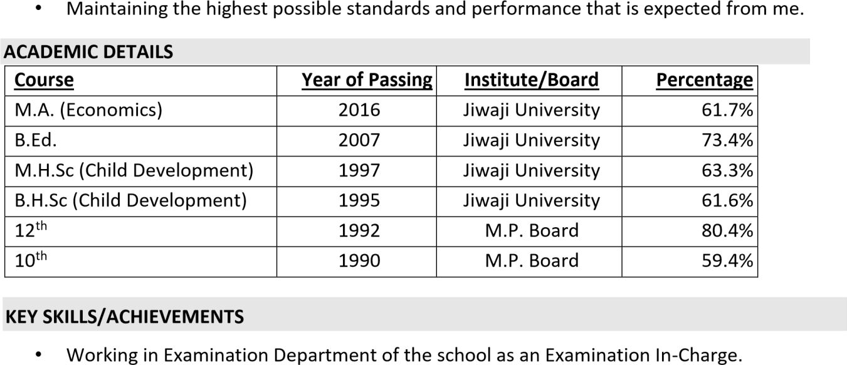

PERSONAL INFORMATION
- Husband’s Name : Mr. Niran Sharma
- Date of Birth : 29/05/1975
- Nationality : Indian
- Religion : Hindu
- Languages : English & Hindi
HOBBIES
- Listening to music.
- Watching informational programs such as Discovery Channel.


- Writing & Reading Books.
DECLARATION

I hereby state that information provided by me is true to the best of my knowledge and belief.
Date: (Richa Sharma)

