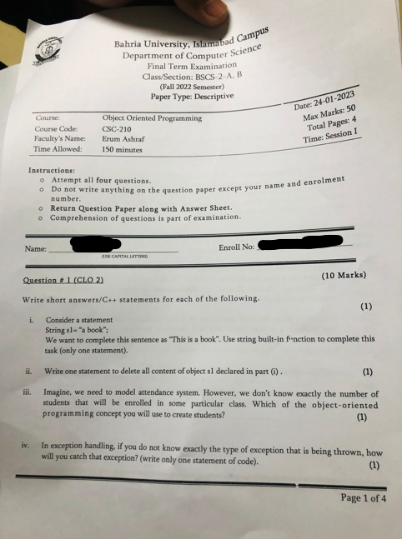  
  
  
**couldn’t find the 2nd page.**  
