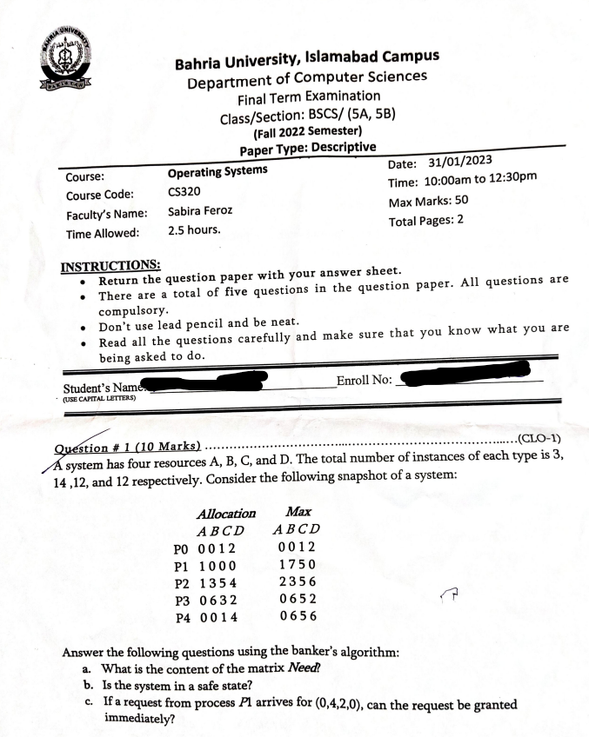  
  
  
  
  
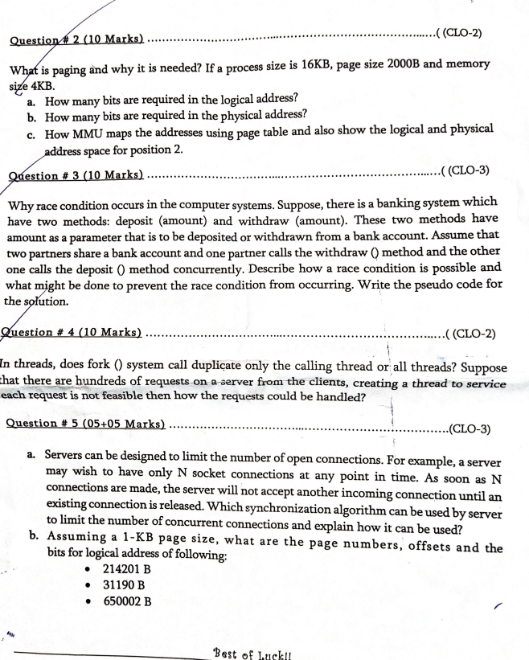  
  
  
  
  
**Not Sure who’s paper is this:**  
  
