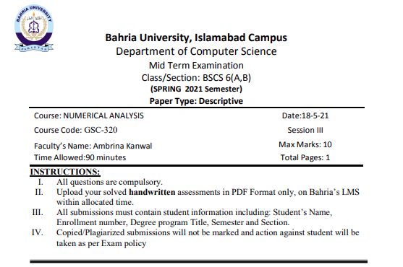  
ss  
