**Q1) Create an object person with properties name as "John", age as 30, and city as "New York".**

**// Add a method greet that logs "Hello, my name is swz".**

**// Solution:**

const person = {

    name:'shawaiz',

    age:24,

    profession:'Front-end Developer',

    greet(name,age,profession) {

    console.log(`Hi ${name}, is your age ${age}. We would like to hire you as ${this.profession}`);

    }

};

person.greet('swz','24','WebDev');

**MERGING:**  
  
const obj1={name:'swz',age:24};

const obj2={name:'mtk',age:22};

const obj3={profession:'WebDev',experience:'Freshie'};

const obj4={...obj1,...obj3}; **//SPREAD OPERATOR**

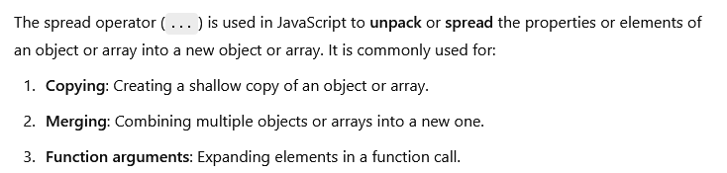

const obj5={

   name: [obj1.name,obj2.name],

   age: [obj1.age,obj2.age]

};

console.log(obj5);

**Q2) Create a function mergeObjects that takes two objects and returns a new object that combines their properties.**

**// If both objects have the same property, the value from the second object should be used.  
  
 Solution:**

 const obj1={name:'swz',age:24};

 const obj3={profession:'WebDev',experience:'Freshie'};

 const mergeObjects=(obj1,obj3)=> ({...obj1,...obj3});

 console.log(mergeObjects(obj1,obj3));