Day - 01

Understanding my System
lscpu : Shows detailed Information about the system’s CPU, Architecture,cores, threads, and clock speed.
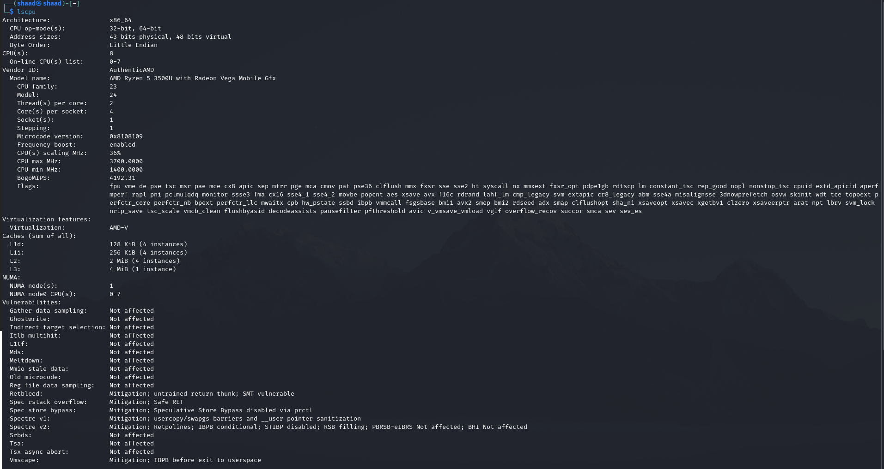
free -h : Shows system's RAM and swap memory usage
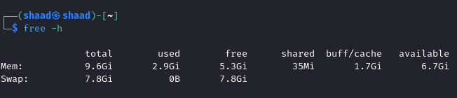

lsblk : lists all storage devices such as hard drives , ssds and their partitions
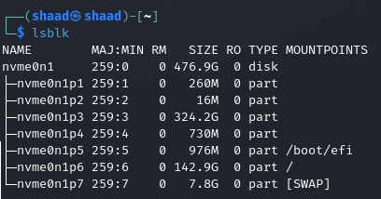
Df -h : shows disk space usage of mounted file system
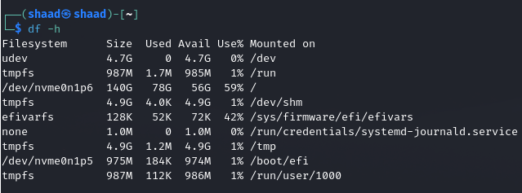
Uname -a : shows system information

Exploring Hardware
Lsusb : shows all USB devices connected to the system
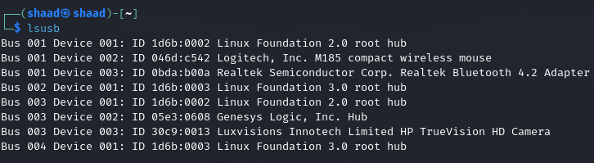
Lspci : shows all PCI devices connected to the system
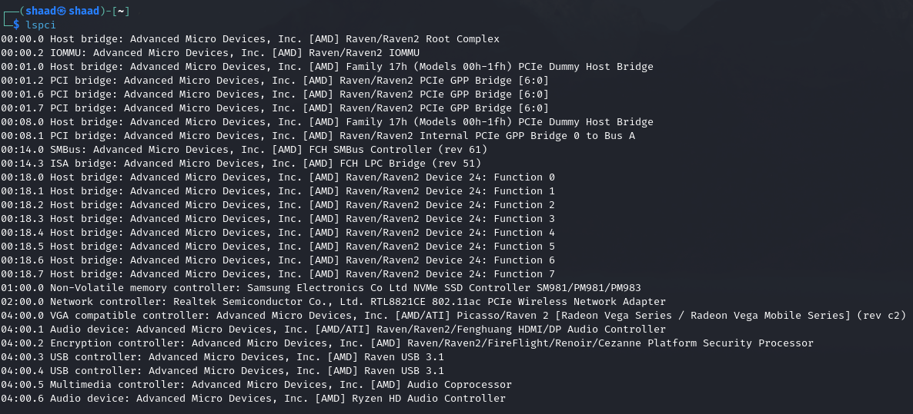

Process Basics
Top : shows running processes , CPU usage, memory usage and system load
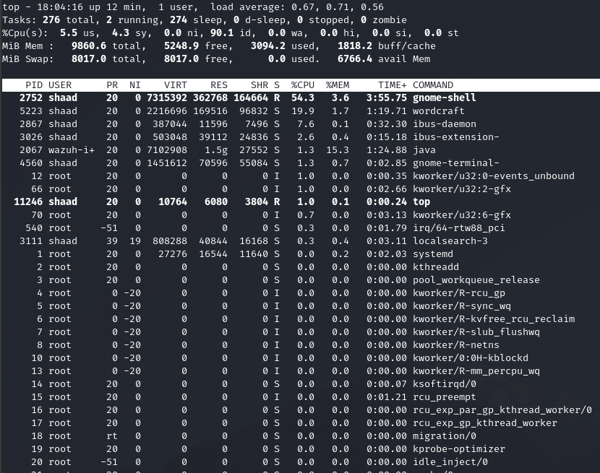
Htop : shows system performance and running process in an interactive user friendly interface
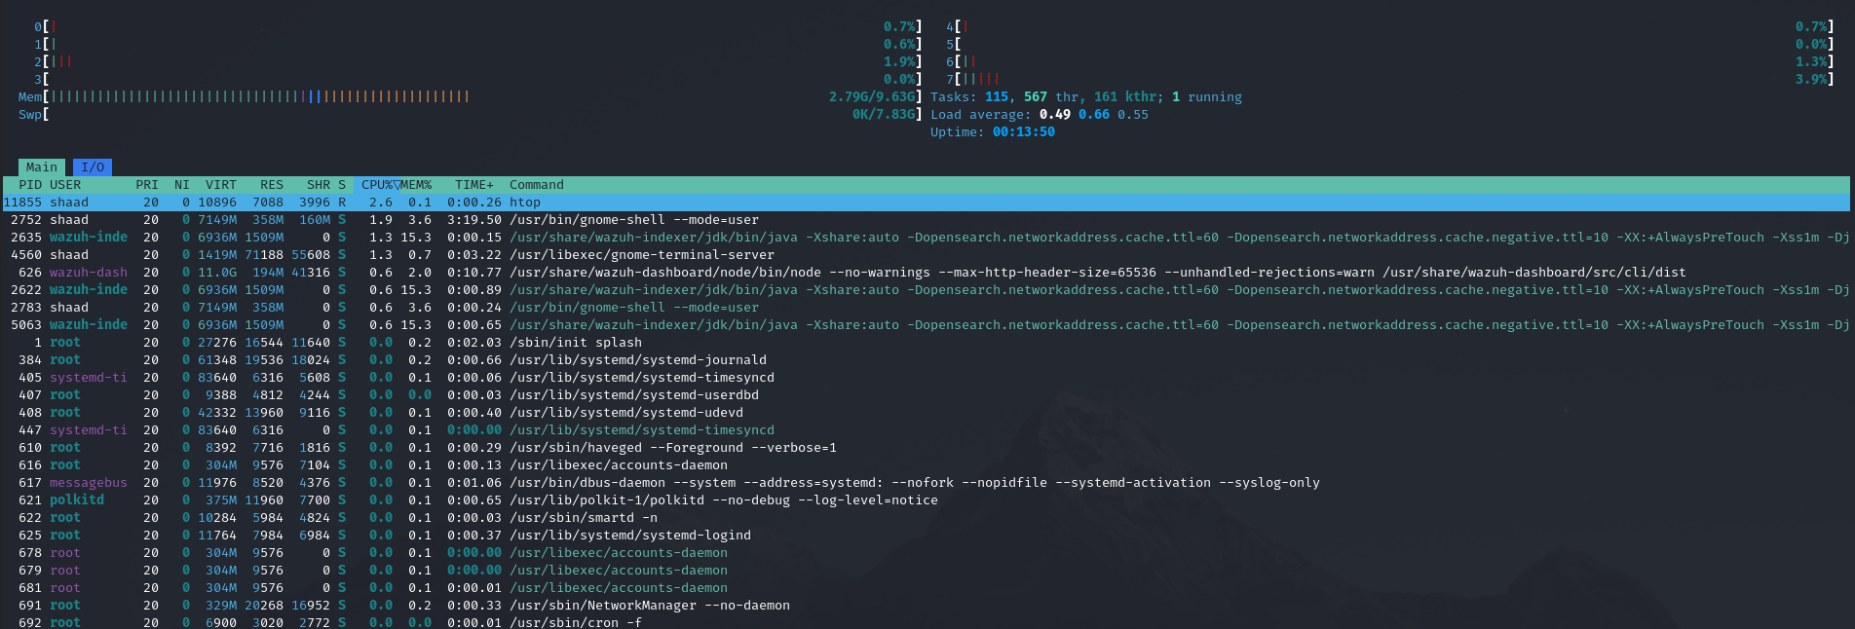
Ps aux : shows currently running processes including users, CPU and memory usage
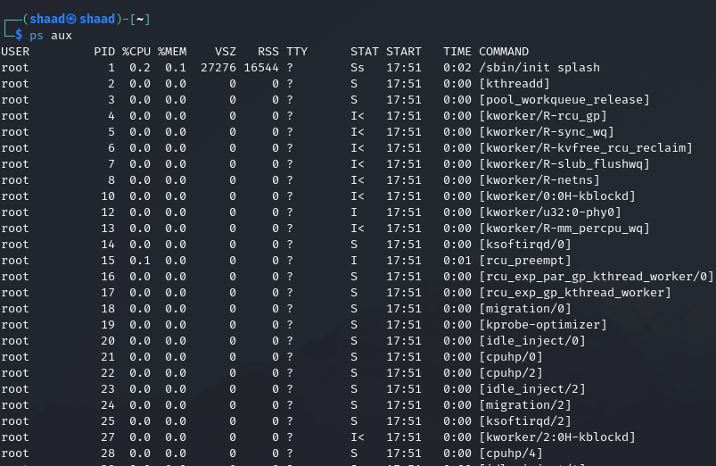

Boot & Logs

Dmesg | less: shows kernel messages
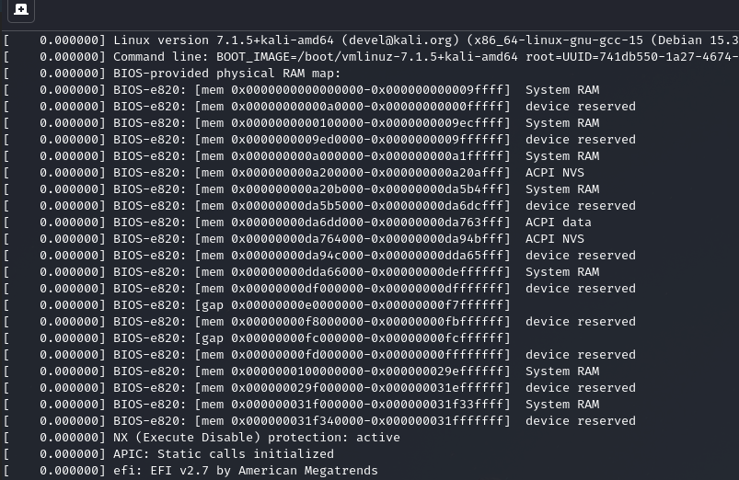
Journalctl -xb : shows system logs from the current boot session , including errors and troubleshooting information
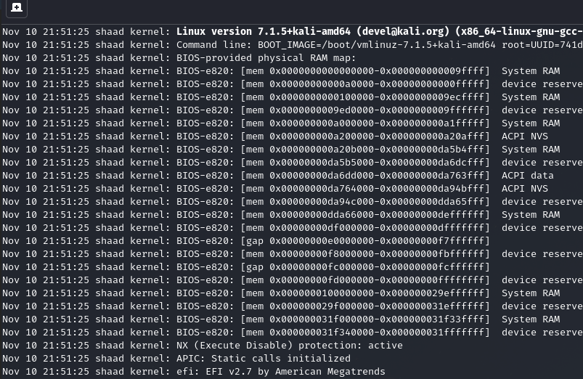

Hands on Task
CPU model : AMD Ryzen 5 3500U with Radeon Vega Mobile Gfx
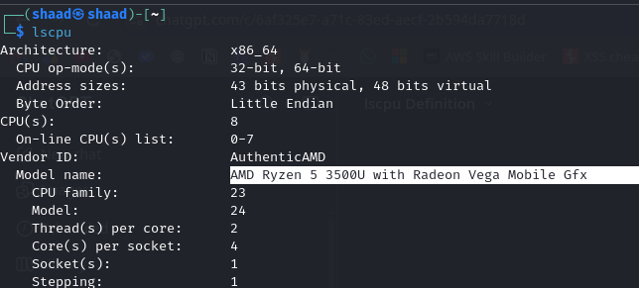

RAM Size : 9.6 GB
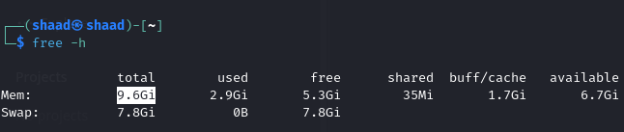

Disk Partition : 476.9 GB divided into 7 partition
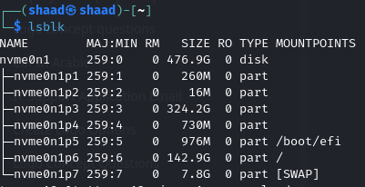
USB devices : 8 USB entries
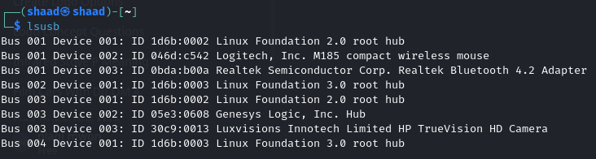

How a System boots?
1.Power on : CPU receives power and starts executing firmware instructions
2.BIOS/UEFI : Initializes hardware components and performs POST (Power On Self Test)
3.Bootloader: The firmware identifies a bootable device and loads the bootloader
4.Kernel Loading: The bootloader loads the operating system kernel into RAM.
5.Init/Systemd: The kernel initializes hardware, drivers and starts the systemd initialization process.
6.Login: System services start, and the login screen or command-line interface appears.

