IoT Packet Loss Reduction using Machine Learning

Objective
This project builds a machine learning model that predicts packet-loss risk in IoT network traffic, so that mitigation actions - retransmit, reroute, reprioritize - could be triggered before loss actually happens. This document summarizes the first part of the project: preparing the data and selecting a model. A simulation testbed that uses the model's predictions to trigger mitigation and measure loss-rate reduction is planned as a separate, later stage.

Dataset
The TON_IoT Train_Test_Network dataset (UNSW Canberra Cyber, sourced from Kaggle) was used. It contains 211,043 rows of IoT network connection records, originally built for intrusion detection rather than packet loss. Since it has no native loss label, one was derived from the missed_bytes field: a connection is treated as having lost packets if missed_bytes is greater than zero. This dataset was chosen over similar options (Edge-IIoTset, IoT-23) because its column structure matched the network log fields needed for this project, and it is a manageable, well-documented size.

Data Preparation

- 28 columns that were 60-100% empty (DNS, SSL, HTTP, and protocol-anomaly fields) were removed, since they carried no packet-loss signal.
- 20,569 exact duplicate rows were removed, checked against the full original record so that genuine repeated attack traffic (scanning, DDoS floods) was not mistaken for duplicates.
- 8 new columns were engineered, including the derived target (packet_lost), traffic totals, an incomplete-connection flag, and a connection-count-per-source-IP feature used as a proxy for network congestion.
- The final cleaned dataset contains 190,474 rows and 24 columns.

Model Selection
Only about 1.55% of connections in the dataset are labeled as having lost packets, which makes this a rare-event detection problem rather than a balanced classification problem.
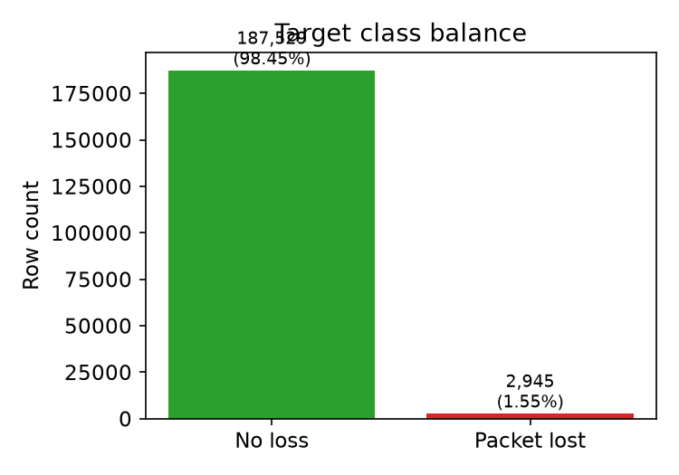
Because of this imbalance, and because the traffic features are heavily skewed with real, class-correlated outliers, tree-based models were expected to outperform linear ones. A direct comparison confirmed this: Random Forest and XGBoost both reached about 0.986-0.987 PR-AUC on a held-out test set, compared to 0.235 for Logistic Regression.

Baseline Results
As an initial baseline, four candidate models were trained on an 80/20 stratified split and compared on accuracy:
Model | Accuracy
Logistic Regression | 0.9434
Decision Tree | 0.9902
Random Forest | 0.9983
XGBoost | 0.9982

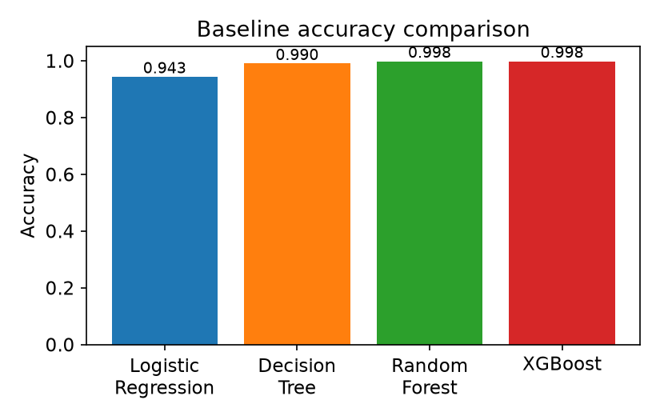
With only 1.55% of rows positive, a model that always predicts "no loss" would already score about 98.45% accuracy, so these numbers alone do not yet prove the models are catching real loss events. A full evaluation using precision, recall, F1-score, and a confusion matrix is the next planned step, along with hyperparameter tuning for Random Forest and XGBoost.

Tools Used
Python 3.12 and Jupyter Notebook, with pandas and numpy for data handling, matplotlib and seaborn for visualization, scikit-learn for preprocessing and baseline models, and XGBoost for the gradient-boosted tree classifier.

Next Steps
- Full evaluation of Random Forest and XGBoost: confusion matrix, precision, recall, F1-score.
- Hyperparameter tuning for both models.
- Design and build the Part 2 simulation testbed to measure real loss-rate reduction.

