**Lab Assignment 1 – HIT326 Database-Driven Web Applications**

# Part 1

**Exercise 1:**

1. The number of rows increases. As shown in the screenshot below. When first loaded and tested, it output 4 rows (Bob, Alice, Eve, Fred). When the load script was run again, the number of rows went up by 4, resulting in 8 rows being the output of the script).

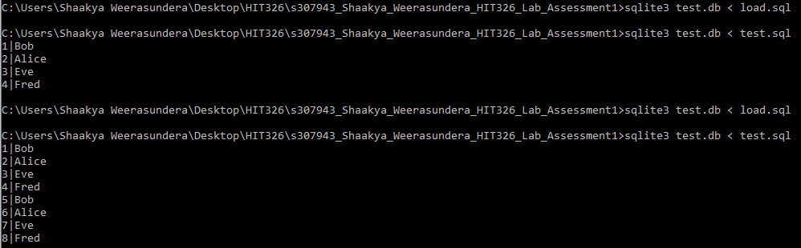

1. I reran the create script before loading it again. Once it was loaded for the first time after being re-created, it output 4 rows (less than the result we got last time).

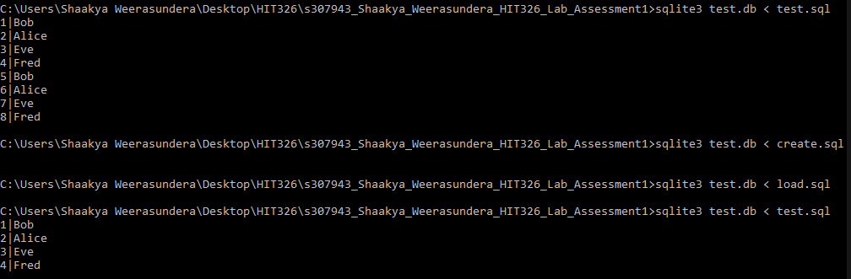

1. Result of commented SELECT statement:



Select name from users;



select user_id, name from users; select name, user_id from users;

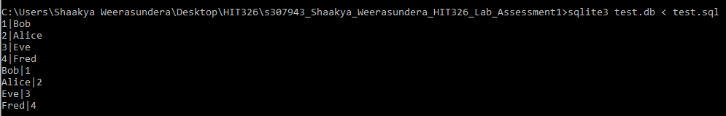

select name from users where user_id='1';



select name from users where user_id='2' and name='Alice';



select name from users where user_id='1' and name='Alice';



select name from users where user_id='1' or name='Alice';



**Exercise 2:**

1. Test

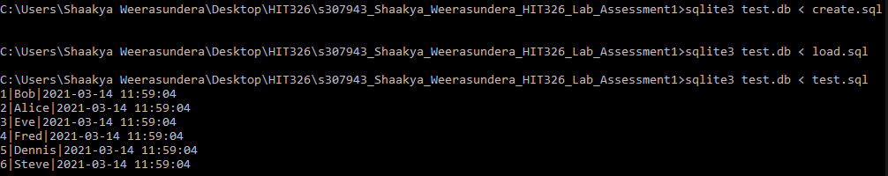

1. Tables

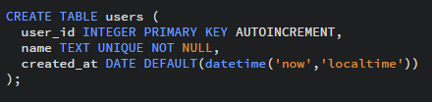

1. 
2. Time after localtime is removed:

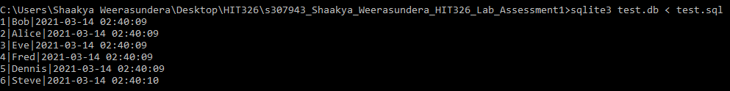

After putting localtime back:

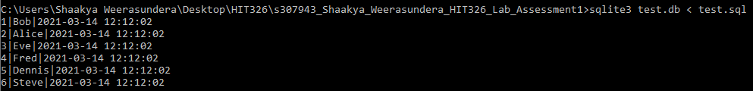

1. UTC is Universal Time Coordinated (default).
2. Error: failed to load the data as the field users.name is of a UNIQUE constraint.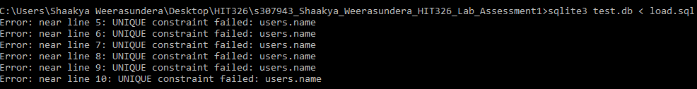
3. a) 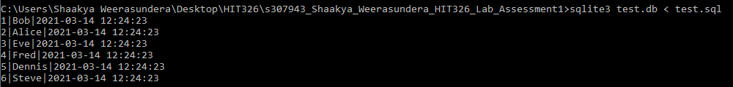

b)The insert issue works. However, when loaded, as they are unique, it gives an error.

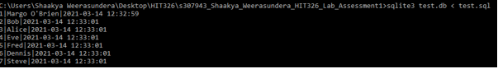

c) The test command works. However, the load statement gives an error as they are unique values. 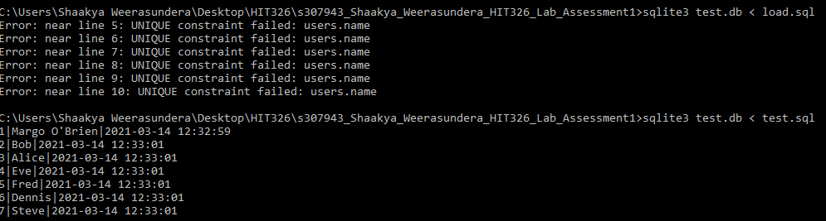

d) 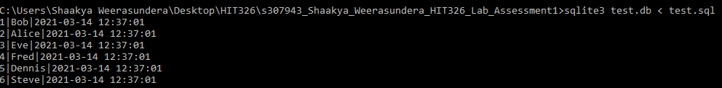

e) DESC:

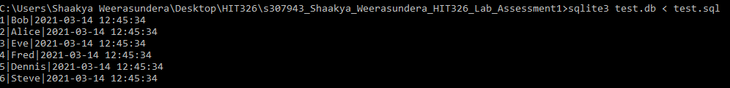

f) ASC:

g) DESC orders the results of the query in descending order. In contrast, ASC orders the results in ascending order.

# Part 2

**Exercise 3:**

1. Inspected airports.csv. 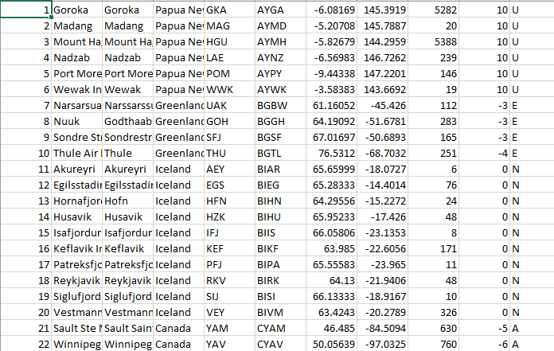
2. Real is used for the latitude and longitude. This data can not be whole numbers such as integers, and can not be interpreted in string. They are like float values.
3. Load script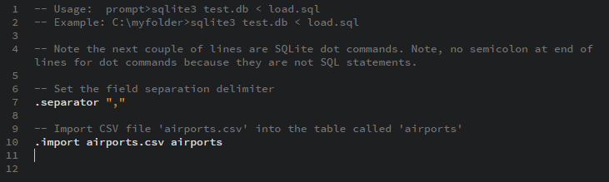
4. Test.sql: Dot command at Line 9.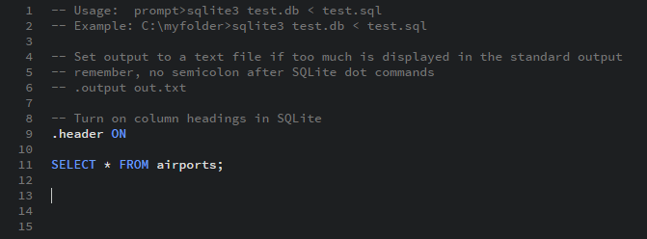
5. a) 

b)

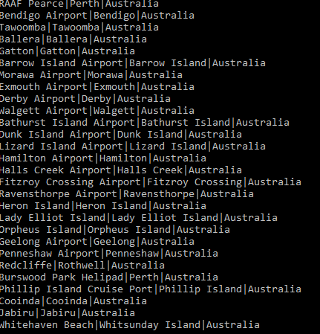

c)

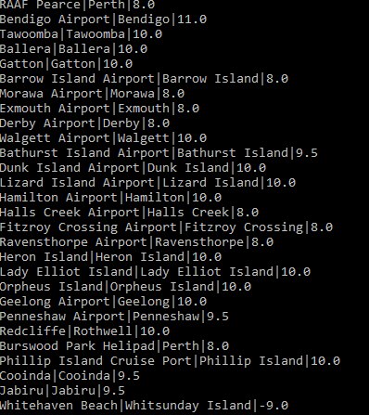

d) 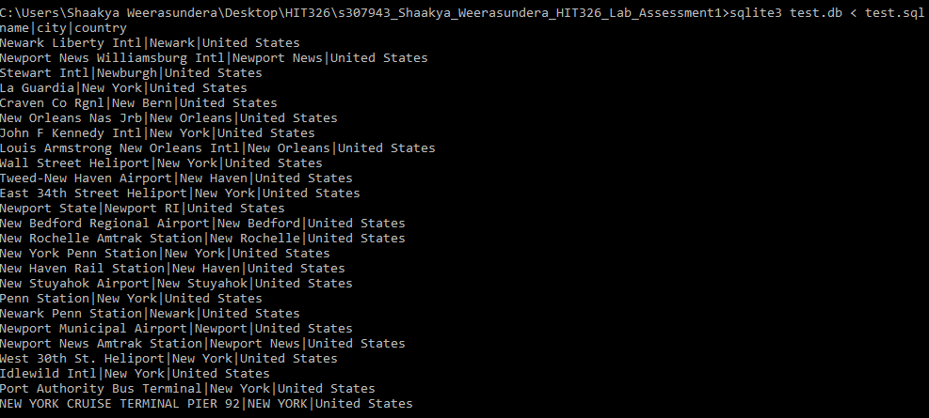

e) 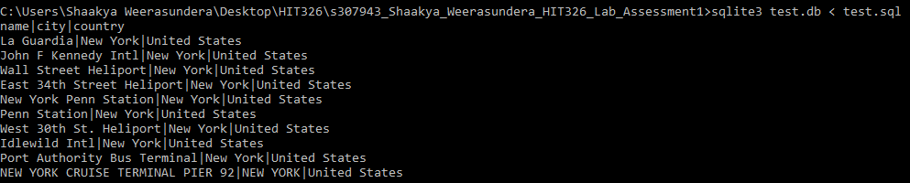

f) 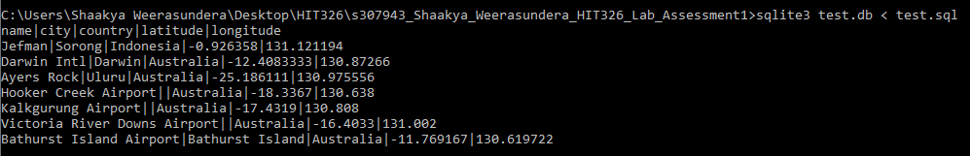

g)



h) 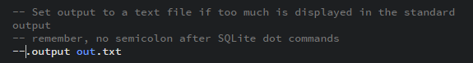



# Part 3

Created table and loaded data from the create, load files.

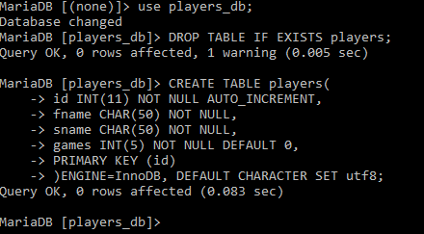

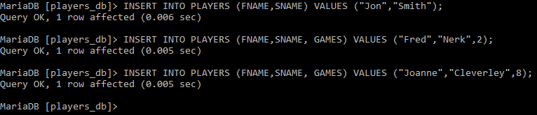

Started PhpMyAdmin.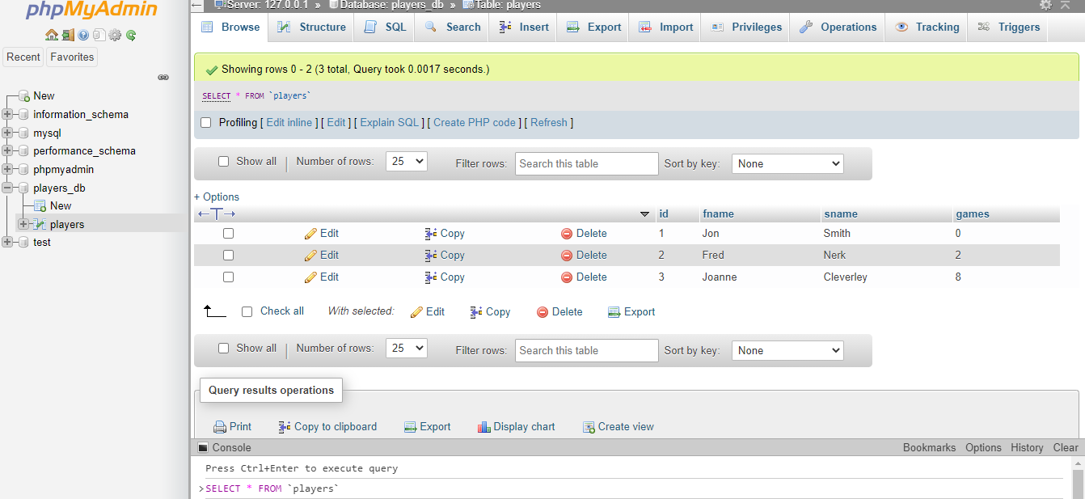

Successfully added my name as a player to the database (“Shaakya Weerasundera”).

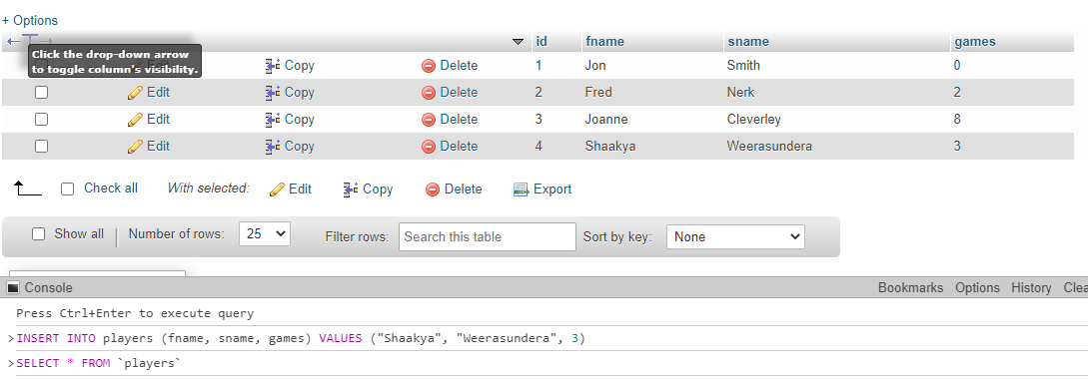

.php files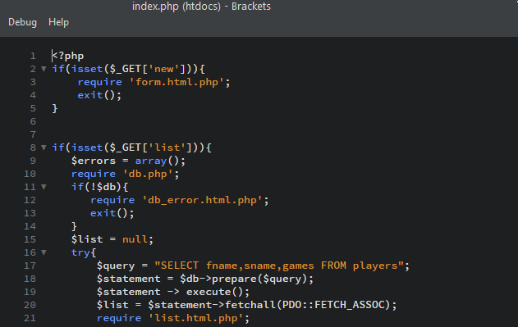

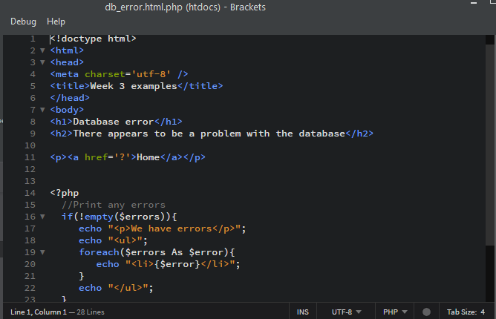

1. The controller is index.php. The code in this file is all Php.
2. The views are represented by form.html.php, db_error.html.php and list.html.php. The majority of the code in those files are HTML.
3. The files not mentioned in the above are of the role: Model. That is the Model of the data.

Source code: workshop zip files from Learnline, by Mostafa Hamadi.