Project Proposal
CricTalentAI
An AI-Powered Cricket Talent Scouting and Performance Prediction Platform
for U19 Cricket Academy Players in the T20 Format
Final Year BSc Software Engineering Project Proposal

Item | Details
Project Domain | Cricket Academy Management, System AI/ML
Target Users | Admin, Coach, Player
Main AI/ML Components | Random Forest / XGBoost for prediction; K-Means for archetype clustering. The Training Recommendation Module uses ML outputs and scoring logic.
System Type | Web-based software system with separate AI/ML service integration
Focused Scope | One U19 cricket academy, T20 format, player development and training support
Core AI Part | Performance prediction model that predicts player potential using match, training, fitness and coach-rating data

For Student Use Only
Student Name | Shamil jafeel | Attempt No | 01
Title of the project | CricTalentAI: An AI-Powered Cricket Talent Scouting and Performance Prediction Platform for U19 Cricket Academy Players in the T20 Format
System platform | ✓ Web Application ☐ Desktop Application  ☐ Mobile Application ................................
Technology | HTML, CSS, JavaScript, React.js / HTML-CSS-JS, Python, FastAPI or Node.js, MySQL/MongoDB, Scikit-learn, Pandas, NumPy, Matplotlib
Programming methodology | ☐ Structured System Analysis and Design Methodology  ✓ Object Oriented Analysis and Design Methodology
SDLC | Agile Development Methodology

Prepared by: Mohamed Jafeel Shamil
CL/BSCSD/34/60

Proposal Structure
- 1. Title
- 2. Introduction
- 3. Current Situation Leading to Problem Identification
- 4. Proposed Technique to Solve the Current Problem
- 5. Feasibility
- 6. Project Description
- 7. Deliverables
- 8. Resources Required
- 9. Expected Output and Outcome
- 10. Time Plan for Implementation
- 11. Limitations
- 12. References

This proposal is arranged according to the provided Software Engineering project proposal template. It also includes selected detailed content from the full CricTalentAI proposal, such as the AI/ML approach, dataset plan, architecture, evaluation plan, user stories, ethical considerations, and project methodology.

1. Title
CricTalentAI: An AI-Powered Cricket Talent Scouting and Performance Prediction Platform for U19 Cricket Academy Players in the T20 Format

2. Introduction
Cricket academies play an important role in identifying and developing young players. At Under-19 level, players need proper monitoring because this is the stage where they prepare for school, club, district, provincial, or national-level opportunities. Coaches need reliable information about each player’s match performance, training attendance, fitness level, fielding contribution, coach feedback, and overall progress.
Many small and medium-level cricket academies still record player details manually using notebooks, paper sheets, or basic spreadsheets. Although this approach may work for a small number of players, it becomes difficult when the academy needs to compare players, track long-term improvement, identify hidden talent, and prepare training reports. Manual record keeping can also create delays, missing information, and unfair decisions because data is not stored and analysed in a structured way.
This project proposes CricTalentAI, an AI-powered web-based sports talent scouting and performance prediction platform for a specific U19 cricket academy. The system will allow coaches and administrators to manage player profiles, match statistics, training records, coach feedback, development goals, schedules, tournaments, dashboards, and reports. The AI/ML module will analyse structured cricket data to predict player potential, group players into cricketing archetypes, and support data-driven coaching decisions.
The system is not designed to replace the coach. Instead, it works as a decision-support tool. The final coaching and training decisions will remain with the coach, while the system provides useful insights, alerts, training recommendations, and development reports to improve fairness and efficiency

3. Current Situation Leading to Problem Identification
The current situation in the selected U19 cricket academy can be summarised as follows:
- Player details, match records, training attendance, coach feedback, and development plans are mainly handled manually.
- Coaches may find it difficult to track player improvement over time because previous records are not stored in a structured and searchable manner.
- Player training may not always be based on complete performance data because information can be scattered across notebooks, spreadsheets, and coach memory.
- Players may not clearly understand their own progress, current goals, strengths, weaknesses, and areas that require improvement.
- Sudden performance drops may not be identified early because coaches need to manually compare recent records with past performance.
- Training schedules, match schedules, tournaments, and development plans may not be managed in one central system.
- Coaches may spend extra time preparing reports manually, reducing the time available for coaching and player development.

Based on these issues, the academy needs a centralised, data-driven platform to manage player development information, analyse performance, predict potential, and support personalised coaching decisions.

3.1 Existing Similar Systems and Research Gap
Several cricket-related systems already exist, including CricHeroes, CricClubs, Ludimos, and PitchVision. CricHeroes focuses on live scoring, statistics, leagues, profiles, and streaming. CricClubs supports academy/club management, attendance, practice scoring, analytics, and reports. Ludimos supports coaching through video analysis, AI insights, scheduling, payments, and profiling. PitchVision provides scoring, streaming, coaching, and analysis tools.
However, these systems do not fully focus on one U19 T20 academy with ML-based player potential prediction, K-Means archetype clustering, performance drop alerts, coach-controlled AI insights, and personalised training recommendations in one web platform. CricTalentAI fills this gap by combining academy management, structured records, AI/ML prediction, explainable recommendations, and development tracking.

4. Proposed Technique to Solve the Current Problem
The proposed technique is to develop a web-based cricket academy management and AI decision-support platform. It combines software engineering, database management, REST API integration, machine learning, rule-based logic, dashboards, and reports. The scope focuses on one U19 academy and the T20 format.

4.1 Overall Technical Approach
- A frontend web application will provide separate portals for Admin, Coach, and Player users.
- A backend REST API will handle authentication, validation, business logic, database operations, and communication with the AI/ML service.
- A database will store users, players, matches, training sessions, tournaments, schedules, goals, coach feedback, AI predictions, training recommendations, and reports.
- A separate AI/ML service will process player data, generate prediction results, identify player archetypes, and return results to the main system.
- Training recommendation logic will generate performance drop alerts, personalised training suggestions, and template-based coaching reports.

4.2 AI/ML and Rule-Based Techniques
The AI/ML part is a separate decision-support service. It receives structured cricket data, prepares it, applies trained models, and returns prediction, clustering, and recommendation outputs to the coach dashboard. It supports coaches with evidence but does not make final decisions.
The machine learning workflow has four main stages: data collection, preprocessing, model prediction, and result presentation.
- Data Collection: The system collects player profile data, batting records, bowling records, fielding records, training attendance, fitness scores, and coach ratings.
- Preprocessing: Missing values, invalid records, duplicate entries, and inconsistent formats are cleaned before the data is used by the model.
- Feature Engineering: The system creates useful calculated features such as recent form index, batting contribution score, bowling contribution score, fielding score, attendance percentage, consistency score, and overall contribution score.
- Prediction and Training Recommendation: The trained ML model predicts the player performance potential score. The Training Recommendation Module then combines this result with role, recent form, fitness, attendance, and coach rating to suggest training focus areas.
Feature | Technique | Purpose
Performance Potential Prediction | Random Forest Regression / Classification or XGBoost | Predicts a player performance potential score or potential category such as Low, Medium, or High.
Player Archetype Clustering | K-Means Clustering | Groups players into cricketing roles such as Power Hitter, Anchor Batter, Bowling Specialist, Death Bowler, All-Rounder Candidate, and Fielding Specialist.
Performance Drop Detection | Rule-Based Logic | Detects sudden performance drops by comparing current performance with recent averages.
Training Priority Scoring | Weighted scoring using ML prediction output, player archetype, recent form, and coach rating | Calculates which training areas should be prioritised for each player, such as batting strike rate, bowling economy, fielding consistency, or fitness improvement.
Personalised Coaching Report | Template-Based Report Generation | Produces readable reports showing strengths, weaknesses, improvements, and recommended training areas.
Training and Development Recommendation Module | Training recommendation logic using performance prediction, archetype clustering, strengths, weaknesses, and recent trend analysis | Suggests personalised training focus areas such as strike-rate improvement, bowling economy control, fielding practice, fitness improvement, or consistency development.
Secondary AI Coaching Summary (optional if approved) | OpenAI API / LLM-based text generation | Generates coach-facing summaries of performance, recommendations, and reports. Not core AI/ML and available only to the Coach.

The final coaching and training decisions will always remain with the coach. The system only provides data-driven support and does not automatically make decisions without human approval.

4.3 AI Model Input and Output Example
Model Input Data | Example Values
Batting data | Runs, balls faced, strike rate, batting average, boundary percentage
Bowling data | Wickets, overs, economy rate, dot-ball percentage, bowling consistency
Fielding data | Catches, run-outs, fielding score, dropped catches
Training data | Attendance percentage, drills completed, practice scores, fitness score
Coach evaluation | Coach rating, coach notes, recent form judgement
AI output | Performance Potential Score: 82/100; Potential Level: High; Player Archetype: Batting All-Rounder; Suggested Training Focus: bowling economy improvement
Recommendation output | Training Recommendation: improve bowling economy, fielding consistency, and training attendance

4.4 Model Training Approach
The model will be trained initially using an accurate and reliable cricket dataset. This dataset will include historical cricket data, academy records, manually collected data, and synthetic data if real data is limited. The data will be cleaned and checked before training to remove missing values, duplicate records, wrong values, and inconsistent formats. The saved model will predict new records through the AI/ML service.

When new players are added, immediate retraining is not required. The model can predict after enough match and training data is entered. Retraining can occur after tournaments, monthly, quarterly, or when enough new accurate data is collected.

4.5 Training Recommendation Module
The system will include a Training Recommendation Module together with the prediction model and clustering model. This module is not a third machine learning model. It will use the AI prediction result to suggest training areas with reasons.
The module will use details such as predicted score, player type, recent form, batting score, bowling score, fielding score, attendance, fitness score, coach rating, and weaknesses. These details will be used to calculate a training focus score and provide a personalised training recommendation.
A weighted scoring method can be used. For example, the system can give 30% importance to the prediction result, 20% to recent form, 15% to attendance, 15% to weakness score, 10% to fitness score, and 10% to coach rating. These percentages can be adjusted after testing and coach feedback.
The module will compare player strengths and weaknesses. For example, low strike rate can suggest batting drills, high bowling economy can suggest bowling control practice, and low attendance or fitness can suggest attendance improvement or fitness goals.
The coach dashboard may show: Score 84/100; Potential High; Player Type Batting All-Rounder; Recommendation: improve bowling economy, match consistency, and fielding reactions; Reason: strong batting but weaker bowling economy.The coach can accept, reject, or change the recommendation.

4.6 Secondary AI/LLM Support Using OpenAI API
If approved by the evaluators, the system may include a secondary AI/LLM component using the OpenAI API. This component will not replace the main machine learning models. It will only be used to generate coach-facing explanations, coaching summaries, and development report summaries. For example, it can convert AI prediction results, player archetypes, and training recommendation outputs into simple natural-language explanations for the Coach.
This secondary AI/LLM feature will not be a core AI/ML model. The core AI/ML parts of the project will remain the Performance Prediction Model, Player Archetype Clustering Model, and Training Recommendation Module. The OpenAI API support will only act as an explanation and report-summary support feature, and it will be available only to the Coach if approved.

5. Feasibility
The project is feasible because it focuses on one academy, U19 players, and the T20 format. It does not attempt to build an IPL-level scouting system or live match analytics platform, but focuses on realistic academy workflows and achievable AI/ML features.
Feasibility Area | Explanation
Technical Feasibility | The system can be developed using HTML, CSS, JavaScript, React.js, Python, FastAPI/Node.js, MySQL/MongoDB, Scikit-learn, Pandas, NumPy, and Matplotlib.
Operational Feasibility | The system matches a real academy workflow: player registration, match records, training logs, coach feedback, dashboards, reports, and player development plans.
Data Feasibility | The dataset can use academy records, manual match/training data, coach ratings, permitted public statistics, and sample/synthetic data for testing.
Time Feasibility | The project can be completed within approximately 12 weeks if the core modules are prioritised first and advanced features are kept as future enhancements.
Scope Feasibility | The project excludes live scoring, video analysis, wearable integration, online payment, mobile app development, and multi-academy deployment.

5.1 Potential Challenges and Risk Management
Risk | Explanation | Mitigation Strategy
Limited real academy data | The academy may not have enough historical records. | Use available records, collect new sample data, and use synthetic/sample data for development and testing.
Model accuracy may be low | Small datasets may reduce prediction accuracy. | Use simple baseline models, evaluate properly, explain limitations clearly, and improve gradually when more data is available.
Scope may become too large | Too many features can make the project difficult. | Focus on core features and move advanced features to future enhancements.
Users may find the system difficult | Coaches and players may not be technical users. | Design a simple dashboard-based UI with clear forms, reports, and graphs.
Time limitation | Final-year project time is limited. | Follow a weekly plan and complete core modules before optional enhancements.
Data privacy issues | U19 player data is sensitive. | Use secure login, role-based access, restricted visibility, and privacy controls.

6. Project Description

6.1 Brief Description of the Project
CricTalentAI is a web-based software system that helps a U19 cricket academy manage player information, record match and training performance, analyse player progress, and generate AI-supported performance insights. The system will include Admin, Coach, and Player portals. Coaches will be able to record match performance, training attendance, fitness scores, and coach ratings. The AI/ML module will use this structured data to predict player potential and group players into meaningful archetypes. The system will also provide performance drop alerts, a Training Recommendation Module, development plans, goal tracking, dashboards, and report generation.

6.2 Aim of the Project
The aim of this project is to design and develop an AI-powered web-based platform that helps a U19 cricket academy manage player records, analyse player performance, predict player potential, support data-driven coaching decisions, and improve player development tracking.

6.3 Project Objectives
- To develop a secure web-based system for managing U19 cricket player profiles, match records, training sessions, tournaments, schedules, development plans, and user accounts.
- To create separate Admin, Coach, and Player portals with role-based access control.
- To create a coach dashboard that displays player statistics, performance trends, comparisons, alerts, and training-related insights.
- To develop a machine learning model that predicts player performance potential using match statistics, training attendance, fitness scores, and coach ratings.
- To apply K-Means clustering to group players into cricketing archetypes such as Power Hitter, Anchor Batter, Bowling Specialist, Death Bowler, All-Rounder Candidate, and Fielding Specialist.
- To develop a separate Training Recommendation Module that suggests personalised training focus areas using ML prediction results, player archetypes, recent form, fitness, attendance, and coach ratings.
- To implement a Training Recommendation Module that helps coaches identify suitable improvement areas for each player.
- To implement a performance drop alert system that identifies sudden decreases in player performance.
- To generate personalised player development reports based on player statistics, AI outputs, and coach feedback.
- To allow coaches to create development plans and assign measurable goals for player improvement.
- To provide a player portal where players can view their profile, match statistics, training records, schedules, goals, feedback, and development reports.
- To evaluate the system through software testing, user feedback, and AI model performance metrics.

6.4 Scope of the Project
Included in the project scope:
- User registration and login
- Role-based access control for Admin, Coach, and Player
- Player profile management
- Match performance recording
- Training session recording
- Coach feedback management
- Training schedule and match schedule management
- Tournament and match management
- Coach dashboard and player performance dashboard
- Player portal
- Player comparison module
- Performance trend graphs
- AI-based player potential prediction
- K-Means-based player archetype clustering
- Training Recommendation Module for personalised training focus
- Optional secondary AI/LLM support using OpenAI API for coach-facing summaries, if approved by evaluators
- Rule-based performance drop alerts
- Training recommendation support
- Development plan and goal tracking
- Personalised coaching report generation
- PDF/Excel report export
- Admin panel
- Basic software testing and AI model evaluation
Excluded from the project scope:
- Parent portal
- Live match scoring system
- Real-time ball-by-ball cricket analytics
- Professional IPL-level scouting system
- Wearable device integration
- Video analysis of batting or bowling techniques
- Injury diagnosis or medical prediction
- Online payment system
- Mobile application version
- Multi-academy commercial deployment
- Fully automated training decisions without coach approval
- Continuous model training
The OpenAI API will not be used as a core AI/ML model or to make final coaching decisions
These excluded features can be considered as future enhancements.

6.5 Target Users
User Role | Main Purpose in the System
Admin | Manages the complete system, user accounts, coaches, players, tournaments, schedules, reports, settings, and access permissions.
Coach | Records match and training data, views dashboards, compares players, generates reports, creates development plans, and uses AI insights for decision-making.
Player | Views personal statistics, training progress, coach feedback, development reports, goals, schedules, and training progress status.

6.5.1 Data Entry Responsibility
Players do not enter or edit official performance records. Admins or coaches manage profiles, while coaches enter match data, attendance, fitness scores, ratings, and feedback. Players can view their own profile, statistics, progress, schedules, goals, feedback, and reports. This improves data reliability for prediction, clustering, and recommendations.

6.5.2 AI Access Responsibility
AI predictions, archetypes, alerts, recommendations, and optional AI/LLM summaries are available only to the Coach through the Coach Dashboard. Players see only coach-approved summaries, goals, feedback, and reports. Admins manage data and permissions, while coaching decisions remain with the Coach.

6.6 System Workflow
1. Admin creates coach and player accounts.
2. Coach creates or updates player profiles.
3. Coach creates training and match schedules.
4. Coach records training attendance, training scores, and coach feedback.
5. Coach records match performance after each match.
6. The system stores all data in the database.
7. The system preprocesses player match and training data.
8. The AI module predicts player potential and identifies player archetypes.
9. Training recommendation logic generates alerts, training suggestions, and report content.
10. Coach creates development plans and goals based on the system output.
11. Players view their progress, schedules, feedback, goals, and development reports through the player portal.

6.7 Functional Requirements
No. | Functional Requirement | Description
FR1 | User Management | The system should support secure login and different user roles such as Admin, Coach, and Player.
FR2 | Player Profile Management | Admin or Coach can add, update, view, and deactivate player profiles.
FR3 | Match Performance Management | Coaches can enter batting, bowling, and fielding records after matches.
FR4 | Training Session Management | Coaches can record attendance, drills, fitness score, practice scores, and notes.
FR5 | Schedule Management | Admins or coaches can create, update, and cancel training sessions and match schedules.
FR6 | Tournament Management | The system can create tournaments, add matches, assign players, record results, and view history.
FR7 | Coach Dashboard | Coaches can view player statistics, recent form, top performers, alerts, and training suggestions.
FR8 | Player Portal | Players can view their own profile, match stats, training records, schedules, feedback, goals, plans, and training progress status.
FR9 | Player Comparison | Coaches can compare players based on batting, bowling, fielding, attendance, fitness, coach rating, and AI score.
FR10 | Performance Trend Graphs | The system shows progress graphs such as runs over matches, strike rate, wickets, economy rate, and attendance.
FR11 | AI Performance Prediction | The system predicts player performance potential using the trained machine learning model.
FR12 | Player Archetype Clustering | The system groups players into cricketing archetypes using K-Means clustering.
FR13 | Training Recommendation Module | The system combines ML prediction output, player archetype, recent form, attendance, fitness score, and coach rating to recommend personalised training focus areas.
FR14 | Performance Drop Alert | The system alerts coaches when a player’s performance drops suddenly.
FR15 | Development Plan and Goal Tracking | Coaches can create personalised development plans, assign goals, set deadlines, and track player progress.
FR16 | Personalised Coaching Report | The system generates a report showing strengths, weaknesses, improvements, and recommended training areas.
FR17 | Admin Panel | Admin can manage users, coaches, players, tournaments, schedules, system data, settings, and access permissions.
FR18 | Report Export | The system should allow player, training, tournament, and performance reports to be exported as PDF or Excel files.
FR19 | Data Entry Control | Players cannot edit official records. Admins and coaches manage official player, match, training, fitness, and feedback records.
FR20 | AI Prediction History | The system should store AI prediction scores, potential levels, player archetypes, training recommendation outputs, dates, and model version details for future review.
FR21 | Secondary AI Coaching Summary | If approved, the OpenAI API can act as secondary AI/LLM support for coach-facing summaries of performance, recommendations, and reports. It is not core AI/ML and does not replace the main models or modules.

6.8 Non-Functional Requirements
Requirement | Description
Security | The system should protect user accounts and player data using secure passwords and role-based access.
Usability | The interface should be simple, clear, responsive, and easy for coaches, admins, and players to use.
Performance | Dashboards, graphs, reports, and prediction results should load within a reasonable time.
Reliability | The system should store data correctly and avoid loss of match, training, and report records.
Maintainability | The frontend, backend, database, and AI module should be separated clearly for easier updates.
Scalability | The system should initially support one academy but allow future expansion.
Data Integrity | The system should validate inputs such as runs, wickets, overs, scores, and attendance values.
Privacy | Players should only access their own records, while coaches and admins should only access data allowed by their roles.
Accuracy | AI predictions should be evaluated using suitable metrics to check usefulness and correctness.
Availability | The system should be accessible during training sessions, match days, and tournament periods.

6.9 Data Collection and Dataset
The project uses structured cricket performance data from academy records, manually entered match/training data, coach ratings, legally permitted public statistics, and sample/synthetic data when needed. Before training, missing values, invalid values, duplicates, and inconsistent formats will be cleaned.
Data Category | Example Fields
Player profile data | Player ID, age, role, batting style, bowling style, height, weight, fitness level
Match performance data | Runs, balls faced, strike rate, wickets, overs, economy rate, catches, run-outs, fielding score
Training data | Attendance, drills completed, batting practice score, bowling practice score, fielding score, fitness score
Coach evaluation data | Coach rating, coach notes, development goals, weaknesses, recommended training
AI target data | Performance score, potential level, recent form score, training focus decision

6.10 Data Model / Main Database Entities
Entity | Purpose
Users | Stores login details, role, status, and authentication information.
Players | Stores player profile details and active/inactive status.
Coaches | Stores coach details and assigned player groups.
Matches | Stores match details such as date, opponent, venue, and tournament.
Match_Performance | Stores batting, bowling, and fielding records for each player per match.
Training_Sessions | Stores scheduled training sessions, type, date, time, and venue.
Training_Records | Stores player attendance, drills completed, practice scores, and fitness score.
Tournaments | Stores tournament information and related matches.
Coach_Feedback | Stores private and player-visible feedback.
Player_Goals | Stores player goals, target values, deadlines, and progress.
Development_Plans | Stores personalised development plans created by coaches.
AI_Predictions | Stores predicted scores, potential levels, model version, and prediction date.
Reports | Stores generated player, training, development, and tournament reports.

6.11 Proposed System Architecture
The system follows a service-oriented or layered architecture. The AI module is separated from the main backend so it can be developed, tested, integrated, and improved without changing the full web application.
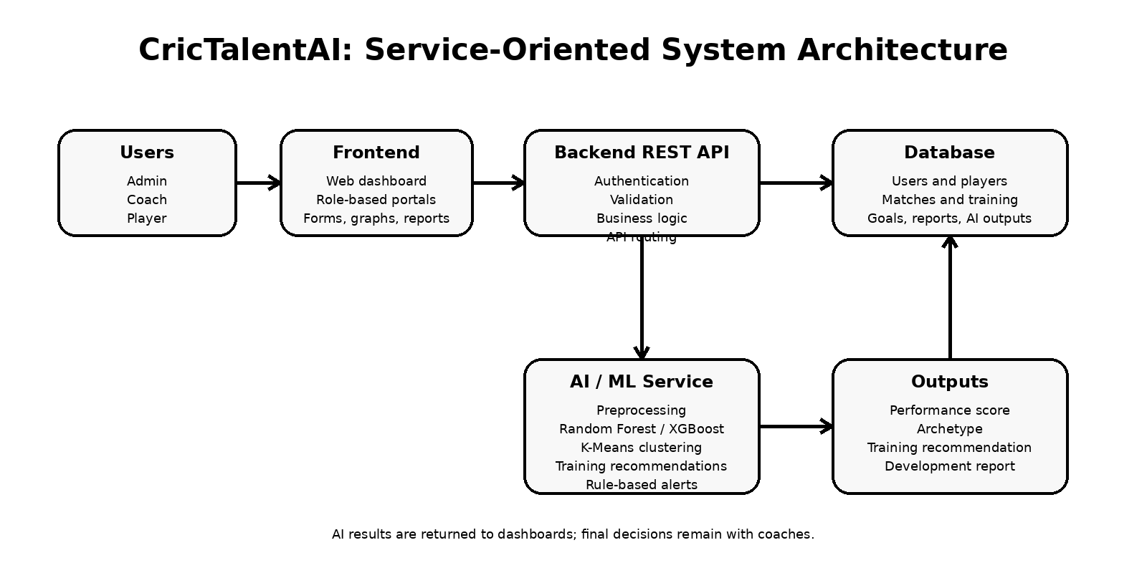
Figure 1: Proposed service-oriented architecture for CricTalentAI.
Component | Purpose
Frontend Layer | The user interface used by Admins, Coaches, and Players.
Backend API Layer | Handles user requests, authentication, database operations, validation, business logic, and communication with the AI module.
Database Layer | Stores user details, player records, match records, training records, schedules, tournament data, goals, reports, and prediction results.
AI/ML Service Layer | Handles prediction, clustering, scoring, alerts, and report generation.

6.12 Proposed Technology Stack
Area | Technologies
Frontend | HTML, CSS, JavaScript, React.js or simple HTML/CSS/JS frontend
Backend | Python FastAPI or Node.js with Express.js
AI / ML Development | Python, Scikit-learn, Pandas, NumPy, Matplotlib
Database | MySQL or MongoDB
Tools | Visual Studio Code, GitHub, Postman, Jupyter Notebook or Google Colab
Secondary AI / LLM Support | OpenAI API, only if approved by evaluators; used only for coach-facing natural-language summaries and not as a core AI/ML model.

Python is suitable for AI/ML because it has strong libraries. Scikit-learn supports Random Forest and K-Means, while REST APIs allow clear communication between the frontend, backend, and AI module.

6.13 UI/UX Design Plan
The system will use a simple dashboard-based interface with separate Admin, Coach, and Player views. The UI will be clean, responsive, and easy for coaches and young players to understand.
User | Main UI Pages
Admin | Admin Dashboard, User Management, Coach Management, Player Management, Tournament Management, Schedule Management, Reports, Settings
Coach | Coach Dashboard, Player List, Match Entry, Training Entry, Player Comparison, AI Prediction View, Training Recommendation, Development Plan, Goal Tracking, Reports
Player | Player Dashboard, My Profile, My Match Stats, My Training Records, My Schedule, My Goals, My Feedback, My Development Report, My Training Progress Status

6.14 User Stories
User Role | User Story
Admin | As an Admin, I want to manage coaches, players, users, schedules, and tournaments so that the academy can control all system data properly.
Coach | As a Coach, I want to enter match and training data so that I can track player performance and improvement.
Coach | As a Coach, I want to view AI predictions, player archetypes, and training recommendations so that I can make better training and development decisions.
Coach | As a Coach, I want to create development plans and goals so that each player can follow a clear improvement path.
Player | As a Player, I want to view my own statistics, feedback, goals, schedule, and development report so that I can understand my strengths and weaknesses.

6.15 Research Questions
Primary research question:
How effectively can a web-based AI-powered cricket academy system support player performance prediction, talent scouting, and data-driven development planning for U19 cricket players?
Secondary research questions:
1. Which player performance and training features are most useful for predicting player potential?
2. How accurately can a Random Forest or XGBoost model predict player performance scores using structured academy data?
3. How useful is K-Means clustering for identifying player archetypes in a U19 cricket academy?
4. How can dashboards, reports, and development plans support coach decision-making and player improvement?

6.16 Ethical and Privacy Considerations
The system handles personal and performance data of U19 players, so privacy, ethics, and responsible AI are important. Secure login, role-based access, and restricted visibility will protect data. Players view only their records; coaches/admins access role-permitted data.
The system will not provide medical diagnosis, injury diagnosis, or automated final decisions. AI outputs will be used only for decision support, and final decisions remain with coaches and academy staff.
If OpenAI API is used as secondary AI/LLM support, only necessary performance information will be used. Personal identifiers should be removed where possible. The API will not make coaching decisions; it only supports Coach-facing explanations and summaries.

6.17 Testing and Evaluation Plan
Evaluation Area | Metrics / Method
Software Testing | Unit testing, integration testing, system testing, user acceptance testing, form validation testing, role-based access testing, and report generation testing.
Regression Model | Mean Absolute Error, Root Mean Squared Error, and R-squared score.
Classification Model | Accuracy, Precision, Recall, and F1-score.
Clustering Model | Silhouette score and coach feedback on whether the player groups are meaningful.
System Success Metrics | Dashboard response time, user satisfaction, reduction in manual record handling, and successful completion of key user tasks.
Training Recommendation Module Evaluation | Coach feedback, clarity of recommendation explanations, and usefulness of suggested training focus areas.

7. Deliverables
The deliverables describe the output of the project, including the software artefact, AI model, reports, documentation, and evaluation results.
Deliverable | Description
Working Web-Based System | Complete CricTalentAI web application with Admin, Coach, and Player portals.
Backend REST API | API for authentication, player management, match records, training records, predictions, reports, and dashboards.
Database | Structured database containing users, players, matches, training records, tournaments, goals, AI outputs, and reports.
AI Performance Prediction Model | Machine learning model to predict player performance potential or category.
Player Archetype Clustering Model | K-Means model to group players into meaningful cricketing archetypes.
Rule-Based Modules | Performance drop alerts, training recommendation support, and template-based coaching report generation.
Dashboards and Graphs | Coach dashboard, player dashboard, performance trend charts, comparison views, and reporting screens.
Reports and Export Outputs | Player development reports, training reports, progress reports, and PDF/Excel exports.
Testing and Evaluation Results | Software testing results, model evaluation metrics, user feedback, and system success evaluation.
Final Documentation | Final project report, proposal, design documentation, user guide, and presentation materials.
Training Recommendation Module | Training Recommendation Module that combines ML prediction score, player archetype, recent form, attendance, fitness, and coach rating to suggest personalised training focus areas.
Secondary AI Coaching Summary (Optional) | If approved by evaluators, OpenAI API-based coach-facing summaries for player performance, training recommendations, and development reports.

8. Resources Required
Resource Type | Resources Required
Hardware | Laptop or desktop computer for development and testing.
Development Tools | Visual Studio Code, GitHub, Postman, Jupyter Notebook or Google Colab.
Frontend Technologies | HTML, CSS, JavaScript, React.js or simple HTML/CSS/JS.
Backend Technologies | Python FastAPI or Node.js with Express.js.
AI/ML Libraries | Python, Scikit-learn, Pandas, NumPy, Matplotlib.
Database | MySQL or MongoDB.
Data Resources | Academy records, manually collected match/training data, coach ratings, legally permitted public cricket statistics, and sample/synthetic data for testing.
Human Resources | Student developer, supervisor guidance, and feedback from academy coaches/users if available.

9. Expected Output and Outcome

9.1 Expected Output
At the end of the project, the expected output is a working web-based CricTalentAI system that allows a U19 cricket academy to manage player records, track performance, analyse improvement, predict player potential, group players into archetypes, generate coaching reports, create development plans, track player goals, and provide personalised training recommendations.
- A secure login system with Admin, Coach, and Player roles.
- Player, coach, match, training, tournament, schedule, goal, feedback, and report management modules.
- A coach dashboard with player statistics, trend graphs, comparison tools, alerts, and training-related insights.
- A player portal where players can view their own progress, goals, schedules, feedback, and development reports.
- An AI/ML prediction module that gives player performance potential scores or categories.
- A clustering module that identifies player archetypes.
- Performance drop alerts and Training Recommendation Module support.
- A Training Recommendation Module that explains why a player is recommended for a specific training focus.
- PDF/Excel report export and system evaluation results.
Optional secondary AI coaching summaries using OpenAI API, if approved by evaluators.

9.2 Expected Outcome
The expected outcome is to help the academy move from manual record keeping to a structured, data-driven player development process. Coaches will be able to make more informed decisions using player statistics, AI-supported insights, and performance trends. Players will be able to understand their progress, goals, weak areas, and feedback more clearly. The system will support personalised development planning and targeted training recommendations, while still keeping the coach as the final decision-maker.

10. Time Plan for Implementation

10.1 Project Methodology
The project will follow Agile methodology. The system will be developed in small stages, with each stage producing a working part. Agile is suitable because requirements may improve based on lecturer feedback, coach feedback, and testing results.
1. Requirement analysis
2. System design and architecture design
3. Database design
4. UI/UX design
5. Frontend development
6. Backend API development
7. AI model development
8. AI integration with the system
9. Testing and evaluation
10. Documentation and final report preparation

10.2 Estimated Timeline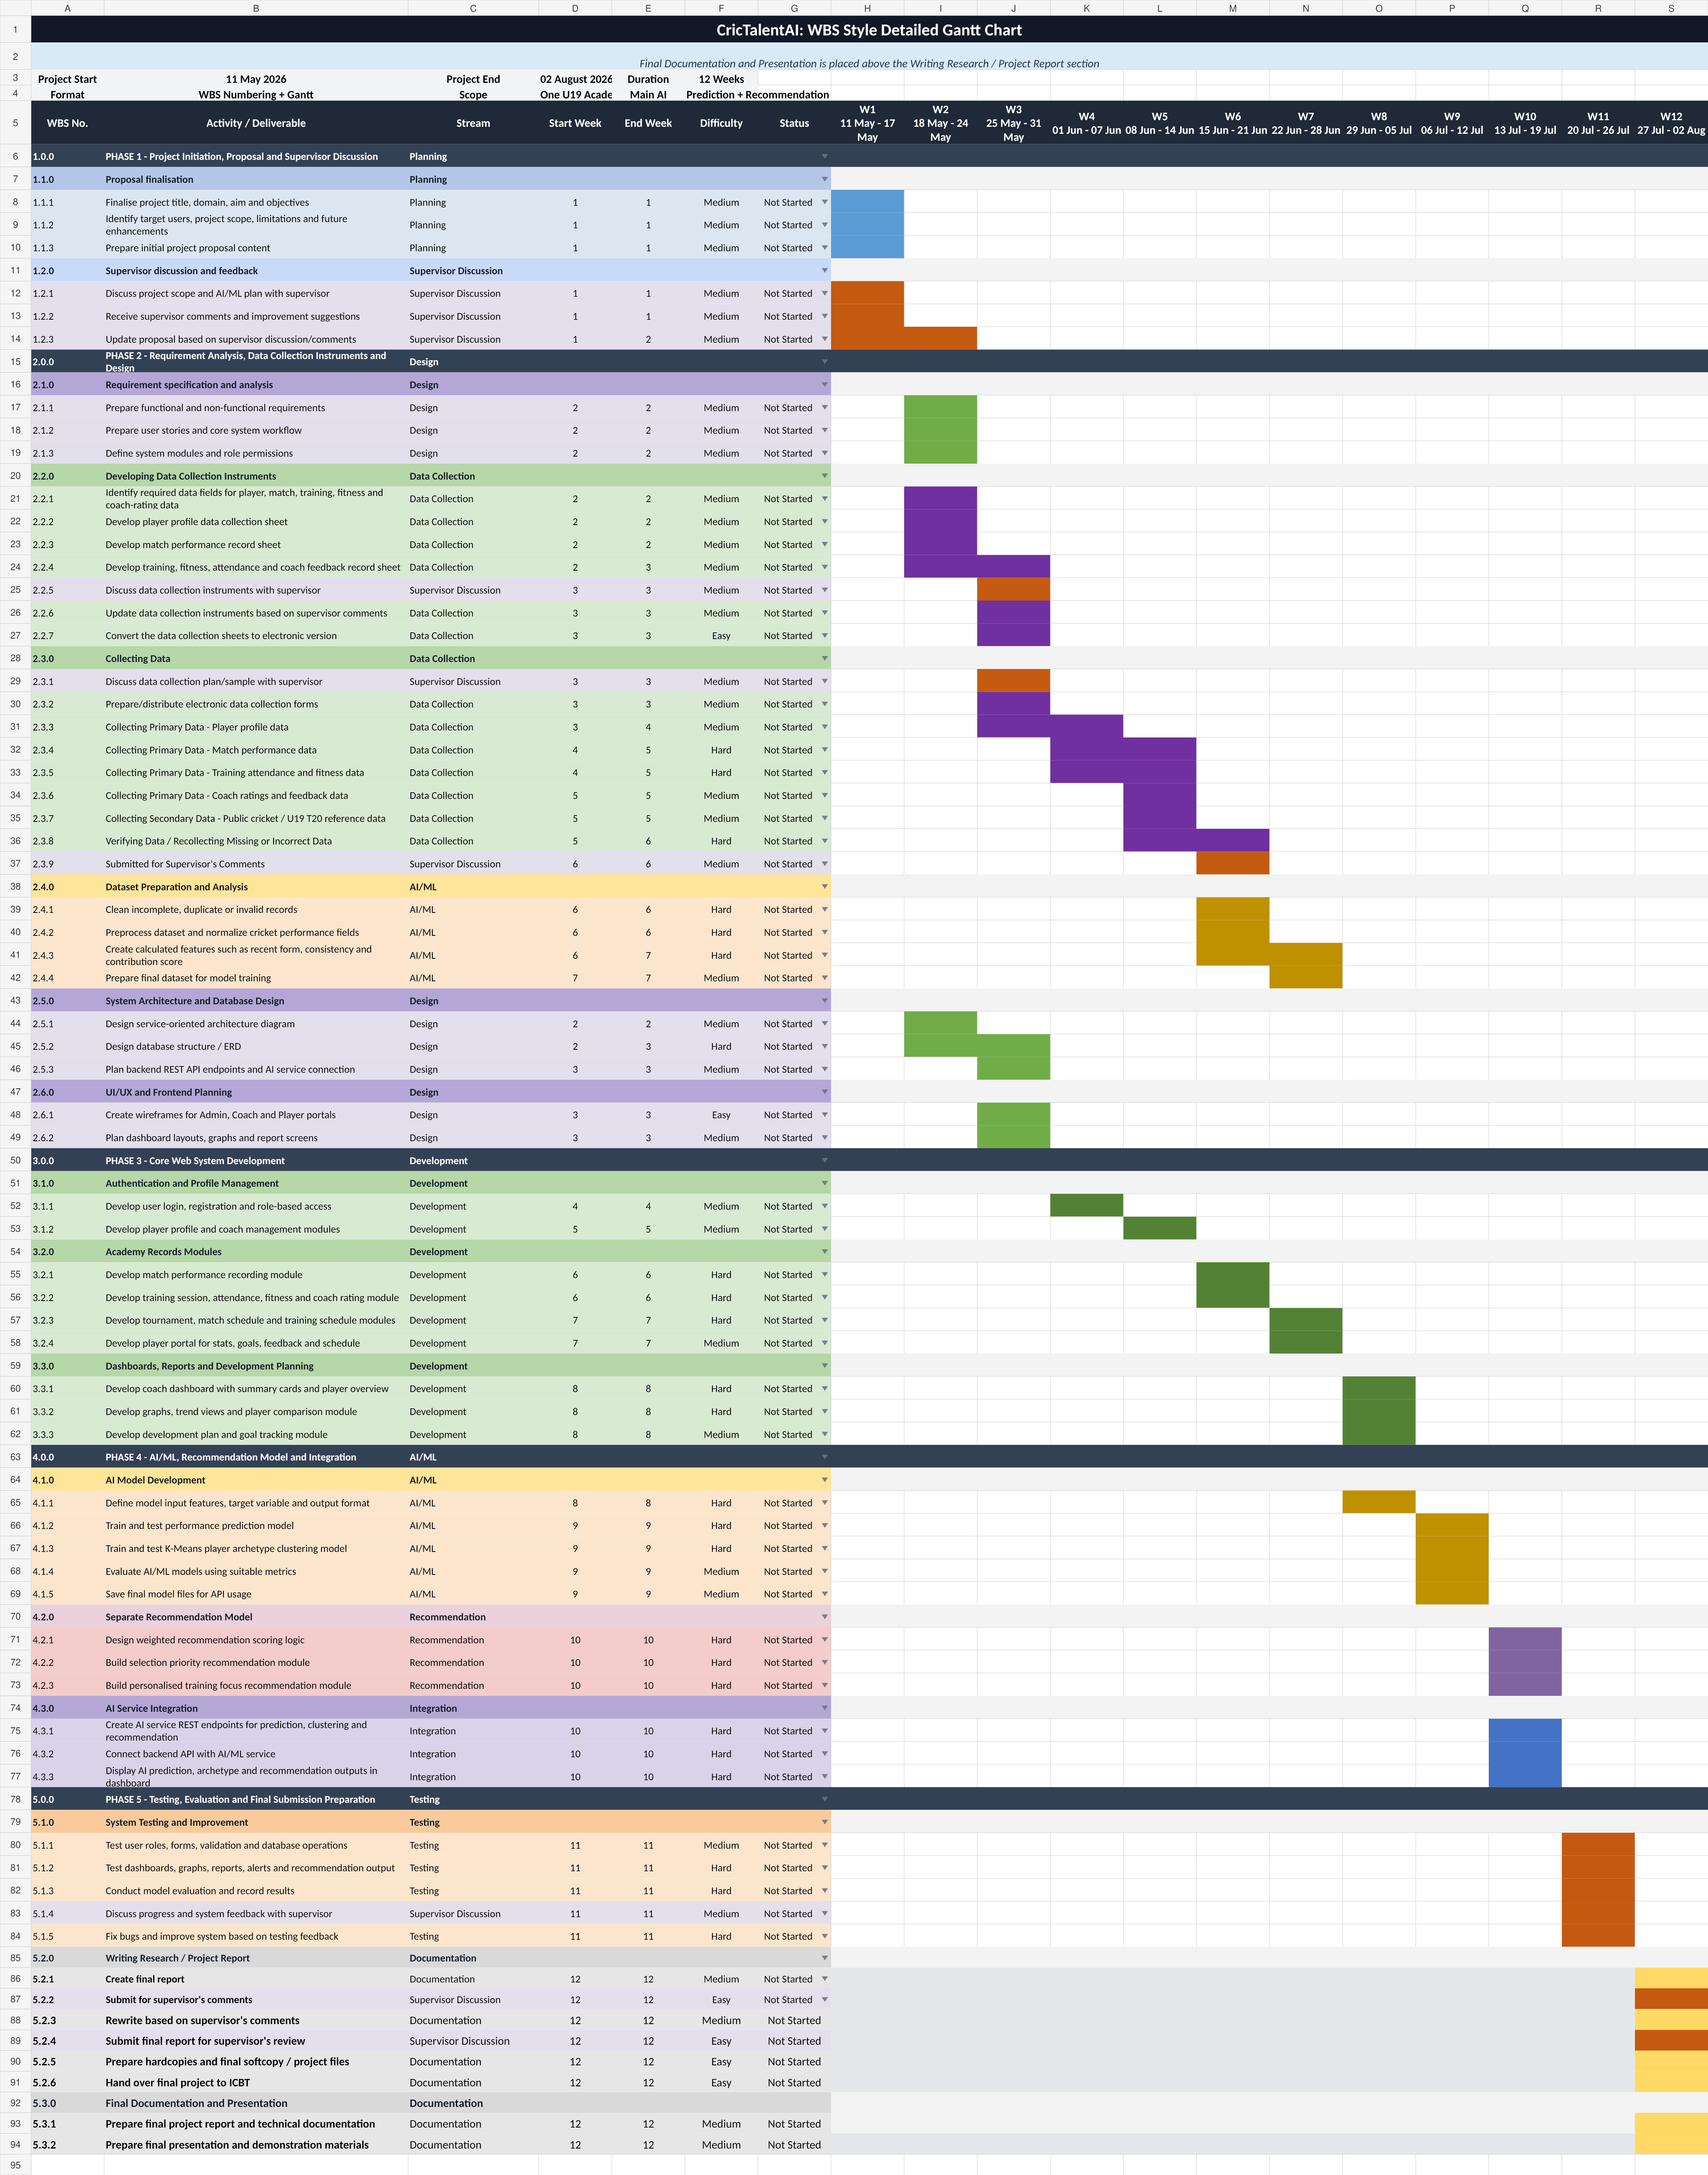

11. Limitations
The following limitations are identified to keep the project realistic and manageable within the final-year project period:
- The system focuses on one U19 cricket academy and mainly the T20 format.
- The accuracy of the AI model may be affected if limited real academy data is available.
- The system will not include live match scoring or ball-by-ball analytics.
- The system will not include video-based batting or bowling technique analysis.
- The system will not include wearable device integration or medical/injury diagnosis.
- The system will not include online payments or commercial multi-academy deployment.
- The system will not make fully automated final coaching or training decisions without coach approval.
- The initial version will not include continuous automatic model retraining.

11.1 Future Enhancements
- Parent portal
- Locally hosted or self-developed LLM-based coaching assistant
- LLM-based player report summarisation and explanation
- Mobile application version
- Video-based batting and bowling analysis
- Wearable device integration
- Injury risk prediction
- Multi-academy support
- Real-time match scoring
- Advanced time-series forecasting
- Advanced generative AI coaching assistant
- Player attendance using QR code scanning
- Integration with national or school-level cricket databases

12. References
Barr, G.D.I. and Kantor, B.S. (2004) 'A criterion for comparing and selecting batsmen in limited overs cricket'. Available at: https://www.tandfonline.com/doi/abs/10.1057/palgrave.jors.2601800 (Accessed: 11 May 2026).
Breiman, L. (2001) 'Random forests'. Available at: https://link.springer.com/article/10.1023/A:1010933404324 (Accessed: 11 May 2026).
Chathurangi, A.K.D.K., Silva, R.M., Withanage, N. and Jayasinghe, C.L. (2025) 'Impact ranking methodologies in limited-overs cricket: A systematic review of performance metrics'. Available at: https://journals.sagepub.com/doi/10.1177/17479541251321477 (Accessed: 11 May 2026).
Chen, T. and Guestrin, C. (2016) 'XGBoost: A scalable tree boosting system'. Available at: https://dl.acm.org/doi/10.1145/2939672.2939785 (Accessed: 11 May 2026).
CricClubs (No date) 'Academy Management'. Available at: https://cricclubs.com/academyManagement.do (Accessed: 11 May 2026).
CricHeroes (No date) 'Free cricket scoring app with league management and live streaming'. Available at: https://cricheroes.com/ (Accessed: 11 May 2026).
FastAPI (No date) 'FastAPI Documentation'. Available at: https://fastapi.tiangolo.com/ (Accessed: 11 May 2026).
Fielding, R.T. (2000) 'Architectural styles and the design of network-based software architectures'. Available at: https://roy.gbiv.com/pubs/dissertation/top.htm (Accessed: 11 May 2026).
Lemmer, H.H. (2004) 'A measure for the batting performance of cricket players'. Available at: https://journals.co.za/doi/10.10520/EJC108775 (Accessed: 11 May 2026).
Ludimos (No date) 'All-in-one AI cricket coaching and academy management platform'. Available at: https://www.ludimos.com/ (Accessed: 11 May 2026).
MacQueen, J. (1967) 'Some methods for classification and analysis of multivariate observations'. Available at: https://projecteuclid.org/ebooks/berkeley-symposium-on-mathematical-statistics-and-probability/Proceedings-of-the-Fifth-Berkeley-Symposium-on-Mathematical-Statistics-and/chapter/Some-methods-for-classification-and-analysis-of-multivariate-observations/bsmsp/1200512992 (Accessed: 11 May 2026).
OpenAI (No date) 'Text generation: OpenAI API documentation'. Available at: https://developers.openai.com/api/docs/guides/text (Accessed: 11 May 2026).
OWASP Foundation (2025) 'OWASP Top Ten Web Application Security Risks'. Available at: https://owasp.org/www-project-top-ten/ (Accessed: 11 May 2026).
Parliament of Sri Lanka (2022) 'Personal Data Protection Act, No. 9 of 2022'. Available at: https://www.parliament.lk/uploads/acts/gbills/english/6242.pdf (Accessed: 11 May 2026).
Pedregosa, F., Varoquaux, G., Gramfort, A., Michel, V., Thirion, B., Grisel, O. and Blondel, M. et al. (2011) 'Scikit-learn: Machine Learning in Python'. Available at: https://jmlr.org/papers/v12/pedregosa11a.html (Accessed: 11 May 2026).
PitchVision (No date) 'Products'. Available at: https://pitchvision.co.za/products (Accessed: 11 May 2026).
Rousseeuw, P.J. (1987) 'Silhouettes: A graphical aid to the interpretation and validation of cluster analysis'. Available at: https://www.sciencedirect.com/science/article/pii/0377042787901257 (Accessed: 11 May 2026).
Scikit-learn Developers (No date) 'RandomForestClassifier'. Available at: https://scikit-learn.org/stable/modules/generated/sklearn.ensemble.RandomForestClassifier.html (Accessed: 11 May 2026).
Scikit-learn Developers (No date) 'KMeans'. Available at: https://scikit-learn.org/stable/modules/generated/sklearn.cluster.KMeans.html (Accessed: 11 May 2026).
Scikit-learn Developers (No date) 'Metrics and scoring: Quantifying the quality of predictions'. Available at: https://scikit-learn.org/stable/modules/model_evaluation.html (Accessed: 11 May 2026).
Sokolova, M. and Lapalme, G. (2009) 'A systematic analysis of performance measures for classification tasks'. Available at: https://www.sciencedirect.com/science/article/abs/pii/S0306457309000259 (Accessed: 11 May 2026).
Sommerville, I. (2016) 'Software Engineering'. Available at: https://www.pearson.com/en-us/subject-catalog/p/software-engineering/P200000003258/9780137503148 (Accessed: 11 May 2026).
Vaeyens, R., Lenoir, M., Williams, A.M. and Philippaerts, R.M. (2008) 'Talent identification and development programmes in sport: Current models and future directions'. Available at: https://pubmed.ncbi.nlm.nih.gov/18712939/ (Accessed: 11 May 2026).

Conclusion
CricTalentAI proposes an AI-powered prediction platform for U19 cricket academy players. It addresses record problems by combining software engineering, ML, dashboards, development plans, and goals. It is suitable for a BSc project because it includes a complete working system, AI/ML, database, REST API, testing, evaluation, and limitations.

