Data Visualisation Toolkit for the Classroom Cloudlet

B.Sc. (Hons) Computer Science

School of Computing and Communications Lancaster University

Date of Submission: 22/03/24

# Declaration

I certify that the material contained in this dissertation is my own work and does not contain unreferenced or unacknowledged material. I also warrant that the above statement applies to the implementation of the project and all associated documentation. Regarding the electronically submitted work, I consent to this being stored electronically and copied for assessment purposes, including the School’s use of plagiarism detection systems in order to check the integrity of assessed work. I agree to my dissertation being placed in the public domain, with my name explicitly included as the author of the work.

Name: Shaan Jassal

Date: 24/02/2024

# Abstract

The aim of this project is to design and implement a data visualisation toolkit for the Classroom Cloudlet, aimed at enhancing the educational experience of students and teachers by providing intuitive and interactive visual representations of weather data. It provides a platform for exploring and visualising data collected through Micro:Bit and Raspberry Pi devices without requiring any JavaScript knowledge. The design of the toolkit project involves the selection and integration of various data visualisation techniques and tools, including interactive charts, graphs and drawing studios. The toolkit bridges the gap between technology and education, providing a valuable resource for enhancing data literacy skills in early education.

# 

# Contents

1 Introduction 6

1.1 Why is data visualisation necessary for children? 6

1.2 Project Aims 7

2 Related Works 8

2 The Classroom Cloudlet 8

2.1 The Classroom Cloudlet Framework 8

2.2 Why Data Visualisation would be beneficial 9

2.2 Energy in Schools 9

2.2.1 Data Visualisation’s role 9

2.2.2 The Advantages of using Data Visualisation 10

2.2.3 Implementation into the Classroom Cloudlet 10

3 Design 11

3.1 Requirements 11

3.1.1 Functional Requirements 11

3.1.2 Non-Functional Requirements 12

3.2 Design 12

3.2.1 System Architecture 12

3.1.4 Human-Computer Interaction 13

4 Implementation 15

4.1 How to run the Toolkit 15

4.2 Technology Stack 15

4.3 The Development Process 15

4.4 Code Structure 15

4.4.1 System Flow 17

4.4.2 Data Flow 17

4.4.3 Data Flow following Integration with Classroom Cloudlet 17

4.5 Key Implementation Details 18

4.5.1 The Weather Data 18

4.5.2 Time Simulation 19

4.5.3 The Weather Art Studio 20

4.5.4 The Showcase Area 21

4.6 Challenges and Solutions 21

4 Evaluation Methodology 22

4.1 Setup of the Specialist Interview 22

4.2. Demonstration Procedure 22

4.3. Feedback Collection 22

4.2 Analysis of Feedback 22

4.2.1 Ease of Use 22

4.2.2 Functionality 22

4.3.3 Performance 23

4.3.4 Alignment with Objectives 23

4.3.5 Suggestions for Improvement 23

5 Conclusion 24

5.1 Review of Project Aims 24

5.2 Evaluation and Feedback Integration 24

5.3 Future Enhancements 24

5.4 Reflection on Learning and Development 24

8.6 Final Thoughts 24

References 25

Appendix A - Project Proposal 26

Introduction 26

Objectives 26

Methodology 26

Appendix B - Research Participant Consent Form 28

# 

# 1 Introduction

The Data Visualisation Toolkit addresses the crucial need for data literacy in children by developing a user-friendly Data Visualisation Toolkit for the Classroom Cloudlet that allows the exploration of weather data. In today's digital era, data literacy is a fundamental skill, and this introduction provides an overview of the project's aims and its significance in the context of early education.

## 1.1 Why is data visualisation necessary for children?

The aim of this project is to develop a data visualisation toolkit tailored for children by recognising the importance of early data literacy. Drawing inspiration from Rebeca Pop's article ‘Seeing is not understanding: how to encourage data literacy early’ which emphasises that "'as early as possible,' children should learn data visualisation," this project seeks to address this gap. Pop's insights underscore the critical need for empowering children with data literacy skills from a young age, preparing them to navigate an increasingly data-driven world.

In today's digital society, the ability to interpret and critically evaluate information is indispensable, even for young learners. As Simon Rogers observes, there is a "data revolution" underway, with stories increasingly being told through numbers and facts. However, while data literacy is often perceived as a skill reserved for adults, Rogers argues that it belongs to everyone, advocating for an early start to data education. Despite the abundance of graphs and charts in their environment, children often lack the necessary skills to interpret and critically evaluate data visualisations. As Pop aptly points out, "seeing is not understanding." Thus, the fundamental question arises: How can we equip children with the tools to comprehend and engage meaningfully with data visualisation?

Through a review of literature and expert opinions, this project aims to design a toolkit that addresses this question. Nicholas Blechman, the designer behind "Animal Kingdom," emphasises the allure of data in capturing children's interest, noting the contrast between the factual nature of data and the fantastical narratives often found in children's entertainment. Blechman contends that children are drawn to the certainty offered by factual information, fuelling their curiosity and thirst for knowledge. Yet the way this data is presented is crucial, as, advocated by Pop, it is imperative to make data visualisation "simple and fun" for children, fostering their curiosity and facilitating a deeper understanding of complex concepts.

At its core, this project strives to bridge the gap between children's exposure to data visualisations and their comprehension thereof, guided by the insights gathered from Pop's paper and the expertise of educators and practitioners in the field. By empowering children with data literacy skills early on, the toolkit aims to help craft a generation capable of navigating the data-rich landscape of the 21st century.

## 

## 1.2 Project Aims

The toolkit aims to address the following objectives:

* To design and develop a user-friendly data visualisation toolkit that introduces children to fundamental concepts of data exploration and visualisation in an engaging and accessible manner.
* To integrate principles of visual literacy and child psychology into the toolkit's design, ensuring that it resonates with the developmental stages and cognitive abilities of children.
* To explore existing literature and insights from educators and data visualisation practitioners to inform the design process and enhance the effectiveness of the toolkit.
* To provide children with the necessary tools and resources to create and explore a range of data visualisations such as bar charts, line charts, radar charts, drawing studios, animations and illustrations.
* Allow customisation in terms of colours, fonts and animation speed in order to promote curiosity and a deeper understanding of complex concepts by making data visualisation "simple and fun".
* To allow visualisations created within the toolkit to be saved, shared and showcased, encouraging collaboration and creative expression among schools.
* To evaluate the effectiveness of the toolkit through an interview with the creator of the Classroom Cloudlet, with the aim of defining and improving its usability and impact.

# 2 Related Works

In developing this project, the two main fields of related work were:

* The Classroom Cloudlet – the main inspiration and reason behind this project, vitally in need of a data visualisation component.
* The Energy in Schools initiative – to use as proof and draw insights from the way data visualisation has aided in educating children in the past.

## 2 The Classroom Cloudlet

The Classroom Cloudlet represents a novel approach to IoT education, aiming to provide students and educators with a hands-on experience with data collection and analysis. According to the Underwood et al. (2022), "providing a good understanding to children and educators on the Internet of Things (IoT) means to make them aware about where the data goes, how it is stored, and what it is stored on." The Classroom Cloudlet addresses this need by aiming to “allow data from multiple devices to be easily shared, collated and analysed without using the Internet, but while still educating students about IoT and cloud concepts."

### 2.1 The Classroom Cloudlet Framework

The framework of the cloudlet consists of two main components: data gathering and data analysis.

In the data gathering phase, students are empowered to code, deploy and collect data from their own sensors using platforms like the BBC micro:bit and a custom add-on board known as the Clip:bit. These sensors, whether fixed in classrooms or used by students directly, facilitate the collection of diverse environmental data points, ranging from temperature and light levels to biodiversity counts. Underwood et al. highlights this aspect, stating, "When gathering the data, we want students to code their own sensors that are visible and tangible to them."

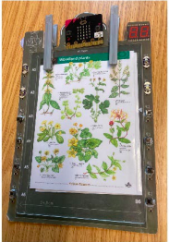 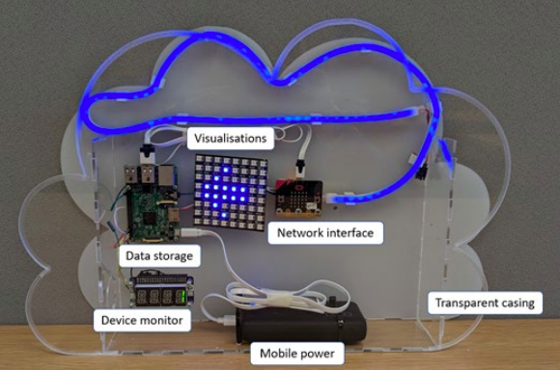

**A B**

**Figure 1:** Clip:bit paper prototype (**A**), the Classroom Cloudlet (**B**)

While the Classroom Cloudlet framework excels in facilitating data collection and storage, its current iteration lacks robust data visualisation capabilities. As highlighted by Underwood et al. (2022), “children and educators can connect to the cloudlet over a Wi-Fi hotspot or through the school intranet into a web front end”. This front end consists of “two pie charts” that “animate as they change”. This indicates that while some visualisation features are present, they may not be sufficient for comprehensive data analysis. Without proper visualisation capabilities, educators and students may struggle to derive meaningful insights from the data, hindering the educational value of the Classroom Cloudlet.

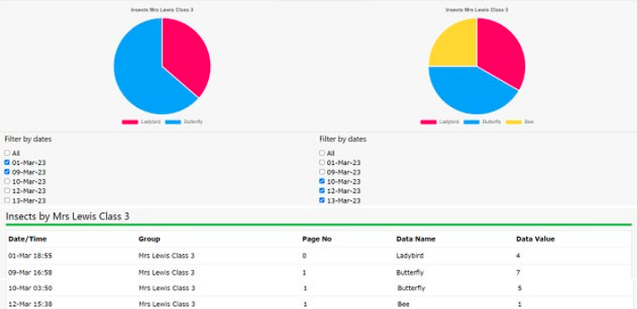

**Figure 2:** The cloudlet's current web front end

### 2.2 Why Data Visualisation would be beneficial

The integration of a data visualisation toolkit within the Classroom Cloudlet framework offers several benefits. Firstly, data visualisation enhances the interpretability of sculpted datasets by presenting information in intuitive and interactive formats. Visual representations such as charts, graphs, and diagrams enable educators and students to identify patterns, trends and relationships within the data more effectively.

Moreover, the absence of data visualisation functionalities hampers the framework's ability to support cross-curricular learning opportunities. Effective visualisation techniques can bridge various subjects, allowing students to explore connections between environmental data, mathematics, and geography, among others. By visualising data in intuitive and interactive formats, the Classroom Cloudlet can enhance interdisciplinary learning experiences and foster deeper engagement with IoT concepts.

In summary, while the Classroom Cloudlet framework offers a promising platform for hands-on IoT education, its full potential can only be realised with the integration of robust data visualisation capabilities. Incorporating data visualisation tools into the framework will not only enrich the learning experience but also empower students and educators to derive meaningful insights from IoT-generated data, thereby advancing data literacy and fostering a deeper understanding of complex systems.

## 2.2 Energy in Schools

In "Energy in Schools: Promoting Global Change Through Socio Technical Deployments" by Kathy New et al., (2019), the authors present an innovative IoT solution designed to “combine(s) real-time smart energy metering, IoT sensing, and curriculum-aligned learning materials". By using sensors and the BBC micro:bit, students and teachers can interact with data produced by sensors and smart meters, engaging in educational activities to solve real-world problems related to energy consumption.

### 2.2.1 Data Visualisation’s role

"The platform includes visual displays that provide real-time statistics on school performance regarding energy consumption," notes New et al. Additionally the micro:bit, equipped with various sensors, allows students to react to changes in data, interact with building sensors and investigate stored data. Through block-based programming experiences, students can visualise and analyse energy consumption patterns, fostering a deeper understanding of energy efficiency.

### 2.2.2 The Advantages of using Data Visualisation

* **Engaging Educational Experience:** According to New et al., "The use of the BBC micro:bit as an educational tool makes learning about energy consumption interactive and engaging for students." It introduces concepts of computer science in a fun and accessible manner.
* **Empowering Students and Teachers:** "The platform empowers students and teachers by providing them with agency in managing energy consumption," New et al. highlight. Students can become "energy champions" for their schools, actively participating in energy-saving initiatives.
* **Real-time Monitoring and Feedback:** As per New et al., "Visual displays offer real-time feedback on energy consumption, enabling students and teachers to make informed decisions to reduce energy usage." This immediate feedback fosters a culture of energy conservation within schools.
* **Cross-Curricular Learning:** "The platform facilitates cross-curricular learning by integrating concepts of energy efficiency into various subjects," emphasises New et al. Students can apply knowledge from different disciplines to address real-world challenges related to energy conservation.

### 2.2.3 Implementation into the Classroom Cloudlet

To implement these advantages in our data visualisation toolkit for the Classroom Cloudlet, we will aim to also create an engaging and educational experience, empowering students to take the lead in creating visualisations that provide real-time feedback and can be displayed on big screens in schools as proven by the Energy in Schools initiative. By integrating similar weather data visualisations into our Classroom Cloudlet toolkit, we aim to foster a deeper understanding of environmental patterns and their effects on daily activities. Empowering students to lead in creating these visualisations not only enhances their learning experience but also instils a sense of ownership and responsibility for the displays.

# 3 Design

This section of the report elucidates the design considerations and the actual implementation of the Data Visualisation Toolkit for the Classroom Cloudlet. The design process involves conceptualising the system's architecture, user interface, and interaction, while the implementation phase details the construction of the system using coding practices, libraries, and tools.

## 3.1 Requirements

Requirements for the data visualisation toolkit include both functional features and non-functional aspects important for its performance, usability, and security that are outlined below.

### 3.1.1 Functional Requirements

**Data Visualisation:**

* The system shall display weather data such as temperature, wind speed and precipitation.
* Users shall be able to choose from a variety of visualisation options.
* Users should be able to select specific parameters to visualise and compare on the charts.

**Interactive Visualisation:**

* Users shall be able to hover over data points to view detailed information about the weather at that time.
* The system should provide interactive charts that allow users to zoom in/out and pan to focus on specific time intervals.

**Real-time Updates:**

* The system shall fetch real-time weather data from external APIs or create mock data to mimic the data flow from the Classroom Cloudlet, ensuring up-to-date visualisation.

**Customisation Options:**

* Users shall be able to customise the appearance of the charts, including colours, labels and chart types.
* The system shall allow users to save their customisation preferences for future sessions.

**Cross-platform Compatibility:**

* The system shall be accessible on multiple platforms, including desktops, laptops, tablets, and mobile devices.
* Users shall have a consistent experience across different devices and screen sizes.

**Data Export:**

* Users shall have the option to export visualised weather data in various formats, such as CSV or PDF.

### 3.1.2 Non-Functional Requirements

**Performance:**

* The system shall load and render weather data visualisations within a reasonable timeframe, even with large datasets.
* Response times for user interactions such as zooming and panning shall be minimal to ensure a smooth user experience.

**Scalability:**

* The system shall be capable of handling a large volume of concurrent users without significant degradation in performance.
* It shall scale seamlessly to accommodate increasing data loads and user traffic.

**Usability:**

* The system shall have an intuitive user interface with clear navigation and descriptive labels for ease of use.
* Help documentation and tooltips should be provided to assist users in understanding the features and functionalities of the system.

**Accessibility:**

* The system shall comply with accessibility standards such as WCAG (Web Content Accessibility Guidelines) to ensure that it is usable by people with disabilities.

## 3.2 Design

### 3.2.1 System Architecture

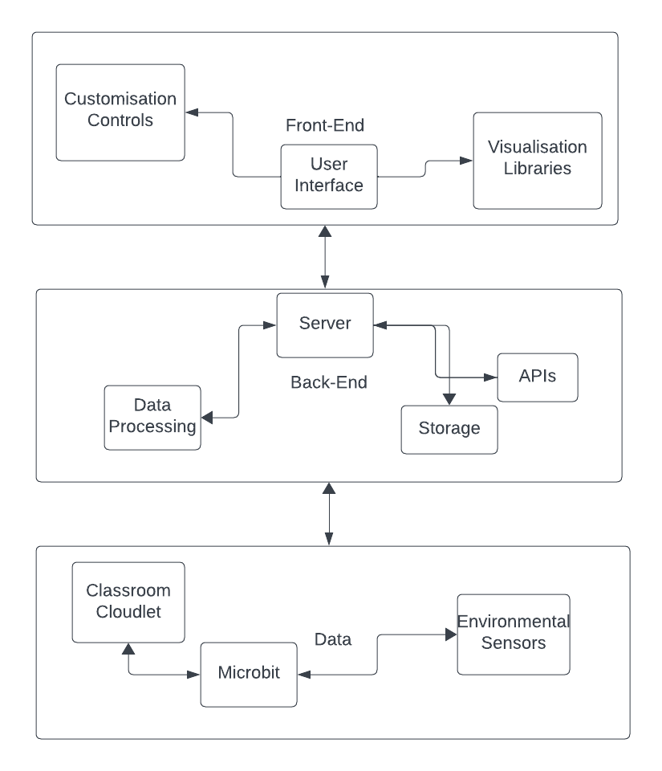

**Figure 3:** System Architecture Diagram

**Front-End:**

* **User Interface (UI):** This is where users, such as students and teachers, interact with the toolkit. The UI includes elements for, selecting datasets, creating and customising visualisations, and saving or sharing results. It's designed to be user-friendly and intuitive, suitable for the targeted age group.
* **Visualisation Modules:** Integrates charting libraries like Chart.js and D3.js to render visual representations of the data. This module would allow for a range of visualisations from simple bar charts to more complex scatter plots, depending on the complexity of the data and user needs.
* **Customisation Controls:** These UI components enable users to change visual aspects of the charts and graphs, such as colour schemes, graph types and animation speeds.

**Back-End:**

* **Server:** The back-end server processes HTTP requests from the front end, interacts with the data storage to retrieve or save data and performs any necessary data processing or transformations.
* **APIs:** A series of endpoints that provide the front-end with access to server-side functions and data.
* **Data Processing Module:** Depicting the logic that transforms raw data into a format suitable for visualisation.
* **Storage:** Representing the databases or file systems where data is stored, both for raw datasets and user-generated content.

**Data Layer:**

* The flow of data from the Classroom Cloudlet made up of IoT devices and their sensors.

### 3.1.4 Human-Computer Interaction

The design and development of the toolkit are deeply informed by key principles of Human-Computer Interaction (HCI) to create an ideal user experience.

**Consistency:** Consistency in design allows users to transfer knowledge from one part of the toolkit to another, minimizing the learning curve and reducing potential confusion. By using familiar icons, consistent colour coding, and predictable navigation paths, users can interact with the toolkit more intuitively.

**Feedback:** Providing immediate and clear feedback for user actions is crucial. Whether adjusting settings, manipulating the interactive clock, or uploading content, the toolkit gives visual or auditory confirmation that the user's action has been received and processed.

**Simplicity:** The complexity of weather data is portrayed by simple and understandable visualisations. The interface focuses on essential elements to make the experience more pleasant and less overwhelming for users.

**Affordance:** Interactive elements are designed to suggest how they should be used. For example, buttons are designed to look pressable, and draggable items have cues to suggest movement. These affordances help users understand how to interact with the toolkit without explicit instructions.

**Minimalist Design:** The information presented is relevant to the task at hand, avoiding unnecessary details that do not support user tasks. This minimalist approach helps in creating a clean interface that users can interact with without distraction.

By incorporating these principles, the toolkit ensures a user-centred design focused on the needs of its users, making data visualisation more accessible and enjoyable experience.

# 

# 4 Implementation

The implementation phase of the Classroom Data Visualisation Toolkit involved a step-by-step approach to convert the requirements and the software architecture into a functioning system. This section describes the methodologies and technologies used, alongside the coding standards and version control practices used to create the final product.

## 4.1 How to run the Toolkit

1) In terminal, navigate into the project folder

2) Run the command ‘node server.js’

3) Open your browser of choice and search ‘http://localhost:3000/’

4) Choose a data visualisation option and wait a couple of seconds for it to load

5) Enjoy!

## 4.2 Technology Stack

**Front-End:**

* HTML5, CSS3, and JavaScript for building the interactive UI.
* Chart.js and D3.js for dynamic data visualisation components and animations.

**Back-End:**

* Node.js as the runtime environment with Express.js framework for managing server-side logic and HTTP requests.

**Development Tools:**

* Git for version control.
* NPM (Node Package Manager) for managing dependencies.
* Visual Studio Code or WebStorm equipped with breakpoints for efficient debugging.

## 4.3 The Development Process

A combination of Agile and Test-Driven Development methodologies guided the development process. Iterative weekly sprints and regular stand-up meetings with both my project supervisor and the creator of the Classroom Cloudlet ensured the project adapted to changing requirements and allowed for continuous progress.

## 4.4 Code Structure

The codebase was organised into modular components for ease of maintenance and scalability:

1. User Interface (UI) Layer

* **Purpose:** Provides the graphical interface for user interaction.
* **Components:**
* **Weather Control Panel:** Allows users to select weather conditions to display.
* **Time Control Panel:** Enables setting and advancing the simulated time.
* **Visualisation Area:** The main display where weather and celestial animations occur.
* **Adjustment Sliders:** For customising animation speeds and other parameters.

2. Simulation Control Module

* **Purpose:** Manages the logic for simulating time and weather conditions.
* **Components:**
* **Time Simulation:** Handles the progression of simulated time and triggers updates to celestial body positions and lighting conditions.
* **Weather Simulation:** Dynamically changes weather conditions based on user selections or predefined scenarios.

3. Animation and Rendering Module

* **Purpose**: Generates and animates visual representations of weather conditions and celestial bodies.
* **Components:**
* **Celestial Bodies:** Manages animations for the sun and moon, adjusting their positions according to the simulated time.
* **Weather Effects:** Creates animations for rain, snow, clouds, and other effects based on the current weather simulation state.
* **Sky Background:** Adjusts the color and gradient of the background to reflect time of day and weather conditions.

4. Data Management Module

* **Purpose:** Stores and updates simulation data, including time, weather conditions, and user preferences.
* **Components:**
* **State Management:** Maintains the current state of the simulation, including time and active weather conditions.

**User Preferences:** Records user inputs from sliders and control panels for personalised simulation behaviour.

5. Event Handling Module

* **Purpose:** Processes user interactions and system events, triggering updates across the system.
* **Components:**
* **UI Event Listeners:** Captures and processes user inputs, such as slider adjustments and button clicks.
* **Simulation Event Triggers:** Initiates updates to the simulation based on time progression or user-defined events.

Following integration with the Classroom Cloudlet:

6. Classroom Cloudlet

* **Purpose:** Acts as a localised data centre, collecting and processing real-time environmental data from classroom-specific sensors or localized weather stations.
* **Components:**
* **Data Collection Module:** Gathers sensor data, including temperature, humidity, wind speed.
* **Data Processing Module:** Cleanses and structures data for integration with the weather simulation system.
* **Communication Module:** Provides APIs for data transmission to and from the cloudlet, ensuring up-to-date information for simulations.

### 4.4.1 System Flow

1. **Initialisation:** Upon loading, the system initialises the UI components and displays the default or user-specified simulation state.
2. **User Interaction:** Users interact with the control panels and sliders to select weather conditions and adjust simulation parameters.
3. **Simulation Update:** Based on user inputs and the progression of simulated time, the Simulation Control Module updates the simulation state.
4. **Visualisation Update:** The Animation and Rendering Module receives updates from the Simulation Control Module and renders the current state onto the Visualisation Area.
5. **Continuous Loop:** The system continuously updates the simulation and visualisation based on time progression and user interactions.

### 4.4.2 Data Flow

* Data flows from the user inputs through the UI Layer to the Simulation Control Module, where the logic determines the necessary updates.
* The Simulation Control Module communicates with the Data Management Module to store and retrieve the current state.
* The Animation and Rendering Module accesses the updated state to visualise the simulation accurately.
* Event Handling Module orchestrates the interaction between user actions and system responses, ensuring a responsive and dynamic simulation environment.

### 4.4.3 Data Flow following Integration with Classroom Cloudlet

1. **Initialisation & Configuration:** The system retrieves initial settings and user preferences from the Data Storage through the User Management Service. Simultaneously, it establishes a connection with the Classroom Cloudlet to fetch real-time weather data.
2. **Real-Time Data Integration:** The Weather Data Service periodically queries the Classroom Cloudlet for the latest environmental readings. This data is processed and translated into parameters understandable by the Simulation Control Module.
3. **Simulation Adjustment:** Based on real-time data and user inputs, the Simulation Control Module updates the simulation's state. This includes adjusting weather conditions, time of day, and celestial body positions to reflect actual environmental conditions.
4. **Visualisation:** The updated simulation state is sent to the Animation and Rendering Module, where it's visually represented in the UI. This process involves dynamically generating weather effects, moving celestial bodies, and altering sky colors.
5. **User Interaction:** Users can interact with the UI to change simulation parameters or query historical data. These interactions are processed by the Event Handling Module, which adjusts the simulation in real-time or fetches data from the server as needed.
6. **Continuous Synchronisation:** The system continuously syncs with the Classroom Cloudlet to ensure the simulation reflects current weather conditions. Additionally, user settings and simulation states are periodically saved to the Data Storage for persistence and analysis.

## Key Implementation Details

### 4.5.1 The Weather Data

In order to simulate live weather data being constantly feeded into the toolkit from the Classroom Cloudlet, I have created the generateRealisticData(hour) function that manipulates the mock data based on the time of day represented by the hour parameter.

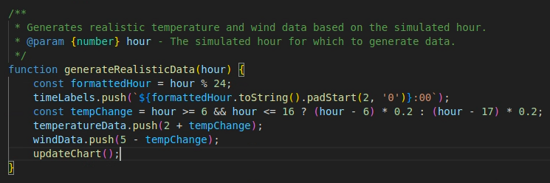

**Figure 4:** JavaScript function that generates the mock weather data

Temperature and wind data are calculated differently depending on the time of day, with specific thresholds determining the simulated weather condition—sunny, cloudy, rainy, or snowy. For instance, the base temperature starts at 2°C in the morning, increasing or decreasing by 0.2°C for every hour past 6 AM or 5 PM, respectively. This results in a gradual change in temperature that mimics the natural rise and fall over the course of a day. A similar approach is taken for wind speed, starting at 5 mph and adjusting in accordance to the time of day.

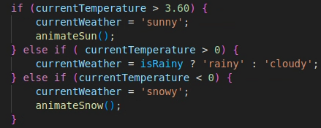

**Figure 5:** JavaScript code that simulates the weather type

The decision to simulate sunny, rainy or snowy weather is determined by the final calculated temperature. If the temperature exceeds 3.6°C, the weather is considered sunny. If the temperature is above 0°C but does not exceed 3.6°C, the weather could be either rainy or cloudy; this is decided by a random chance, reflecting the unpredictable nature of rain. If the temperature falls below 0°C, the weather is classified as snowy, simulating a winter scenario.

This approach to simulating weather data is designed to allow easy integration with live data feeds in a real-world application. By structuring the simulation around temperature thresholds and time-based changes, the system can be adapted to use actual data collected by the Classroom Cloudlet, offering an accurate and dynamic representation of current weather conditions.

### 4.5.2 Time Simulation

The central theme of the interactive weather visualization toolkit revolves around the concept of time and its intrinsic link to weather patterns and conditions. Time progression within the toolkit is simulated through a combination of visual elements, animations, and interactive components. This is easily visible by the simulated information core and clock visualisation on the top corners of the screen. As time advances, the toolkit updates the weather data and animations accordingly, transitioning smoothly from morning to night. This progression influences the entire web page, from the background animations in the Showcase Area to the available weather elements in the Art Studio.

**How Each Hour Is Simulated**:

At the heart of time simulation, the toolkit uses the simulateTimeProgression() function that operates on a loop, incrementally advancing the simulated hour. With each tick, corresponding to a predefined interval (currently every 10 seconds for demonstration purposes), the current hour variable is incremented. This incrementation triggers a series of updates across the toolkit:

1. **Weather Data Generation:** For each new simulated hour, the toolkit generates realistic temperature and wind data based on time-specific patterns. Morning hours might show a gradual increase in temperature as the world warms up with the sunrise, while wind speeds might vary depending on the time of day, reflecting typical daily wind patterns.
2. **Background Animation Updates:** Depending on the hour, the toolkit's background animations change to mirror real-world conditions. Sunrises and sunsets trigger vibrant colour changes in the sky, nights are illustrated with a darker palette and possibly stars, and the position of the sun or moon is adjusted to reflect their path across the sky.
3. **Weather Visualisation Updates:** The simulated weather conditions (sunny, rainy, snowy, or cloudy) are determined by the generated temperature data and a chance mechanism for precipitation. A warmer temperature might result in sunny weather visuals, while specific temperature thresholds combined with random chance elements could trigger rain or snow animations, simulating the unpredictability of weather.
4. **Interactive Clock Adjustments:** The interactive clock visualisation is directly synced with the simulated hour, ensuring that the clock's display is always in harmony with the current time being simulated. This visual representation allows users to observe the passage of time in a more engaging and intuitive manner.

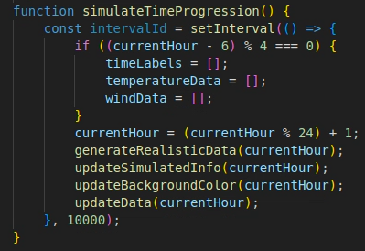

**Figure 6**: JavaScript function that simulates the progression of time

Additionally, users can also drag the hands of the clock to change the time to whichever hour they wish, also triggering the immediate updates across the system. This allows for an interactive experience where the changes in time are not just observed but can be actively controlled, providing a sense of engagement with the passage of time and allowing weather data hours apart to be compared at the click of a button.

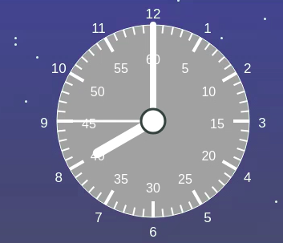

**Figure 7:** The draggable clock

### 4.5.3 The Weather Art Studio

The Art Studio is an exciting section where users can select different weather scenes—sunny, cloudy, rainy, and snowy—to create weather-themed art that can be dragged and dropped onto a canvas to compose a scene. Each weather condition requires specific elements corresponding to the selected scene, such as suns and clouds for a sunny day or raindrops and puddles for a rainy scene. Users can upload their own drawings or images to integrate personal artwork with the simulated weather elements, promoting creativity and personal expression.

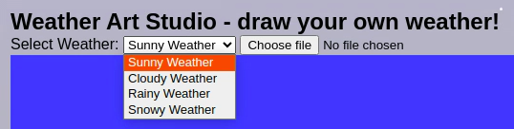

**Figure 8**: the Weather Studio’s available conditions

### 4.5.4 The Showcase Area

The Showcase Area is where the created art comes to life, animated according to the current simulated weather data. This area dynamically updates to reflect changes in the weather simulation, altering its background and animating elements like falling raindrops or drifting snowflakes to match the selected weather scene. For example, if the simulated data indicates snowy weather, the Showcase Area will display snowflakes gently falling across the screen, while a sunny scenario might animate sun rays shining across the canvas.



**Figure 9:** An example of light snow displayed on the Showcase Area

## 4.6 Challenges and Solutions

The existing framework of the toolkit has been designed to simulate temperature and wind data, which inadvertently correlates higher temperatures with sunny conditions. This presents a challenge because it assumes a direct causation between temperature and sunlight, a reflection not entirely accurate within real-world meteorological patterns. For instance, high temperatures can occur in conditions that are overcast or even during rain if certain atmospheric pressures are at play.

To address this challenge a more nuanced approach is necessary, integrating a broader set of environmental variables such as humidity, atmospheric pressure and cloud cover data. This additional data can provide a more comprehensive and realistic simulation of weather conditions.

Furthermore, the current system's limitation of representing only a single weather condition at a time is a simplification that fails to capture the complexity of natural weather phenomena, where multiple conditions can coexist, such as during a rain storm. To overcome this limitation, a layered system that allows for the combination of different weather representations could be implemented, such as weighted probabilities or a decision matrix.

Implementing these solutions would involve extending the data model and possibly the user interface to allow for more sophisticated interactions and representations. However, these improvements would significantly enhance the educational value of the toolkit, providing users with a realistic and interactive learning environment.

# 4 Evaluation Methodology

The evaluation of the data visualisation toolkit for the Classroom Cloudlet involved a demonstration session followed by feedback collection from the creator of the Classroom Cloudlet. The methodology includes the setup, demonstration procedure, feedback collection and analysis of feedback on the findings from the session.

## 4.1 Setup of the Specialist Interview

The evaluation took place in a quiet and well-lit space suitable for software demonstration. A computer with internet access was set up with the toolkit, and the session was voice recorded for reference and analysis purposes.

## 4.2. Demonstration Procedure

The creator of the Classroom Cloudlet was provided with a detailed demonstration of the data visualisation toolkit. The demonstration involved showcasing the features and functionalities of the toolkit including its user interface, data visualisation options, customisation capabilities and possible integration with the Classroom Cloudlet platform. The creator was encouraged to interact with the toolkit, explore its various components and ask questions for clarification.

## 4.3. Feedback Collection

Following the demonstration, structured feedback was collected from the creator of the Classroom Cloudlet through a verbal interview. The interview process focused on various aspects of the toolkit, including:

* **Ease of Use**: How intuitive and user-friendly the toolkit interface was perceived to be.
* **Functionality:** The toolkit's ability to meet the intended objectives and requirements, including its suitability for integration with the Classroom Cloudlet.
* **Performance:**

How smoothly the toolkit operated when generating visualisations

* **Alignment with Objectives:** How well the toolkit aligned with the creator's objectives for the Classroom Cloudlet project.
* **Suggestions for Improvement:** Suggestions and recommendations for enhancing the toolkit's features, usability and integration with the Classroom Cloudlet.

## 4.2 Analysis of Feedback

The feedback provided by the creator of the Classroom Cloudlet offers valuable insights into the usability, functionality, alignment with objectives, and areas for improvement of the toolkit. Here is a breakdown of the analysis based on the feedback received:

### 4.2.1 Ease of Use

The creator praised the simplicity and intuitiveness of the toolkit, particularly appreciating the layout on a single page and the inclusion of an overarching clock control. This positive assessment indicates that the toolkit's design resonates well with the intended user base of children aged 9 to 10.

4.2.2 Functionality

While the functionality of the toolkit was generally well-received, there were suggestions for enhancements. The creator highlighted the need for additional visualisations beyond temperature-based ones, suggesting the incorporation of weather conditions like rain, cloud cover and wind speed. This feedback underscores the importance of expanding the toolkit's features to provide a more comprehensive representation of weather data.

### 4.3.3 Performance

The feedback did not indicate any major technical issues or disruptions during the demonstration apart from the initial delay of the time simulation upon loading the web page. The toolkit operated smoothly, contributing to a positive user experience.

### 4.3.4 Alignment with Objectives

The creator expressed satisfaction with how the toolkit aligned with the objectives of the Classroom Cloudlet project. The toolkit effectively enables children to visualise and analyse their data, fostering engagement and ownership. Additionally, the creator appreciated the toolkit's innovative features, such as allowing children to customise visualisation colours, which enhance the educational value and appeal to young learners.

### 4.3.5 Suggestions for Improvement

The feedback provided valuable suggestions for improving the toolkit's functionality and complexity. Specifically, the creator raised concerns about the use of the radar chart as one of the visualisations, stating that it was too complicated for children to understand and analyse. Furthermore, there were considerations about integrating the toolkit seamlessly into the Classroom Cloudlet environment, emphasising the importance of compatibility and ease of use within existing educational frameworks.

Overall, the feedback analysis indicates a positive reception of the toolkit's design and functionality, along with insightful suggestions for future enhancements to further enrich the user experience and educational value. These insights could inform the ongoing development and refinement of the Classroom Cloudlet toolkit to better meet the needs and expectations of its target users.

# 5 Conclusion

## 5.1 Review of Project Aims

The primary objective of this project was to design and implement a data visualisation toolkit specifically for the Classroom Cloudlet platform to encourage data literacy among children. This toolkit was envisioned to make the process of understanding and interacting with weather data collected from Micro:Bit and Raspberry Pi devices engaging and intuitive, without the need for JavaScript knowledge. The project successfully integrates various data visualisation techniques and tools, including interactive charts and drawing studios, into a platform beneficial for education, resonating with the project's vision of making data visualisation accessible and fun.

## 5.2 Evaluation and Feedback Integration

Feedback from the creator of the Classroom Cloudlet indicated that the toolkit was user-friendly and aligned well with the project's educational objectives. However, recommendations were made to include a wider array of weather conditions and to simplify certain visualisations such as radar charts to suit the target age group better. This constructive feedback is pivotal for future iterations, ensuring the toolkit remains effective and relevant for educational purposes.

## 5.3 Future Enhancements

To enhance the toolkit's functionality, future work could focus on expanding the range of visualisations, improving real-time capabilities and ensuring seamless integration with the Classroom Cloudlet. There is also an opportunity to incorporate gamification elements to make the learning process even more engaging for children.

## 5.4 Reflection on Learning and Development

This project has been a learning curve, requiring an in-depth understanding of both technical aspects and educational theories. It provided insight into the importance of data literacy in early education and emphasised the need for tools that can translate complex data into formats that are easily comprehensible by children.

## 8.6 Final Thoughts

The Data Visualisation Toolkit for the Classroom Cloudlet proves the potential and benefits of combining technology and education. As data continues to play a significant role in our daily lives, initiatives like the Classroom Cloudlet, Energy in Schools and this toolkit become increasingly important in preparing future generations to navigate a data-driven world confidently.

# References

Pop, R. (2021) *Who Will Shape the Future of Data Visualization? Today’s Kids!* Available at:

<https://medium.com/nightingale/who-will-shape-the-future-of-data-visualizations-todays-kids-75d1111d346e>

Rogers, S. (2014) *Infographics for children: what they can learn from data visualisations* Available at: https://www.theguardian.com/news/datablog/2014/mar/07/infographics-for-children-can-learn-from-data-visualisations

[Underwood, L](https://www.research.lancs.ac.uk/portal/en/people/lorraine-underwood(108bc2f4-bc23-47d6-a125-afc66ab0b280).html).[, Edwards, L](https://www.research.lancs.ac.uk/portal/en/people/liz-edwards(0c432ee4-25a2-4b34-b15b-24e2595a5335).html).[, Vidler, J](https://www.research.lancs.ac.uk/portal/en/people/john-vidler(ddf321a9-0869-43b5-9b95-4821b1793ab0).html).[, Rubegni, E](https://www.research.lancs.ac.uk/portal/en/people/elisa-rubegni(8937633b-b6d1-41df-8547-5df7a8de992a).html).[& Finney, J](https://www.research.lancs.ac.uk/portal/en/people/joe-finney(d0ef7f4d-a300-4968-be13-557f19e14d51).html). (2023), [*Introducing Classroom Cloudlet: a mobile, tangible, and transparent approach to Internet of Things education*](https://www.research.lancs.ac.uk/portal/en/publications/introducing-classroom-cloudlet(ccfc4480-447e-4e24-acd1-1e2db60bcf60).html)*.* in Proceedings of IDC 2023 - 22nd Annual ACM Interaction Design and Children Conference: Rediscovering Childhood. Proceedings of IDC 2023 - 22nd Annual ACM Interaction Design and Children Conference: Rediscovering Childhood, ACM, New York, pp. 740-744. [**https://doi.org/10.1145/3585088.3594487**](https://doi.org/10.1145/3585088.3594487)

[Underwood, L](https://www.research.lancs.ac.uk/portal/en/people/lorraine-underwood(108bc2f4-bc23-47d6-a125-afc66ab0b280).html)., Smith, K.[, Rubegni, E](https://www.research.lancs.ac.uk/portal/en/people/elisa-rubegni(8937633b-b6d1-41df-8547-5df7a8de992a).html).[& Finney, J](https://www.research.lancs.ac.uk/portal/en/people/joe-finney(d0ef7f4d-a300-4968-be13-557f19e14d51).html). (2022), [*Energy in Schools: Empowering Children to Deliver Behavioural Change for Sustainability*](https://www.research.lancs.ac.uk/portal/en/publications/energy-in-schools(c15aa1c5-407d-4f7e-9d01-bbbfe0ccdce6).html)*.* in Proceedings of Interaction Design and Children, IDC 2022. Proceedings of Interaction Design and Children, IDC 2022, ACM, New York, pp. 308-314. [**https://doi.org/10.1145/3501712.3529744**](https://doi.org/10.1145/3501712.3529744)

[Underwood, L](https://www.research.lancs.ac.uk/portal/en/people/lorraine-underwood(108bc2f4-bc23-47d6-a125-afc66ab0b280).html).[, Edwards, L](https://www.research.lancs.ac.uk/portal/en/people/liz-edwards(0c432ee4-25a2-4b34-b15b-24e2595a5335).html).[, Vidler, J](https://www.research.lancs.ac.uk/portal/en/people/john-vidler(ddf321a9-0869-43b5-9b95-4821b1793ab0).html).[, Finney, J](https://www.research.lancs.ac.uk/portal/en/people/joe-finney(d0ef7f4d-a300-4968-be13-557f19e14d51).html).[& Rubegni, E](https://www.research.lancs.ac.uk/portal/en/people/elisa-rubegni(8937633b-b6d1-41df-8547-5df7a8de992a).html). (2023), [*Supporting fieldwork for primary education with computing - micro:bit, clip:bit and game controllers*](https://www.research.lancs.ac.uk/portal/en/publications/supporting-fieldwork-for-primary-education-with-computing--microbit-clipbit-and-game-controllers(90d293d1-8cf0-433c-83a2-71ee819d0baa).html)*.* in Proceedings of IDC 2023 - 22nd Annual ACM Interaction Design and Children Conference: Rediscovering Childhood. Proceedings of IDC 2023 - 22nd Annual ACM Interaction Design and Children Conference: Rediscovering Childhood, ACM, pp. 553-557. [**https://doi.org/10.1145/3585088.3593897**](https://doi.org/10.1145/3585088.3593897)

[New, K](https://www.research.lancs.ac.uk/portal/en/people/kathy-new(0d47583f-2403-47d8-8581-e7497680dec7).html)[, Devine, J](https://www.research.lancs.ac.uk/portal/en/people/james-devine(516b2f25-8c9b-413c-837a-d9b61ff2edd2).html)[, Woodcock, T](https://www.research.lancs.ac.uk/portal/en/people/taylor-woodcock(3b26ec77-3336-4ada-a8a0-76c57516681d).html)[, Beck, S](https://www.research.lancs.ac.uk/portal/en/people/sophie-beck(793a43b9-ca47-47fa-8591-2da8aa0cbf47).html).[, Finney, J](https://www.research.lancs.ac.uk/portal/en/people/joe-finney(d0ef7f4d-a300-4968-be13-557f19e14d51).html).[, Hazas, M](https://www.research.lancs.ac.uk/portal/en/people/mike-hazas(101d20d6-0993-4d69-9a4e-033cd352493b).html)., Banks, N., Smith, K. & Bailey, T. (2019), [*Energy in Schools: Promoting Global Change through Social Technical Deployments*](https://www.research.lancs.ac.uk/portal/en/publications/energy-in-schools(47b3421c-8433-435c-a9e6-dbaebe6bb39c).html). in Living in the Internet of Things. IET.

# Appendix A - Project Proposal

## Introduction

The proposed project reported in this paper will aim to develop a user-friendly Data Visualisation Toolkit for the Classroom Cloudlet. In today's data-driven world, the ability to collect, analyse and communicate data is a vital skill. The aim is to offer children an innovative platform for exploring and creatively visualising data gathered through Micro:Bit and Raspberry Pi devices, all without needing to know any JavaScript. By harnessing the potential of Classroom Cloudlet, the project seeks to offer an educational toolkit that not only simplifies data visualisation but also transforms the learning experience for children.

## Objectives

* Develop a user-friendly toolkit for educational data exploration and visualization.
* Allow data to be exported out of the Raspberry Pi and access it with the toolkit
* Provide diverse options for displaying data: bar charts, pictograms, maps, interactive pie charts, line charts, scatter plots, animations, illustrations etc
* Allow customisation in terms of colours, fonts, labels etc
* Allow visualisations to be saved, shared and showcased

## Methodology

The software engineering approach used will be similar to the Agile development process using 5-week cycles, allowing adaptability to changing requirements that are common in student-led projects.

For the research, a sample of 10 participants will be selected. Using 10 participants will allow for confident and reliable evaluation results to be concluded within the study. The user must fill out the appropriate ethics forms, i.e. the participant information sheet and agreement form so that they know the nature of the study and the types of data to be stored by the application. To make people aware of the study and therefore gain study participants, advertisements such as fliers and emails will be dispersed within the Lancaster area.

**Quantitative Phase: Toolkit Functionality Testing:**

In the quantitative phase, the toolkit's functionality will be tested to ensure its effectiveness in data visualization. This phase involves systematic testing of various features and capabilities, including:

* **Usability Testing**: Participants will be given specific tasks to perform using the toolkit, evaluating its user-friendliness, and identifying any potential usability issues
* **Export-Import Testing:** The process of exporting data from Raspberry Pi to the toolkit and importing it without error will be tested to guarantee smooth data transfer
* **Visualisation Options Testing:** Each visualisation option, such as bar charts, pictograms, maps etc will be individually tested for accuracy and functionality
* **Customisation Testing:** Customisation features, such as adjusting colours, fonts, and labels, will be tested to ensure flexibility.
* **Save and Share Testing:** The toolkit's ability to save, share, and showcase visualizations will be examined to confirm its reliability and ease of use

**Qualitative Phase: User Experience and Feedback Collection**

The qualitative phase aims to gather detailed insights into the user experience and thoughts on the toolkit. This phase involves:

* **User Interviews:** Conducting interviews with a diverse group of users, including children and educators, to understand their experiences, and suggestions for improvement
* **Observational Studies:** Observing users as they interact with the toolkit to identify any unanticipated issues
* **Feedback Collection:** Encouraging users to provide feedback on their overall experience

**Proposed Analysis:**

* **Quantitative Analysis:** Using statistical measures to analyse quantitative data gathered, such as performance metrics, success rates, and time taken for different tasks.
* **Qualitative Analysis:** Identifying common themes, challenges, and areas of improvement to categorise and interpret qualitative data.
* **Integration of Findings:** Combining quantitative and qualitative findings to present a comprehensive evaluation of the Data Visualization Toolkit for Classroom Cloudlet.

# Appendix B - Research Participant Consent Form



