**INFO 7390- Advance Data Science**

Case: Machine learning with Energy datasets

Course: INFO7390

Advance Data Science & Architecture

PROFESSOR:

Srikanth Krishnamurthy

Submitted By:

Team 8

Birwa Galia

Milony Mehta

Shantanu Deosthale

Table of Contents:

1. Introduction…………………………………………………………………………………………………………
2. Part 2: Exploratory Data Analysis…………………………………………………………………………
3. Part 3: Feature Engineering………………………………………………………………………………….
4. Part 4: Prediction Algorithm…………………………………………………………………………………
5. Part 5: Feature Selection………………………………………………………………………………………
6. Part 6: Model Validation and Selection…………………………………………………………………
7. Part 7: Final Pipeline…………………………………………………………………………………………….
8. Part 8: Report and Model development methodology………………………………………….

Part 2: Exploratory Data Analysis:

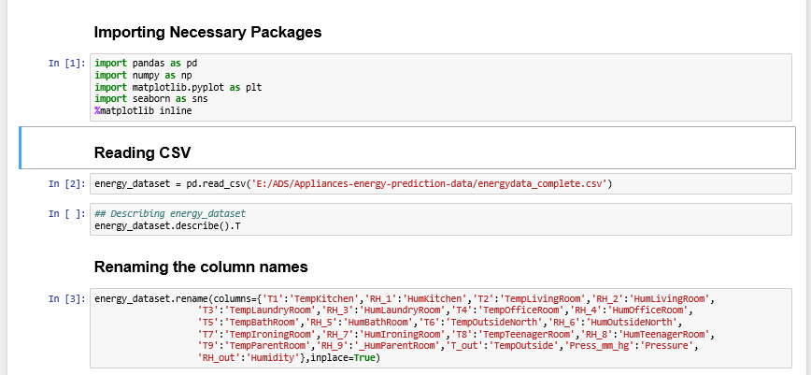

1. Importing Packages
2. Loading the CSV
3. Renaming the column name for better understanding and labels

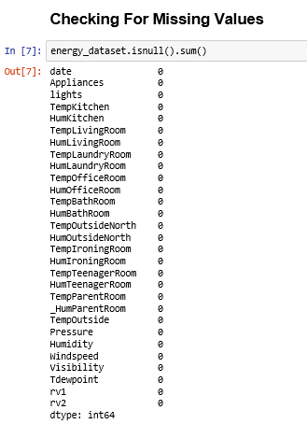

Checking for missing values. There were no missing values found.

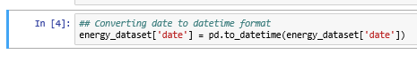

Converting the Object Date column to Datetime Format.

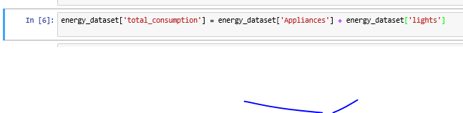

Forming new column “Time_Consumption” by adding Appliance and lights columns.

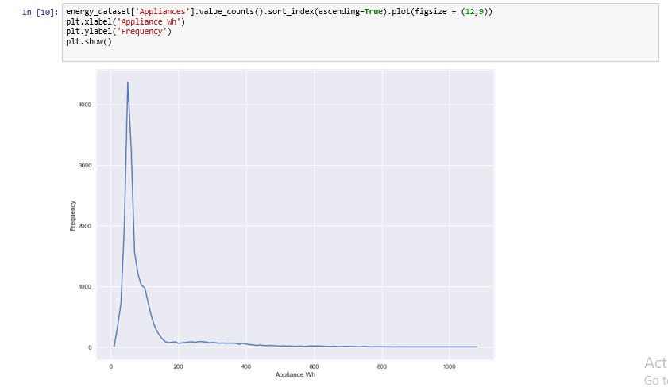

Frequency of Count of Appliances in Wh

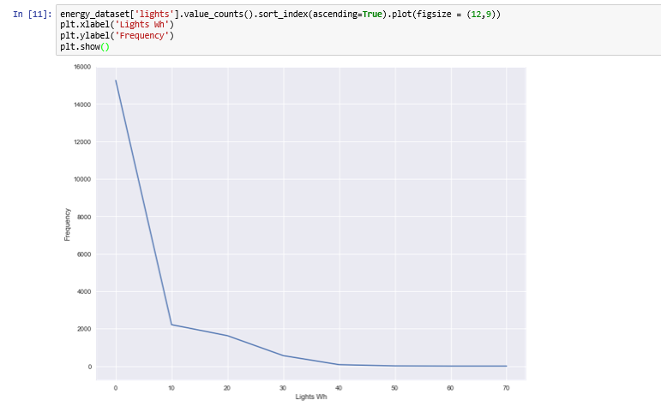

Frequency of Count of Lights in Wh

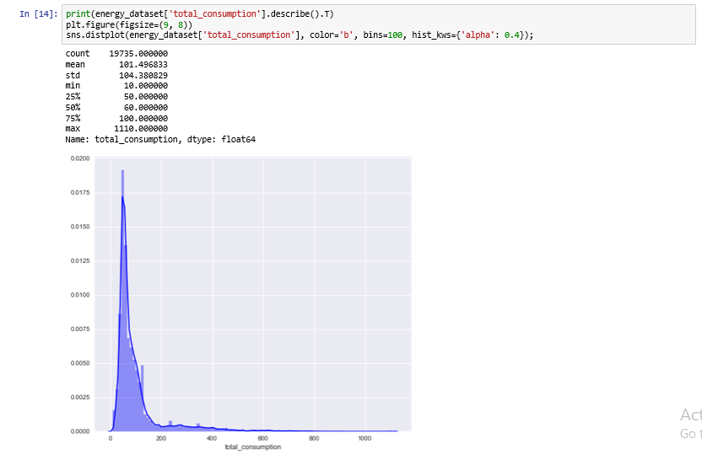

Distribution Plot of total consumption

A screenshot of a cell phone

Description generated with very high confidence

* Performing feature transformation, converting datetime format to Day, Month, hour, and NSM
* Using seaborn package, plotting stripplot for day vs total_consumption, Month vs total_consumption, hour vs total_consumption
* Stripplot is used to plot the categorical values.

A screenshot of a cell phone

Description generated with very high confidence

A screenshot of a cell phone

Description generated with very high confidence

A screenshot of a social media post

Description generated with very high confidence

Part 3: Feature Engineering:

We checked the data type of each column, converted the object type date to datetime and performed featuring transformation on date column.

A screenshot of a social media post

Description generated with very high confidence

The data was clean as there were no null values

A screenshot of a cell phone

Description generated with very high confidence

Calculating the correlation score

A screenshot of a cell phone

Description generated with very high confidence

Plotting the Heatmap using the correlation score.

A screenshot of a social media post

Description generated with very high confidence

From above heatmap, is it is clear that random variables and Visibility are not correlated to any of the remaining features thus, they can be removed

Part 4: Prediction Algorithms

After getting relevant features from Correlation, we used the obtained features and applied it to the LinearRegression, Random Forest, Neural Network with target variable as “Appliances” and obtained the following scores.

A screenshot of a cell phone

Description generated with very high confidence

As you can see from the scores, the r2_test and rmse_test score of Random Forest Regressor are better than LinearRegression and MLP_NeuralNetwork, we would recommend Random Forest Regressor as a model based on the features obtained from Correlation.

Part 5: Feature Selection

To get the importance of a feature we used Extra Trees Regressor

A screenshot of a social media post

Description generated with very high confidence

We got the scores as follows:

A screen shot of a social media post

Description generated with very high confidence

**Tpot Implementation:**

A screenshot of a cell phone

Description generated with very high confidence

With tpot implementation we received the best pipeline as ExtraTreesRegressor, and received the scores as follows:

A screen shot of a social media post

Description generated with very high confidence

**Boruta Implementation:**

A screenshot of a social media post

Description generated with very high confidence

With Boruta implementation, we received the following best features:

A screenshot of a cell phone

Description generated with very high confidence

With rank 1 as the best features and rest as Tentative or Rejected features.

We applied LinearRegression, Random Forest, Neural Network models on the features obtained by Boruta and received the scores as follows:

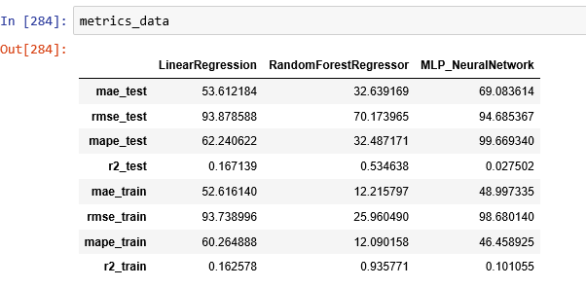

Stepwise Selection implementation:

A screenshot of a cell phone

Description generated with high confidence

It includes both forward selection and backward elimination.

A screenshot of a social media post

Description generated with very high confidence

We received the following features from stepwise selection.

We applied LinearRegression, Random Forest, Neural Network models on the features obtained by Stepwise Selection and received the scores as follows:

A screenshot of a cell phone

Description generated with very high confidence