CHAPTER 5
SCREENSHOTS
5.1 Peer Dialog on different plaforms
5.2 Text Messaging
5.3 Transfers
5.4 Multicast
5.5 Search
5.1 Peer Dialog on different platforms
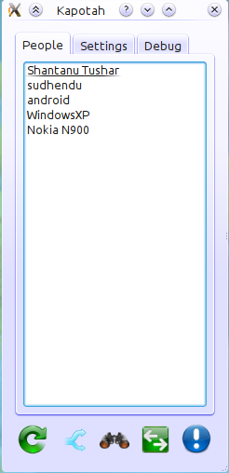
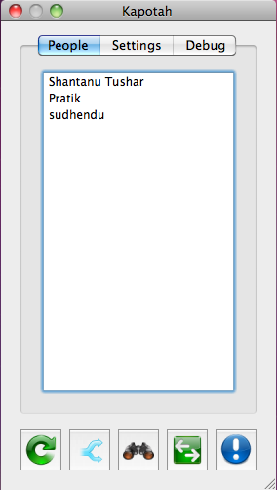
Fig 5.1 Kapotah on GNU/Linux
Fig 5.2 Kapotah on Mac OS X
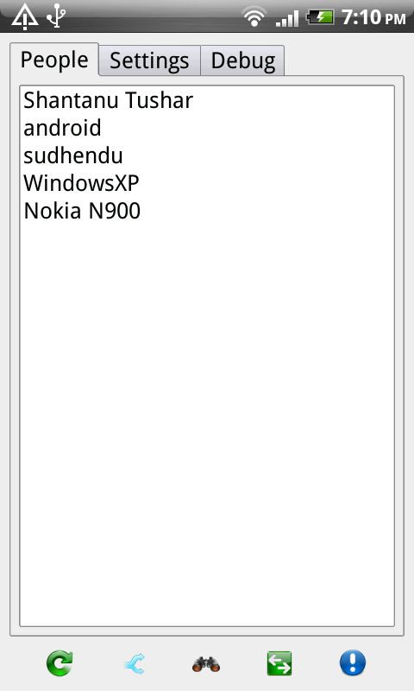
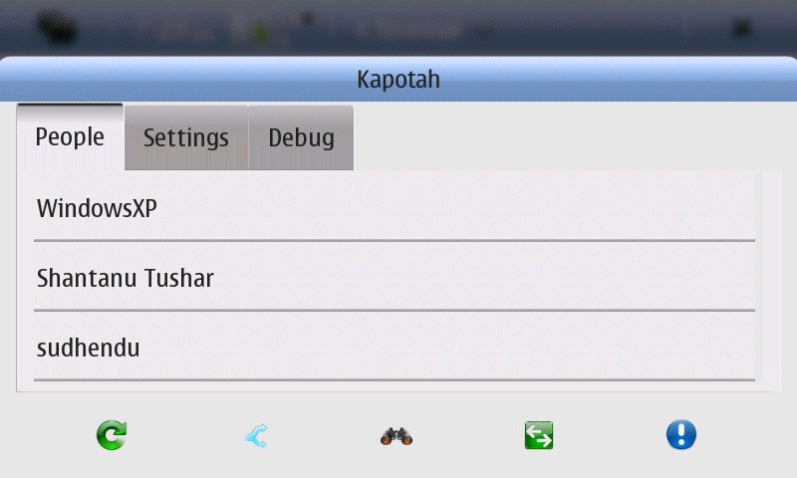
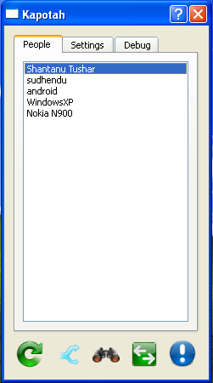
Fig 5.3 Kapotah on Windows XP
Fig 5.4 Kapotah on Android
Fig 5.5 Kapotah on Nokia N900 running Maemo 5
5.2 Text Messaging
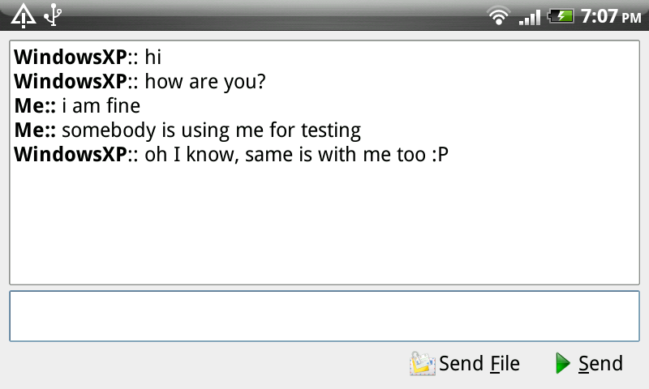
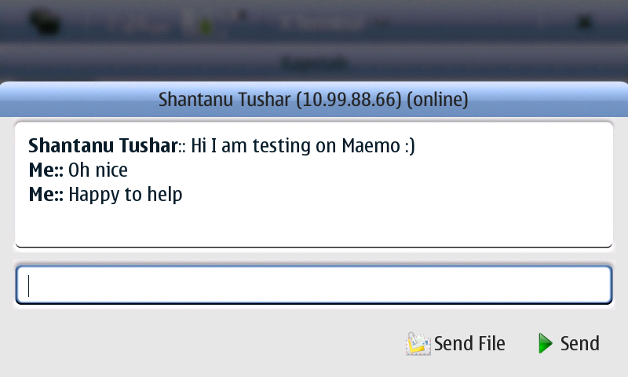
Fig 5.6 Messaing on Android
Fig 5.7 Messaging on Maemo 5
Fig 5.8 Messaging on Windows XP
5.3 Transfers
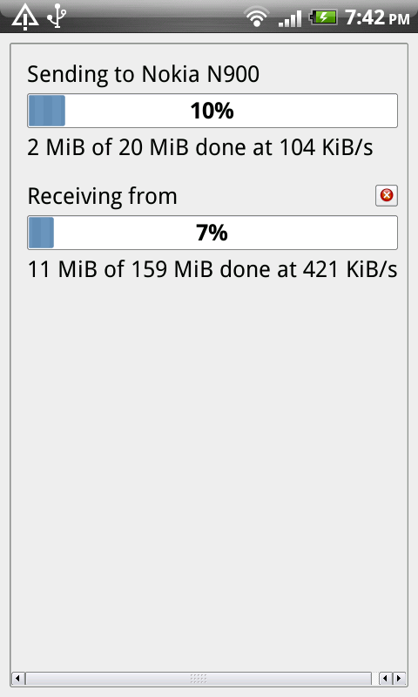
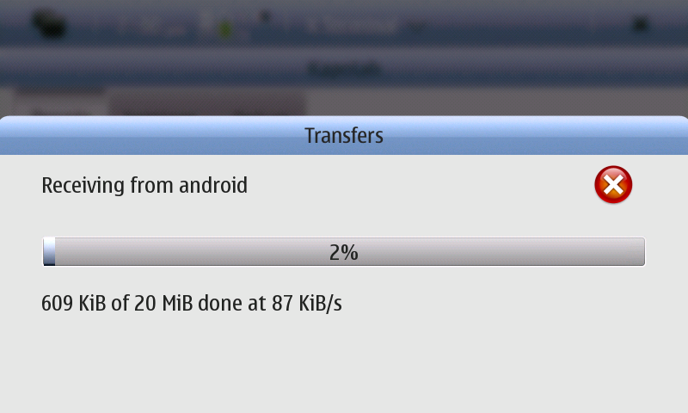
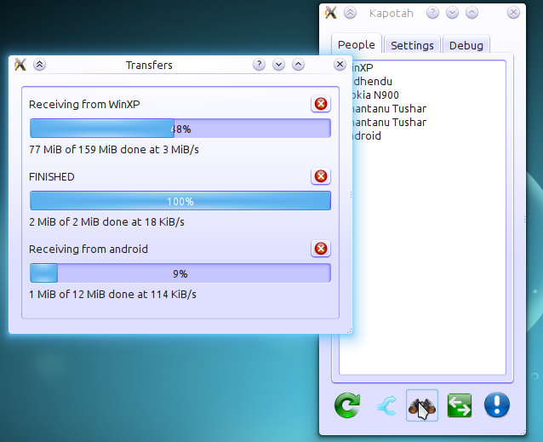
Fig 5.11 Transfers on Maemo
Fig 5.9 Transfers from/to 3 peers on GNU/Linux
Fig 5.10 Transfers to/from 2 peers on Android
5.4 Multicast
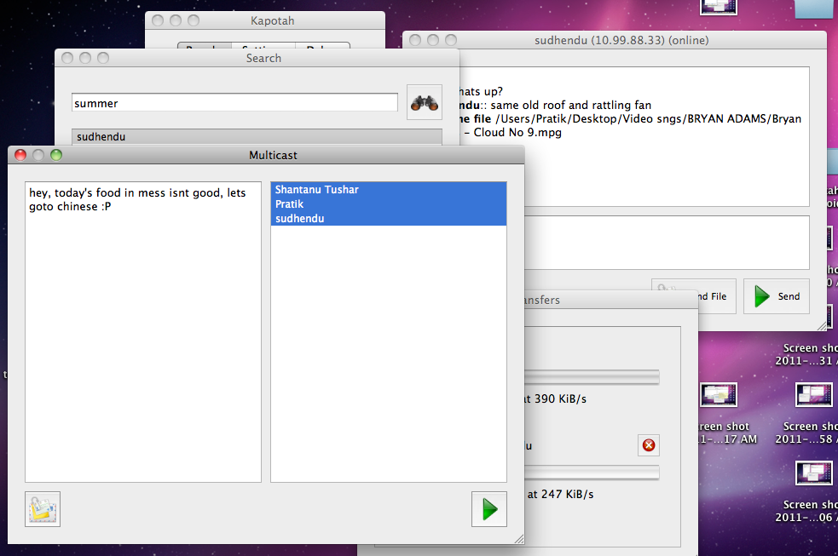
Fig 5.12 Multicast to 3 Peers at once
5.5 Search
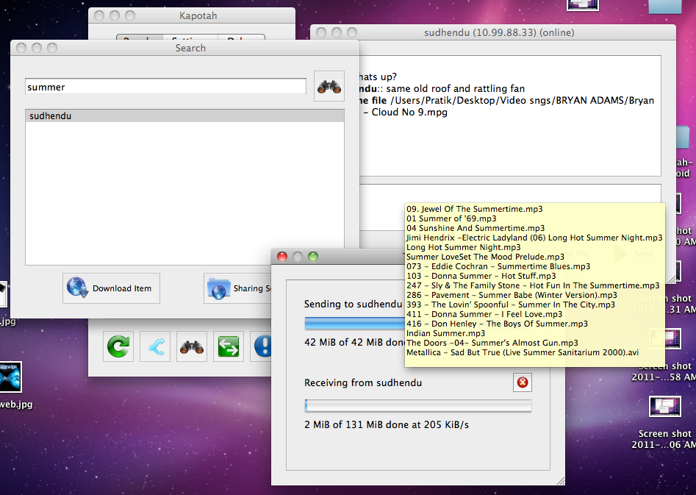
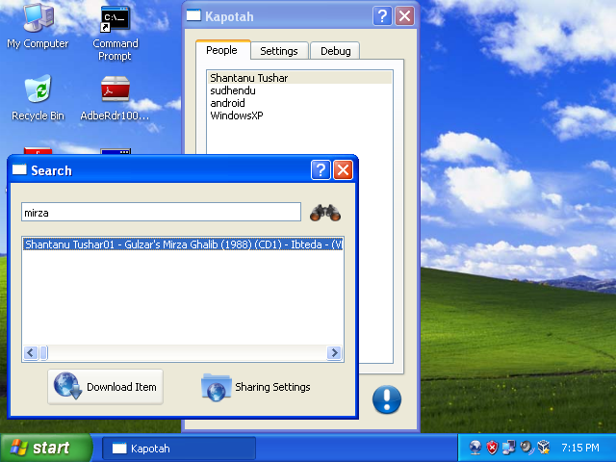
Fig 5.13 Searching for file, seeing contents, and then transferring the files
Fig 5.14 Sharing Settings dialog with Search
5.6 Notifications

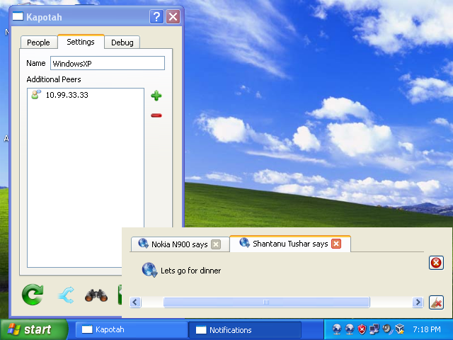
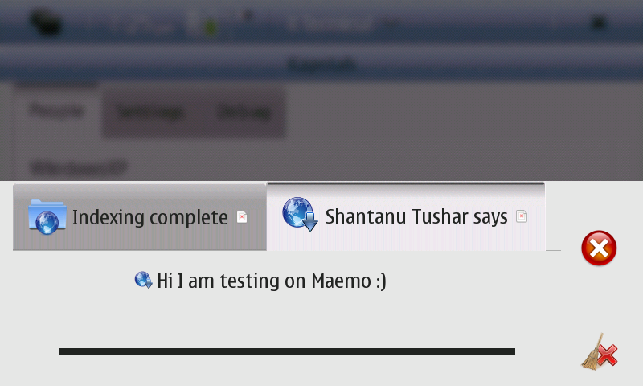
Fig 5.15 Messaging notification from 2 peers
Fig 5.16 Indexing completion and Messaging notifcation

