VISVESVARAYA TECHNOLOGICAL UNIVERSITY
BELGAUM
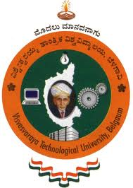

Project Report On
“KAPOTAH – A Cross Platform LAN Messaging
and
File Transfer System”

Submitted in the partial fulfillment of award of degree
Bachelor of Engineering
In
Information Science Engineering
By
SUDHENDU KUMAR (1BM07IS082)

Under the guidance of

Mrs. SHEELA S. V.

Sr. Lecturer,

Department of Information Science,

BMSCE, Bengaluru - 19
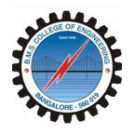

Department of Information Science Engineering
BMS College of Engineering
BMS College of Engineering, Bull Temple Road, Bengaluru – 560019
2010-2011

