CHAPTER 4
DESIGN
5.1 Design Overview
5.2 Announcer module
5.2.1 Announcer
5.2.2 UDP Manager
5.3 Peer Management module
5.3.1 Peer Manager
5.3.2 Peers Model
5.4 Message Dispatcher module
5.5 Transfers module
5.5.1 File Server
5.5.2 Abstract Transfer
5.5.2.1 Incoming Transfers
5.5.2.2 Outgoing Transfers
5.5.3 Transfer Manager
5.5.4 Transfer Threads
5.5.4.1 Incoming Transfer Thread
5.5.4.2 Outgoing Transfer Thread
5.6 Indexing and Search module
5.6.1 File Searcher (Indexer)
5.6.2 File Search Thread
5.7 Notifications module
5.8 XML Module
5.8.1 Abstract XML Data
5.8.2 Abstract XML Parser
5.9 GUI Modules
5.9.1 Peer Dialog
5.9.2 Transfer Widget
5.9.3 Notification Item Widget
5.1 Overview

5.2 Announcer Module
5.2.1 Announcer
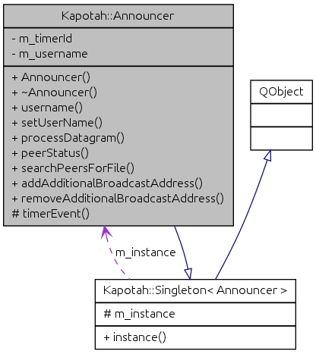

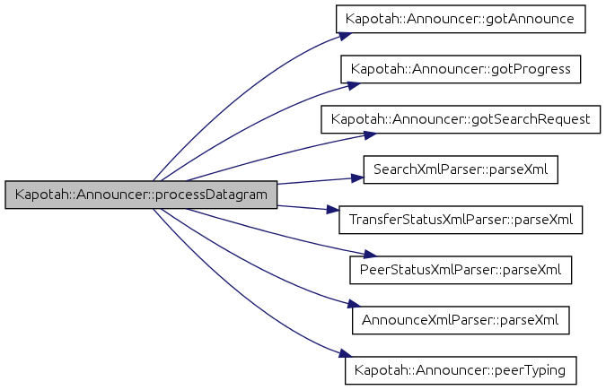
This class processes user name announces, peer status, search and additional broadcasts. The class gets datagrams from the lower UdpManager layer and process it to determine announces and peer status. Announcer is also used to add or remove additional broadcast addresses, send search requests to the network and receive requests.

5.2.2 UDP Manager
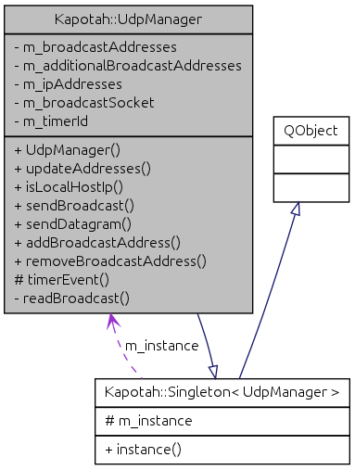

This class handles UDP datagrams. The Singleton class handles low level UDP functions such as sending, broadcasts and unicasts and receiving datagrams. Other library classes can connect to this to get the data.

5.3 Peer Management Module
5.3.1 Peer Manager
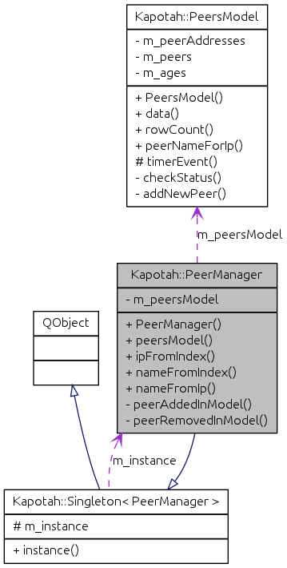

This class stores the list the client has of the peers on the network. The list is updated from the network time to time, and dead peers are removed as required. The class also provides convenience functions to get name, ip etc for a peer according to model indices. Singleton serves as central management of peer information.

5.3.2 Peers Model
This model contains data about online peers on the network.

5.4 Message Dispatcher Module
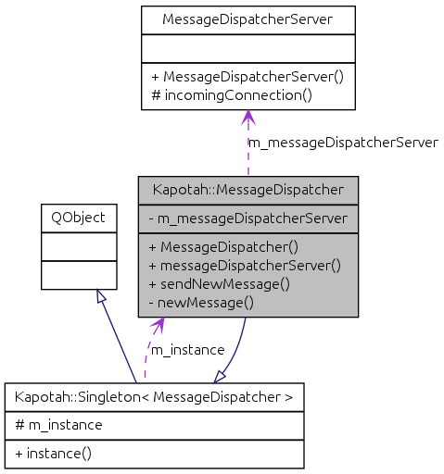

5.5 Transfers Module
5.5.1 File Server

This class is basically a TCP Server which listens for transfer requests. This class is a TCP server that listens for file transfer requests.
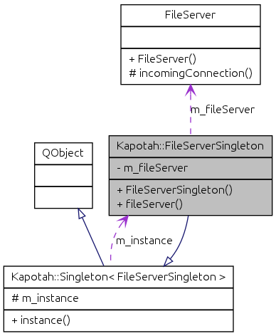

5.5.2 Abstract Transfer
5.5.2.1 Incoming Transfers
This class handles one incoming transfer, that is a collection of files which a peer has sent at once (together).
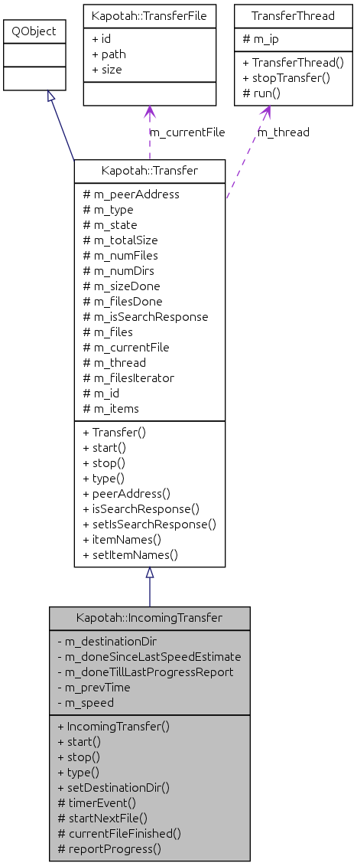
5.5.2.2 Outgoing Transfers
This class handles one outgoing transfer, that is a collection of files which a peer has sent at once (together).
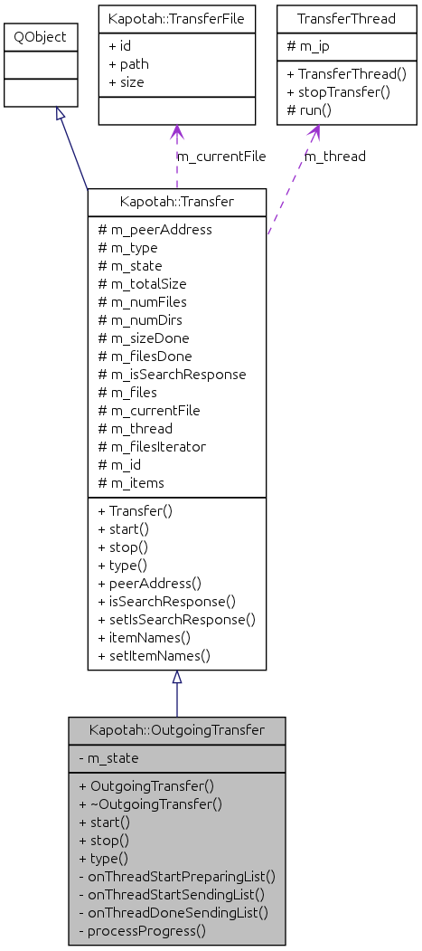
5.5.3 Transfer Manager
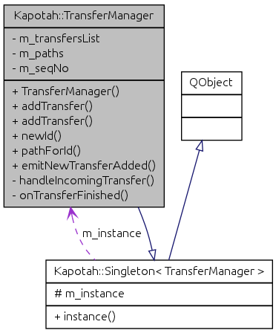

This is a singleton class which handles current transfers. This class maintains pointers to ongoing transfers, both incoming and outgoing. The class should be used when a new transfer is to be added to the system. This class also provides convenience functions to generate IDs and resolve the IDs to files.

5.5.4 Transfer Threads
5.5.4.1 Incoming Transfer Thread
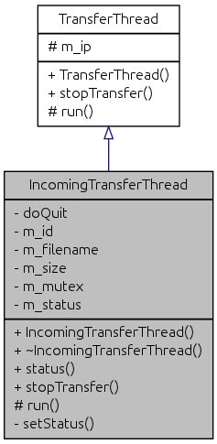
5.5.4.2 Outgoing Transfer Thread
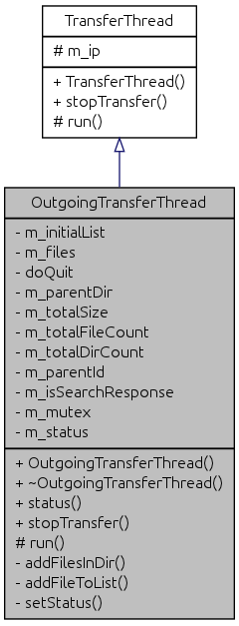

5.6 Indexing and Search module
5.6.1 File Searcher (Indexer)

This class handles the file search requests and processing. The class does the initial indexing for files and uses FileSearcherThread to process searches received from other peers. At any given time, only one search is in progress, this is done for performance reasons.
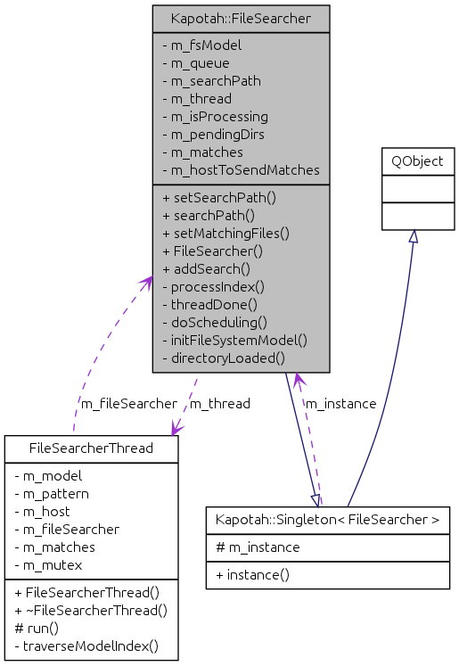

    - 5.6.2 File Search Thread

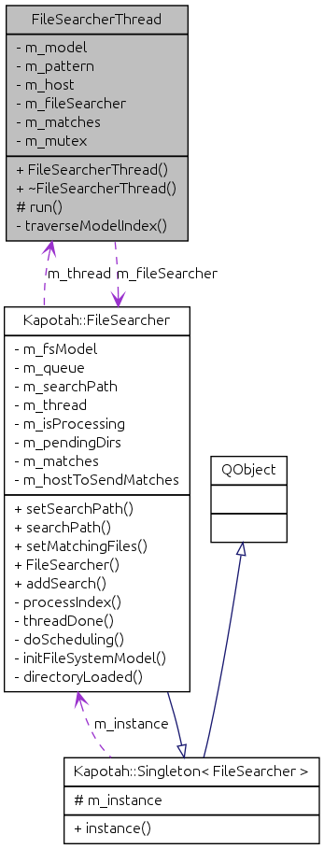

5.7 Notifications Module
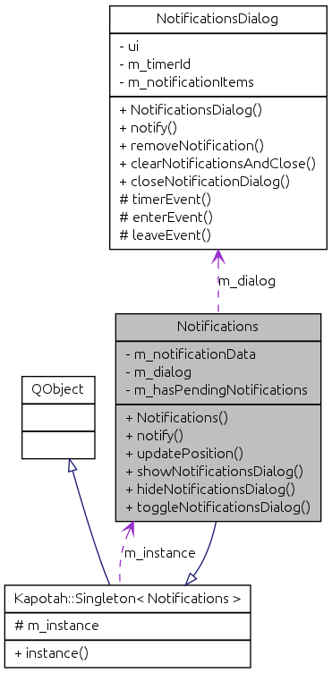

5.8 XML Module
5.8.1 Abstract XML Data

This class is the abstract base class for data storage for XML parsers for parsing Kapotah data. This class provides a base for implementing XML data storage classes for various XML parsers which implement AbstractXmlParser.

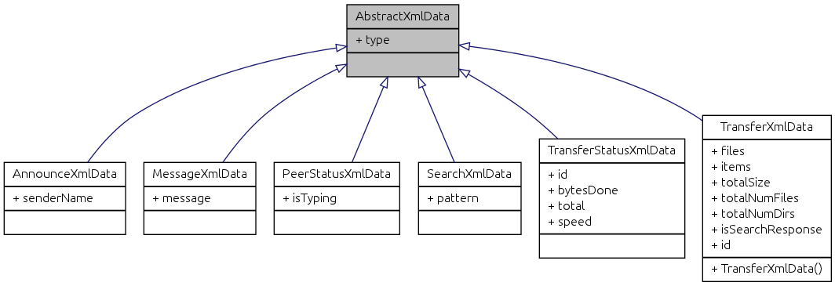

5.8.2 Abstract XML Parser

This is a abstract base class for XML parsers for parsing Kapotah data. This class provides a base for implementing XML parsers for various uses inside Kapotah communications.

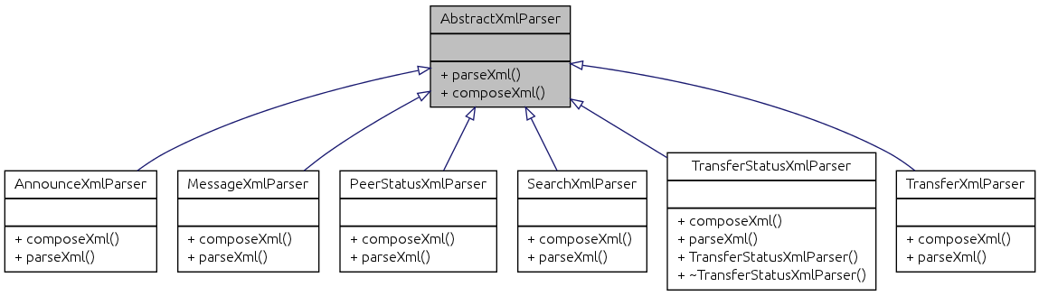

5.9 GUI Modules
5.9.1 Peer Dialog

This class displays the dialog which contains list of peers, address of IP of other subnet and debug messages. This dialog contains 3 tabWidget. 1) showing list of peers online 2) settings tab which contains the IP address of peers from other subnet 3) debug tab for showing debug messages. It also has refresh, open-multicast-dialog, open-search-dialog,open-transfer-dialog and open-notifications button.
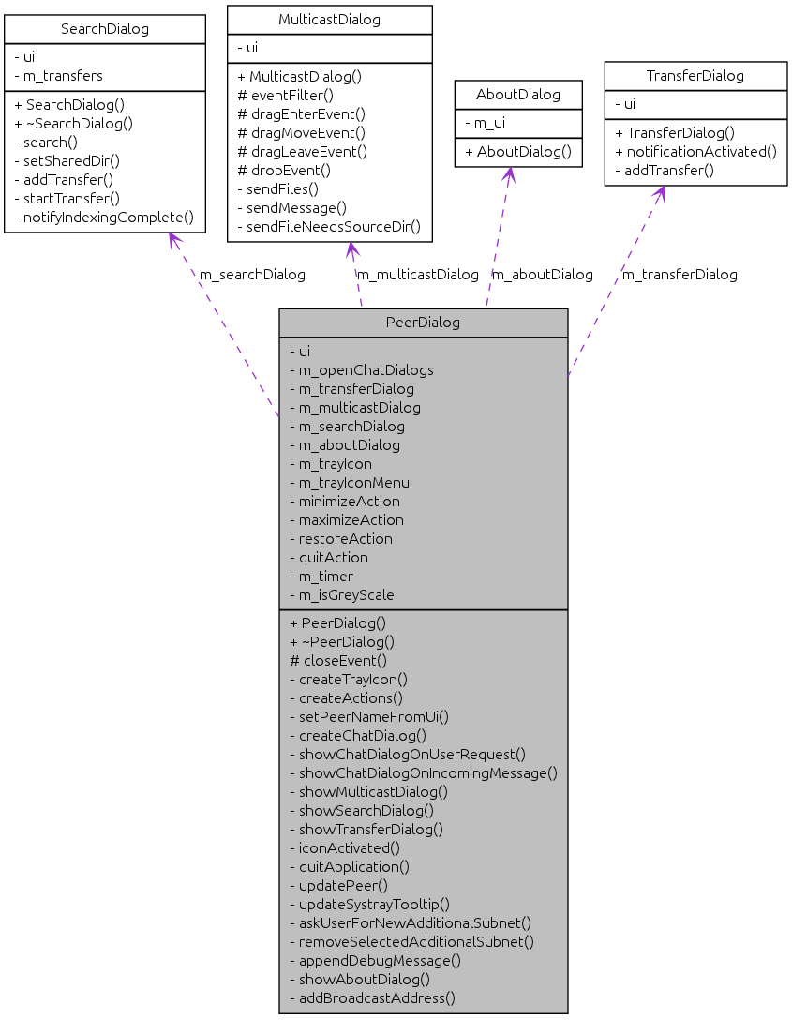
5.9.2 Transfer Widget
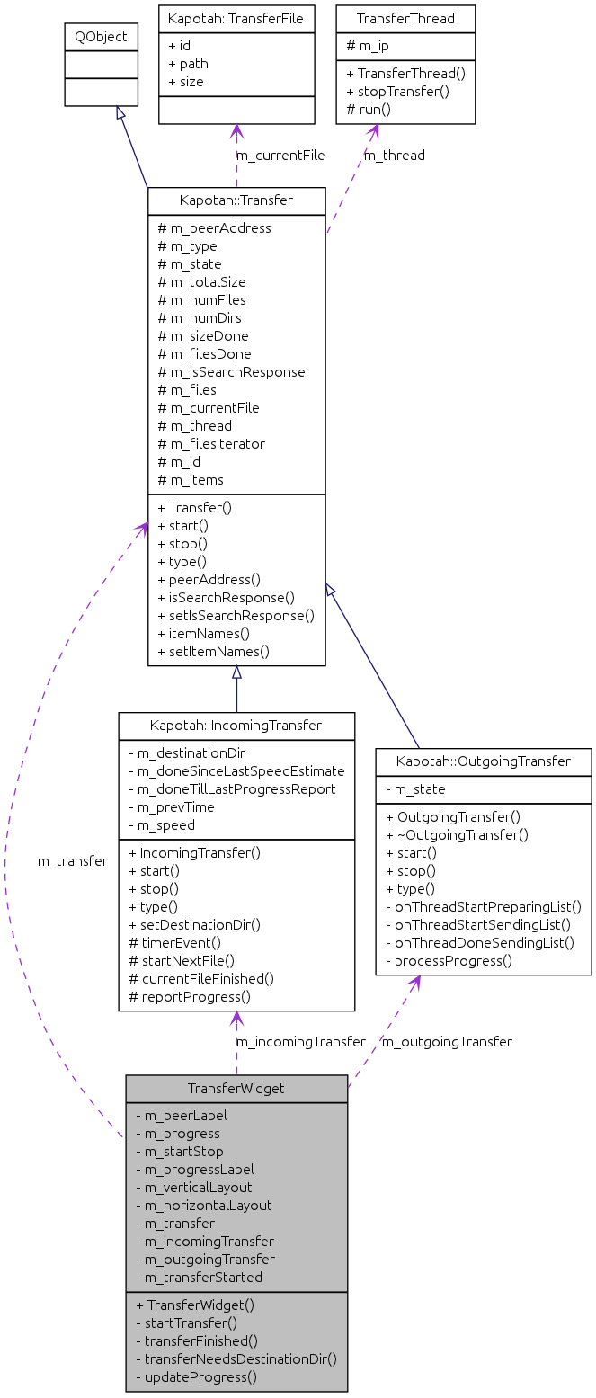
5.9.3 Notification Item Widget

Shows the particular notification message. This class shows the particular notification message like recieved messages, recieved transfers and indexing completed for a particular directory.

