Use this same template every day, for every task, throughout all 6 phases. Fill in every field before submitting.
1

📋 Intern & Task Details

Intern Name | Shaan Abishek
Phase / Day | PHASE-1/DAY-3
Date | 3/07/2026
Task / Topic Title | FUNCTIONS & MODULES
Time Spent (hrs) | 1 hour

2

📝 Summary of Work Done
2–4 sentences: what did you build or learn today?
Today I learned Python functions, modules and file handling by completing five practical tasks. I built a Receipt Builder, Journal Builder, ATM Simulator, and Campus Library project, while also practicing small demo programs on functions, scope, modules and file operations.

3

👣 Steps Followed
List the key steps you completed, in order.
- Practiced functions and modules.
- Built Receipt Builder and Journal Builder.
- Created ATM Simulator using modules.
- Developed Campus Library project with file handling.

4

🧩 Challenges Faced & How You Solved Them

I was able to understand and complete all the tasks successfully.

5

💡 Key Learnings
What’s the one thing you understand better now than this morning?
I now understand how to organize programs using functions and modules, and how to use file handling to store and retrieve data.

6

🔗 Proof of Work

File(s) / Folder  Name | receipt.py, journal_practice.py, bank_utils.py, atm_simulator.py, campus_lib.py, library_utils.py
GitHub Repo Link | https://github.com/shaanabishek/internship_projects
Screenshot Attached? | Yes
Live/Deployed  Link (Later Phase) | -

Screenshots:
- Receipt.py

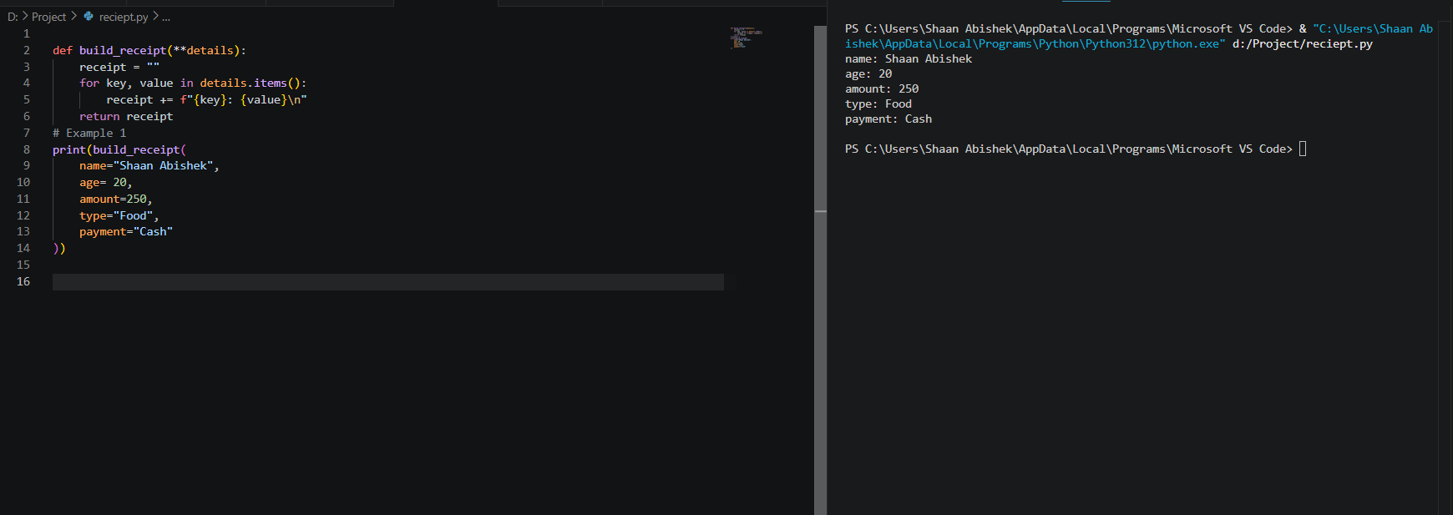

- Journal.py

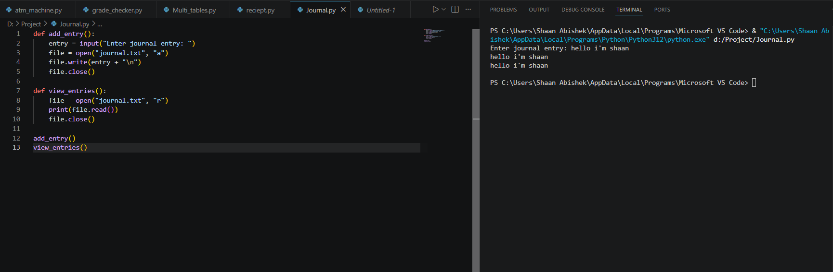

- Campus Library project

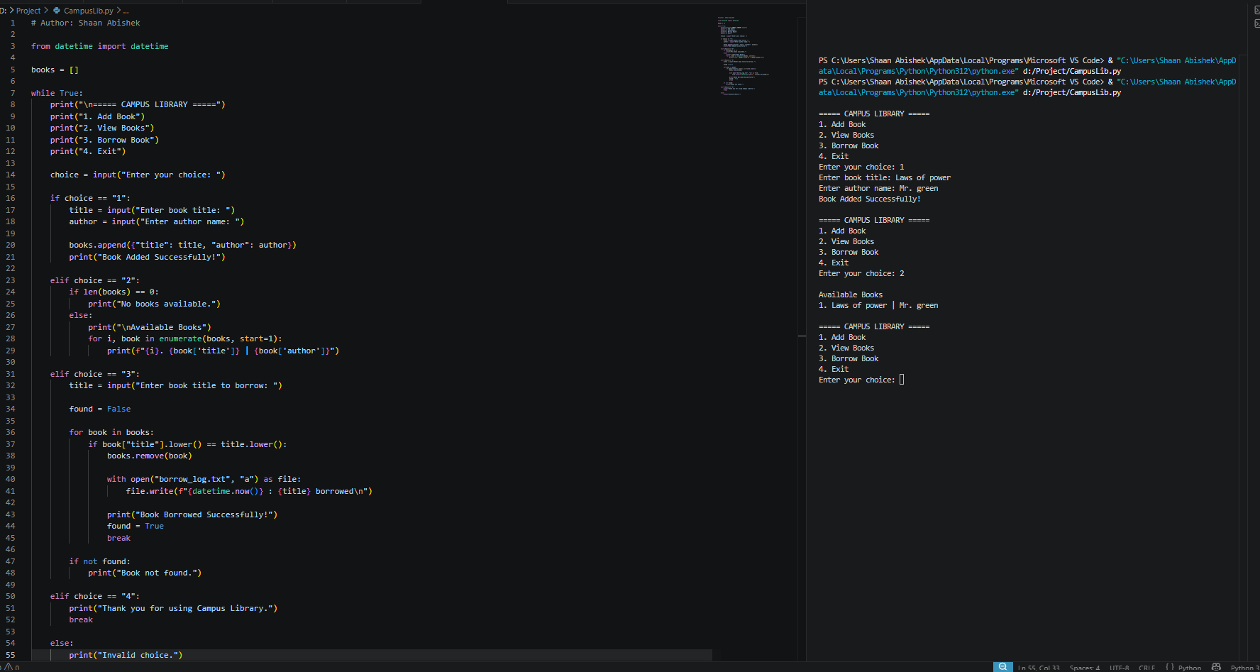

4. Atm_sumulatorv3.py

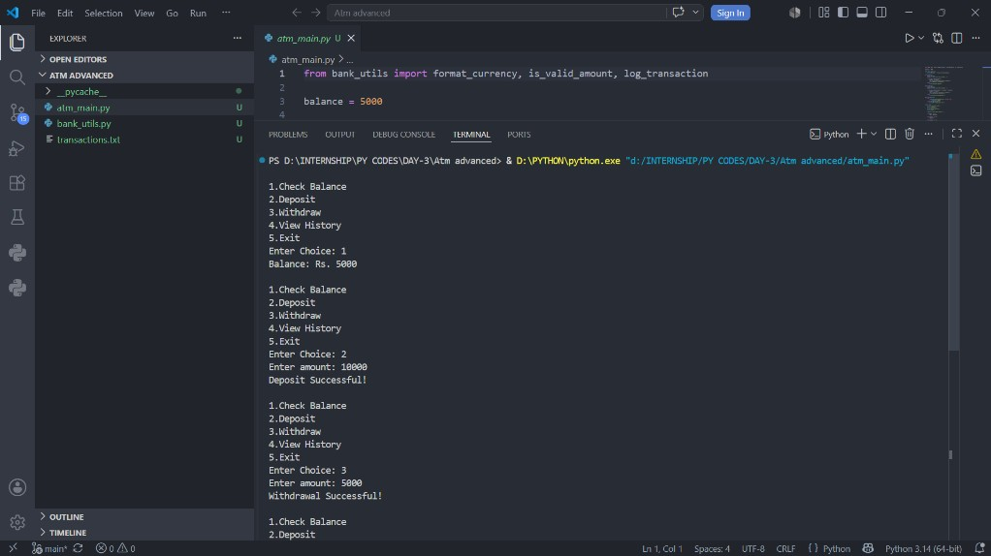

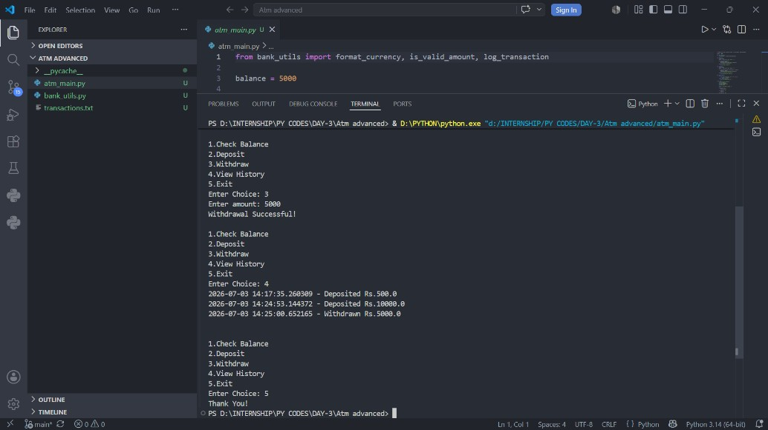

5. Demo Screenshots:

1. Global Variable.py
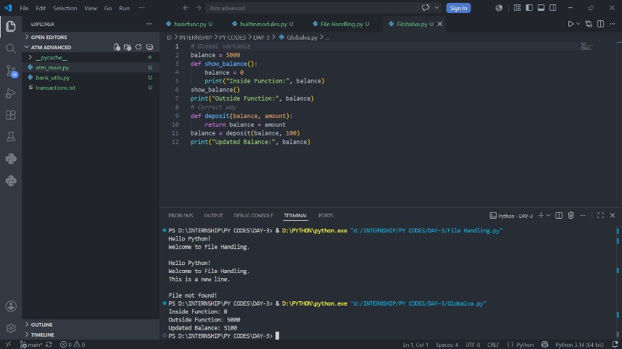

2. File Handling.py
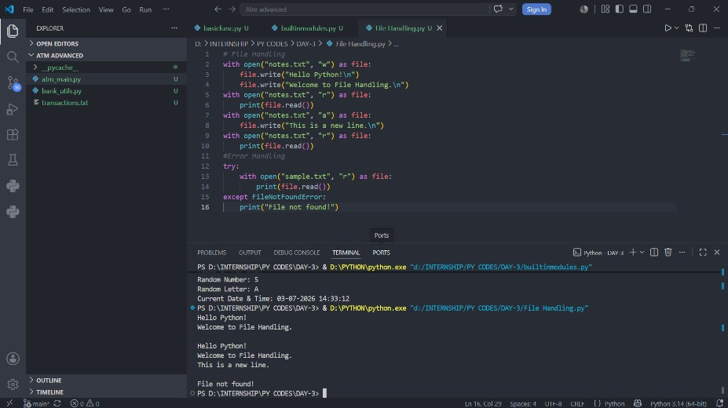

3. Builtin modules

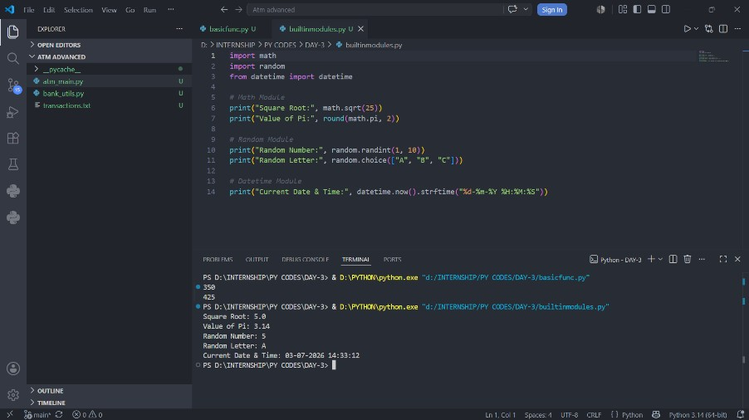

4. Basicfun.py
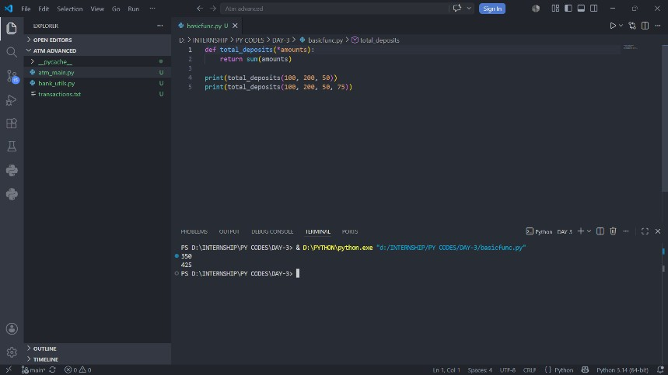

7

⭐ Self-Assessment

Star Rating | ★★★★
Comments | Completed all assigned tasks and gained confidence in using functions, modules, and basic file handling.

8

🎯 Mentor Feedback (left blank by intern)

Status
Comments

