- Flybrain biological neurons are reconstructed and mapped the connection that we can find at flywire https://codex.flywire.ai/?dataset=fafb which is in csv .
- but the Computational implementation is what we need to do, which is to convert the csv to network

​.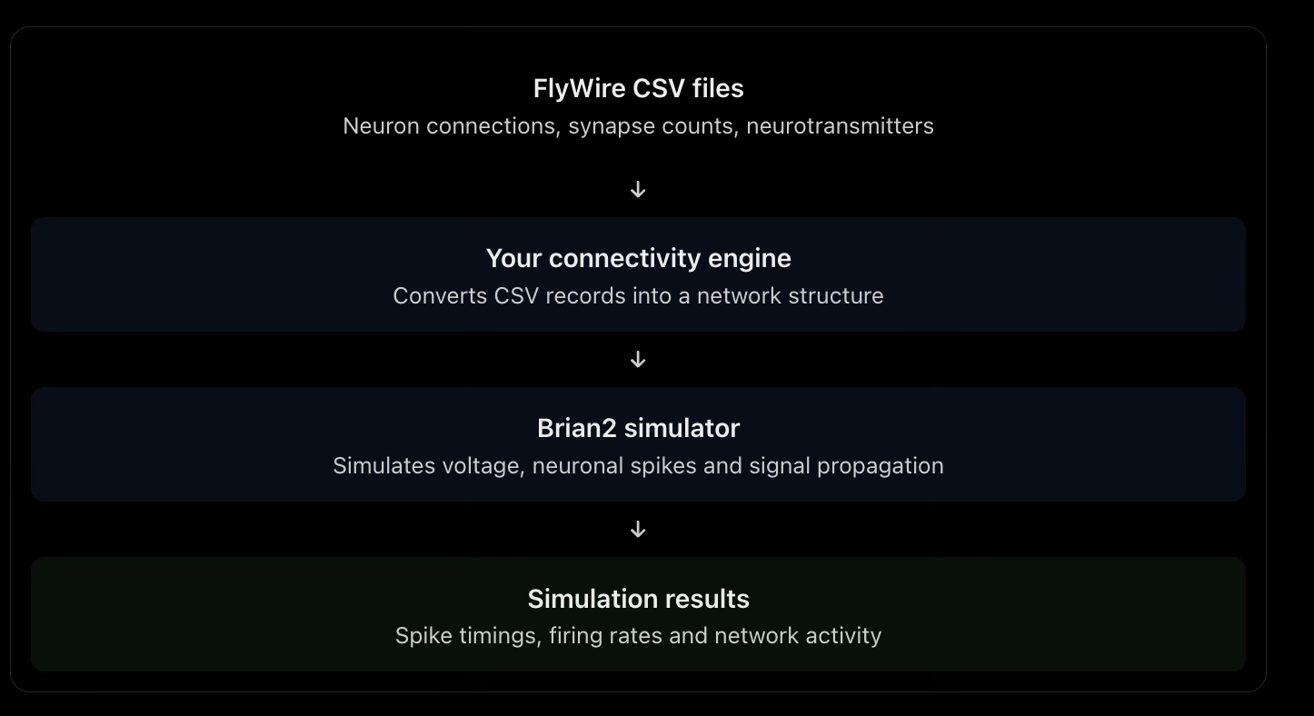

FLYWIRE CSV FILES
​we get the connectivity csv file which has
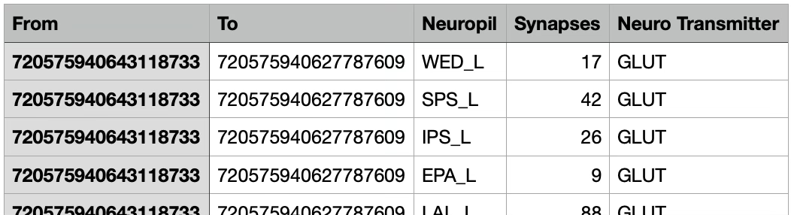
​from : neuron id from Presynaptic neurone(signal incoming from)
to : neuron id of Postsynaptic neurone(signal outgoing to)
neuropil : region of the brain
synapses : how many synapses are involved
neuro transmitter : chemical which are being transmitted (chemical will have diff massage
depending who is receiving it )

CONNECTIVITY ENGINE

it is to build the neural graph from the csv, once the neural graph is developed it can be saved and used
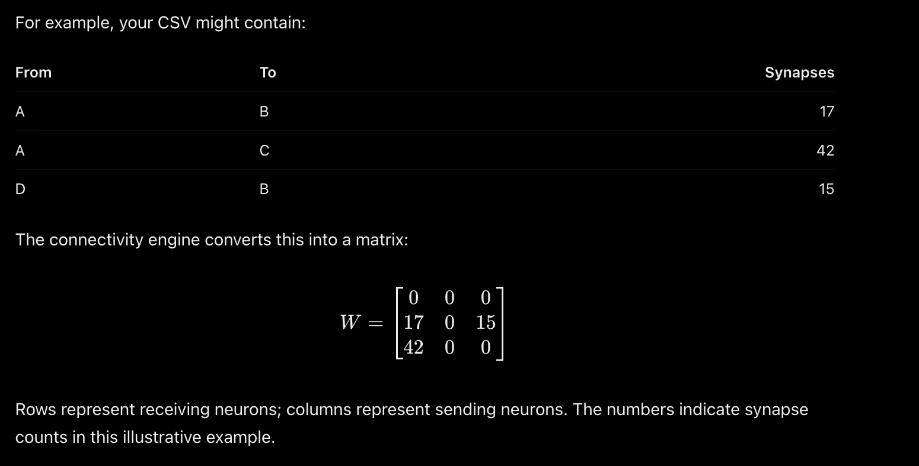
- ​python has the library called “fafbseg” specifically for flybrain , which can fetch the data of the specific neurons form the directly from the flywire api or u could provide the csv
- Provides tools to query FlyWire connectivity, retrieve neurons and synapses, and access annotations. It can help you obtain and process the biological connections.
- https://github.com/navis-org/fafbseg-py?utm_source=chatgpt.com

- For analysing and constructing the sparse matrix SciPy lib could be used
- https://github.com/navis-org/navis?utm_source=chatgpt.com

​SIMULATE
- Once the network is developed it need to simulated. Python provide the lib “brain2” which runs the network and simulates the neuron activity

What exactly is simulated?

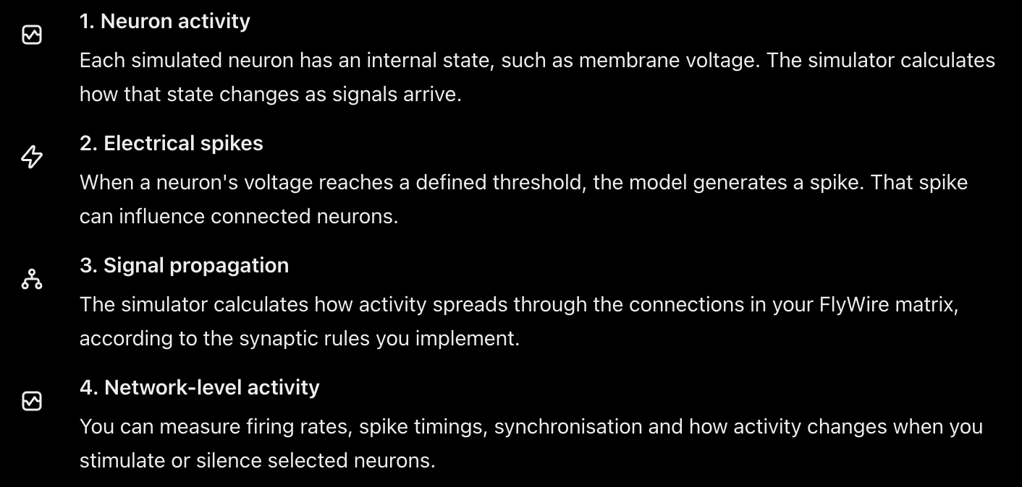

For implementation of flybrain with 6-leg fly body
There is a tools which is framework and provides the simulated body of the fly and biomechanics and sensory feedback
https://github.com/NeLy-EPFL/flygym?utm_source=chatgpt.com
https://neuromechfly.org/?utm_source=chatgpt.com

