CREATE TABLE BRANCH(

BRANCH_NAME VARCHAR2(25),

BRANCHCITY VARCHAR2(25),

ASSETS REAL,

PRIMARY KEY(BRANCH_NAME)

);

CREATE TABLE ACCOUNTS(

ACCNO INT,

BRANCH_NAME VARCHAR2(25),

BALANCE REAL,

PRIMARY KEY(ACCNO),

FOREIGN KEY(BRANCH_NAME) REFERENCES BRANCH(BRANCH_NAME) ON DELETE CASCADE

);

CREATE TABLE CUSTOMER(

CUSTOMER_NAME VARCHAR(25),

CUSTOMER_STREET VARCHAR2(25),

CUSTOMER_CITY VARCHAR2(25),

PRIMARY KEY(CUSTOMER_NAME)

);

CREATE TABLE DEPOSITOR(

CUSTOMER_NAME VARCHAR(25),

ACCNO INT,

PRIMARY KEY(CUSTOMER_NAME, ACCNO),

FOREIGN KEY(CUSTOMER_NAME) REFERENCES CUSTOMER(CUSTOMER_NAME) ON DELETE CASCADE,

FOREIGN KEY(ACCNO) REFERENCES ACCOUNTS(ACCNO) ON DELETE CASCADE

);

CREATE TABLE LOAN(

LOAN_NUMBER INT,

BRANCH_NAME VARCHAR2(25),

AMOUNT REAL,

PRIMARY KEY(LOAN_NUMBER),

FOREIGN KEY(BRANCH_NAME) REFERENCES BRANCH(BRANCH_NAME) ON DELETE CASCADE

);

CREATE TABLE BORROWER(

CUSTOMER_NAME VARCHAR2(25),

LOAN_NUMBER INT,

PRIMARY KEY(CUSTOMER_NAME),

FOREIGN KEY(CUSTOMER_NAME) REFERENCES CUSTOMER(CUSTOMER_NAME) ON DELETE CASCADE,

FOREIGN KEY(LOAN_NUMBER) REFERENCES LOAN(LOAN_NUMBER) ON DELETE CASCADE

);

-- QUICK DELETE :)

DROP TABLE BRANCH;

DROP TABLE ACCOUNTS;

DROP TABLE CUSTOMER;

DROP TABLE DEPOSITOR;

DROP TABLE BORROWER;

DROP TABLE LOAN;

INSERT INTO BRANCH VALUES('&BRANCH_NAME', '&BRANCHCITY', &ASSETS);

SELECT * FROM BRANCH;

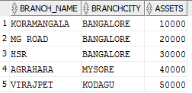

INSERT INTO ACCOUNTS VALUES(&ACCNO, '&BRANCH_NAME', &BALANCE);

SELECT * FROM ACCOUNTS;

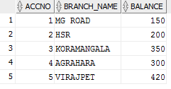

INSERT INTO CUSTOMER VALUES('&CUSTOMER_NAME', '&CUSTOMER_STREET', '&CUSTOMER_CITY');

SELECT * FROM CUSTOMER;

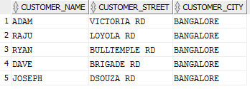

INSERT INTO DEPOSITOR VALUES('&CUSTOMER_NAME', &ACCNO);

SELECT * FROM DEPOSITOR;

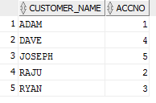

INSERT INTO LOAN VALUES(&LOAN_NUMBER, '&BRANCH_NUMBER', &AMOUNT);

SELECT * FROM LOAN;

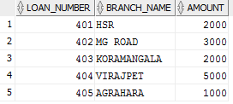

INSERT INTO BORROWER VALUES('&CUSTOMER_NAME', &LOAN_NUMBER);

SELECT * FROM BORROWER;

