CREATE TABLE CUSTOMERS(

CUSTNO INT,

CNAME VARCHAR2(50),

CITY VARCHAR2(50),

PRIMARY KEY(CUSTNO)

)

CREATE TABLE ORDERS(

ORDERNO INT,

ODATE DATE,

CUSTNO INT,

ORD_AMT INT,

PRIMARY KEY(ORDERNO),

FOREIGN KEY(CUSTNO) REFERENCES CUSTOMERS(CUSTNO)

)

CREATE TABLE ITEM(

ITEMNO INT,

UNIT_PRICE INT,

PRIMARY KEY(ITEMNO)

)

CREATE TABLE ORDER_ITEM(

ORDERNO INT,

ITEMNO INT,

QTY INT,

PRIMARY KEY(ORDERNO, ITEMNO),

FOREIGN KEY(ORDERNO) REFERENCES ORDERS(ORDERNO),

FOREIGN KEY(ITEMNO) REFERENCES ITEM(ITEMNO)

)

CREATE TABLE WAREHOUSE(

WAREHOUSENO INT,

CITY VARCHAR2(50),

PRIMARY KEY(WAREHOUSENO)

)

CREATE TABLE SHIPMENT(

ORDERNO INT,

WAREHOUSENO INT,

SHIP_DATE DATE,

PRIMARY KEY(ORDERNO, WAREHOUSENO),

FOREIGN KEY(ORDERNO) REFERENCES ORDERS(ORDERNO),

FOREIGN KEY(WAREHOUSENO) REFERENCES WAREHOUSE(WAREHOUSENO)

)

SELECT * FROM CUSTOMERS;

SELECT * FROM ORDERS;

SELECT * FROM ITEM;

SELECT * FROM ORDER_ITEM;

SELECT * FROM WAREHOUSE;

SELECT * FROM SHIPMENT;

TABLE CUSTOMERS

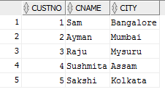

TABLE ORDERS

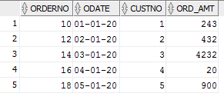

TABLE ITEM

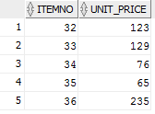

TABLE ORDER_ITEM

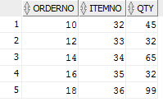

TABLE WAREHOUSE

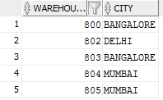

TABLE SHIPMENT

