CREATE TABLE STUDENT(

REGNO VARCHAR2(20),

NAME VARCHAR2(20),

MAJOR VARCHAR2(5),

BDATE DATE,

PRIMARY KEY(REGNO)

);

CREATE TABLE COURSE(

COURSE_ID INT,

CNAME VARCHAR2(20),

DEPT VARCHAR2(4),

PRIMARY KEY(COURSE_ID)

);

CREATE TABLE TEXT(

ISBN INT,

BOOK_TITLE VARCHAR2(50),

PUBLISHER VARCHAR2(20),

AUTHOR VARCHAR2(20),

PRIMARY KEY(ISBN)

);

CREATE TABLE ADOPTION(

COURSE_ID INT,

SEM INT,

ISBN INT,

PRIMARY KEY(COURSE_ID, ISBN),

FOREIGN KEY(COURSE_ID) REFERENCES COURSE(COURSE_ID),

FOREIGN KEY(ISBN) REFERENCES TEXT(ISBN)

);

CREATE TABLE ENROLL(

REGNO VARCHAR2(20),

COURSE_ID INT,

SEM INT,

MARKS INT,

PRIMARY KEY(REGNO, COURSE_ID),

FOREIGN KEY(REGNO) REFERENCES STUDENT(REGNO),

FOREIGN KEY(COURSE_ID) REFERENCES COURSE(COURSE_ID)

);

INSERT INTO STUDENT VALUES('&REGNO', '&NAME', '&MAJOR', '&DATE');

INSERT INTO COURSE VALUES(&COURSE_ID, '&CNAME', '&DEPT');

INSERT INTO TEXT VALUES(&ISBN, '&BOOK_TITLE', '&PUBLISHER', '&AUTHOR');

INSERT INTO ADOPTION VALUES(&COURSE_ID, &SEM, &ISBN);

INSERT INTO ENROLL VALUES('&REGNO', &COURSE_ID, &SEM, &MARKS);

STUDENT

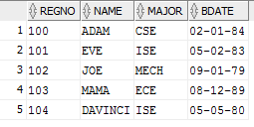

COURSE

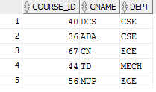

TEXT

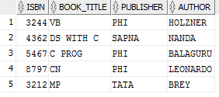

ADOPTION

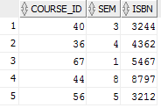

ENROLL

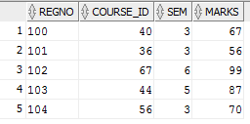

ANS 1

INSERT INTO TEXT VALUES('4242', 'PYTHON PROG', 'PHI', 'DAVE R');

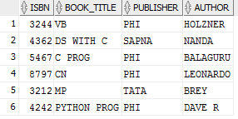

INSERT INTO ADOPTION VALUES(40, 4, 4242);

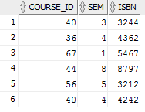

ANS 2