CREATE TABLE AUTHORS(

AUTHOR_ID INT,

A_NAME VARCHAR(10),

CITY VARCHAR(10),

COUNTRY VARCHAR(10),

PRIMARY KEY(AUTHOR_ID)

);

CREATE TABLE PUBLISHERS(

PUBLISHER_ID INT,

P_NAME VARCHAR(10),

CITY VARCHAR(20),

COUNTRY VARCHAR(10),

PRIMARY KEY(PUBLISHER_ID)

);

CREATE TABLE CATEGORY(

CATEGORY_ID INT,

DESCRIPTIONS VARCHAR(10),

PRIMARY KEY(CATEGORY_ID)

);

CREATE TABLE CATALOG(

BOOK_ID INT,

TITLE VARCHAR(10),

AUTHOR_ID INT,

PUBLISHER_ID INT,

CATEGORY_ID INT,

P_YEAR INT,

PRICE INT,

PRIMARY KEY(BOOK_ID),

FOREIGN KEY(AUTHOR_ID) REFERENCES AUTHORS(AUTHOR_ID),

FOREIGN KEY(PUBLISHER_ID) REFERENCES PUBLISHERS(PUBLISHER_ID),

FOREIGN KEY(CATEGORY_ID) REFERENCES CATEGORY(CATEGORY_ID)

);

CREATE TABLE ORDER_DETAILS(

ORDER_NO INT,

BOOK_ID INT,

QTY INT,

PRIMARY KEY(ORDER_NO),

FOREIGN KEY (BOOK_ID) REFERENCES CATALOG(BOOK_ID)

);

INSERT INTO AUTHORS VALUES(10,'SAM','BLORE','INDIA');

INSERT INTO AUTHORS VALUES(20,'SHAAN','COORG','INDIA');

INSERT INTO AUTHORS VALUES(30,'SARA','CA','USA');

INSERT INTO AUTHORS VALUES(40,'AYMAN','SPAIN','BARCELONA');

INSERT INTO AUTHORS VALUES(50,'TANYA','DELHI','INDIA');

SELECT * FROM AUTHORS;

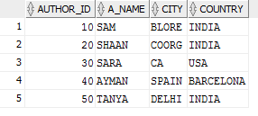

INSERT INTO PUBLISHERS VALUES(1,'PHI','NY','USA');

INSERT INTO PUBLISHERS VALUES(2,'EEE','LA','USA');

INSERT INTO PUBLISHERS VALUES(3,'SWAPNA','','INDIA');

INSERT INTO PUBLISHERS VALUES(4,'MGH','NY','USA');

INSERT INTO PUBLISHERS VALUES(5,'PEARSON','DELHI','INDIA');

SELECT * FROM PUBLISHERS;

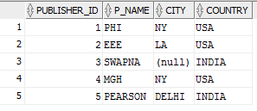

INSERT INTO CATEGORY VALUES(11,'CS');

INSERT INTO CATEGORY VALUES(22,'EC');

INSERT INTO CATEGORY VALUES(33,'OS');

INSERT INTO CATEGORY VALUES(44,'C++');

INSERT INTO CATEGORY VALUES(55,'DBMS');

SELECT * FROM CATEGORY;

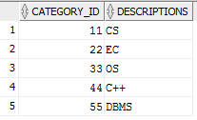

INSERT INTO CATALOG VALUES(111,'BASICS',50,2,11,2003,200);

INSERT INTO CATALOG VALUES(222,'PROG',40,5,44,1999,500);

INSERT INTO CATALOG VALUES(333,'MP',50,1,11,2009,900);

INSERT INTO CATALOG VALUES(444,'CIRCUITS',50,2,22,1997,300);

INSERT INTO CATALOG VALUES(555,'DATA',30,3,55,2005,600);

SELECT * FROM CATALOG;

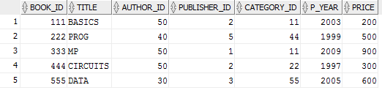

INSERT INTO ORDER_DETAILS VALUES(123,222,100);

INSERT INTO ORDER_DETAILS VALUES(231,111,150);

INSERT INTO ORDER_DETAILS VALUES(143,333,90);

INSERT INTO ORDER_DETAILS VALUES(156,555,200);

INSERT INTO ORDER_DETAILS VALUES(218,444,70);

SELECT * FROM ORDER_DETAILS;

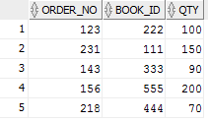

SELECT A.A_NAME,C.TITLE,C.PRICE FROM AUTHORS A,CATALOG C WHERE C.AUTHOR_ID=A.AUTHOR_ID AND C.P_YEAR>=2000 AND A.A_NAME=(SELECT A.A_NAME FROM AUTHORS A,CATALOG C WHERE A.AUTHOR_ID=C.AUTHOR_ID GROUP BY C.AUTHOR_ID HAVING COUNT(*)>=2);

SELECT A.A_NAME FROM AUTHORS A,CATALOG C,ORDER_DETAILS O WHERE O.BOOK_ID=C.BOOK_ID AND A.AUTHOR_ID=C.AUTHOR_ID AND O.BOOK_ID=(SELECT BOOK_ID FROM ORDER_DETAILS WHERE QTY=(SELECT MAX(QTY) FROM ORDER_DETAILS));

UPDATE CATALOG SET PRICE=1.10*PRICE;

SELECT * FROM CATALOG;