Shaan Subbaiah B C - 1BM18CS096
Program no – 04
Program Title – Potentiometer
Aim
To fade an LED on and off using a potentiometer

Hardware Required

- Arduino Board
- LED
- 240 Ohm Resistor

Circuit Diagram

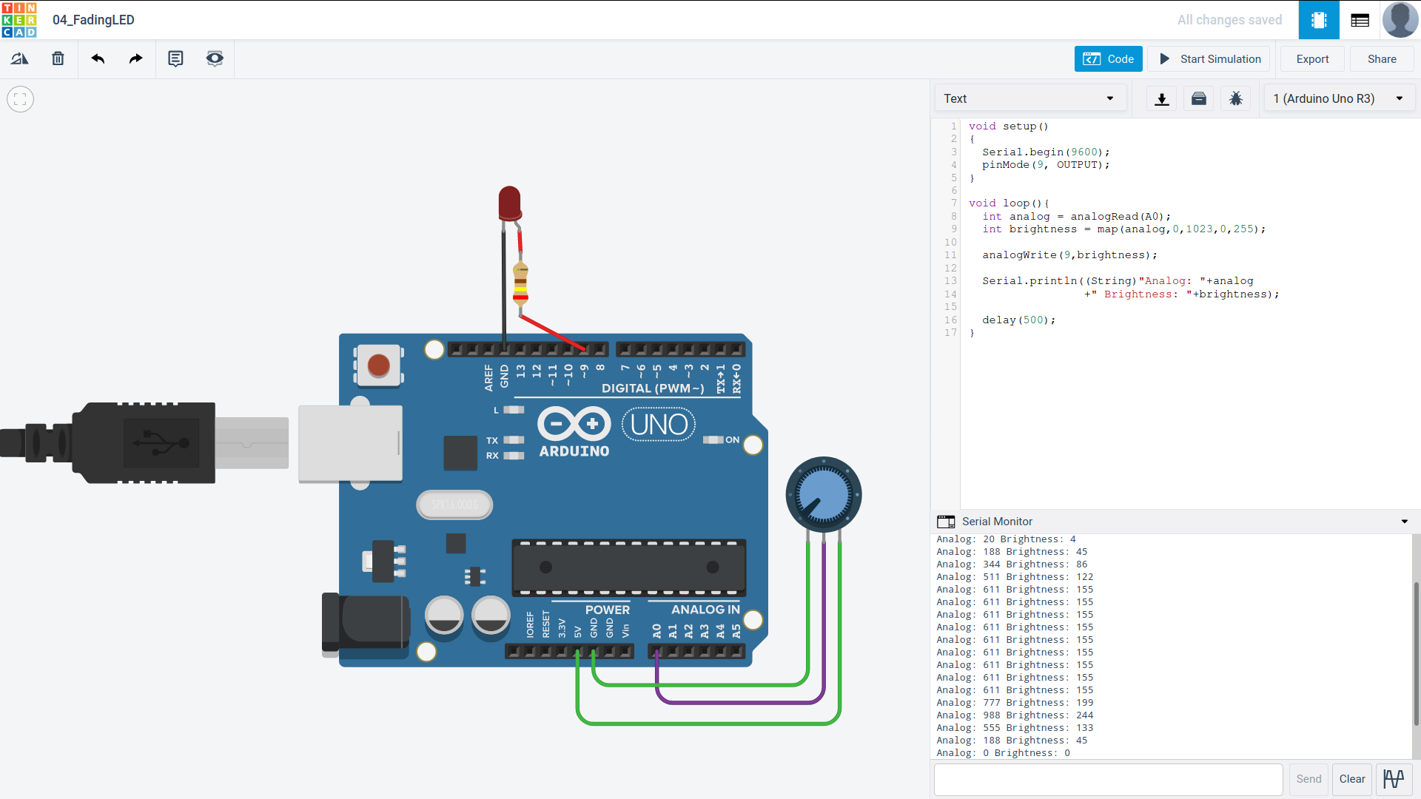
Code:
void setup()
{
Serial.begin(9600);
pinMode(9, OUTPUT);
}

void loop(){
int analog = analogRead(A0);
int brightness = map(analog,0,1023,0,255);
analogWrite(9,brightness);
Serial.println((String)"Analog: "+analog
+" Brightness: "+brightness);
delay(500);
}

Observation /Output
LED is faded on and off using the potentiometer.

