EXP2 : Thermostat with Hysteresis

# Shaan Sundar - 19BPS1082

**Aim:**

To design a thermostat using Finite State Machines using ptolemy

**Procedure:**

1. Drag and drop the given below actors/sources/sinks/directors into the graphical editor
2. Change number of iterations of SDF director to 300
3. Create the four parameters in the design
4. Create the model for the composite actor as given below
5. Create the FSM model for the ModalModel as given below
6. Connect the circuit to form a closed loop feedback system
7. Run and get the plots

**Design:**

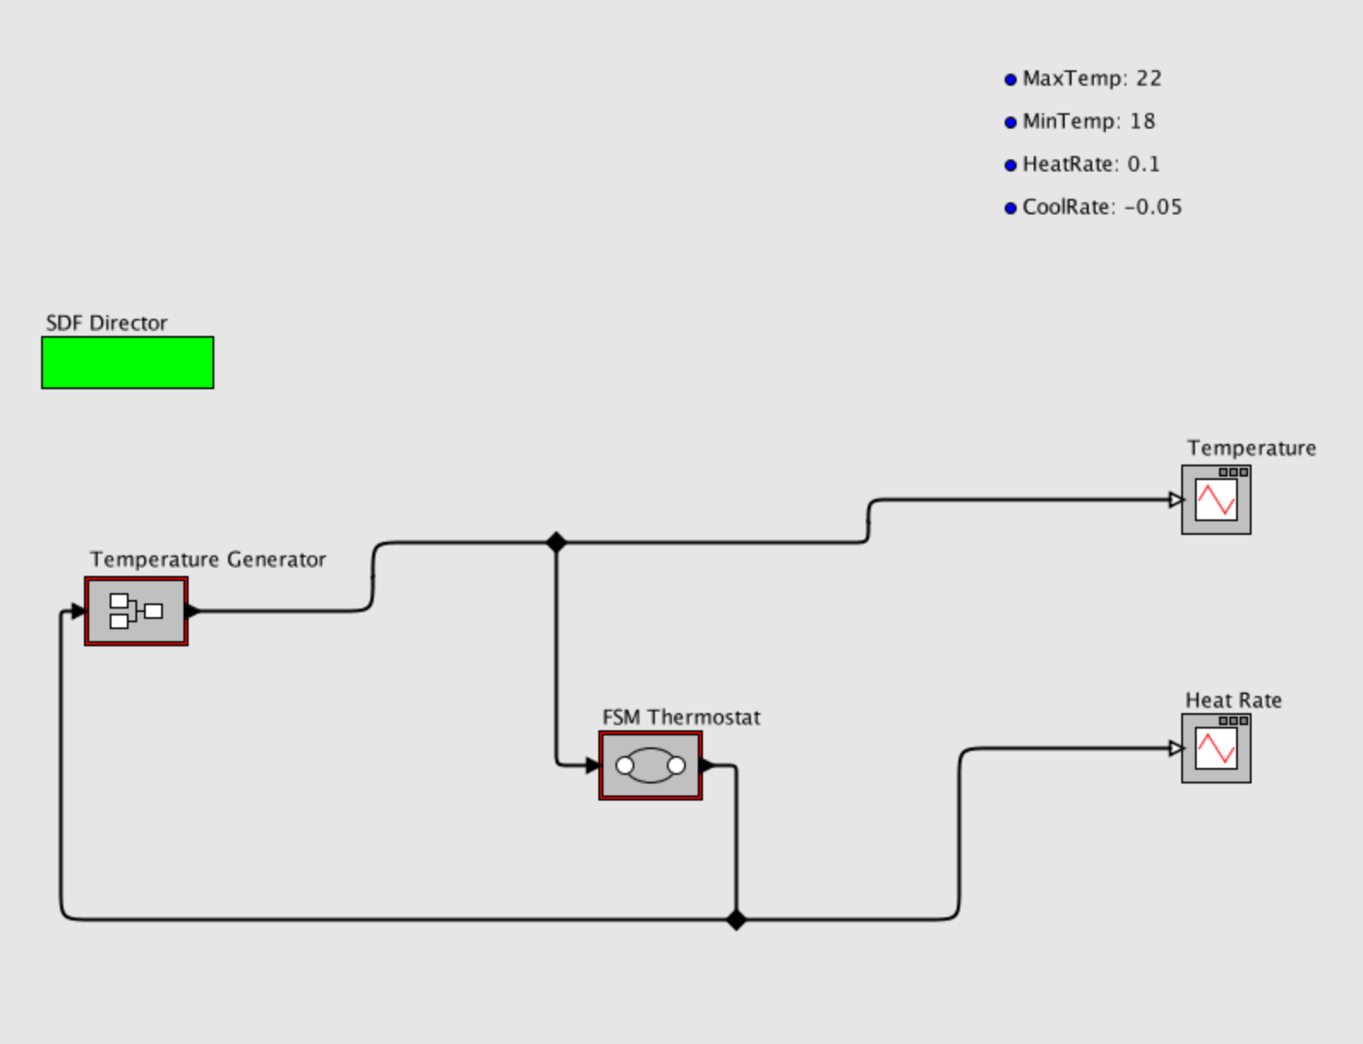

Temperature Generator:

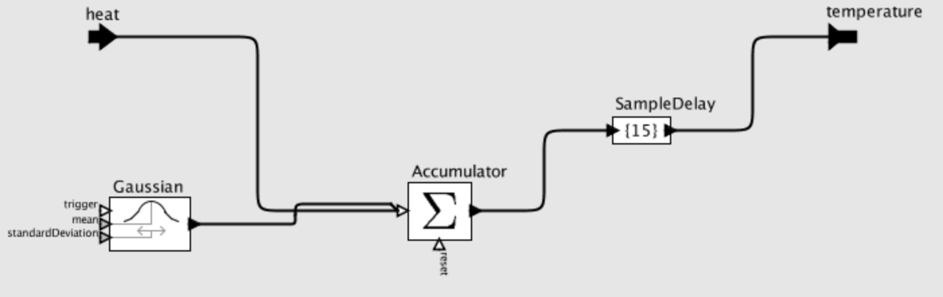

FSM Thermostat:

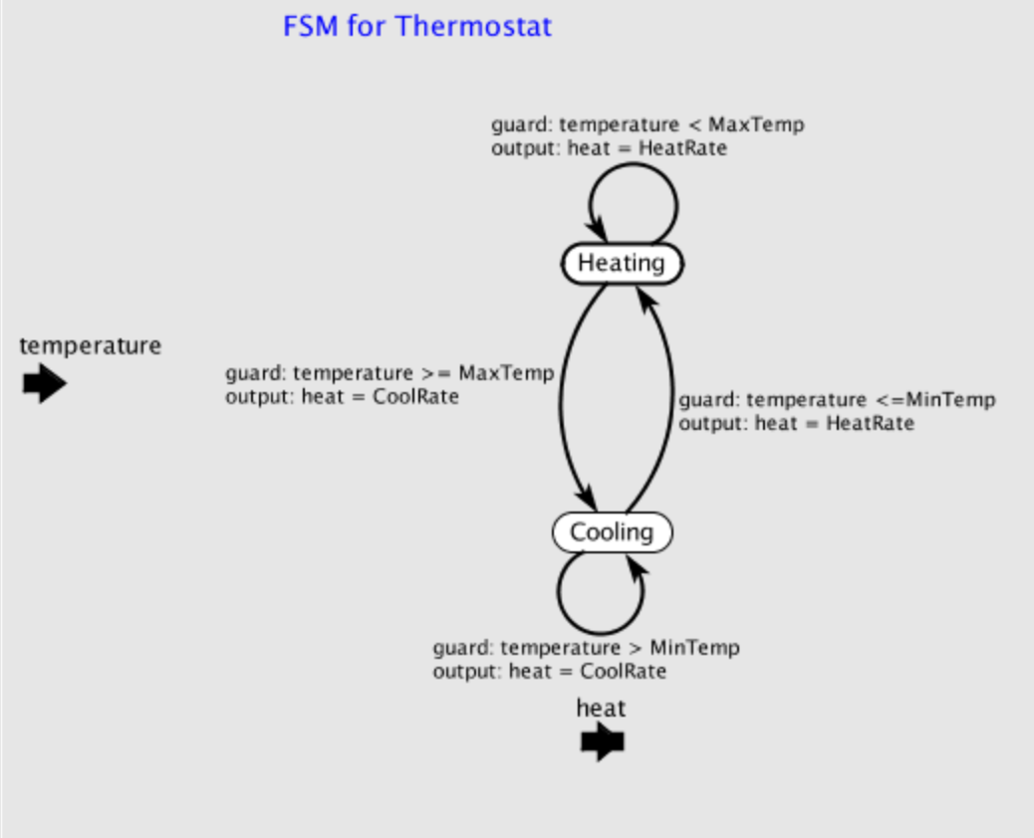

**Output:**

