EXP3 : Model of Time in DE Domain

# Shaan Sundar : 19BPS1082

**Aim:**

To understand the difference between ModelTime and WallClockTime using Clock actors

**ModelTime vs RealTime**

**Procedure:**

1. Drag and drop the given below timed actors, DE director and Timed Plotter into the graphical editor interface
2. Set the PoissonClock to run for a finite number of times
3. Run and observe the difference between model time and real time in the graph
4. Check the SynchronizetoRealTime option in the DE Director and run once
5. Observe the graph that both the lines coincide now

**Design & Output:**

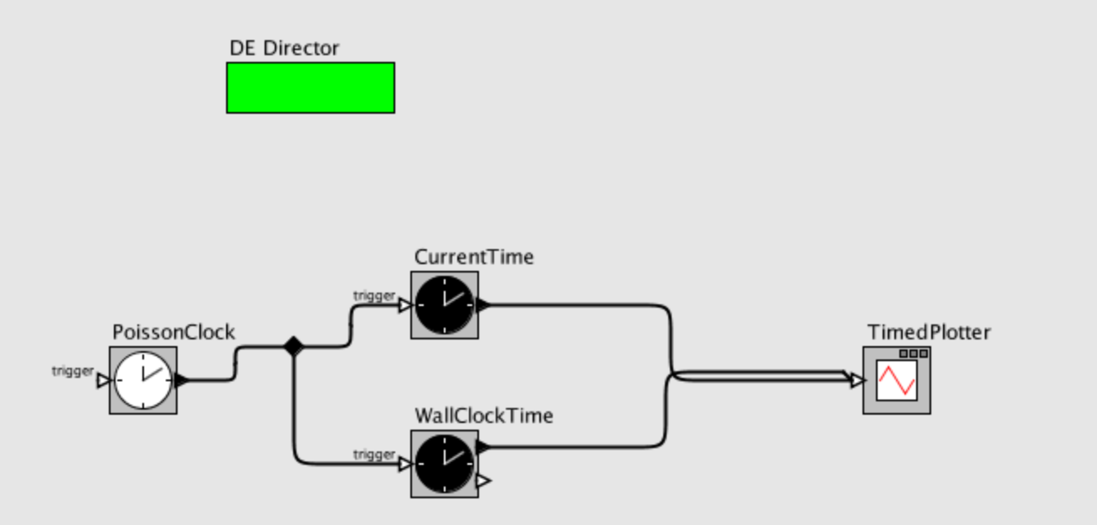

Not Synchronized to Realtime

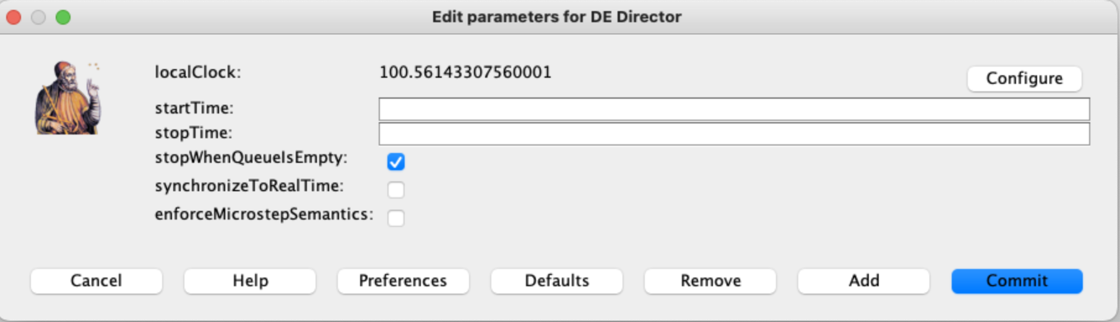

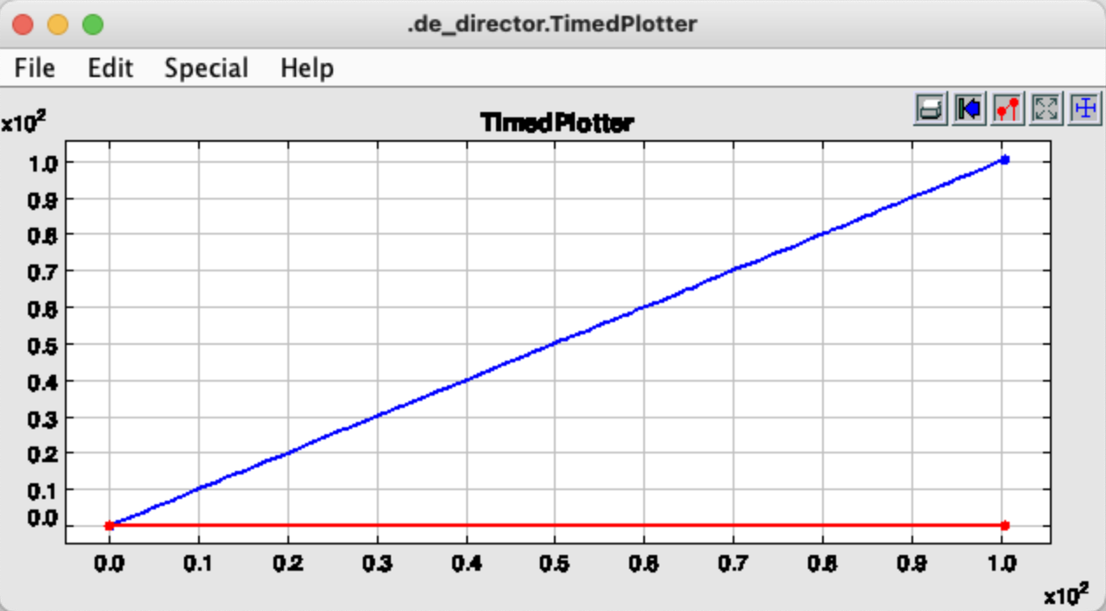

Synchronized to Realtime

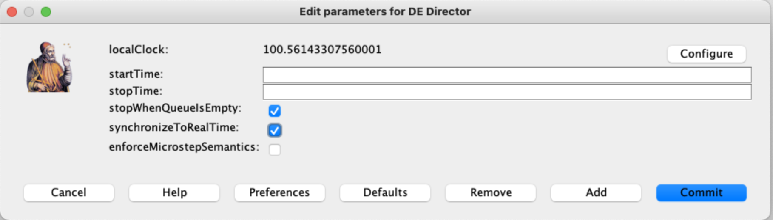

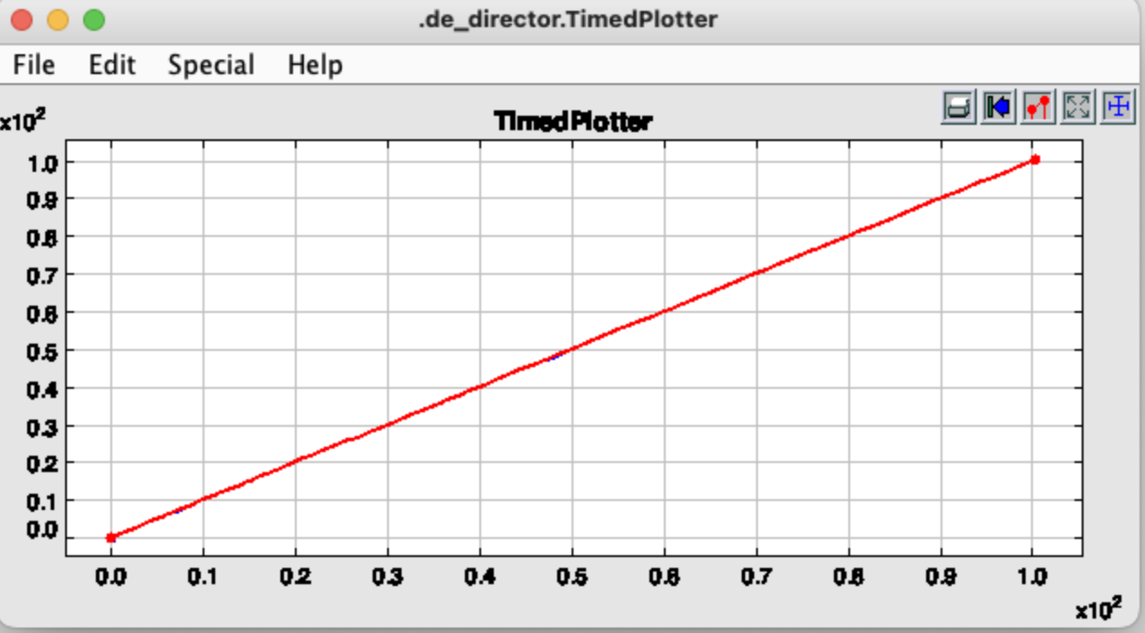

**Interarrival times of Poisson Events**

**Procedure:**

1. Drag and drop the given below timed actors, DE director and Histogram Plotter into the graphical editor interface
2. Set the PoissonClock to run for a finite number of times
3. Run to observe the histogram following a one sided poisson distribution

**Design & Output:**

