EXP4: Round Robin Scheduling

# Shaan Sundar : 19BPS1082

**Aim:**

To design a round robin scheduler with 3 tasks using DE director.

**Procedure:**

1. Drag and drop the below given actors
2. Create the parameters as shown for time quantum, execution times of the 3 tasks
3. Create the FSM model inside the ModalModel as shown.
4. Set the parameters TQ,P1ET, P2ET, P3ET before running the model
5. The output is displayed for the given set of tasks

**Design:**

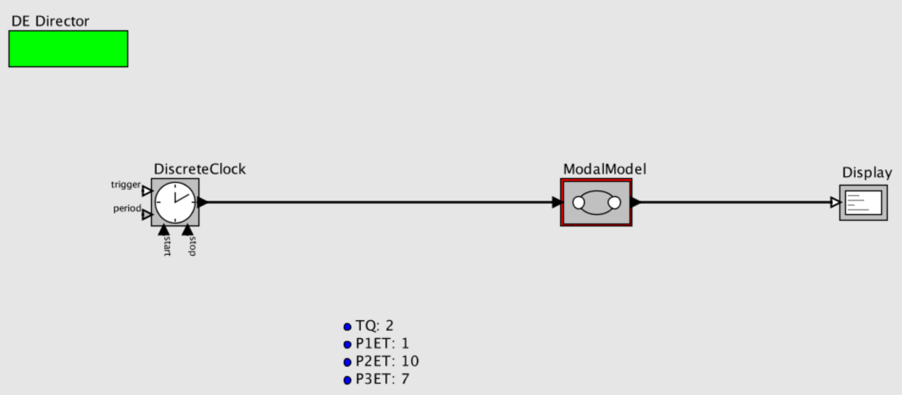

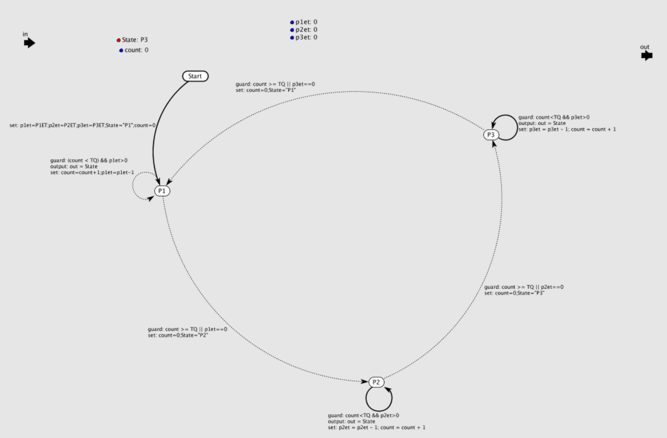

**Output:**

