**Aim:**

To implement table driven scheduling using ptolemy

**Procedure:**

1. Drag and drop the below given actors
2. Create the parameters as shown for task starting times, end time and count inside the FSM model.
3. Create the FSM model inside the ModalModel as shown.
4. The output is displayed for the given set of tasks

**Design:**

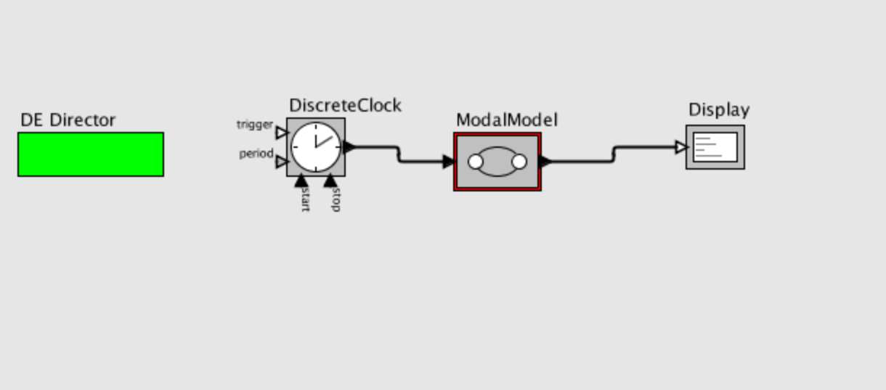

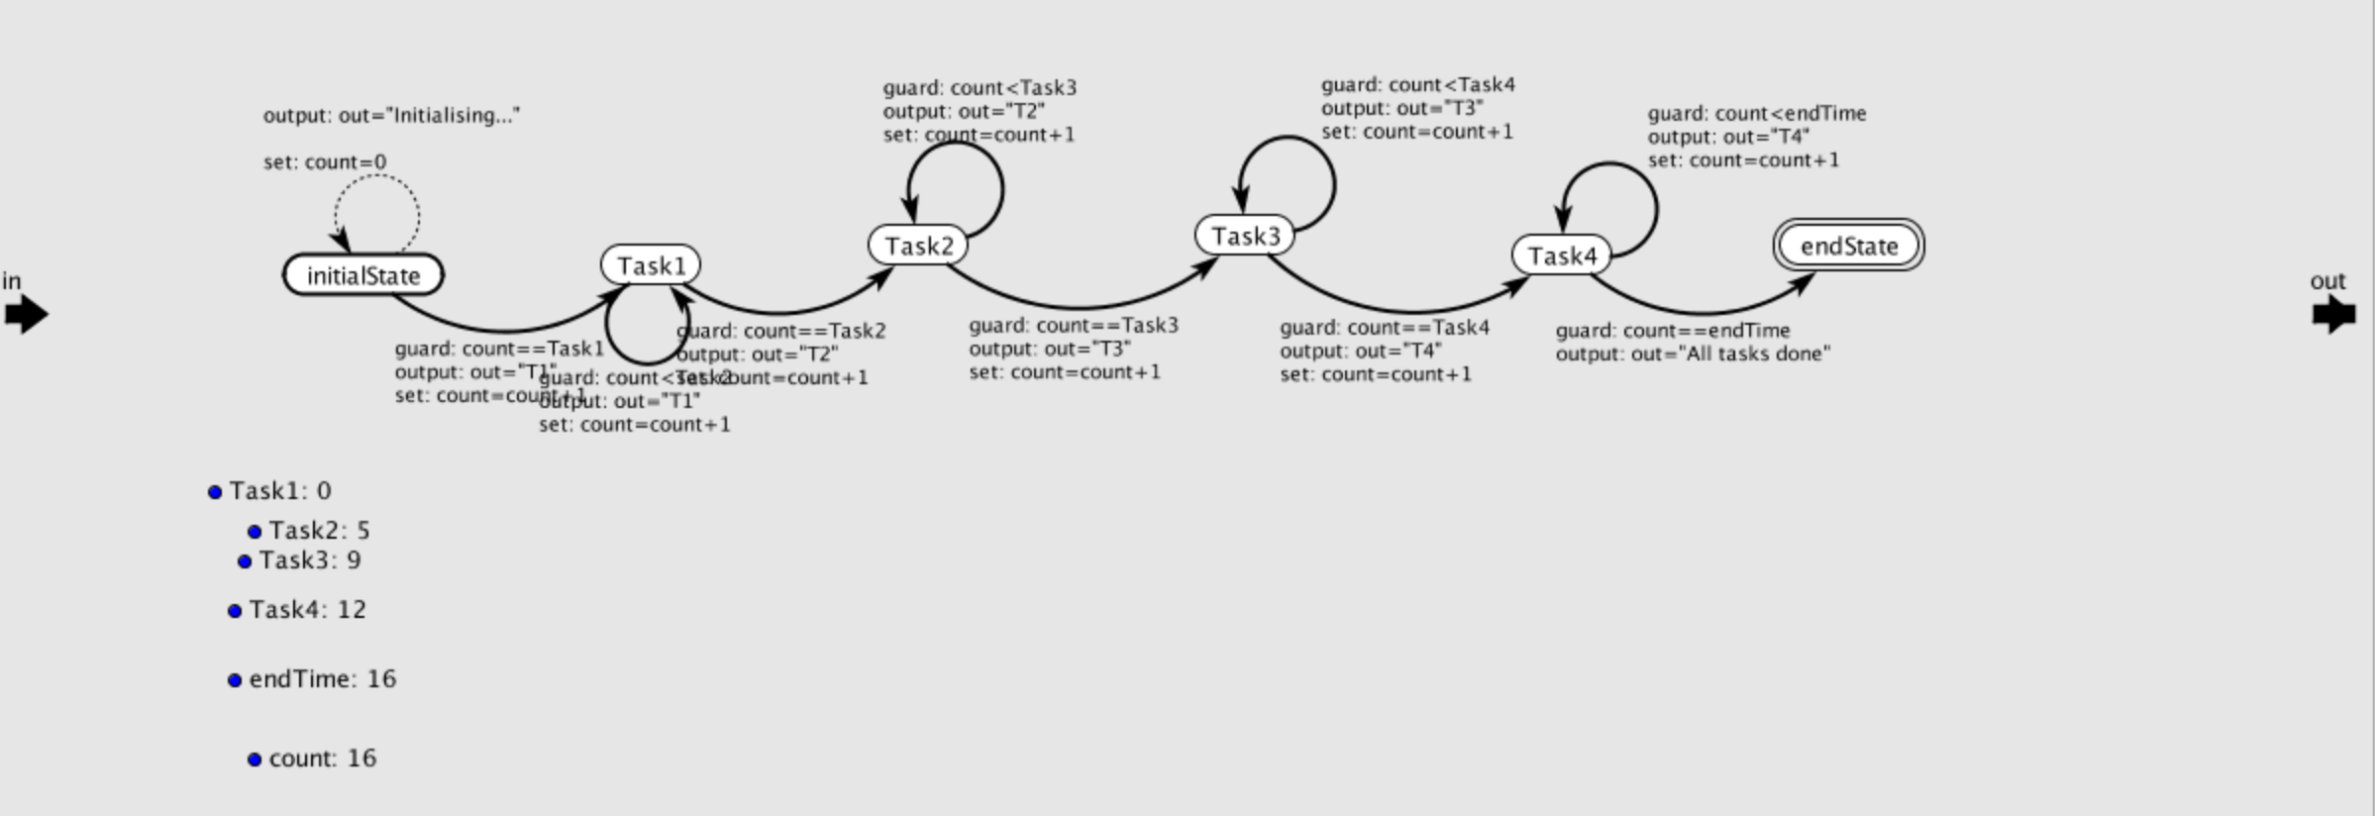

**Output:**

