EXP7 - Cyclic Scheduling

| **Aim :**  To implement a Ptolemy model to illustrate Cyclic Scheduling. |
| --- |

**Procedure :**

1. Drag and drop the below given actors
2. Create the parameters as shown for task period times, completion times and count inside the FSM model.
3. Create the FSM model inside the ModalModel as shown.
4. The output is displayed for the given set of tasks

**Design :**

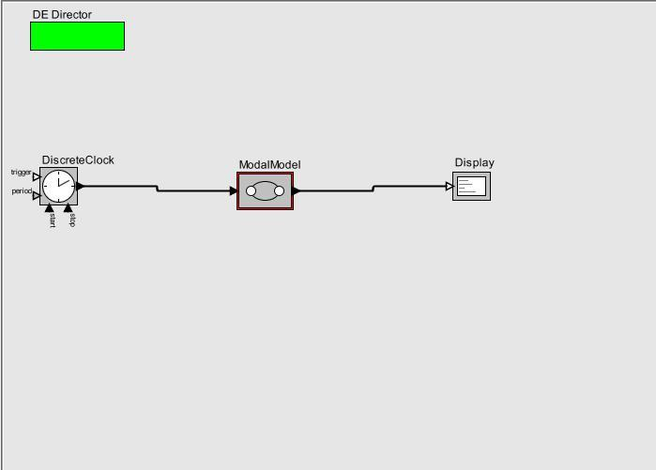

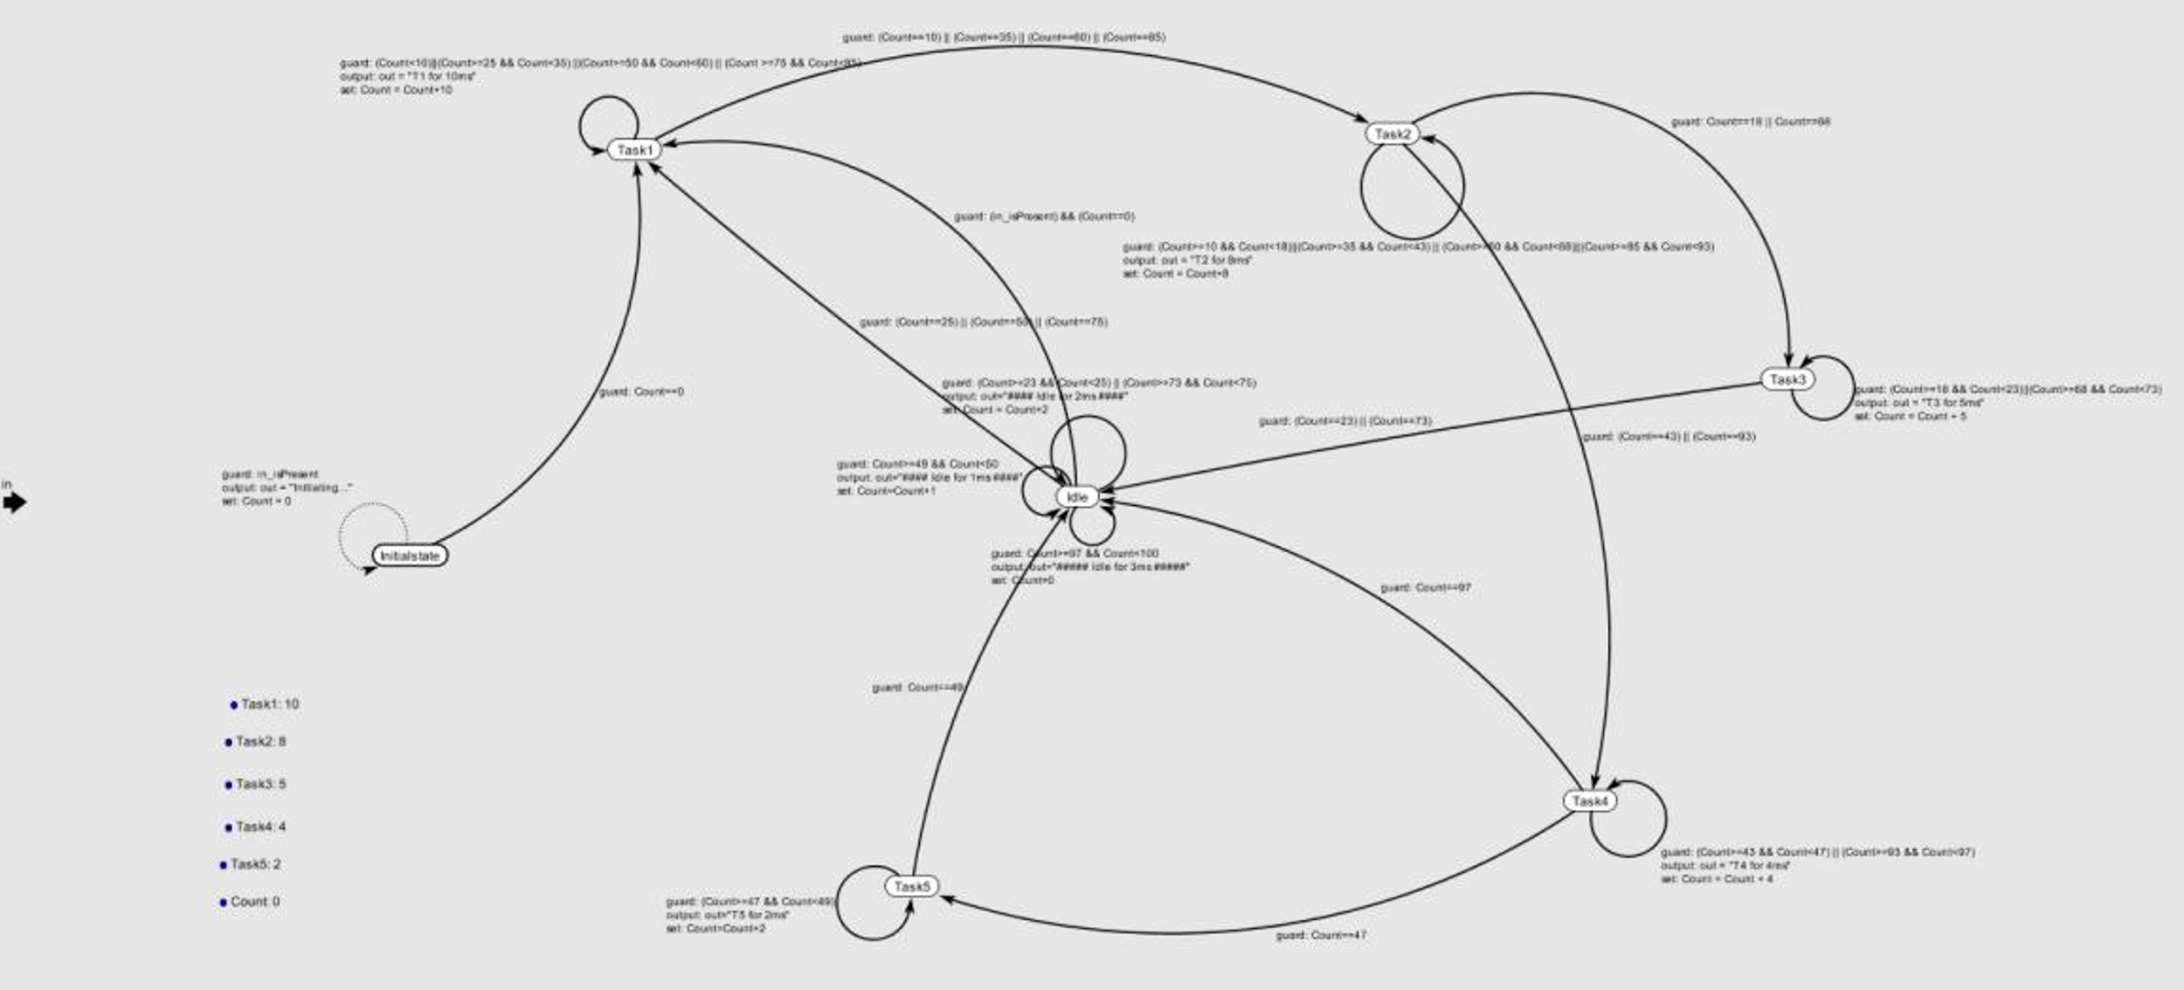

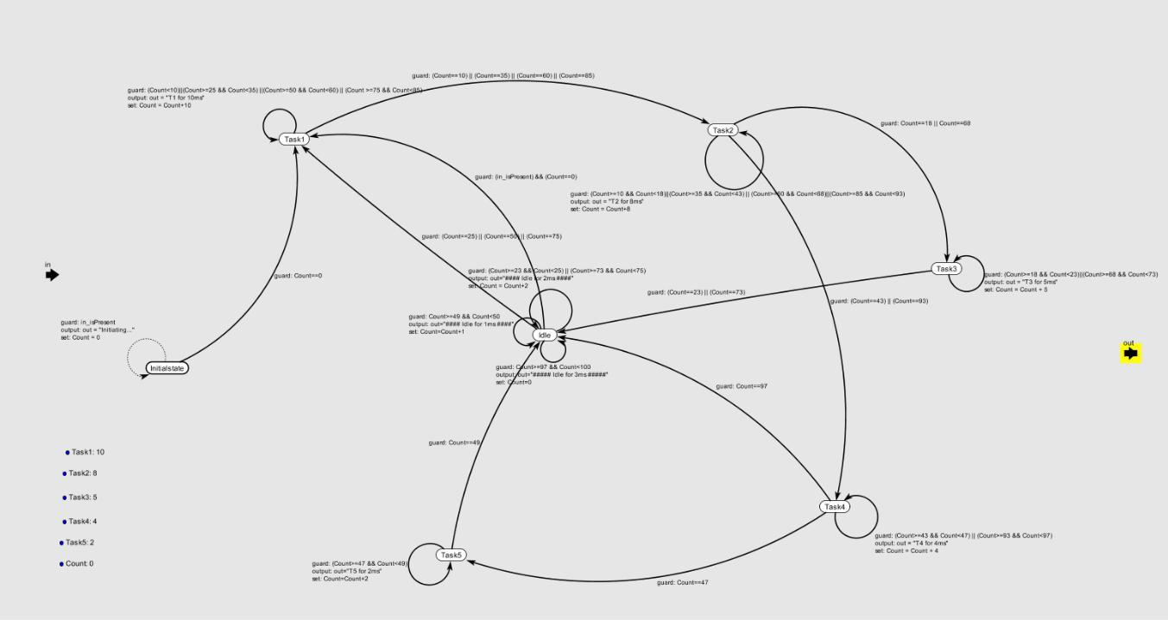

**Output :**

