EXP1 : Traffic light simulation

Shaan Sundar - 19BPS1082

Aim:
To Design a traffic light simulation model using Ptolemy with three states – Red, Orange, Green

Procedure:
- Drag and drop the given below actors/sources/sinks/directors into the graphical editor
- Change number of iterations of SDF director to 30
- Create FSM model as given below in the ModalModel Actor
- Set the delay as per requirement preferably delay>no. of iterations
- Connect the components as shown and run

Design:

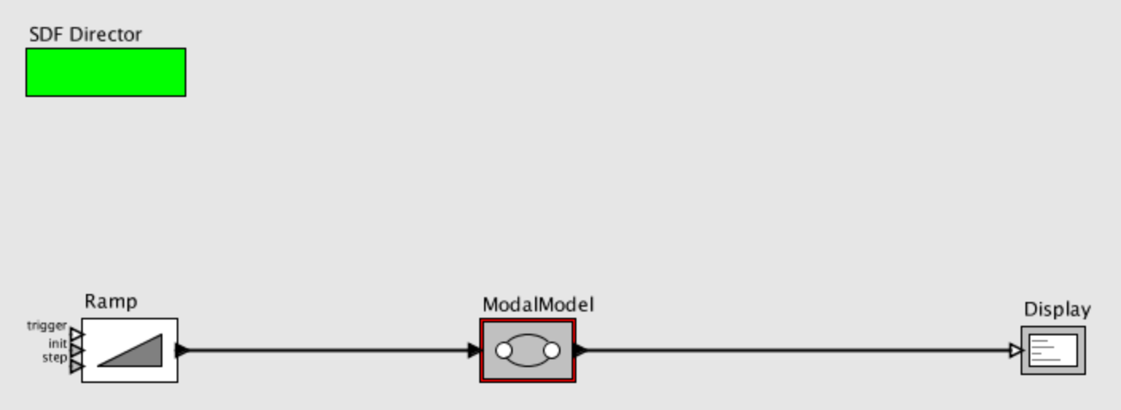
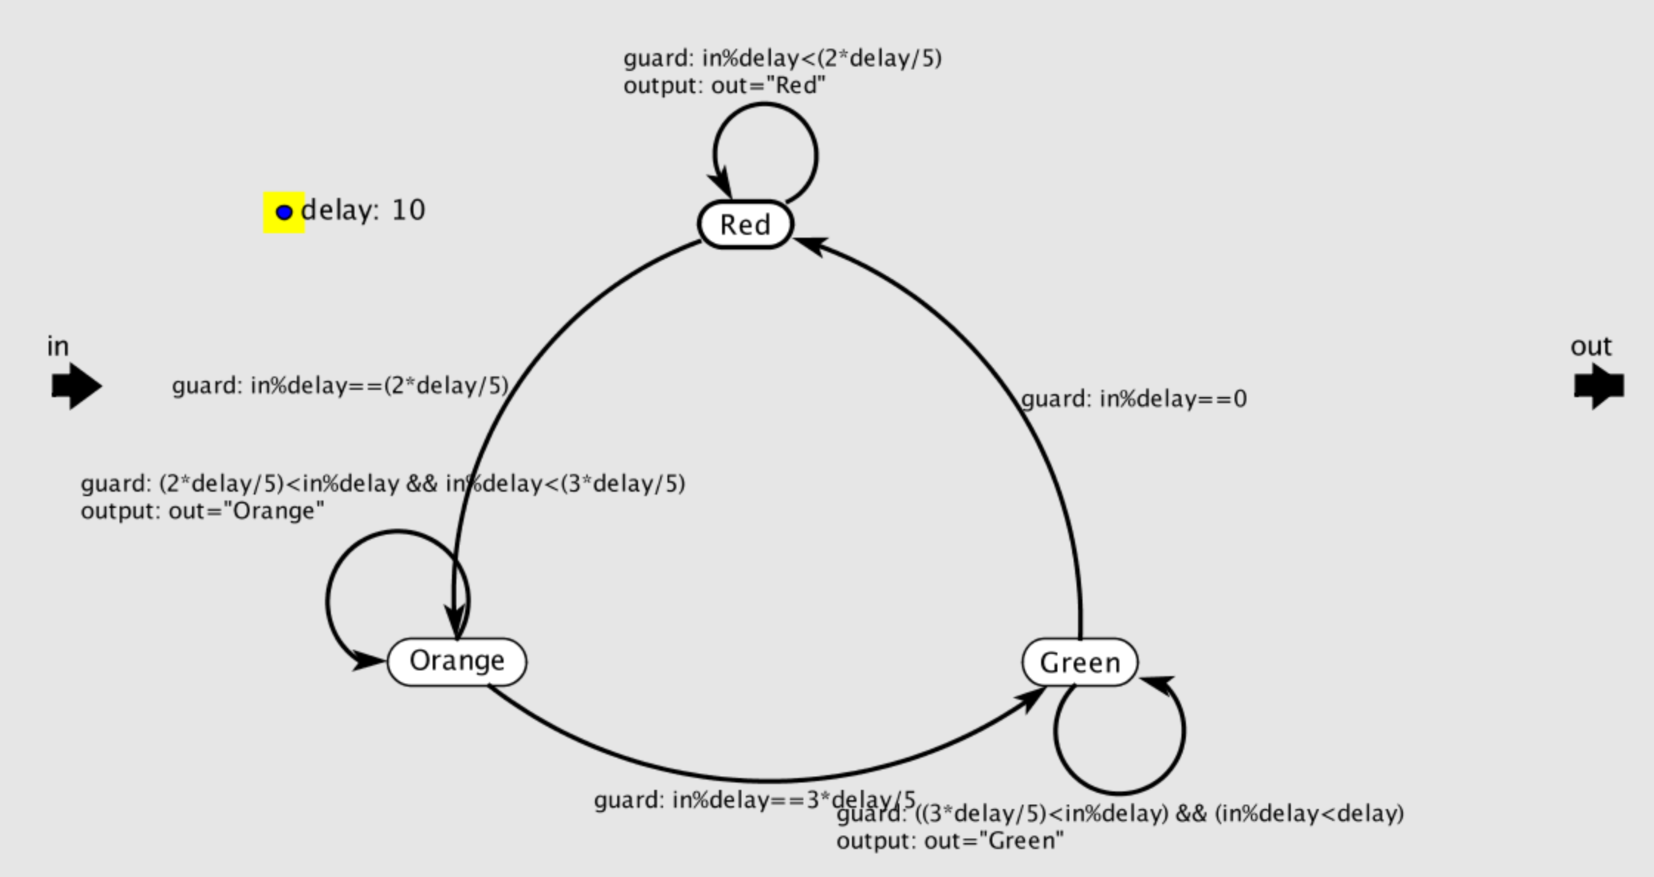

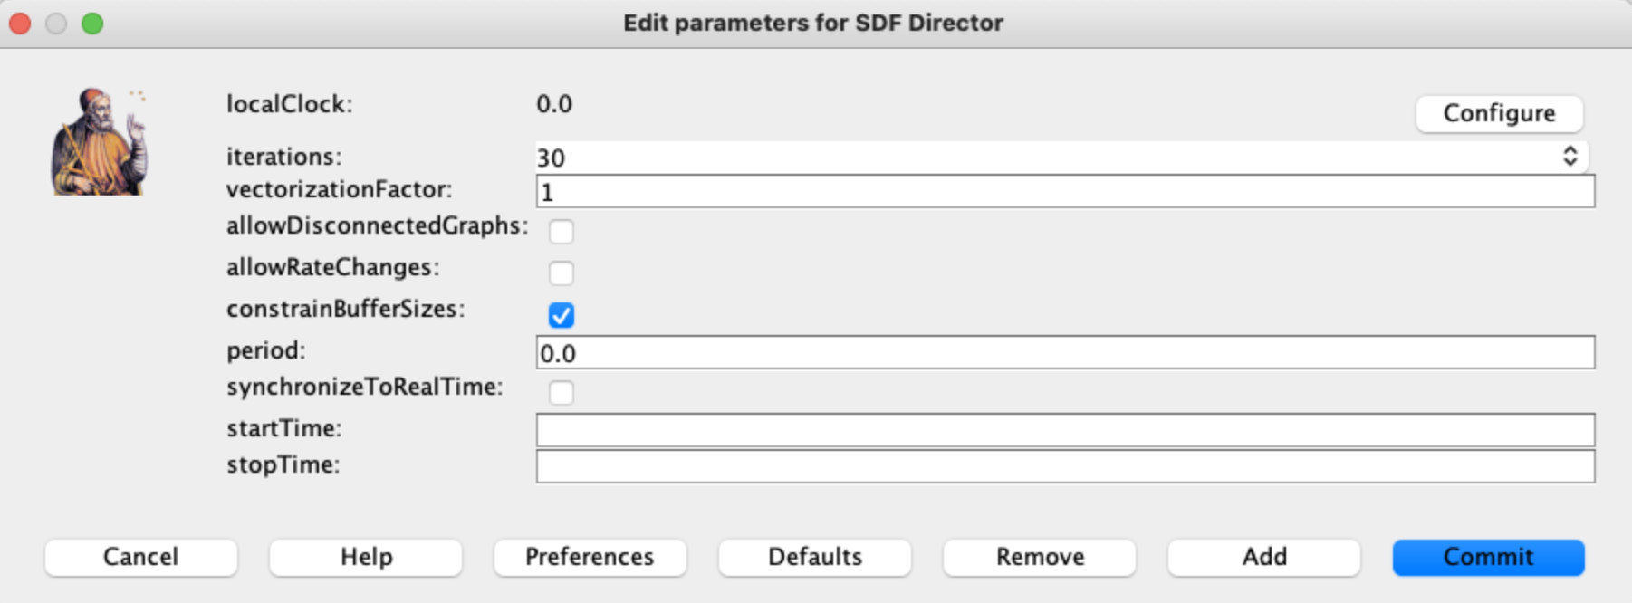

Output:

