1) Find all employees whose Employee name ends with 'N'. List the
employee number, the Employee name, and the last character of the Employee name.
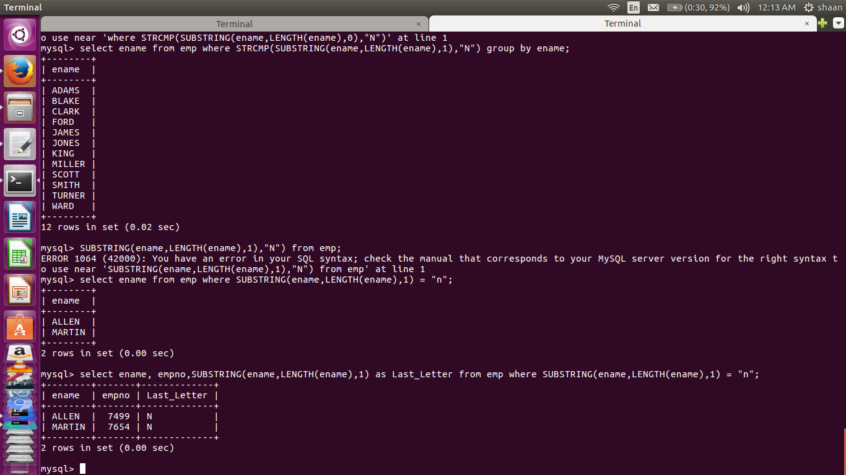

2) write a procedure to increment the sallary of employee who works in sales department
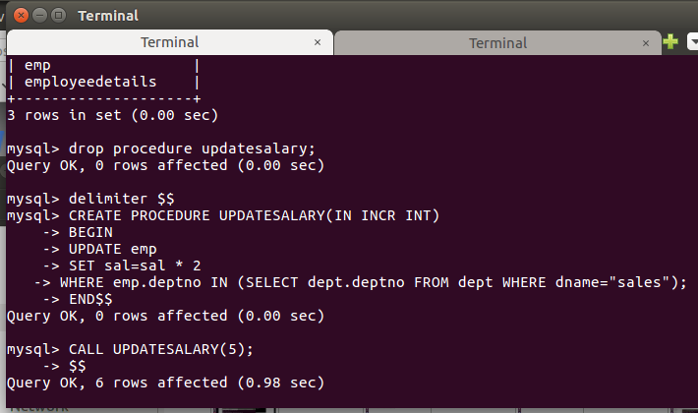
Before Update :-
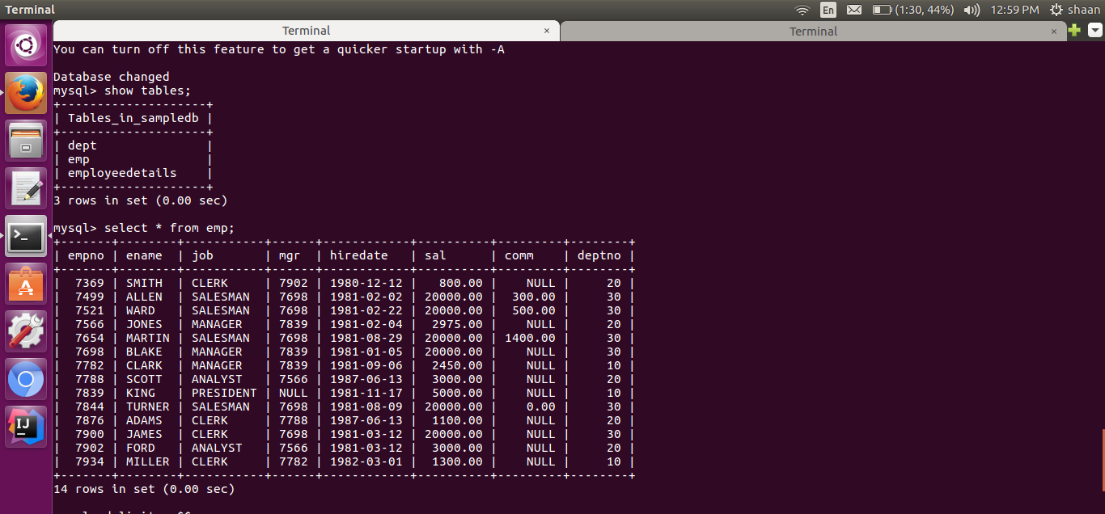
After Update:-
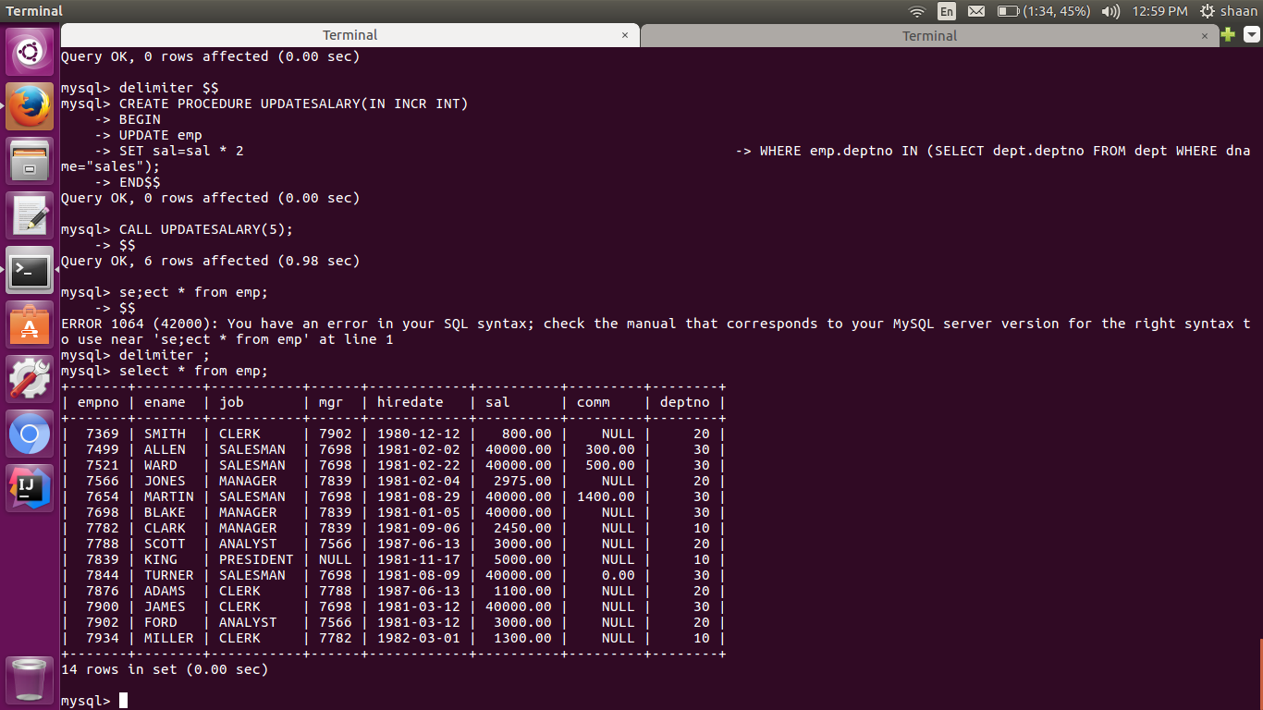

3.write a function to find the total salary of employees, who works in Accounts department

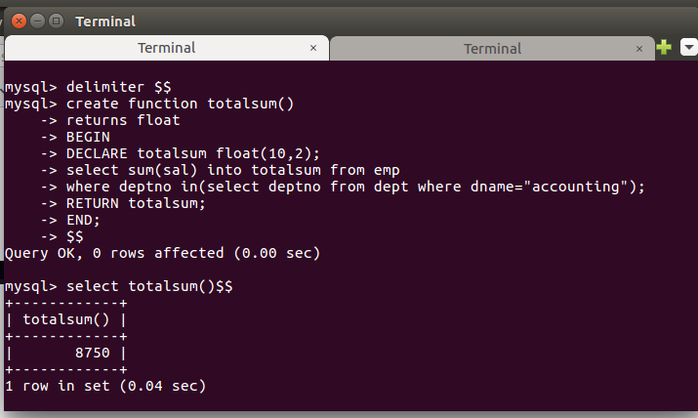

4.Create a new table for keeping transaction records,record will be updated in this table when there is deduction in the salary,when salary is deducted a trigger is executed which insert employee name ,updatedby ,changedsalary,updateddate in new table.

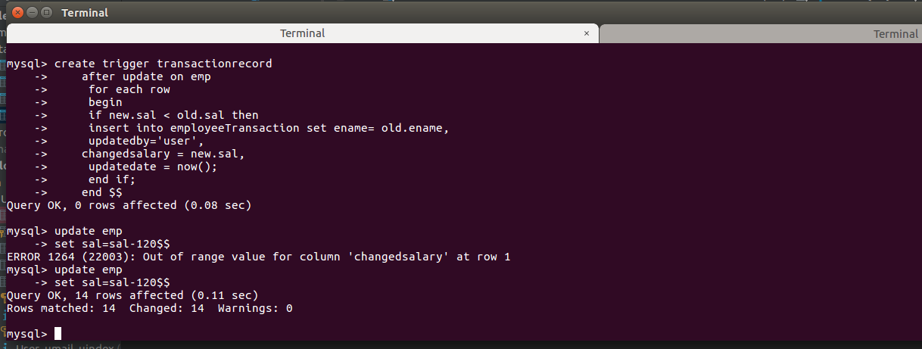

New table creation :-

