Abelam Private Ledger
AI-Powered Real Estate Acquisition Platform

MILESTONE 1 — TECHNICAL DOCUMENTATION
Document Intake, Processing & AI Agent Pipeline

Version 1.0 | April 2026
Confidential — For Client Review Only

1. Executive Summary
Abelam Private Ledger is an AI-powered real estate acquisition platform designed to automate the document-heavy due diligence process in commercial and multi-family real estate transactions. The platform ingests property documents (leases, rent rolls, offering memorandums, and financial statements), processes them through an intelligent OCR pipeline, and applies a 5-agent AI system to extract, validate, underwrite, and report on each deal.
Milestone 1 delivers the complete end-to-end pipeline: from document upload through AI-powered analysis to deal report generation. This document provides a technical overview of the implemented architecture, features, and capabilities.

2. Technology Stack
The platform is built on a modern, production-grade stack:
Layer | Technology | Runtime
Backend | FastAPI, SQLAlchemy (async), SQLite | Python 3.13
Frontend | React 18, TypeScript, Vite | Node.js
AI / LLM | OpenAI GPT-4o, LangGraph, LangChain | OpenAI API
OCR | AWS Textract, PyMuPDF (fallback) | AWS SDK
Vector Store | Pinecone (text-embedding-3-small) | Pinecone API
Auth | JWT (python-jose), bcrypt | HS256

3. Architecture Overview

3.1 System Architecture
The system follows a three-tier architecture with clear separation of concerns:
- Frontend (React/TypeScript) — Single-page application for portfolio management, document upload, and deal review
- Backend (FastAPI) — RESTful API with async SQLAlchemy ORM, JWT authentication, and WebSocket support for real-time pipeline status
- AI Pipeline (LangGraph) — 5-agent state machine orchestrating document classification, extraction, validation, underwriting, and reporting
- Vector Store (Pinecone) — Semantic search over indexed document chunks for RAG-powered chatbot

3.2 Data Model
The entity hierarchy follows a property-centric design:
- Tenant → Multi-tenant organization isolation
- Property → Real estate asset with address, type, unit count
- Document → Uploaded file with OCR text, AI classification, and processing status
- Deal → Structured financial analysis output from the AI pipeline
- Apartment → Individual unit within a property (rent, lease terms, tenant info)
- ChatMessage → RAG chatbot conversation history with source citations

3.3 API Endpoints
The backend exposes a RESTful API organized into the following modules:
Module | Prefix | Endpoints
Auth | /api/auth | Login, register, JWT token management
Documents | /api/documents | Upload, list, get, verify, delete documents
Properties | /api/properties | CRUD for properties and apartment units
Agents | /api/agents | Trigger AI pipeline, status, WebSocket updates
Chat | /api/chat | RAG-powered concierge conversations
Deals | /api/deals | View AI-generated deal analyses

4. Document Intake & Processing (Section A)

4.1 Document Upload & Acceptance
The platform accepts the following document types for real estate due diligence:
- Leases — Individual apartment lease agreements and renewals
- Rent Rolls — Portfolio-level tenant and revenue summaries
- Offering Memorandums — Investment prospectus with financial projections
- Financial Statements — Operating expense reports, tax assessments, insurance documents
Documents are uploaded via a multi-file upload endpoint with category tagging. Supported formats include PDF, JPG, PNG, and TIFF. Each document is stored on disk with a UUID-based filename and tracked in the database with full metadata.

4.2 OCR Processing
The OCR pipeline uses a three-tier extraction strategy for maximum reliability:
- Tier 1 (Institutional Grade): PDF pages are rendered to 300 DPI images using pdf2image or PyMuPDF, then processed page-by-page through AWS Textract for highest fidelity extraction
- Tier 2 (Direct Textract): For non-PDF files or as a fallback, documents are sent directly to AWS Textract
- Tier 3 (Local Fallback): If cloud services are unavailable, PyPDF2 is used for basic text extraction from digital PDFs
OCR results include extracted text, confidence scores, and geometric block data. Documents with confidence below 85% are automatically flagged for Human-in-the-Loop (HITL) review.

4.3 Auto-Classification & Structured Data Extraction
Each document is classified using GPT-4o into one of seven categories: due_diligence, lease, expense, financial, legal, condition, or photo. The AI also assigns a subcategory and confidence score.
Structured data extraction uses GPT-4o to pull financial fields (purchase price, NOI, cap rate, gross revenue, operating expenses), lease terms (tenant name, unit number, monthly rent, dates), and expense items (type, amount, period, vendor) into a normalized JSON schema.

4.4 RAG-Based Document Retrieval
After processing, document text is chunked (1000 characters with 200-character overlap), embedded using OpenAI text-embedding-3-small, and stored in a Pinecone vector index with tenant and property-level isolation.
The RAG chatbot (Investment Concierge) performs semantic search over indexed documents, builds a context window from the top 6 matching chunks, and generates responses using GPT-4o with source citations. Conversation history is maintained for multi-turn interactions.

5. AI Agent System — 5 Modular Agents (Section B)
The core of the platform is a LangGraph StateGraph pipeline that orchestrates five specialized agents in sequence, with conditional routing for error recovery and HITL escalation.

5.1 Pipeline Flow
START → Intake → Extraction → Validation → Underwriting → Reporting → END
The Validation agent can loop back to Extraction up to 3 times if data inconsistencies are detected. After 3 failed retries, the pipeline halts and escalates to human review.

5.2 Agent Details
Agent | Role | Details
Intake | Receives, validates, routes documents | Initial classification by filename pattern, text length validation
Extraction | AI classification and data extraction | GPT-4o classifies documents into 7 categories, extracts structured financial fields
Validation | Data consistency and completeness checks | NOI consistency, cap rate validation, negative value checks, retry loop (max 3)
Underwriting | Financial metric calculations | Computes NOI, Cap Rate, GRM, Cash-on-Cash, Expense Ratio, Deal Score (0-100)
Reporting | AI-generated executive summaries | GPT-4o writes 3-5 paragraph deal summary with risk factors and recommendation

5.3 Underwriting Metrics
The Underwriting Agent computes the following financial metrics:
- Net Operating Income (NOI) = Gross Revenue − Operating Expenses
- Cap Rate = (NOI / Purchase Price) × 100
- Gross Rent Multiplier (GRM) = Purchase Price / Gross Revenue
- Expense Ratio = (Operating Expenses / Gross Revenue) × 100
- Cash-on-Cash Return = (NOI − Debt Service) / Down Payment × 100 (assumes 75% LTV, 6.5% debt constant)
- Deal Score (0-100) — Composite score based on cap rate, cash-on-cash, expense ratio, and risk factors

5.4 Risk Flagging (Estimated)
The system automatically flags the following risk indicators:
- Cap rate below 4% — Potentially overpriced asset
- Cap rate above 10% — Higher risk profile
- Expense ratio above 55% — Operating cost concern
- Negative cash-on-cash — Deal may not cash flow
- Missing lease data — Tenant stability unknown

6. Milestone 1 Feature Status

6.1 Section A — Document Intake & Processing
Feature | Details | Status
Document acceptance (leases, rent rolls, OMs, financials) | Multi-file upload with category tagging; PDF, JPG, PNG, TIFF | Implemented
OCR for scanned/image documents | AWS Textract + pdf2image (300 DPI) + PyPDF2 fallback | Implemented
Auto-classification & extraction | GPT-4o classification (7 categories) + structured field extraction | Implemented
RAG vector database | Pinecone with OpenAI embeddings; requires external Pinecone setup | Implemented

6.2 Section B — AI Agent System (LangGraph)
Feature | Details | Status
Intake Agent | Routes, logs, validates file type and content length | Implemented
Extraction Agent | GPT-4o classification + structured deal data extraction | Implemented
Validation Agent | NOI/cap rate consistency, retry loop (max 3), HITL escalation | Implemented
Underwriting Agent | NOI, Cap Rate, GRM, Cash-on-Cash, Deal Score | Implemented
Reporting Agent | GPT-4o executive summary + markdown deal report | Implemented

7. Application Screenshots

7.1 Login Page
Secure authentication with JWT-based session management and multi-tenant isolation.
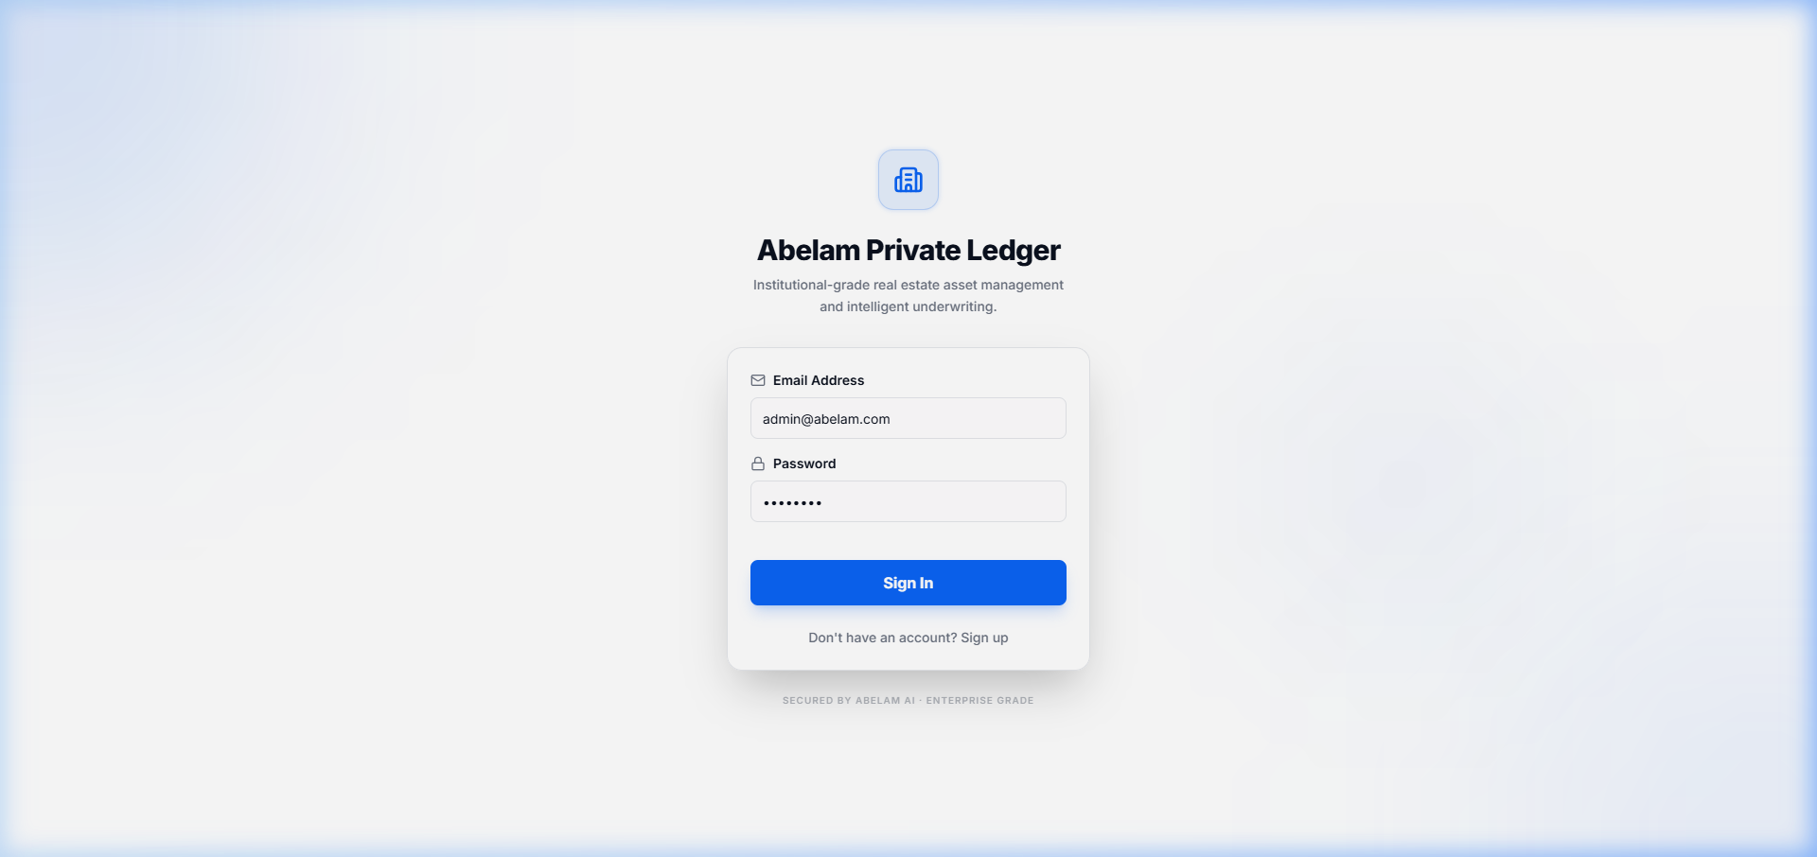

7.2 Institutional Dashboard
Portfolio overview with real-time metrics: total properties, document count, active deals, and HITL review queue. Recent AI structuring activity is displayed with document status tracking.
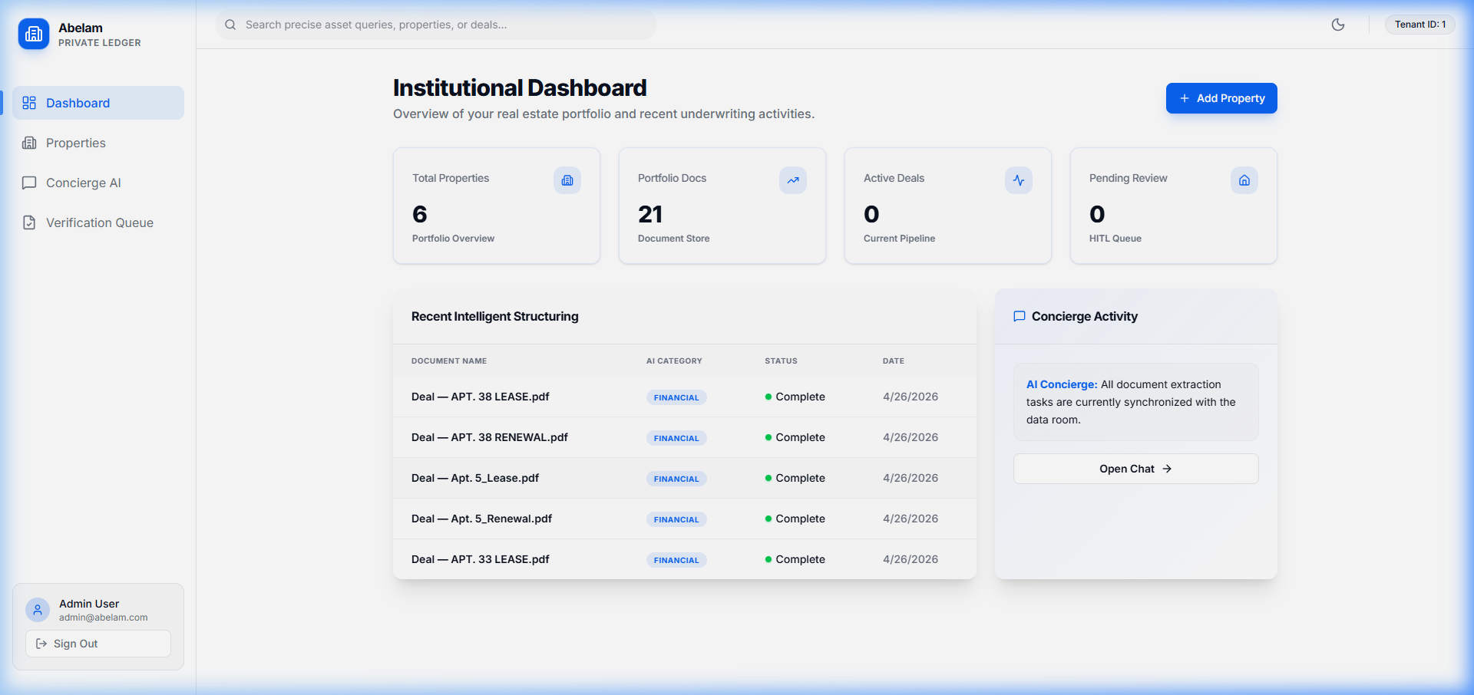

7.3 Property Portfolio
Grid and list views for managing real estate assets. Each property card shows address, unit count, and quick access to the data room.
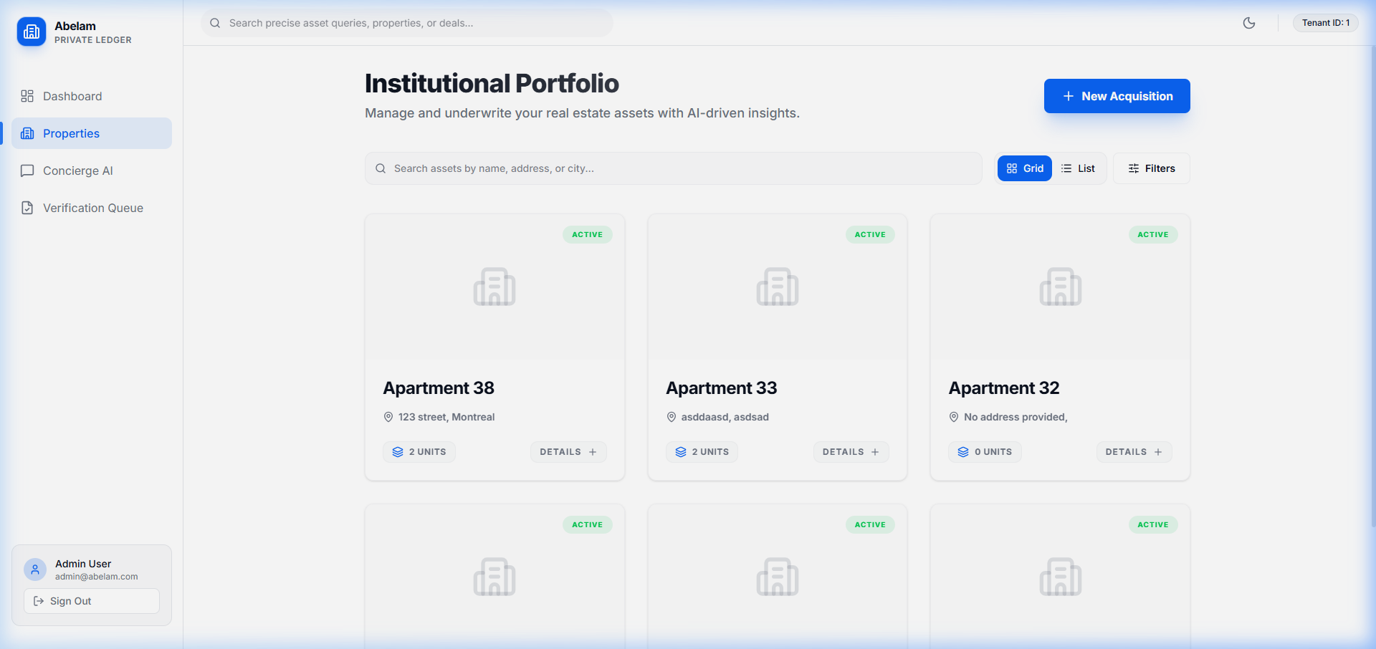

8. Deployment & Configuration

8.1 Environment Variables
The following environment variables must be configured in the backend .env file:
- OPENAI_API_KEY — Required for AI classification, extraction, summaries, and embeddings
- AWS_ACCESS_KEY_ID / AWS_SECRET_ACCESS_KEY — Required for Textract OCR (has PyPDF2 fallback)
- PINECONE_API_KEY / PINECONE_INDEX — Required for RAG vector search (degrades gracefully if absent)
- SECRET_KEY — JWT signing key for authentication
- DATABASE_URL — SQLite connection string (default: sqlite:///./test.db)

8.2 Running Locally
Backend: python -m uvicorn app.main:app --reload --port 8001
Frontend: npm run dev (serves on http://localhost:5173)
Docker: docker-compose up --build (full stack with PostgreSQL and Redis)

9. Next Steps
With Milestone 1 complete, the following enhancements are recommended for Milestone 2:
- PostgreSQL migration for production-grade data persistence
- ChromaDB local fallback for RAG when Pinecone is unavailable
- Celery/Redis background task queue for scalable document processing
- Enhanced HITL review interface with side-by-side OCR correction
- Pro-forma financial modeling with interactive projections
- Role-based access control enforcement across all endpoints

