**Zerodha:**

* Process for installing the libraries:

1. Open command prompt (start menu --> type cmd)

2. pip install Twisted

3. pip install KiteConnect

4. pip install pandas

5. pip install xlwings

6. pip install flask

7. pip install pandas_ta

8. pip install ta

9. pip install requests

* When it is showing **wheel is not supported or any other error** while installing the Twisted library:

1. open the below <https://drive.google.com/drive/u/0/folders/1fGsytsaWwcdVNFEBpGL6EJfR_CvMawuW>
2. go to the folder 🡪 Zerodha (installation + login)
3. download twisted_iocpsupport-1.0.2-cp311-cp311-win_amd64.whl
4. Open downloads folder, click on the address bar, type CMD and hit enter
5. Type the following command and hit enter
6. pip install twisted_iocpsupport-1.0.2-cp311-cp311-win_amd64.whl

This process is shown in this video:

<https://drive.google.com/file/d/1Mx20P598zxbxFrzh4jdyW-5pKAOErl7P/view?usp=share_link>

**Zerodha Access Token**

1. Login to Zerodha on Chrome
2. Get api key and secret key from <https://developers.kite.trade/apps>

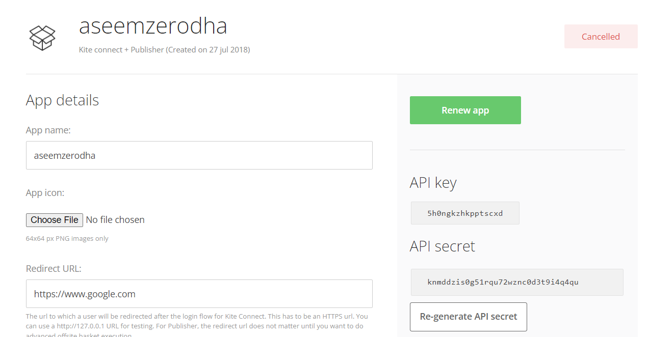

1. Add your api details (api key and secret key) to the zerodha_python file and then run

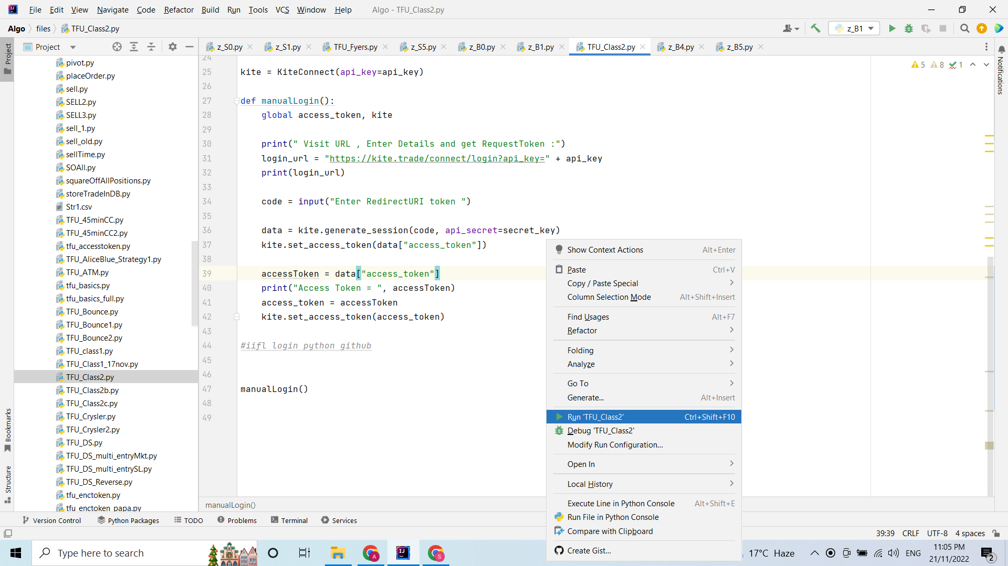

1. Copy the link from the terminal and paste it on Chrome and then press enter.

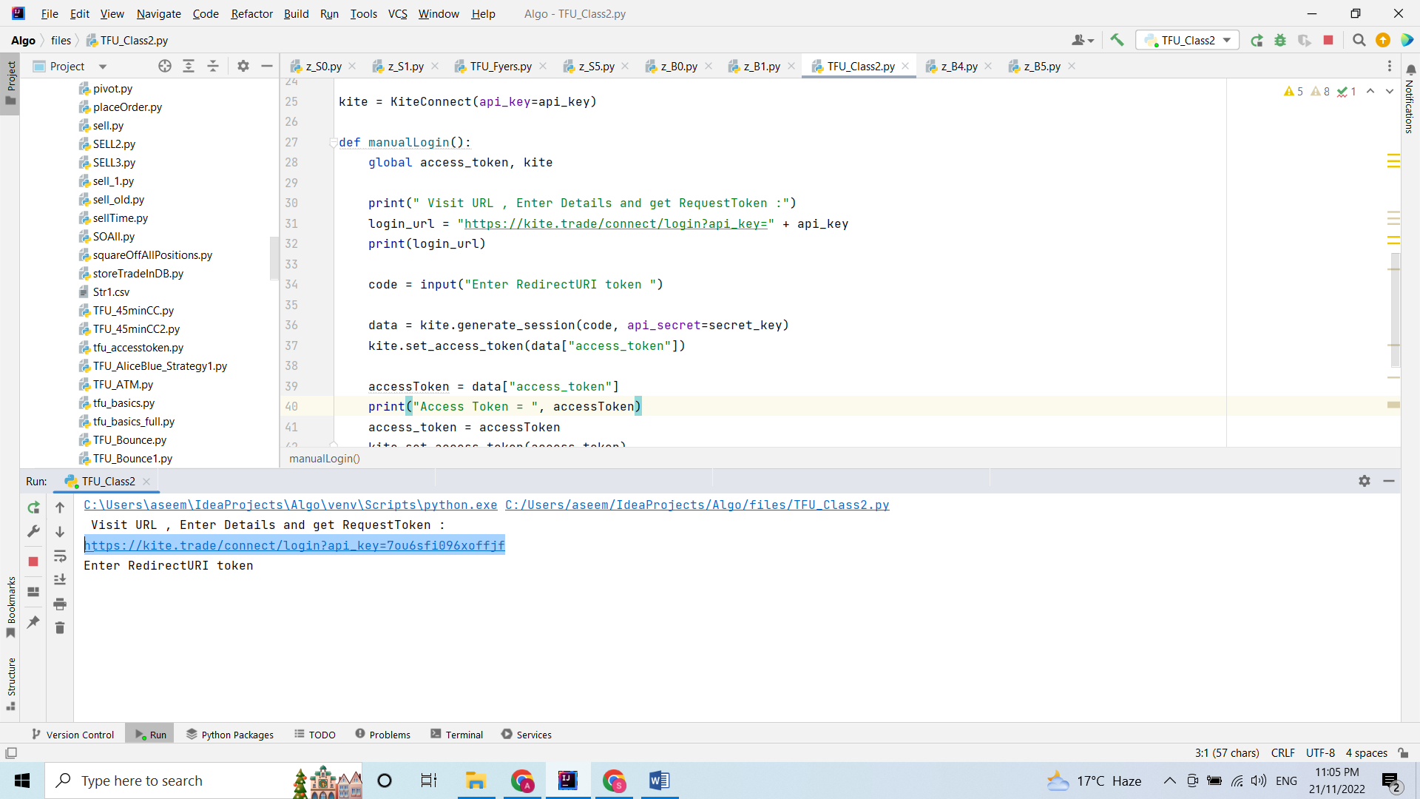

1. Then you will get this kind of URL. Copy request_token:

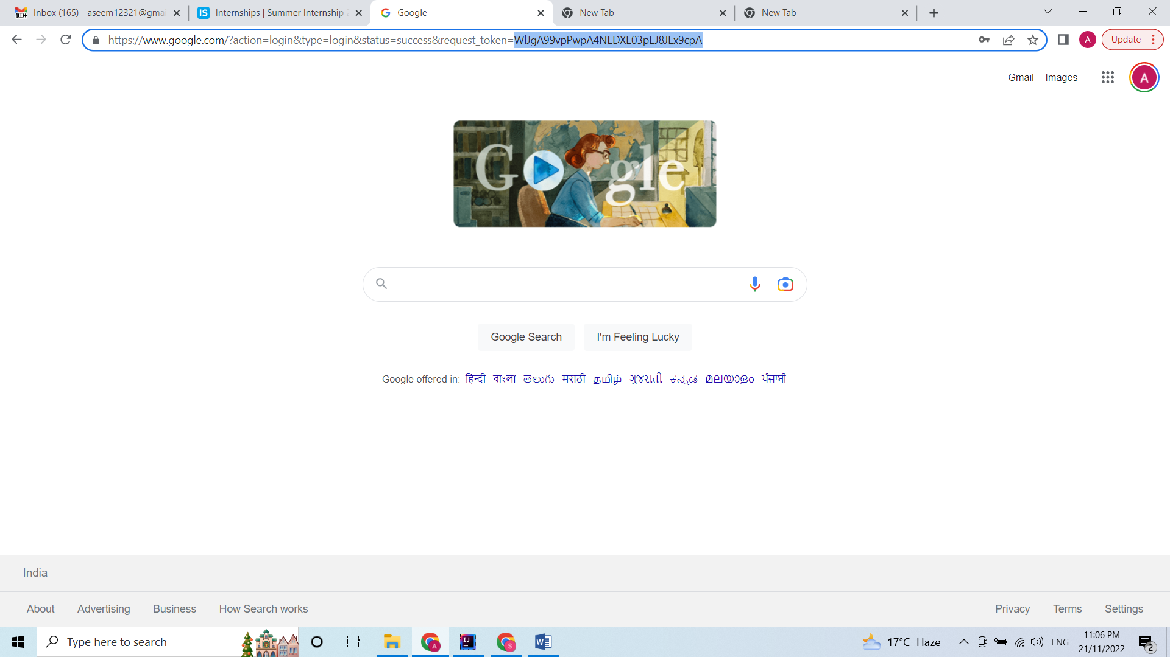

1. Paste the request token in the terminal:

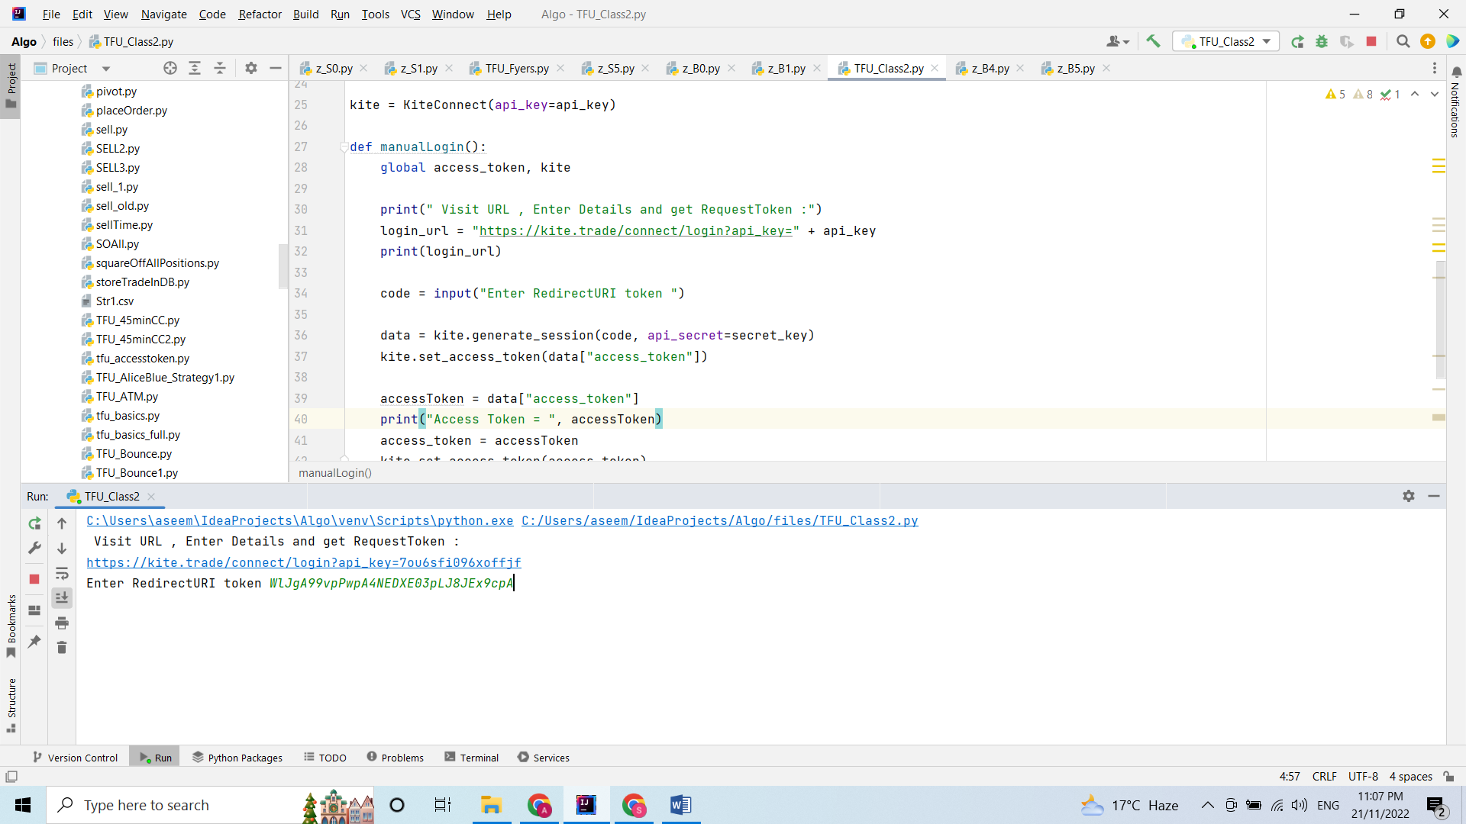

1. Press enter. Then you will get the ACCESS TOKEN

