**Fyers:**

* Process for installing the libraries:

1. Open command prompt (start menu --> type cmd)
2. pip install fyers_apiv3
3. pip install flask
4. pip install xlwings
5. pip install pandas
6. pip install requests
7. pip install ta
8. pip install pandas_ta

**Fyers Access Token and Login**

1. Login to Fyers
2. Get appid, secret ID and URL from <https://myapi.fyers.in/dashboard>

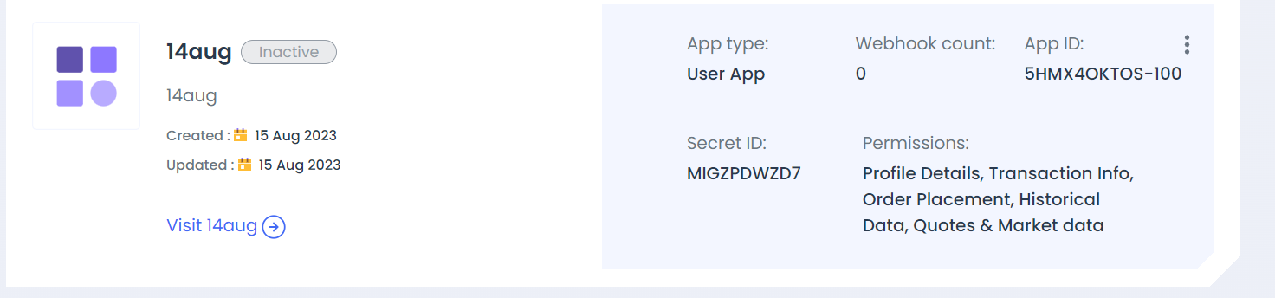

1. Paste appid, secret id and url in python code and Run the file (fyers_login.py) 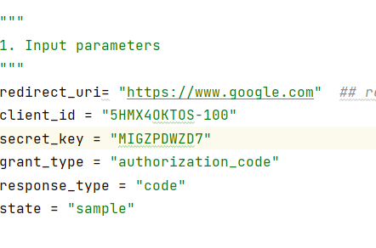
2. Automatically page will open. If you are running for first time (INACTIVE API), then below page will come. Click I ACCEPT. And then click CONTINUE.

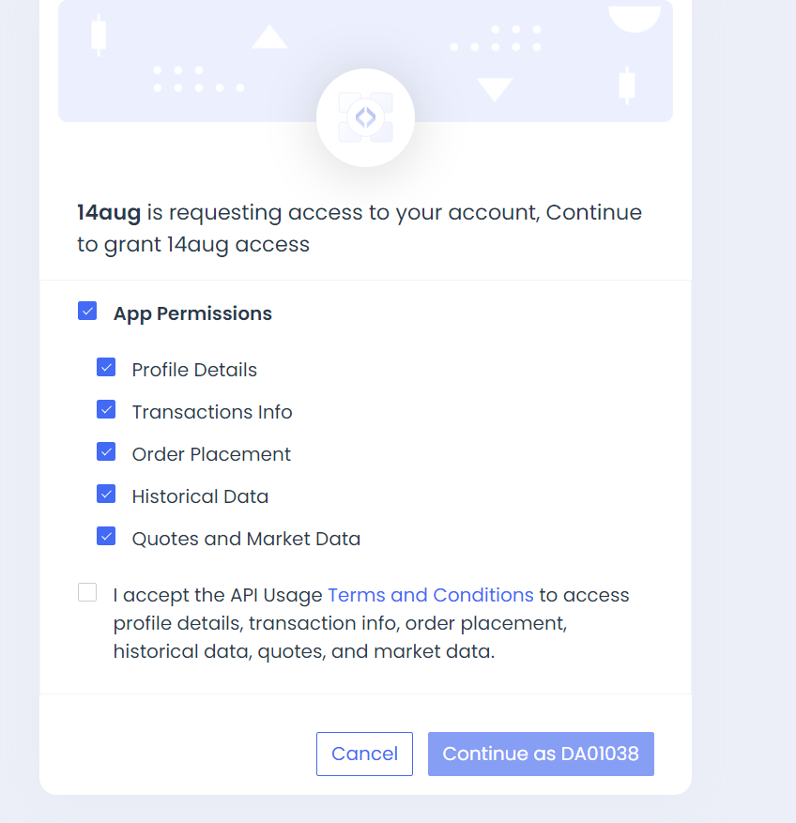

1. Copy the authcode. Make sure you don’t copy anything which is after “&”

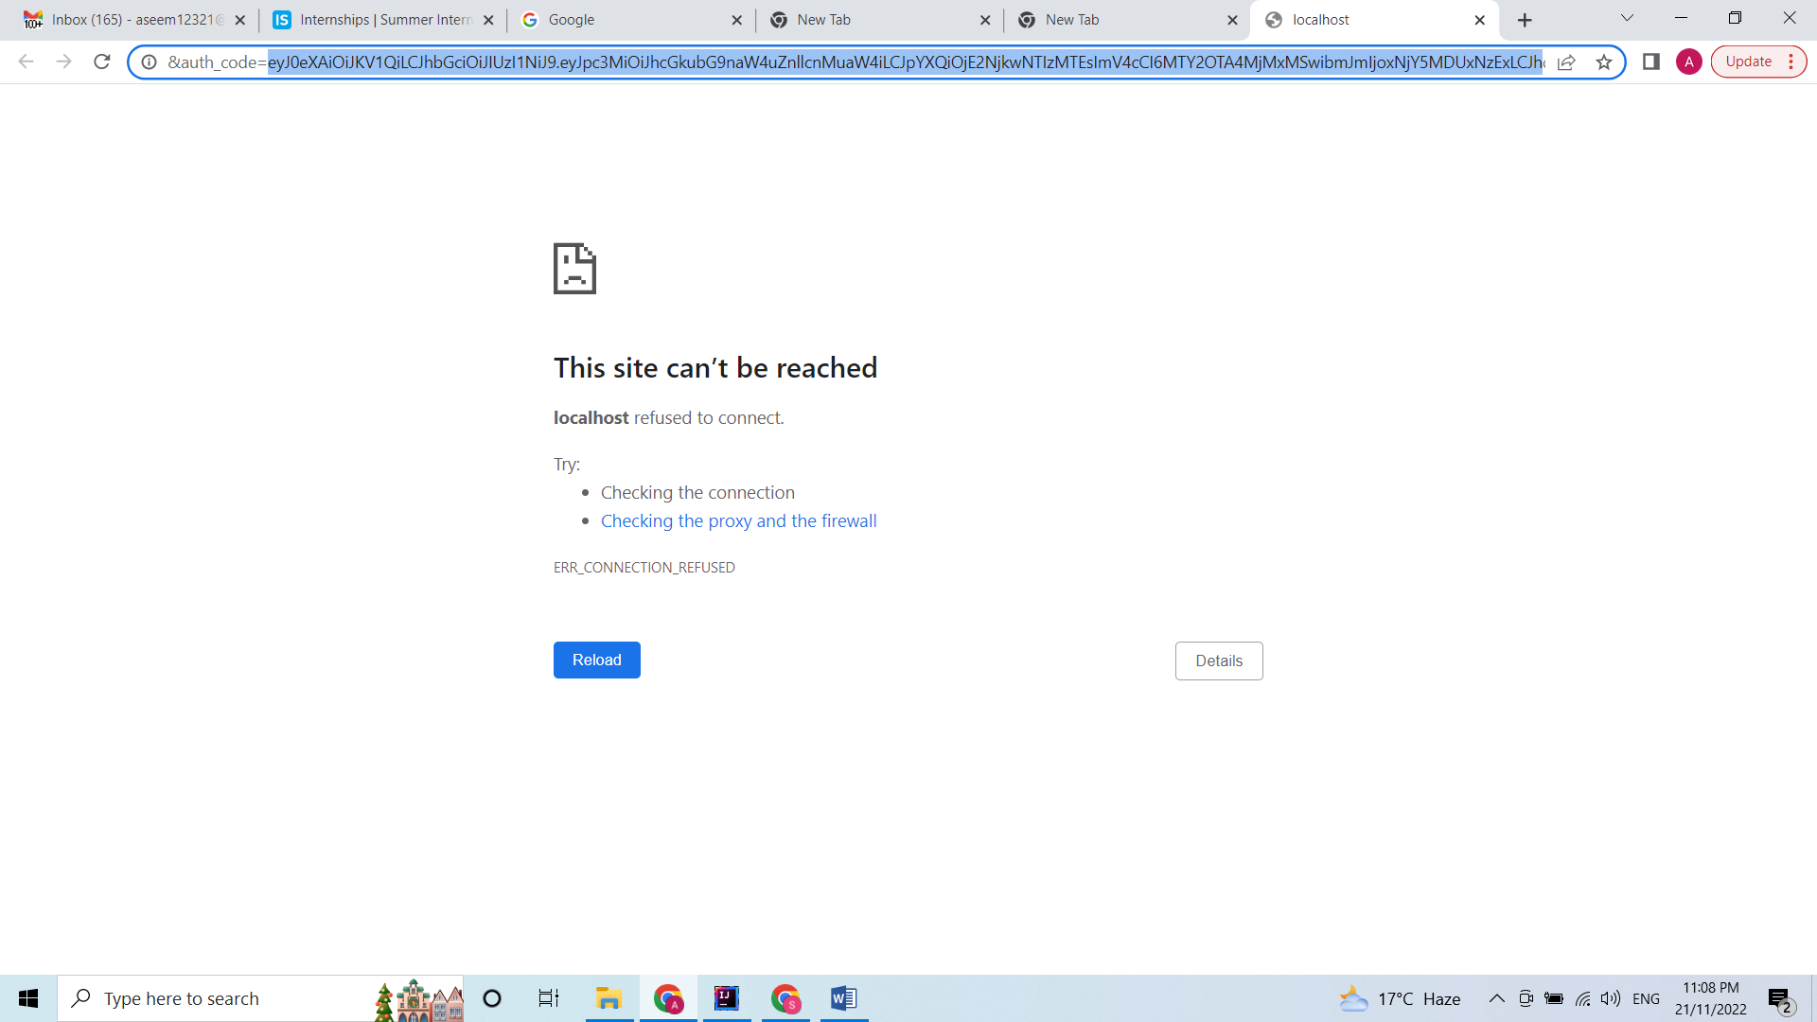

1. Paste the auth code in terminal

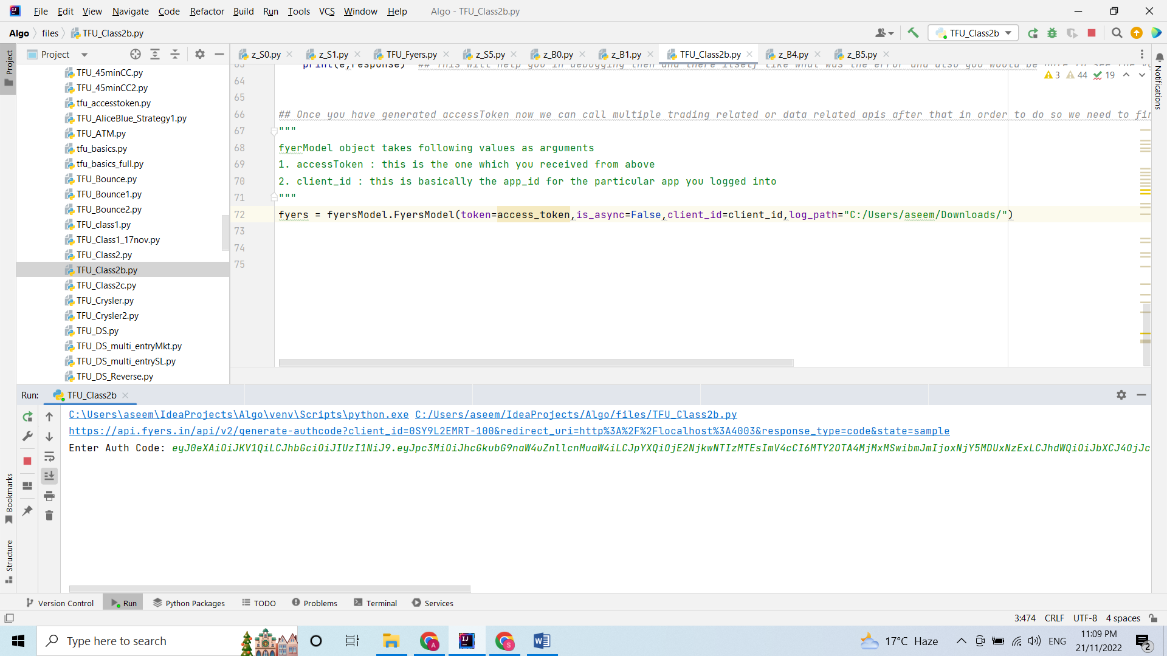

1. Press enter. And get the Access token.