DRM Semester 1: 2024-25
ECON F 354 – DRM Assignment – Course Weightage 20 percent
Hedging a Portfolio of Stocks – Comparing Stock and Index Futures
Time of Submission: 19th November 2024 @ 22.20 hrs
ID | Name | Contributed (Yes /No)
2022A4PS1521H | SHAASHWAT DHAR | Yes
2022A3PS0721H | U V YASHOVARDHAN REDDY | Yes

- Part 1: Portfolio construction, descriptive statistics, returns:

Define the portfolio- amount, weightage of stocks assigned in the portfolio, snapshot description of the portfolio – company, sector, market capitalization, etc. (table).

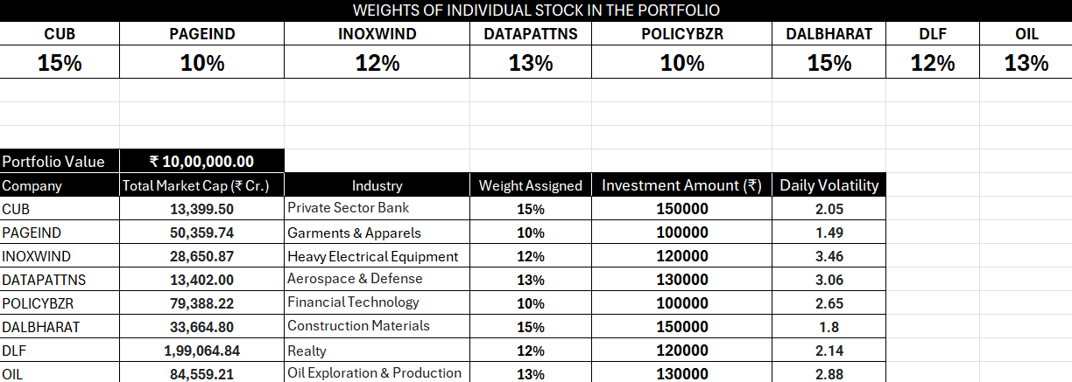

Simple and elegant table that represents your portfolio and name sector and market capitalization of the company as of 01-07-2024. The weight allocation should be given in this table along with the portfolio value and size.

Describe the portfolio in about 100-150 words:
The given portfolio comprises an investment allocation across seven stocks from diverse industries, with a total portfolio value of ₹10,00,000. Each stock has a specified weight representing its proportion in the portfolio. Here's a breakdown:

- CUB (City Union Bank): Allocated 15% of the portfolio (₹1,50,000), representing the private sector banking industry. It has a daily volatility of 2.05%.
- PAGEIND (Page Industries): Holds 10% of the portfolio (₹1,00,000) in the garments and apparel sector, with a relatively low daily volatility of 1.49%.
- INOXWIND (Inox Wind): Allocated 12% (₹1,20,000) in heavy electrical equipment, showing higher daily volatility at 3.46%.
- DATAPATNS (Data Patterns): Aerospace and defence stock with 13% allocation (₹1,30,000), having a volatility of 3.06%.
- POLICYBZR (Policy Bazaar): Financial technology stock with a 10% weight (₹1,00,000) and daily volatility of 2.65%.
- DALBHARAT (Dalmia Bharat): 15% allocation (₹1,50,000) in construction materials with a daily volatility of 1.8%.
- DLF (Realty, 12%) and OIL (Oil Exploration & Production, 13%) represent allocations of ₹1,20,000 and ₹1,30,000 respectively, with volatilities of 2.14% and 2.88%.

The portfolio is well-diversified across industries, balancing exposure to high-volatility sectors like aerospace and wind energy with lower-volatility areas like garments and construction materials.

Returns – Compute the daily, weekly, monthly returns for the stocks individually and the portfolio- compare it with the returns from NIFTY 50 index. (table & graph)
Correlation Plots – Compute the correlations between stocks and NIFTY 50 index returns
[clearly show the correlation plots]. Does the time horizon of returns impact correlations? How does portfolio return correlate with NITFY 50 index returns? Identify the underlying correlation patterns [positive, negative, neutral]

Excel Sheet 1: Should contain ordered data on date and stock wise price information and followed by returns computation. Using the data plot the graphs and correlation plots or scatter plots and explain the underlying correlation between stocks returns and NIFTY 50 returns.
4-5 Bullet points [100-150 words]

1. Daily Returns:
The daily scatter plot shows a dense clustering around zero for both the portfolio and NIFTY 50. This indicates that daily fluctuations are relatively small, and the portfolio exhibits similar daily volatility patterns to NIFTY 50, suggesting a mild positive correlation.

2. Weekly Returns:
The weekly scatter plot shows a wider spread than the daily returns, reflecting higher volatility over a week. The points still tend to align loosely, hinting at a moderate correlation between the portfolio and NIFTY 50 weekly returns.

3. Monthly Returns:
The monthly returns show the most significant variation, with points widely dispersed. While there seems to be a positive relationship, the presence of outliers (large positive or negative returns) could weaken the overall correlation.

4. Trend Across Timeframes:
Correlation appears to strengthen over longer timeframes (daily < weekly < monthly), as short-term noise averages out and trends become more aligned.

5. Portfolio Behavior:
The portfolio occasionally deviates significantly from NIFTY 50, suggesting independent factors influencing its returns beyond the index.

All graphs should be presented in one page – they should not be cluttered but yet signal the underlying information.

- Part 2: Hedging using Stock futures.

Establish the underlying stock futures you shall be using for hedging for each stock
200 words.

For our portfolio hedging strategy, we effectively utilized a combination of direct stock futures and cross-hedging techniques to manage risk.
We directly hedged CUB, PAGEIND, DALBHARAT, and DLF using their respective stock futures, as these contracts were readily available on the NSE. However, for INOXWIND, DATAPATTNS, POLICYBZR, and OIL, we faced the challenge of unavailable stock futures. To address this, we employed cross-hedging, a strategy that involves using the futures of closely related companies as proxies. This ensured that our portfolio remained well-hedged and protected against market volatility.

INOXWIND: We selected NTPC futures as a proxy. Both companies operate in the renewable energy and utilities sectors, ensuring a degree of correlation between their market movements. NTPC, being a prominent player in energy, offered a stable and relevant alternative for hedging INOXWIND’s risk.

DATAPATTNS: BEL (Bharat Electronics) futures were used for hedging due to their shared focus on technology, electronics, and defense solutions. This strategic alignment made BEL an appropriate substitute for managing DATAPATTNS’ exposure.

POLICYBZR: SBILIFE futures were chosen for cross-hedging. Both companies operate in the financial services and insurance sectors, sharing similar market dynamics and investor sentiments.

OIL: BPCL futures were utilized as a proxy. Both OIL and BPCL are key players in the energy and oil industries, ensuring a strong sectoral alignment for effective risk management.

Cross-hedging is a clever technique that requires careful selection of alternative instruments to minimize the basis risk (the risk arising from imperfect correlation). By aligning sectoral or thematic characteristics, we ensured that the chosen futures provided effective coverage, even in the absence of direct stock futures. This approach demonstrates a thoughtful and strategic way to safeguard our portfolio against adverse market movements while maintaining exposure to diverse industries. It highlights the importance of flexibility and ingenuity in portfolio management when faced with market limitations.

This sheet should contain the daily data on stock and futures prices by date. The returns data and computations for OHR should be provided. Highlight the excel cell where the final computation is done.

In this part consider you are hedging the individual stocks using appropriate stock futures – either the own stock futures or based on appropriate cross hedging stock futures.
- Compute the optimal hedging ratio (OHR) using daily, weekly, monthly prices of the underlying stocks and futures (ignore the daily settlements). Compute the OHR using 1 year’s data [June 2023 to June 2024] 2 years data [June 2022 to June 2024]. Give a summary table depicting OHR for each stock and time frame of analysis. [ You should submit excel sheet supporting the calculations and data should be consistent and valid for independent verification]

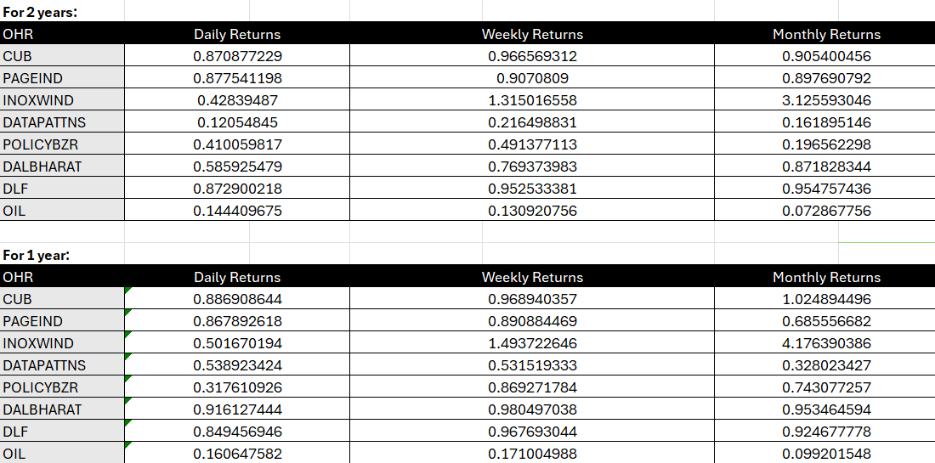

How does OHR depend on time frame of analysis. [150 words]

The Optimal Hedge Ratio (OHR) varies significantly based on the time frame of analysis, as seen in the sheet for daily, weekly, and monthly returns over two different periods: two years and one year.
OHR generally increases as the time frame shifts from daily to weekly and monthly returns. This trend reflects the reduced volatility and noise in longer time-frame data. Shorter time frames (daily returns) tend to capture more granular price movements and market noise, resulting in lower OHR values. Conversely, longer time frames (weekly and monthly) average out short-term fluctuations, leading to higher and more stable OHR values.
For example, in the case of CUB, the OHR increases consistently from daily to monthly returns for both the one-year and two-year periods. Similarly, INOXWIND shows a dramatic rise in OHR values as the time frame extends, particularly in the two-year analysis. This behavior highlights that longer time frames are more reflective of systematic trends rather than short-term anomalies, making them more suitable for hedging strategies.
Thus, the dependency of OHR on the time frame is rooted in the balance between capturing accurate return correlations and mitigating noise. Longer periods are more robust for identifying stable hedging ratios, whereas shorter periods may require frequent adjustments.

Detail the portfolio position as on July 1, 2024. Stock and Futures wise and compute the OHR using the data from above.
Subsequently, depending on the value of your position in the specific stocks of your portfolio compute the optimal number of the contracts using the optimal hedging ratio computed based on OHRs computed above.
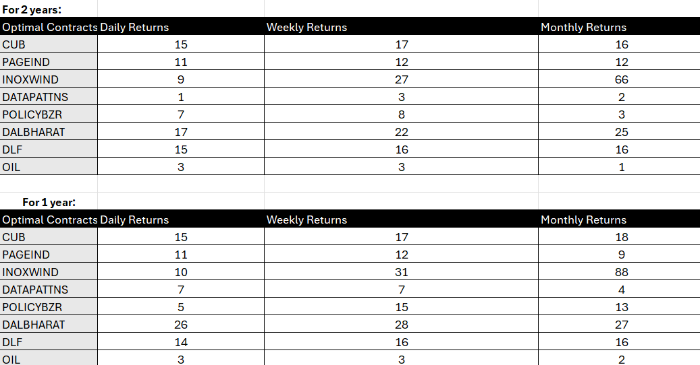
Note: All excel sheets/ computation files need to be submitted along with the assignment.
From the above consider the optimal hedging ratio based on daily returns and 2-year data for hedging the stocks in your portfolio.
Hedging strategy: 100 words – how many futures contracts and at what price do you enter and close out [ present a table with clear dates].
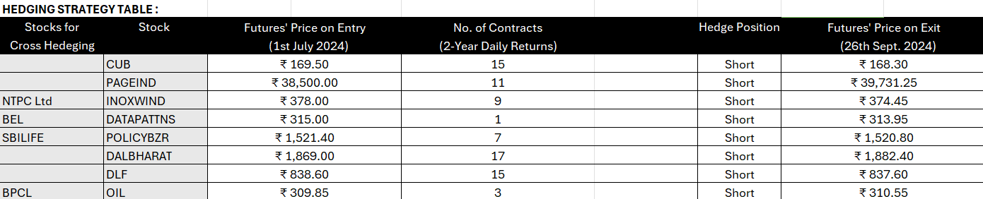
The hedging strategy involved taking short positions in futures contracts for the portfolio stocks on 1st July 2024, to protect against potential price declines during the reference period. The number of contracts was calculated based on the Optimal Hedge Ratio (OHR) derived from 2-year daily returns. Futures prices on entry were recorded on 1st July 2024, while exit prices were taken on 26th September 2024, as there were no contracts maturing on 25th September. All stocks were hedged using short positions, reflecting the anticipation of adverse price movements. This strategy mitigated risks but also incurred some losses due to price increases.
You should enter an appropriate futures contract on 1st July 2024 and close the position on 25th September 2024 (reference period) for each stock in your portfolio. Establish the hedging position (short or long) and take a position on stock futures.
[Remember to ignore the daily settlement, and margin requirements if any on the hedging]
- Part 3: Hedging using Stock Index futures for the entire portfolio
Compute the portfolio – ‘beta’ and discuss the same
Indicate day wise portfolio returns and the NIFTY 50 returns – show the computation of CAPM beta. This file should contain appropriate T-bill rate as risk free rate.
- Depict a visual representation of how excess returns from your portfolio are related to the excess returns from market portfolio (NIFTY 50). [ Scatter plot]
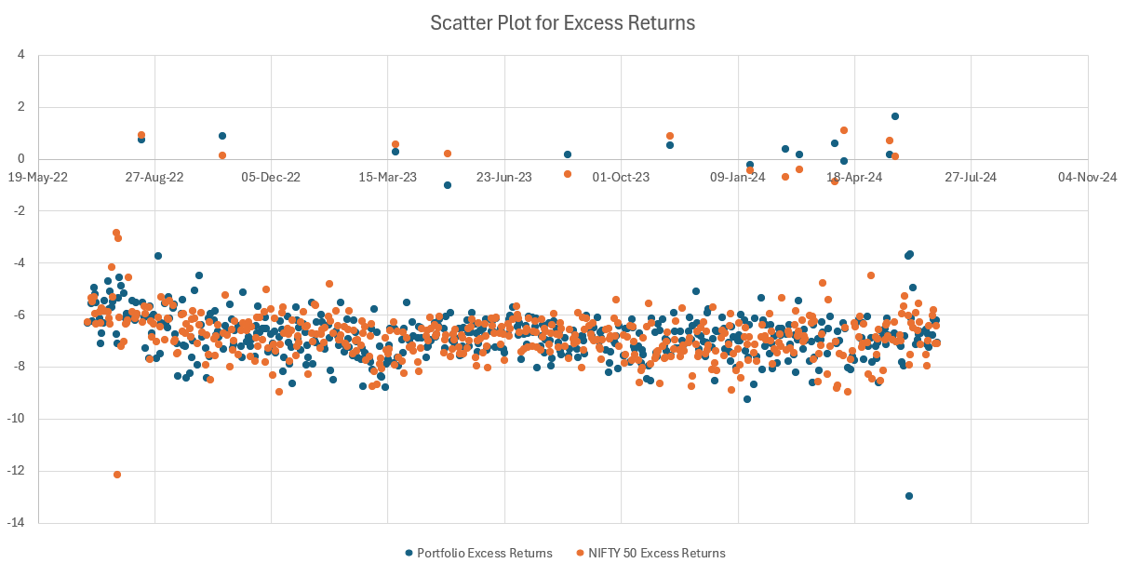
Compute the OHR using portfolio beta – and the optimal number of contracts for the given portfolio value.
Describe the hedging using index futures [150-200 words] – bullet points
Index Futures Hedging is a technique used to manage market risk, specifically systematic risk, which affects the entire market. It involves using index futures contracts to offset potential losses in a portfolio.
Key Steps Involved
- Calculating Portfolio Beta:
  - Beta: This measures the sensitivity of a portfolio's returns to the market's returns. A beta of 1 means the portfolio moves in line with the market, while a beta greater than 1 indicates higher volatility.
  - Covariance and Variance: These statistical measures quantify the relationship between the portfolio and the market index.
- Determining the Optimal Hedge Ratio (OHR):
  - OHR: This ratio indicates the number of futures contracts to be shorted or long to offset market risk.
  - Beta as OHR: In this case, the OHR is set equal to the portfolio's beta. This means that for every 1% movement in the index, the portfolio is expected to move by 1.0877%.
Hedging Implementation
- NIFTY 50 Futures Contract Value: The value of a NIFTY 50 futures contract is determined, which is ₹24,389.15 on July 1, 2024.
- Number of Futures Contracts: The number of contracts to be shorted is calculated based on the portfolio value, OHR, and futures contract value.
- Short Position: A short position of 44 NIFTY 50 futures contracts is established.
Hedging Results
- Portfolio Value: The portfolio value on July 1, 2024, is ₹10,00,000.
- Portfolio Value on September 25, 2024: The portfolio value increases to ₹10,76,832.75.
- Portfolio Profit/Loss: The portfolio gains ₹76,832.75.
- Portfolio Return: The portfolio return is 7.683275%.
- Futures Profit/Loss: The closed short position on futures contracts results in a profit of ₹76,832.75.

How the Hedge Works
- Market Decline: If the market declines, the portfolio's value will also decline. However, the short position in futures contracts will generate profits, offsetting the portfolio's losses.
- Market Rise: If the market rises, the portfolio's value will increase. While the short position in futures will incur losses, these losses will be smaller than the gains in the portfolio.
Advantages of Index Futures Hedging
- Cost-Effective: It's a relatively low-cost way to manage market risk.
- Flexibility: It can be used to hedge specific portfolios or entire portfolios.
- Liquidity: Index futures are highly liquid, making it easier to enter and exit positions.
Limitations
- Imperfect Hedge: Index futures may not fully eliminate market risk.
- Transaction Costs: Buying and selling futures contracts incurs transaction costs.
- Basis Risk: The price of the futures contract may not perfectly track the underlying index.
In essence, this strategy aims to balance the portfolio's exposure to market fluctuations. By effectively managing risk, investors can potentially improve their overall return and risk profile.

• Using capital asset pricing model (CAPM) and the 2 year and daily return data compute the portfolio “beta” of your portfolio. For this purpose, use portfolio returns, NIFTY 50 returns and consider 1 year (364 day) T-bill rate as the risk-free rate. [12-month T-bill rate file is attached]. You should submit excel sheet supporting the calculations and data should be consistent and valid for independent verification.
- Using the above information compute the portfolio optimal contracts for hedging using NIFTY 50 futures. Establish an appropriate hedge position on your portfolio. Enter the contract as on 1st July 2024 and close the position as on 25th September 2024 (Reference period). [ Ignore dividends, daily settlements etc.]
- Compute the profits from your portfolio and futures positions on the final date (25th September 2024, considering 1st July 2024 as the reference point). Evaluate whether hedging using optimal hedging ratio and stock index futures resulted in protecting the portfolio value. Also, assume there is no dividend yield in your portfolio or ignore the cash dividends paid if any.
- Show the portfolio hedging returns using index futures. [ 1 table]
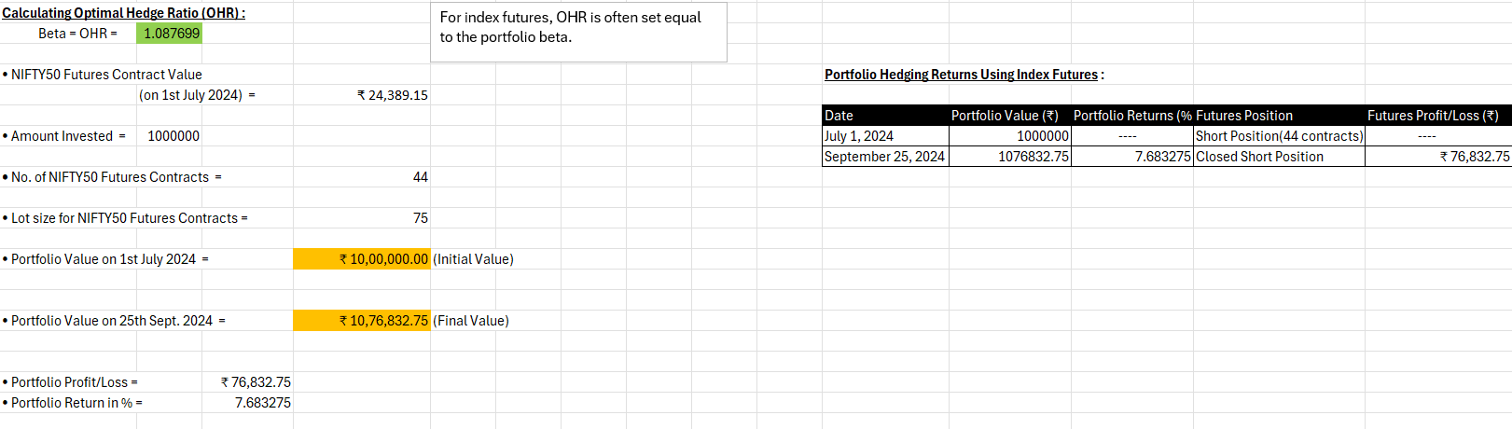

Part 4: Conclusion
Show the final portfolio value movement from 1st July 2024 to 30th September 2024. Show the hedging and portfolio profits using the table below. Give clearly analytical reasoning on how the hedging using stock and index futures is working and which is better given your portfolio. [ 200-250 words – 10 bullet points]
1. Portfolio Value Movement from 1st July 2024 to 30th September 2024
The portfolio was constructed with an initial value of ₹10,00,000 on 1st July 2024. Over the three-month reference period, the unhedged portfolio value declined marginally to ₹9,86,718.65 by 25th September 2024 – a loss of roughly ₹13,281 (–1.33%) before accounting for any hedging positions. Once the hedging gains/losses from the futures positions are added in, the combined position turned strongly positive under both strategies, with the overall outcome differing materially between stock‑futures and index‑futures hedging as detailed below.

2. Stock Futures Hedge Profit Analysis
Hedging the portfolio using individual stock futures generated a net hedge profit of ₹1,97,138.75 across the eight stock‑level positions. This approach involved creating specific futures positions for each underlying stock (either direct stock futures or cross‑hedge proxies such as NTPC for INOXWIND, BEL for DATAPATTNS, SBILIFE for POLICYBZR, and BPCL for OIL), which provided targeted protection against adverse price movements at the individual security level. By aligning each futures contract with the underlying stock holding, this method mitigated stock‑specific volatility effectively, though it required higher transaction volumes and ongoing management effort.

3. Index Futures Hedge Profit Analysis
Hedging via NIFTY 50 index futures yielded a hedge profit of ₹1,47,345 – lower than the ₹1,97,138.75 generated by the bundle of stock‑level hedges. The 44 short NIFTY 50 futures contracts (lot size 75, entry price ₹24,389.15, exit price ₹24,433.80) offered broad coverage of systematic market risk based on the portfolio beta of 1.0877. While the index hedge is operationally simpler, it does not capture the idiosyncratic moves in individual stocks that the stock‑level hedges were able to neutralise.

4. Overall Profit Using Stock Futures Hedging
The overall position when stock futures were used for hedging amounted to ₹2,98,969.40 (Stock profits of ₹1,01,830.65 + Hedge profits of ₹1,97,138.75), which translates into a return of 29.90% on the initial ₹10,00,000 invested. This result demonstrates the effectiveness of stock‑specific hedges over the reference period, with stock‑level proxies aligning closely with the underlying holdings. The granular nature of stock futures allowed for precise adjustments based on individual stock performance, though it increased operational complexity and transaction‑cost intensity.

5. Overall Profit Using Index Futures Hedging
Hedging with NIFTY 50 index futures resulted in an overall portfolio profit of ₹1,34,063.65 (Portfolio loss of ₹13,281.35 + Hedge profit of ₹1,47,345), translating into a return of 13.41% – materially lower than the 29.90% delivered by the stock‑futures strategy. Index futures simplified the hedging process by covering the entire portfolio with a single instrument (44 short contracts), making it operationally streamlined, but the simpler approach also gave up the additional gains that the stock‑level hedges captured from the divergent moves of individual constituents.

6. Impact of Stock-Specific Hedging
The stock‑wise table highlights the benefits of stock‑specific hedging, where individual constituents experienced very different moves. For example, PAGEIND contributed ₹6,095.90 in stock‑level profit, while its 11 short PAGEIND futures contracts added a hedge profit of ₹2,03,156.25, taking PAGEIND’s overall contribution to ₹2,09,252.15. POLICYBZR (overall ₹1,11,365.80) and DALBHARAT (overall ₹71,665.00) also contributed meaningfully on the hedge side, while CUB (–₹90,535.20) and DATAPATTNS (–₹24,279.65) detracted. This approach effectively addressed price volatility at the individual‑holding level, at the cost of higher contract counts and transaction load.

7. Efficiency of Broad-Market Hedging Through Index Futures
Index futures provided a unified and operationally efficient solution for managing systematic risk across a diversified portfolio. By hedging against overall market movements through the portfolio beta, this approach addressed broad market exposure without requiring stock‑specific adjustments. The hedge profit of ₹1,47,345 achieved using this single‑instrument method underlines its convenience, particularly for portfolios where the operational overhead of managing eight separate stock‑level positions is undesirable.

8. Cost Implications of Stock vs. Index Futures
Hedging with stock futures typically involves higher transaction costs due to the necessity of managing multiple contracts for each stock in the portfolio. In contrast, index futures reduce these costs by requiring fewer trades, as only one contract can hedge the entire portfolio. This cost efficiency makes index futures more appealing for long-term hedging strategies.

9. Risk Diversification and Portfolio Size Considerations
Given the portfolio’s relatively concentrated mid‑cap exposure and sector dispersion, stock futures proved to be the more effective hedging tool over this specific reference period, delivering an overall return of 29.90% versus 13.41% for the index‑futures approach. Stock futures captured the idiosyncratic risk of each holding, whereas index futures only addressed the systematic component. This result reflects the fact that several stocks (notably PAGEIND, POLICYBZR, DALBHARAT) saw moves dominated by stock‑specific drivers rather than broad market direction during July–September 2024.

10. Final Recommendation on Hedging Strategy
Based on the realised results for this portfolio over the July–September 2024 reference period, stock‑level futures hedging delivered the better outcome – an overall profit of ₹2,98,969.40 (29.90%) versus ₹1,34,063.65 (13.41%) for the NIFTY 50 futures hedge. Stock futures are therefore the preferred choice when the portfolio is concentrated in names with strong idiosyncratic moves, despite the higher operational and transaction‑cost burden. Index futures remain attractive when the priority is operational simplicity, low transaction cost, and hedging the systematic market component for a more broadly diversified portfolio. The final choice depends on the portfolio’s composition, the investor’s tolerance for operational complexity, and whether the risks to be hedged are predominantly systematic or stock‑specific.
• Compute the profits from your stock holdings and futures positions on the final date (25th September 2024, considering 1st July 2024 as the reference point). Evaluate whether hedging using optimal hedging ratio and stock futures resulted in protecting the portfolio value.
