Design:
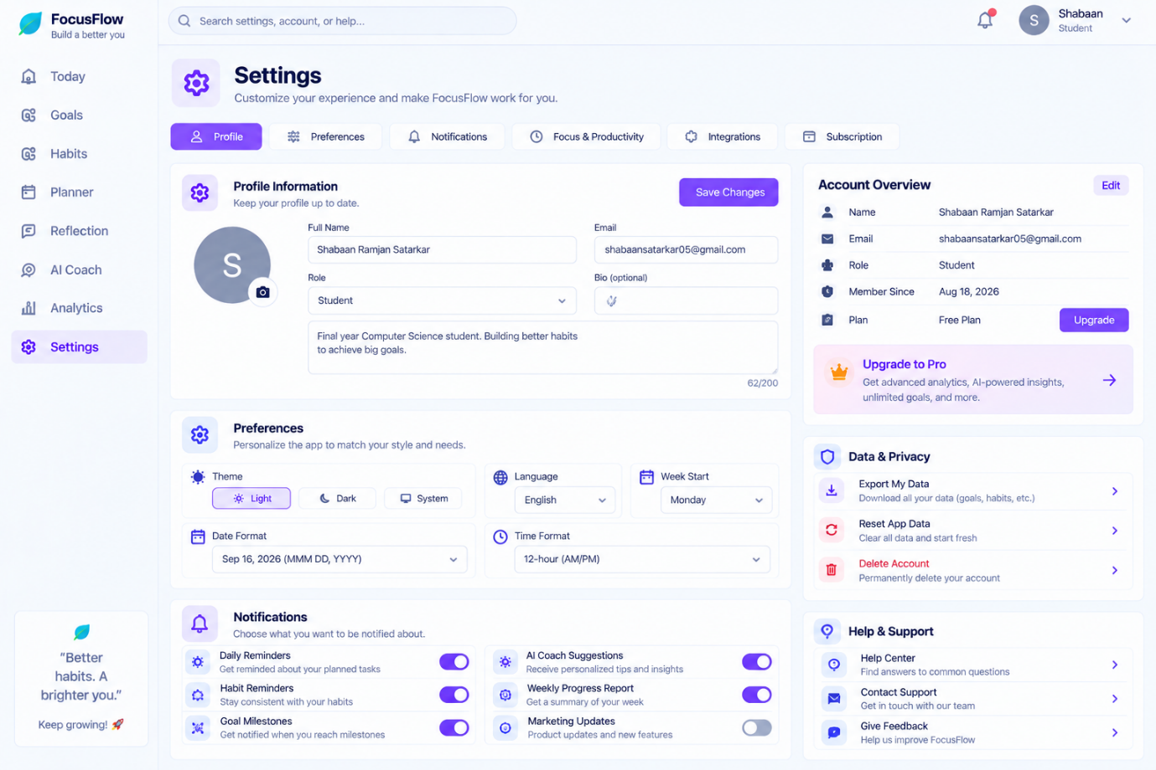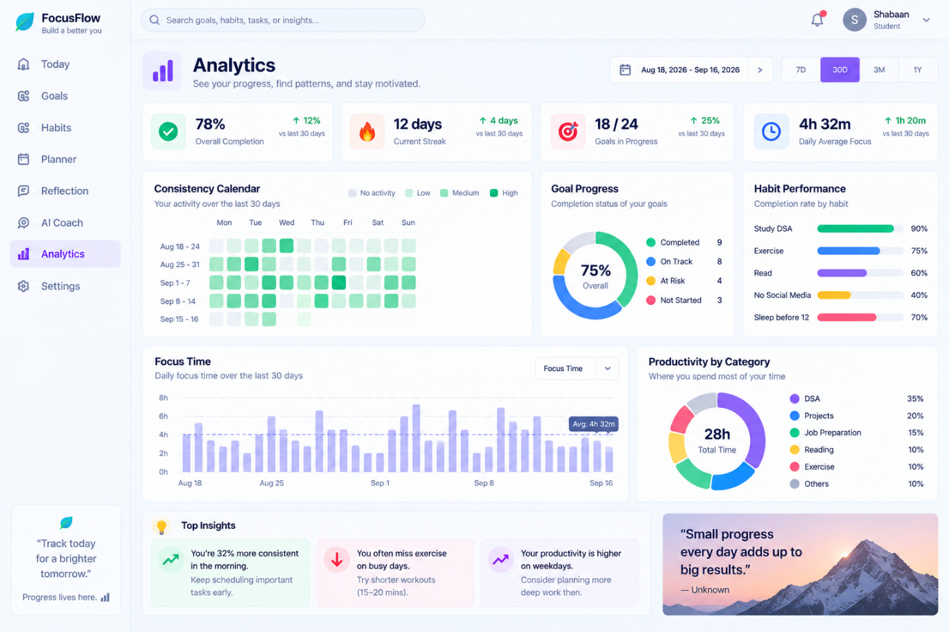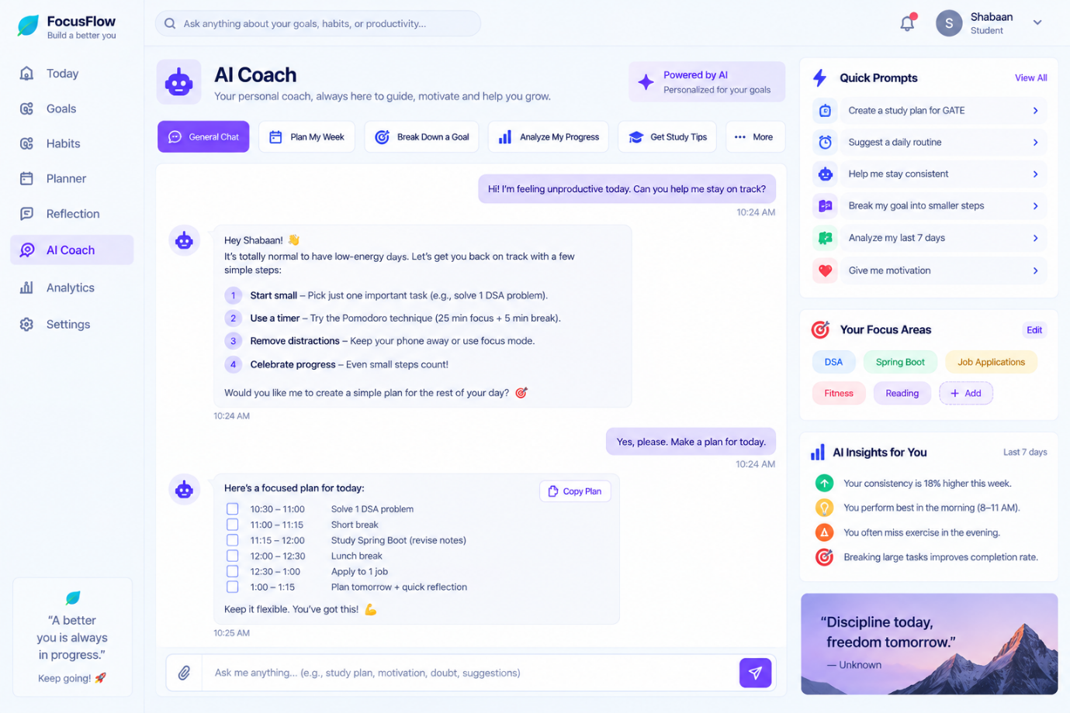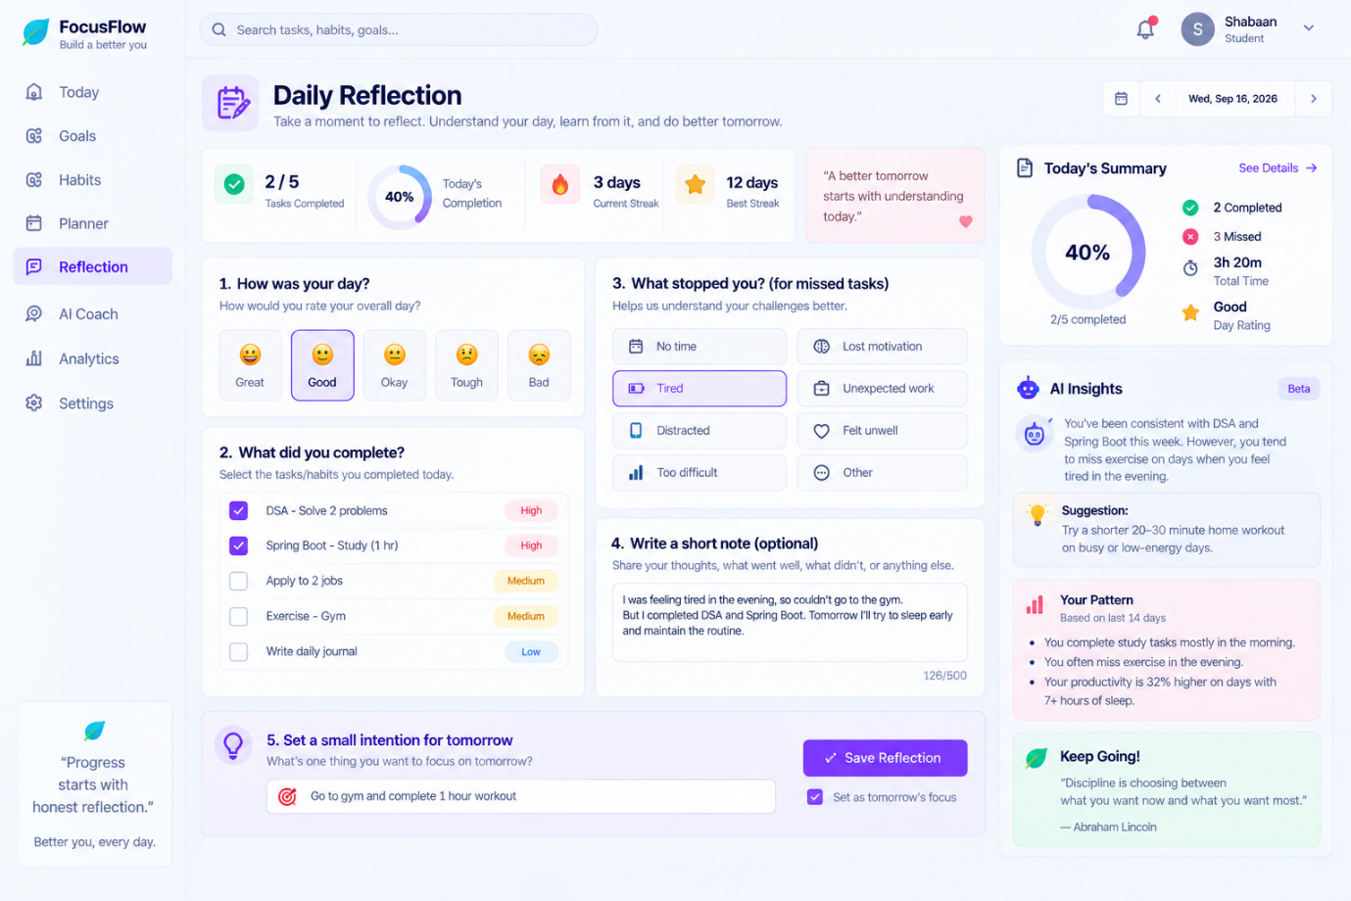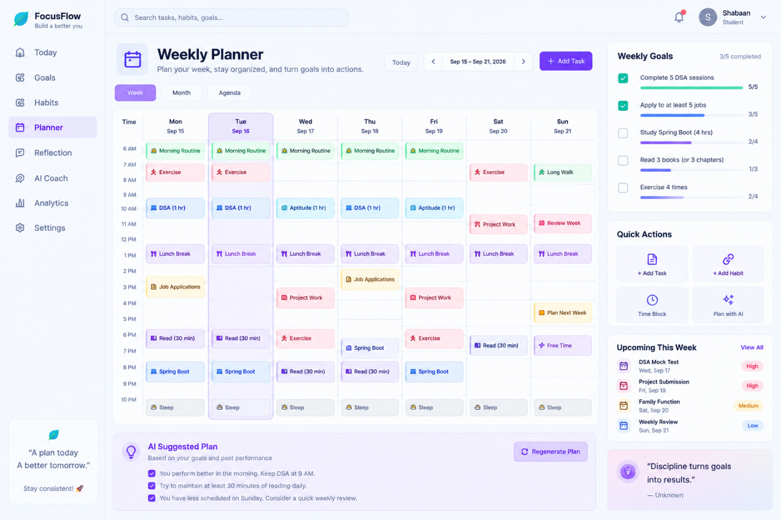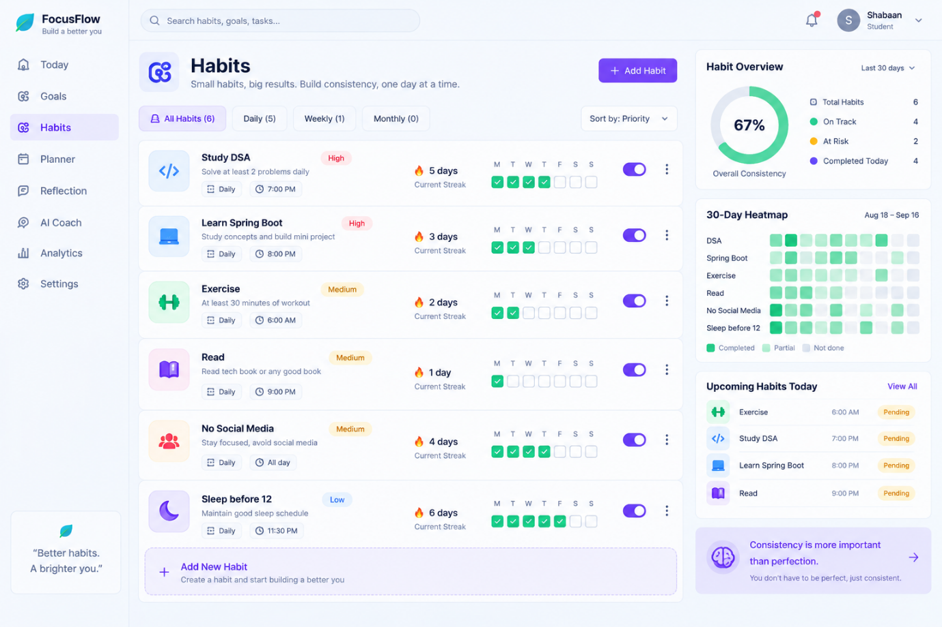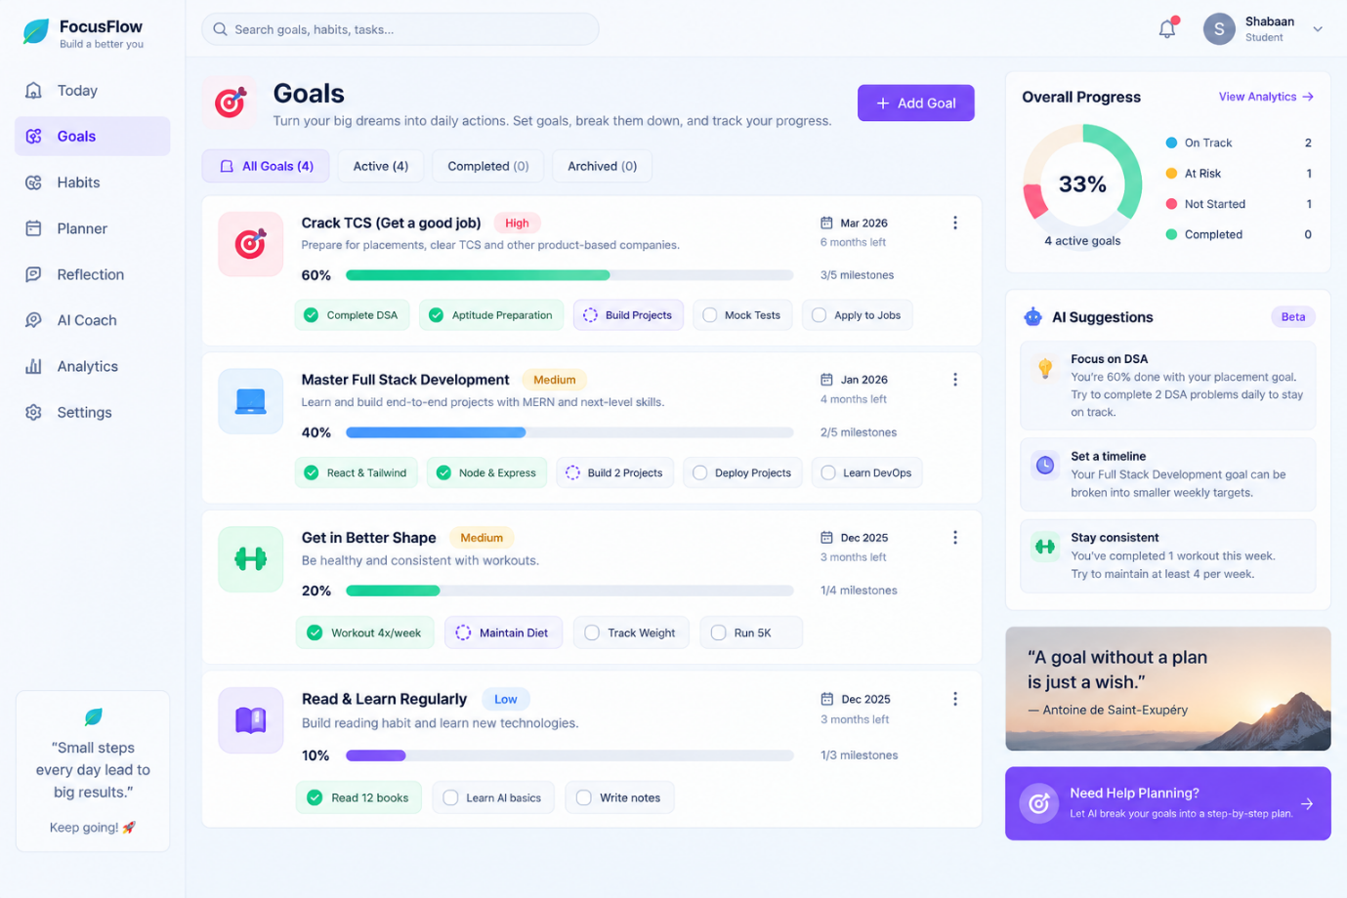

Philosophy:
Don't punish users for inconsistency. Help them understand it and recover from it.
Big picture:

┌──────────────────┐
│ USER │
└────────┬─────────┘
↓
Goals & Intentions
↓
Daily Actions
↓
┌─────────────┐
│ TRACKING │
└──────┬──────┘
↓
Behavior Data
↓
┌─────────────────────┐
│ CONSISTENCY ENGINE │
└──────────┬──────────┘
↓
Pattern Detection
↓
Why did I fail?
↓
┌────────────────┐
│ AI COACH │
└───────┬────────┘
↓
Intervention
↓
User acts
↓
Results
↓
↺
User does | Platform responds
Creates goal: "Learn Java" | Breaks it into habits/tasks
Creates habit: "DSA daily" | Adds it to daily tracker
Creates today's tasks | Shows prioritized Today page
Completes task | Updates progress, streak & analytics
Misses task | Asks why?
Selects "Too tired" | Records the reason
Repeatedly misses evening tasks | Detects the pattern
Opens dashboard | Shows personalized insights
Has low consistency | Suggests a smaller/recovery plan
Completes a good week | Shows weekly achievement
End of week | Generates weekly review
After 30 days | Shows trends, strengths, weak areas
Starts another day | Uses previous data to personalize the plan

PLAN → DO → TRACK → REFLECT → UNDERSTAND → ADJUST → DO AGAIN
Techstack:
🚀 Final Tech Stack for Our Startup
We'll use a modern, scalable, but cost-friendly stack:
🎨 Frontend
- Next.js
- TypeScript
- Tailwind CSS
- shadcn/ui
- TanStack Query
- Recharts — graphs & analytics
- Zod + React Hook Form — forms & validation
⚙️ Backend
- Java + Spring Boot
- Spring Security
- Spring Data JPA / Hibernate
- REST APIs
- Bean Validation
🗄️ Database
- PostgreSQL
- Redis — add later for caching/session/rate limiting
🤖 AI
- LLM API
- Vercel AI SDK where useful
- AI for:
  - Goal breakdown
  - Daily/weekly recommendations
  - Reflection analysis
  - Behavior-pattern insights
  - AI Coach
🔐 Authentication & Security
- Spring Security
- JWT / secure HTTP-only cookies
- Password hashing
- OAuth/Google login later
- Rate limiting
- CORS
- HTTPS
- Input validation
🔔 Communication
- Resend — email
- Web Push — notifications
- Inngest — scheduled/background jobs later
💳 Payments — later
- Stripe
- Or Razorpay if targeting India initially
📊 Product Analytics
- PostHog
- Sentry — error monitoring
☁️ Deployment
Starting:
Next.js → Vercel
Spring Boot → Render / Railway
PostgreSQL → Supabase / Neon
Redis → Upstash
Later, when scale requires:
AWS / Cloudflare
Docker
CDN
Load Balancer
Object Storage
🏗️ Architecture
USER
↓
Next.js + TS
↓
REST API
↓
Spring Boot + Java
↓
PostgreSQL
↙ ↘
Redis AI API
Core stack to start:
Next.js + TypeScript + Tailwind + shadcn/ui + Spring Boot + PostgreSQL + JPA/Hibernate + Spring Security + LLM API
Everything else can be added when the product actually needs it.
Rough approximation:
Stage | Users | What I'd use | Cost situation
🧪 MVP | 0–100 | Free tiers | ₹0 possible
🌱 Early testing | 100–500 | Same stack | ₹0–₹2k/month
🚀 Early growth | 500–2,000 | Paid hosting/DB may become useful | ₹2k–₹8k/month
📈 Growth | 2k–10k | Better server + DB + Redis + monitoring | ₹5k–₹25k+/month
🏢 Larger scale | 10k+ | Scale based on actual traffic | Highly variable

Workflow:
Page | User does | Platform responds
1. Onboarding | Selects purpose: Study / Career / Fitness / Personal → sets basic preferences | Creates personalized starting setup
2. Goals | Clicks Add Goal → enters goal, deadline, importance | Breaks goal into suggested milestones/habits
3. Habits | Adds habit → frequency, target, preferred time | Adds habit to calendar and daily routine
4. Weekly Planner | Adds 3–5 goals for the week | Shows weekly progress and distributes goals across days
5. Today / Dashboard | Sees today's tasks + habits → checks them off | Updates completion %, streak, progress and remaining work
6. Reflection | At end of day → selects completed/missed + reason → optional short diary | Saves behavior data and identifies possible patterns
7. AI Coach | Asks for help / opens personalized insight | Analyzes history and suggests what to change
8. Analytics | Views 7/30-day charts, heatmap, streaks, habit performance | Shows trends, strong/weak habits and consistency patterns
9. Weekly Review | Reviews the previous week | Shows what went well, what failed and suggests next week's plan
10. Profile / Settings | Changes habits, goals, notification preferences | Updates personalization

Ai architecture:
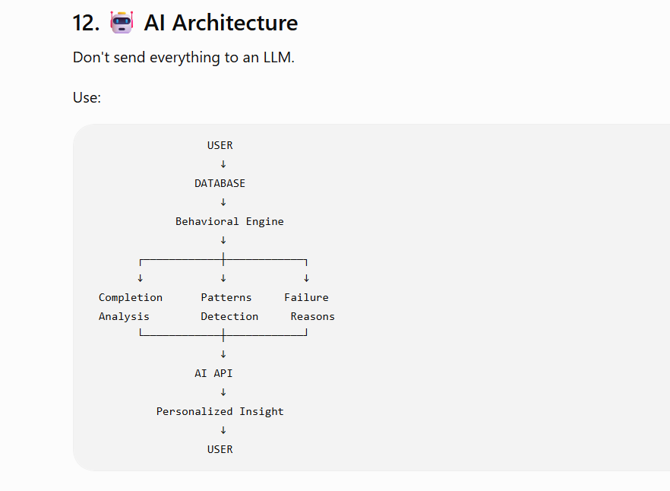
Note : do bakend analysis as much possible use ai where it should be which efficient with money.
Monetization:
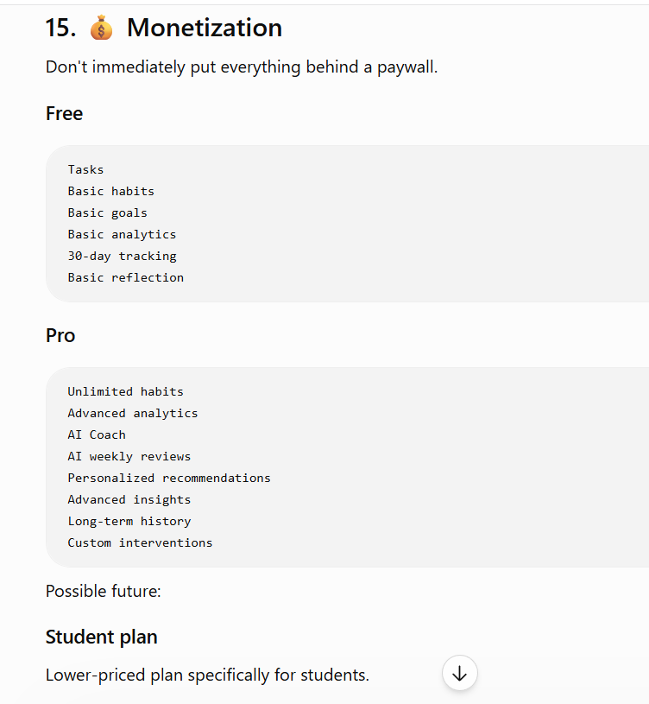
What makes long term usp:
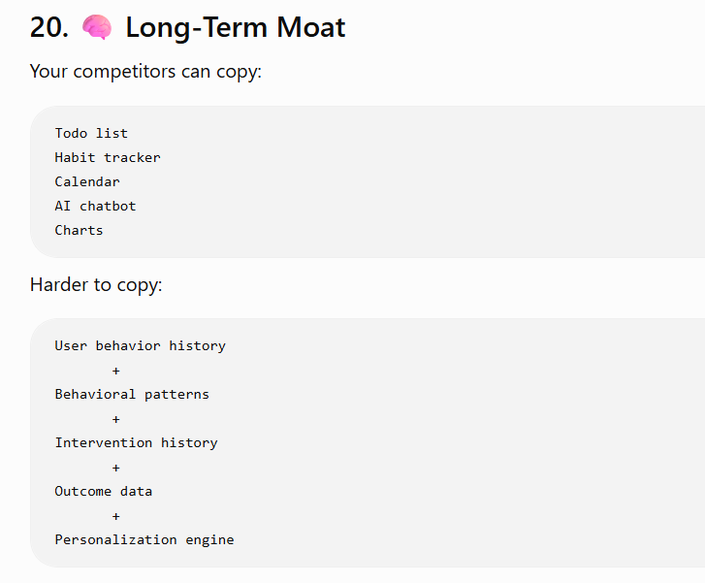
Steps to start and phase:
16. 🧪 MVP
Your first version should NOT contain everything.
MVP V1
Build:
Authentication
↓
Goals
↓
Habits
↓
Tasks
↓
Today dashboard
↓
Weekly planner
↓
Reflection
↓
Basic analytics
Then:
V2
Failure reasons
Recovery mode
Behavior patterns
AI weekly review
AI recommendations
Then:
V3
AI Coach
Personalized interventions
Notifications
Subscriptions
Advanced analytics
Survey anout product Quality and user experience:
Start with 10–20 people you can directly observe and interview, then expand.
Qhestionnare:
Ask:
What did you use before FocusFlow?
Why did you stop using it?
What feature did you actually use?
What did you ignore?
Did the weekly review help?
Did the AI recommendation change what you did?
Most importantly:
Would you come back tomorrow?
How to review: engagement+ retention+ usage
Don’t just obsess with downloads.
Roadmap:
21. 🚀 Startup Development Roadmap
Month 1 — Foundation
Project architecture
Authentication
Database
User profile
Goals
Habits
Tasks
Month 2 — Core Product
Today
Planner
Daily tracking
Streaks
Reflection
Analytics
Month 3 — Differentiation
Behavior events
Failure reasons
Consistency engine
Recovery mode
AI weekly review
AI recommendations
Month 4 — Real Users
10 users
↓
30 users
↓
100 users
Collect feedback continuously.
Month 5+
Improve based on actual usage:
Retention
UX
AI
Notifications
Personalization
Monetization
22. Your biggest mistake to avoid
Don't spend 6 months building:
20 pages
100 features
beautiful animations
complex AI
microservices
mobile app
// use feedback to build better.
Final Product Vision
The final product shouldn't feel like:
"Here's another productivity dashboard."
It should feel like:
"This system knows what I'm trying to accomplish, knows how consistently I'm executing, understands where I'm struggling, and helps me adjust my behavior."
Deployment Strategy:
Phase 1 — Development
- Everything local
- GitHub for code
- Docker optional
Phase 2 — MVP ready
Deploy:
- Next.js → Vercel
- Spring Boot → Render/Railway
- PostgreSQL → Supabase/Neon
Phase 3 — Real users
Once you have real usage, add:
- Custom domain
- HTTPS
- Environment variables/secrets
- CI/CD
- Sentry
- PostHog
- Automated DB backups
- Redis if needed

Phase 4 — Growth
Only when traffic requires it:
Load Balancer
Multiple backend instances
Redis
CDN
Object storage
AWS/Cloudflare
Background workers
After mvp:
- Trademark: Important for your startup name, logo, and brand. This is likely the first IP protection worth considering.
- Copyright: Your source code, UI artwork, written content, original graphics, documentation, etc. are generally copyright-protected automatically when created. Registration can provide additional evidence/procedural benefits depending on jurisdiction.
- Patent: Your general idea — “an app for goals, habits, streaks, AI coaching and consistency” — generally isn't something you can simply patent. A patent is potentially relevant only if you develop a novel, patentable technical invention, subject to the applicable patent rules.
- Trade secrets: Your recommendation/behavior algorithms, internal methods, datasets and business processes can potentially be protected as confidential information if you actually keep them secret.
- Third-party content: Don't copy other apps' code, designs, images, quotes/content, or research text. You can use research findings and cite the studies, but don't copy their protected expression.
For your startup, I'd initially think:
Brand/trademark + ownership of code/content + proper third-party licenses + confidentiality → investigate patents only if you later create genuinely novel technology.

