SOFTWARE ENGINEERING LABORATORY

GitStack
  - Git Learning and Team Collaboration Platform
Complete project documentation based on the latest release
30 September 2026

Project team
Member | Assigned role
Jubair Ahmed Efty | Core A and Team Lead
Shabab Ahmed | Core B
Siam Ibne Sarwar | Support

Individual Git practice · Docker terminals · Real Gitea teamwork
Assessment · Progress · Instructor monitoring
Package version 1.0.0

Abstract and contents
GitStack is a local laboratory platform for learning Git by doing. Students complete ordered missions inside Docker sandboxes; the server checks actual repository state and stores their progress, assessment and feedback. In a prepared three-person team exercise, separate workspaces connect to a private Gitea repository so students can push branches and perform real issue, pull-request, review, test and merge work. Instructors author supported individual missions, assign work and inspect reports.
The release uses HTML, CSS and vanilla JavaScript; Node.js/Express; Prisma and PostgreSQL; Docker; and Gitea. This report reflects all 233 source files in the latest archive, including the restored Open Gitea repository handoff, terminal auto-scroll and guarded daily startup. The two supplied planning files establish team responsibilities only; implemented behavior was verified against the current source. Automated source and behavior checks passed, while the final live-host demonstration remains an operational acceptance activity.
Page | Section
3 | Project overview and team
4 | Requirements and scope
5 | Architecture and deployment
6 | Database design
7 | Missions and validation
8 | Hints XP and learning tools
9 | Collaboration preparation
10 | Collaboration workflow
11 | Team assessment and event evidence
12 | Student and instructor modules
13 | Sandbox terminal and security
14 | Startup data and recovery
15 | Installation and upgrade
16 | Verification and demonstration
17 | API source references and conclusion

Keywords: Git, repository-state assessment, Gitea, Docker sandbox, software engineering laboratory, collaboration.

1 Project overview and team

Problem and objectives
Command memorization alone does not show whether a student has made a correct commit, repaired a mistake or collaborated responsibly. GitStack links each learning step to observable Git state. Its objectives are to provide progressive practice, isolate terminal work, give corrective feedback, record durable progress and support a real issue-to-merge team exercise that an instructor can inspect.

Delivered scope
The current release has authentication and encrypted profiles; four seeded individual missions and one team mission; a supported instructor mission authoring flow; Docker terminal and workspace lifecycle; dynamic hints and time-based attempts; XP, levels, two leaderboards and rank badges; Gitea provisioning/webhooks and 70/30 team assessment; student and instructor dashboards; EN/BN UI, themes, Git Flow Lab and Hangman; and first-run, daily-start and verification scripts. The standard use case is a local Docker-capable laboratory host.

Team responsibility allocation
Member | Responsibility recorded in the supplied roadmap
Jubair Ahmed Efty  Core A and Team Lead | Platform/backend, Express APIs, Prisma/PostgreSQL, authentication, sandbox orchestration, Gitea integration, assessment, integration gates and demonstration readiness.
Shabab Ahmed  Core B | Product/frontend flows, mission and dashboard UI, terminal client, reports, EN/BN presentation, responsive behavior and usability.
Siam Ibne Sarwar  Support | Bounded QA/test cases, seed/content and Bangla review, setup instructions, regression evidence and demo checklist, with core-member review.

This is responsibility allocation, not a claim of individual code authorship. The earlier roadmap proposed a Next.js interface and a smaller team; the delivered source uses HTML/CSS/JavaScript and three distinct collaboration roles. Current implementation determines the description in this report.

Project method
The source is organized around auth and data, sandbox missions, assessment, instructor tools, Gitea teamwork and regression tests. Migrations and focused test scripts show incremental integration. Dates in the planning roadmap are treated as planned milestones, not verified completion dates.

2 Requirements and scope
The matrix groups implemented requirements without losing individual feature coverage. Route and service names in the last column trace each group to the release.
ID | Implemented requirement | Source area
R01 | Student/instructor registration and login; session, profile and password management; role and owner checks. | server.js; routes; security
R02 | Published catalogue, assignment windows, start/resume/retry/reset/abandon, ordered steps, deadline and final repository validation. | student routes; mission engine
R03 | Instructor authoring/publishing of supported custom individual missions with objective, 1–12 steps, rules, XP and 5–240-minute estimate. | instructor routes; contract
R04 | Verified step hints; weighted costs, legacy accounting and one-time eligible XP on completion. | hint services; MissionHintUse
R05 | Persisted attempts, assessment results, feedback, XP level, history, two leaderboards and top-five rank badges. | Prisma; leaderboard
R06 | Three-person team formation and assignments with distinct feature, test and reviewer roles. | team/assignment routes
R07 | Private organization-owned Gitea repository, members, issue, role branches, signed webhook and separate student clones. | collaboration; Gitea client
R08 | Real branch push, PR, review, changes requested, test evidence, controlled conflict and ordered merges; rule-based team score/report. | Gitea; collaboration service
R09 | Student and instructor dashboards including teams, students, missions, assessments, analytics, activity and instructor Gitea management. | public/; routes/
R10 | Git Flow Lab ten-command visualization and Git vocabulary Hangman; EN/BN UI, themes and responsive pages. | public/ learning modules
R11 | Owned non-root sandbox, resource limits, network separation, WebSocket terminal and readable latest output. | sandbox services; terminal UI
R12 | Protected mission/archive and repository deletion; persistent volumes, preflight readiness and guarded network repair. | routes; startup scripts

Quality boundaries
The backend, not the browser, decides assessment and access. Docker workspaces are temporary, while application and Gitea data use named volumes. Tested source behavior is distinguished from a live host acceptance run; the implementation is a laboratory platform rather than a certified public cloud service.

3 Architecture and deployment
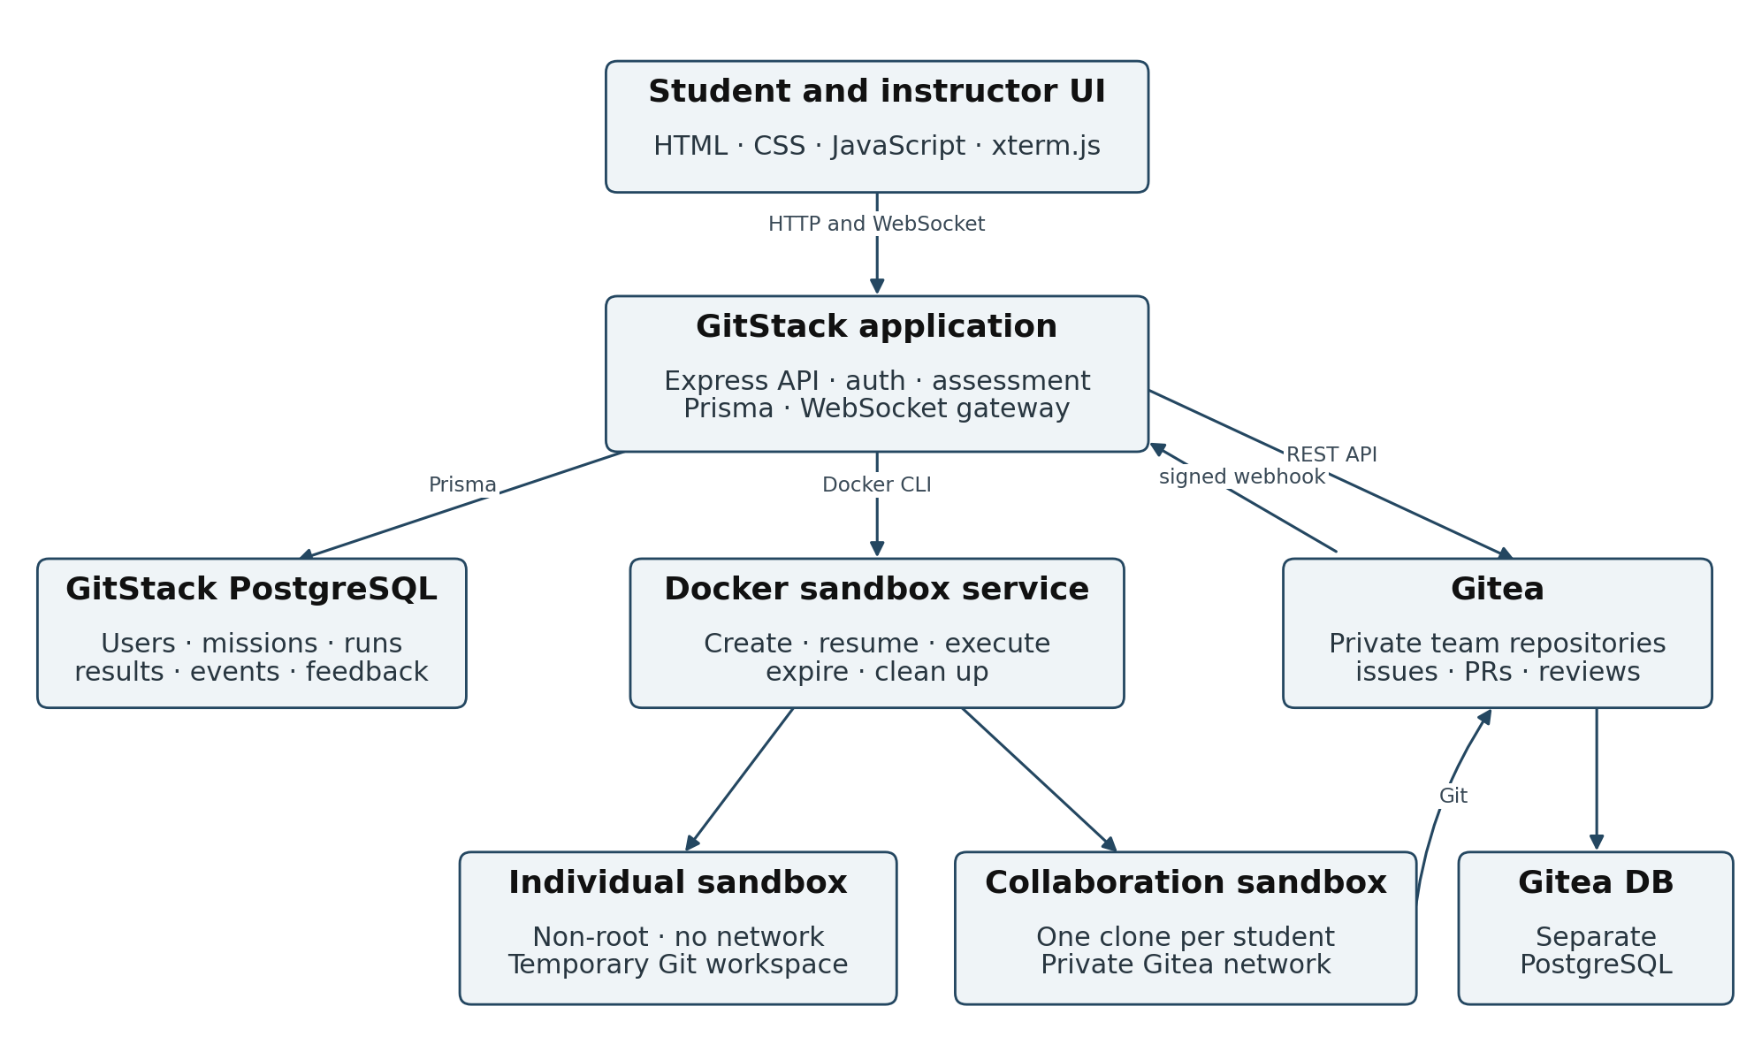
Figure 1 GitStack components and their principal communication paths.
Component | Default local deployment
Browser frontend | Static HTML/CSS/JavaScript with xterm.js 5.3.0; GitStack at localhost:3000.
Application and data | Node.js 20+ / Express 5.2.1; Prisma 6.19.0; GitStack PostgreSQL 17.6 on host port 5432.
Gitea and its data | Gitea image tag 1.24 at host port 3002 and SSH 2222; a separate PostgreSQL 17.6 container.
Docker workspaces | Non-root Debian bookworm-slim containers; individual network none; team internal bridge.
Persistence | Three named volumes: GitStack database, Gitea database and Gitea /data repositories.

The Compose project is gitstack-main. Gitea joins its default service network and the internal gitstack-sandbox-network. A team sandbox reaches Gitea through the latter; individual missions have no network. The host application calls Gitea’s API, and Gitea returns signed event callbacks to the host. Docker and the running databases are needed for full operation.

4 Database design
Prisma defines eleven GitStack models with identifiers and indexes for lookup and deduplication. Gitea maintains its own PostgreSQL records and Git repositories. The diagrams show principal relationships; additional creator and actor references appear in the schema.
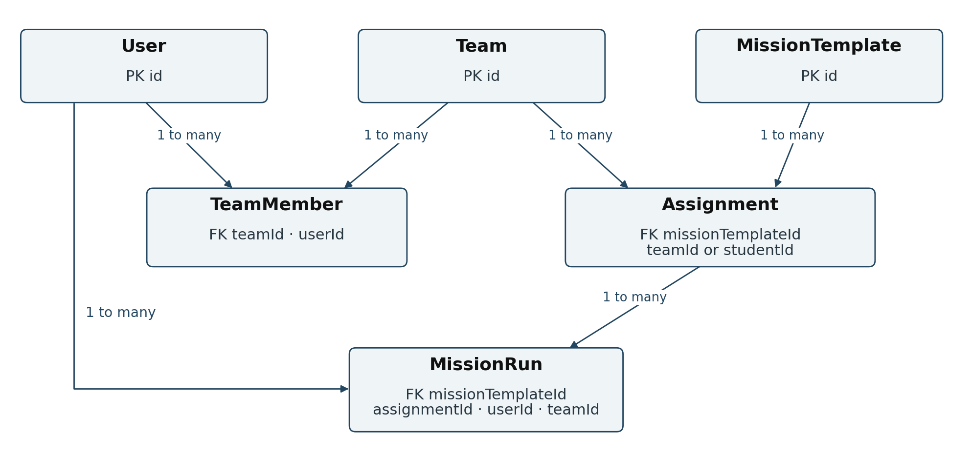
Figure 2 Identity, team, template, assignment and run relationships.
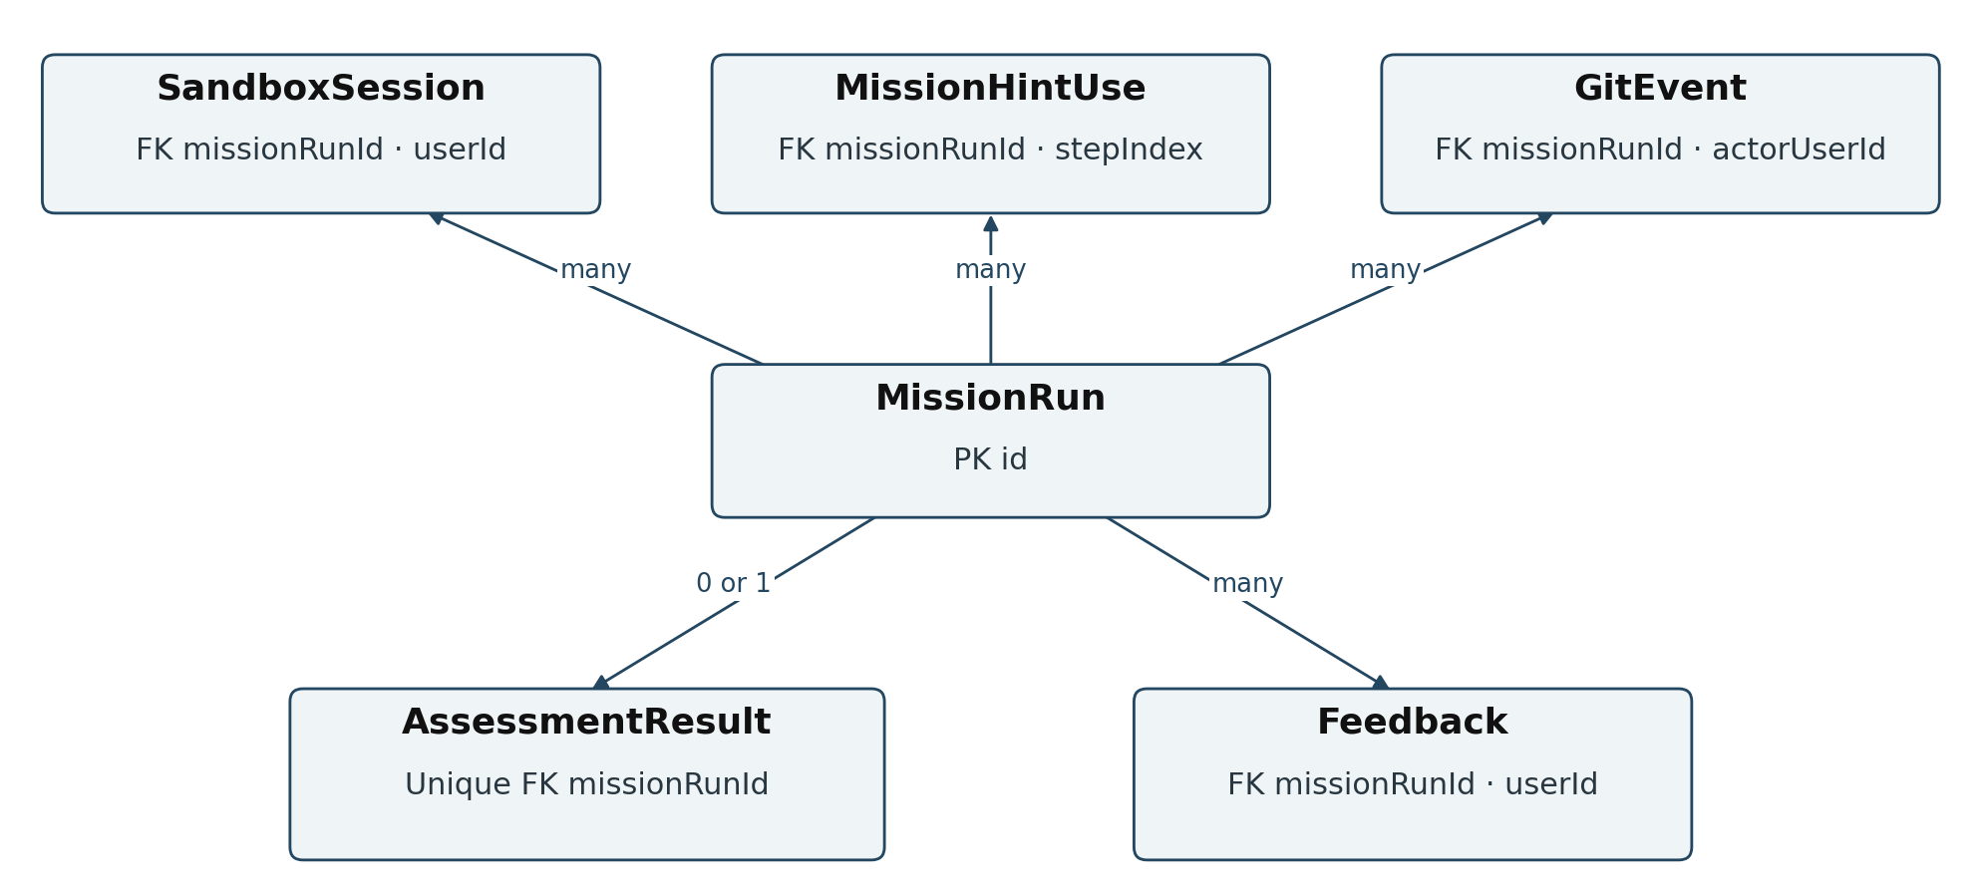
Figure 3 Runtime resources and assessment evidence linked to a run.
Data group | Models and meaning
Identity and team | User stores account/XP; Team maps to a Gitea repository; TeamMember links a user and one role to a team.
Coursework | MissionTemplate stores steps/rules; Assignment targets a student or team with status and dates.
Execution | MissionRun holds attempt, progress, expiry and XP; SandboxSession maps to a container; MissionHintUse records one cost per step.
Evidence | GitEvent stores signed workflow activity; AssessmentResult stores scores/rules; Feedback stores messages.

5 Missions and validation
Seeded mission | Level | Time · XP | Required result
Git Basics | 1 | 25 min · 100 | Initialize, track profile.html, commit and inspect history.
Branching & Merge | 2 | 35 min · 150 | Feature branch work merged into main; finish on main.
Remote Workflow | 3 | 40 min · 170 | Clone local remote, commit, pull and push latest main.
Mistake Recovery | 4 | 30 min · 160 | Restore notes.txt, commit recovery-note.md, clean tree.
Collaboration Basics | 5 | 120 min · 180 | Three-role issue-to-merge team workflow in Gitea.

Individual mission lifecycle
A student starts an available published individual mission. The server creates or resumes a MissionRun and owned Docker workspace; new runs use the displayed time estimate as deadline and sandbox expiry. The terminal executes permitted commands, while a step engine validates the current command and repository state in order. Reset prepares the starter state without extending that deadline. Retry creates a new attempt. Expired runs require another attempt.
Submission requires all steps complete, time remaining and an owned working sandbox. Final repository validation checks observable files, Git index, branches, commits, remotes and clean status as required by that mission. A mismatch returns a 409 with failed checks, preserving the recorded progress for correction. A passing result is stored with feedback and the individual sandbox is cleaned up; a practice retry cannot collect the same individual mission XP again.

Instructor-authored missions
The authoring form accepts title, objective, description, level, XP, ordered steps, estimate and effective repository validation rules. A published individual mission must pass the supported command contract; arbitrary written instructions are not silently executed. A missing estimate defaults to 30 minutes for a new run. Built-in missions are protected from route deletion; custom missions with history are archived rather than erasing grades.

6 Hints progression and learning tools

Verified hints and XP
A hint is generated for the current unfinished step from a supported command and read-only inspection of the student repository. The service checks the proposed action against the live step gate. Each revealed step is recorded once; opening it again costs no XP. For reward R and n steps, step i receives weight n+i (i starts at zero). Integer cost allocation distributes the full R across steps, with later steps usually costing more. New runs deduct selected hint costs from their completion reward, not from XP earned elsewhere. Legacy immediately charged runs retain their accounting. Individual completion locks and updates XP transactionally; team rewards use a conditional claim.
100 XP mission with eight steps | Completion reward
No hints | 100 XP
First and last hints (9 + 16 XP) | 75 XP
Every hint | 0 XP; the mission can still pass

Progress and rankings
Student level is floor(XP / 250) + 1 for nonnegative XP. The XP leaderboard sorts by XP and learning completion; the contributor leaderboard combines completed missions, passed assessments, bounded attempts, active work and recorded Git-event points. Rank positions one through five carry Diamond, Platinum, Gold, Silver and Bronze labels. Instructor analytics present mission completion, XP bands, pass rate and common failed rules.

Supplementary learning
Git Flow Lab visually explains init, clone, status, add, commit, push, pull, branch, checkout and merge through a guided example with optional sound. Git Hangman teaches vocabulary through clues, an extra hint and easy/medium/hard rounds (8/6/5 allowed mistakes); sessionStorage holds local wins and streaks. Neither tool executes a graded mission nor changes account XP. Shared pages provide EN/BN text, light/dark themes and responsive layouts.

7 Team collaboration preparation
Student role | Assigned branch | Focus
Feature Developer | feature/login-improvement | Feature commits and responding to changes
Test Developer | test/login-improvement | Test evidence and conflict resolution
Code Reviewer | review/login-improvement | Reviews, approval and merge order

An instructor creates a team or eligible students form one. All three members must have distinct roles and link their exact Gitea usernames. An ACTIVE Collaboration Basics assignment provisions or repairs an organization-owned private repository, team access, role branches, a prepared issue and test/conflict files, a signed webhook and three member runs. The instructor Gitea area manages repositories and access; student PR/review work happens in Gitea.

Workspace preparation and recovery
Each student starts a separate Docker sandbox with a clone under /workspace/team-repo and the assigned role branch. A preparation lock and temporary clone path protect duplicate starts. Existing workspaces are checked and fetched with a timeout; a non-repository directory is not overwritten. When a stopped/restarted container loses its temporary clone, the application can reconstruct pushed work from the remote. Unpushed temporary work is not recoverable from Gitea.
The backend temporarily uses its service credential during clone/fetch and restores a credential-free origin. A student uses their own Gitea credentials to push. Open Gitea opens the team repository root. The final interface has no View assigned branch control: branch selection and pull requests are handled through Gitea’s normal navigation. A branch push makes work visible on that branch; main changes after the merge.

8 Team collaboration workflow
The seeded scenario is a real issue-to-merge exercise. The Feature and Test Developers edit the same policy line from their own branches, producing a controlled merge conflict after the feature PR is merged.
Stage | Required action
1 Feature | Make at least two meaningful commits on feature/login-improvement; preserve FEATURE_FLAG=enabled; push and open an issue-linked PR.
2 Requested changes | The reviewer writes a specific comment and requests changes; the feature developer pushes an updated commit afterward.
3 Feature merge | The reviewer approves and merges the corrected feature PR.
4 Test branch | Commit on test/login-improvement; run sh tests/verify-login-policy.sh and record a meaningful FAIL explanation in tests/test-evidence.md; push and open an issue-linked PR.
5 Conflict | After the feature merge, bring main into the test branch; resolve src/login-policy.txt to preserve both role changes and remove conflict markers.
6 Passing tests | Rerun the supplied test, record a meaningful PASS explanation, then commit and push the resolution and evidence.
7 Final review | Reviewer verifies the updated evidence, approves after the TEST event and merges the test PR after the feature PR.

Final policy and repository visibility
AUTH_MODE=secure-verified
FEATURE_FLAG=enabled
TEST_GUARD=enabled
Assessment checks the final file, FAIL/PASS explanations, recorded workflow events and merge order. The supplied shell test helps students verify their work. A commit still local to the sandbox is absent from Gitea until its push succeeds; an unmerged PR’s changes are absent from main. Students should confirm the correct remote, role branch and Gitea repository before requesting assessment.

9 Team assessment and evidence
Each member can earn 70 points for their role plus 30 shared team points. Passing requires at least 70 total points and completion of every shared workflow rule.
Role | Individual rules | Max
Feature Developer | Correct branch 15; two meaningful commits 20; PR 20; response after requested changes 15. | 70
Test Developer | Correct branch 10; meaningful commit 15; passing evidence and TEST event 25; PR 20. | 70
Code Reviewer | Specific review 25; request changes before approval 20; final approval 15; approval after tests 10. | 70

Shared workflow rule | Points
Both PRs link the mission issue | 6
Core issue, branch, commit, push, PR, review, requested-change, approval and merge events | 8
Test FAIL/PASS and final policy evidence with a TEST event | 6
Prepared conflict created and correctly resolved | 6
Feature PR merged before test PR | 4

Gitea’s callback carries event, actor, branch, delivery and resource data. GitStack verifies HMAC-SHA256 over the raw request body, records normalized GitEvent rows and ignores unique-key duplicates. Assessment reconciles webhook activity with Gitea repository state. AssessmentResult stores role/team totals and rule detail; Feedback gives corrective Bangla text. Award-enabled passes claim team mission XP once per member run. An assignment closes when the shared workflow and every member’s pass are complete.
This rubric validates a prepared teaching exercise. Text length, actor and timing signals do not prove semantic code quality; the instructor can inspect linked Gitea evidence. The application is not a general CI system.

10 Student and instructor modules
Student interface | Delivered behavior
Dashboard | Mission summary, XP level, leaderboard and recent progress.
Missions and workspace | Catalogue, ordered steps, real terminal, countdown, hints, submit/reset/retry and feedback.
Progress and assessment | Attempt history, grades, checks, earned XP and corrective messages.
Team Activity | Role, issue, workspace readiness, Open Gitea, assessment and report.
Profile | Personal details, Gitea username and password change.

Instructor interface | Delivered behavior
Dashboard and students | Cohort overview, student records and individual learning detail.
Missions | Create, edit, publish and safely remove supported custom missions.
Assignments and teams | Schedule work, create/edit teams and prepare or assess collaboration.
Assessments | Individual and team results, rule details, feedback and repository links.
Analytics and activity | XP bands, pass rate, average scores, mission completion, rule failures and activity.
Gitea | Connection, organization, repository, access, branch and pull-request management.
Profile | Instructor profile, Gitea identity and password.

The package has 30 HTML pages, with shared language and theme scripts. The repository deletion route protects collaboration history and active assignments. Student APIs use run ownership and team membership; instructor integration routes require the appropriate role.

11 Sandbox terminal and security
Sandbox default | Value and control
Process identity | Non-root UID/GID 10001; no host project bind mount or Docker socket inside student containers.
Resource caps | 0.5 CPU, 256 MiB memory, 64 PIDs, 64 MiB workspace tmpfs, 32 MiB /tmp.
Lifecycle | 60-minute standalone TTL, 30-minute terminal idle limit, five-minute cleanup interval, at most three owned sandboxes per user.
Networking | No network for individual work; internal collaboration network with Gitea for team work.
WebSocket | JWT and origin checked on upgrade; requires an active user and owned running sandbox.
Terminal interface | xterm output callback scrolls after rendering; Run, direct input and Latest output move to the newest line. Team host stays 470 px high with a scrollable viewport.

SandboxSession and Docker labels associate containers with owners, modes and expiry. The terminal gateway at /ws/sandboxes/:id/terminal carries input/resize and output/status/error/exit messages. A separate HTTP route executes only approved named commands with a 10-second default timeout. Individual mission commands are also checked by the mission policy.

Application controls and deployment boundary
Passwords use Argon2id, login/register have a 20-per-15-minute rate limit, and signed JWTs are placed in HttpOnly, SameSite Strict cookies (Secure in production). Profile fields use AES-256-GCM with HMAC lookup hashes. Zod validates inputs, the server enforces roles/ownership and Gitea webhooks require a shared-secret signature. Preserve DATA_ENCRYPTION_KEY when carrying a database forward.
Read-only root filesystems, all-capability dropping and no-new-privileges are supported flags but default to false. Helmet CSP and cross-origin embedder policy are disabled. Public instructor self-registration and local development credentials require a stricter policy before public deployment; the current baseline is a controlled laboratory host.

12 Startup persistence and recovery
The application database, Gitea database and Gitea /data repositories are three different named volumes. The project ZIP contains code, not the live account, assessment or repository data. The Compose project name is fixed as gitstack-main to avoid a directory rename silently selecting a new set of volumes.

Daily operation
npm run project:start
Preflight requires the prior .env, default Docker context, expected Compose project and three existing data volumes. It starts infrastructure, waits for GitStack PostgreSQL, checks the Gitea-to-gitea-db TCP path and Gitea API, confirms/builds a compatible sandbox image and launches Node. npm run dev uses the same preflight through predev; npm start starts Node directly. Daily startup does not deploy migrations or refresh built-in mission templates.

Guarded repair
If Gitea cannot reach its database, the script checks both relevant networks for unrelated or active student containers. When safe it performs one compose down/up network recreation without deleting volumes, then probes again. Missing volumes, wrong Docker context or unresolved connectivity stop with a diagnostic. This targets the observed container-network failure but cannot prevent manual volume removal, host failure or every future Docker fault.
Symptom | Interpretation and safe response
Gitea connection reset | Container status alone is insufficient; inspect recent logs and use preflight’s database/API readiness checks.
gitea-db resolves but port times out | DNS works but the network path fails; use guarded repair only when other containers are not attached.
Volume reported missing | Check original Docker context and resolved volume names; restore prior data rather than creating an empty installation.
Sandbox clone absent after restart | Workspace tmpfs is temporary; resume to restore pushed history from Gitea. Unpushed work needs its own backup.
Push not visible on main | Verify push, assigned branch, remote and PR; main changes after merge.

A complete backup must keep both PostgreSQL databases, Gitea /data and the matching private .env. Test recovery separately. Never delete named volumes as part of an ordinary restart.

13 Installation and upgrade

Fresh laboratory setup
Prerequisites are Node.js 20+, npm, Docker Engine/Compose, Git, accessible ports 3000/3002/2222/5432 and a Docker-capable Linux host. From the newly extracted GitStack-main directory:
unset DOCKER_HOST
unset DOCKER_CONTEXT
docker context use default
sudo systemctl enable --now docker
npm ci
npm run setup -- --rebuild
Fresh setup prepares secrets, images and services; deploys Prisma migrations; and seeds the five built-in missions. Complete Gitea’s one-time installation at http://localhost:3002, create the intended administrator account and an integration token with write:admin, write:organization, write:repository, write:issue and read:user scopes. Keep the token in private .env configuration, then run gitea:doctor and project:start.

Upgrade while preserving existing data
Copy the previous working .env, retaining DATA_ENCRYPTION_KEY and established database/Gitea settings exactly. Keep the named volumes. In the new project directory run:
npm ci
docker compose up -d postgres gitea-db gitea
npm run db:validate
npm run db:generate
npm run db:deploy
npm run verify
npm run gitea:doctor
npm run project:start
Use setup for a new installation; use db:deploy when an upgrade contains migrations. db:seed and acceptance:host refresh the built-in templates, so run them deliberately on an existing database. Do not use docker compose down -v to repair connectivity. Existing in-progress attempts retain their earlier deadline; new ones use their mission estimate.

14 Verification and laboratory demonstration
Completed check on 30 September 2026 | Observed result
Latest ZIP versus inspected source | All 233 packaged files matched byte for byte.
npm run verify | Passed 19 chained source/behavior checks; syntax for 129 JS files and structure checks for 30 HTML pages.
Startup and collaboration regressions | Passed mocked startup, webhook/workspace/handoff and local bare-Git branch restoration cases.
Hints, timers, Hangman and terminal framing | Passed their packaged behavior checks, including weighted XP and WebSocket framing.
npm run db:validate | Passed schema validation using a temporary validation URL; no live database migration executed.

Docker was unavailable in the report-preparation environment. No claim is made that a full browser, PostgreSQL/Gitea or reboot acceptance test passed there. On the actual laboratory host, run the doctors, sandbox:test and terminal:test, then rehearse the end-to-end flow.

Short demonstration sequence
- Start with project:start. Confirm known accounts, mission records and the Gitea API are present.
- Complete one individual mission; show ordered validation, a hint cost, result and XP history. Show mission authoring and assignment as instructor.
- Use three accounts to push role branches, open Gitea PRs, request changes, record FAIL/PASS tests, resolve the conflict and merge feature before test.
- Inspect the 70/30 report and Bangla feedback. Fill the terminal with harmless output and confirm the newest prompt stays visible; resume a pushed team workspace.

Limitations and next steps
Sandbox files are temporary; source checks do not replace a real-host rehearsal. The prepared evaluator checks event and repository evidence rather than semantic code quality or a general CI pipeline. Before public deployment, add instructor approval, TLS, stronger Docker hardening, asset hosting and tested backups. Browser acceptance, accessibility review and learning-outcome measurement remain future evaluation work.

15 API map references and conclusion
Most application routes return JSON; authenticated calls use the session cookie. HTTP 401 denotes authentication failure, 403 forbidden access, 404 missing resources and 409 conflicting workflow state. The following map gives the principal API families and current source paths.
API family | Principal operations and access
/api/auth; /api/missions | Register, login, logout, current user, public mission catalogue and detail; server.js.
/api/student | Dashboard; mission start/run/hints/reset/submit/abandon; leaderboard/progress/feedback; team workspace/report/assess; own profile.
/api/instructor | Student, mission, assignment, team, assessment, analytics, activity and instructor profile operations.
/api/gitea | Instructor organization, repositories, team access, branches and pull-request management.
/api/gitea/webhook | Signed Gitea event ingestion, delivery identification and deduplication.
/api/sandboxes; /ws/sandboxes/:id/terminal | Owned sandbox lifecycle and approved HTTP commands; authenticated interactive WebSocket terminal.

Release identity and source references
Reviewed archive: GitStack-Open-Gitea-Auto-Scroll-Final.zip; package version 1.0.0; 233 packaged files. SHA256:
4e4b67a6f0504a2b56c549ab22bdeabdae2c708bf2a1292852e21d863fb61c64
Implementation references: server.js; package.json; docker-compose.yml; prisma/schema.prisma, migrations and seed; public/; routes/; services/student/, services/sandbox/, services/collaboration/, services/gitea/, services/security/ and services/leaderboard/; scripts/ regression and startup tools; README.md and RUN_COMMANDS.md. The supplied GitStack_Reset_Roadmap_August_September_2026 .docx supplied names/responsibilities, and GitStack_Complete_Project_Plan.txt supplied supporting role categories. Historical planned features were not treated as implementation evidence.

Conclusion
GitStack brings individual Git practice, real Gitea teamwork and explainable assessment into one laboratory system. Its current implementation covers student and instructor flows, protected records, isolated workspaces, repository/event validation and operational recovery. The latest release preserves normal repository-level Open Gitea work and keeps new sandbox output visible. Host acceptance on the demonstration laptop remains the final readiness check.

