INFT 6201 Big Data
Heart Attack Prediction Using Machine Learning
Assessment 3: Data Analysis Report
Kazi Shabab Mahfuz-3475165
11-17-2024

Contents
1. Executive Summary 2
2. Introduction 3
2.1 Overview 3
2.2 Objectives 3
2.3 Methodologies 3
2.4 Relevance 3
3. Dataset 4
3.1 Source 4
3.2 Feature Descriptions: 4
3.3 Quality of the dataset 4
4. Dataset Analysis 5
4.1 Dataset 5
4.2 Handling missing Data 5
4.3 Data Distribution 5
4.4 Scatter Plot 6
4.5 Box-plot 6
4.6 Finding Outliers 7
4.7 Heatmap 8
5. Data Modelling and Results 9
5.1 Choice of Models 9
5.2 Training and Testing Process 9
5.3 Models and their performance 10
5.4 Precision-Recall Curve 12
5.5 ROC Curve 13
6. Discussion and Conclusion 15
6.1 Findings and Implications 15
6.2 Future Applications 15
6.3 Limitations 15
6.4 Conclusion 16
7. Reference 16

Executive Summary

This project aims to predict the likelihood of heart attacks using machine learning techniques. The initiative stems from the growing global burden of coronary heart disease (CHD), a leading cause of mortality worldwide. The project leverages machine learning to facilitate early diagnosis and prevention, which can significantly reduce hospital admissions and improve patient outcomes. Our project also aligns with the United Nations' Sustainable Development Goal (SDG) of promoting health and well-being for all.
The dataset used was sourced from Kaggle and contains 2,182 records merged from five publicly available heart disease datasets. Key preprocessing steps taken to optimize the dataset was handling missing data, capping outliers, and encoding categorical variables.
Machine learning models that were chosen for this project were Naive Bayes, Decision Tree, KNN and, Random Forest keeping in mind of the type our dataset and are common classification type models each having their own advantages and limitations depending on the scenario. To get key insights and to compare the model’s performance relative to each other metrics like accuracy, precision, recall etc. were used.
The broader impact of this project includes supporting healthcare providers in resource-limited settings by enabling cost-effective and scalable diagnostic tools. This can potentially reduce the burden of cardiovascular diseases, particularly in low- and middle-income countries, where access to advanced healthcare systems is limited and prevention plays a big role when faced with financial constraints.

Introduction

2.1 Overview
Coronary heart disease (CHD) is the single largest cause of death in the developed countries and is one of the leading causes of disease burden in developing countries. (Girish, Trevedi, & Navarathna, 2010) At least three-quarters of the world's deaths from CVDs occur in low- and middle-income countries. People living in low- and middle-income countries often do not have the benefit of primary health care programs for early detection and treatment of people with risk factors for CVDs. (World Health Organization, 2011) Early prediction and prevention can significantly reduce hospital admissions and improve patient outcomes is a key element in its management and treatment. (Centre Cardiologique Laval, 2024)
Leveraging advancements in machine learning, this project explores the predictive power of various algorithms to assess heart attack risk using patient health data. By identifying individuals at higher risk, timely interventions can be implemented to improve outcomes.

2.2 Objectives
The primary objectives of this project are:
- To develop machine learning models that accurately predict heart attack risk based on patient health metrics.
- To compare the performance of Naive Bayes, Decision Tree, K-Nearest Neighbours (KNN), and Random Forest algorithms on this dataset.
- To provide actionable insights that can assist healthcare providers in prioritizing high-risk patients.
- Achieve one of the SDG goals of United Nations. That is - Ensure healthy lives and promote well-being for all at all ages.

2.3 Methodologies
- Data Preprocessing: Steps included handling missing values, encoding categorical variables, and capping outliers to ensure data quality.
- Model Development: Four machine learning models—Naive Bayes, Decision Tree, KNN, and Random Forest—were trained and evaluated for accuracy, precision, recall, and F1-score.
- Evaluation: ROC and Precision-Recall curves were analysed for deeper insights into model performance.

2.4 Relevance
The study is highly relevant in addressing the global challenge of cardiovascular disease. Machine learning models can aid in early diagnosis, reduce the burden on healthcare systems, and enhance the precision of decision-making in resource-constrained environments. By automating risk prediction, this project contributes to scalable and cost-effective solutions for heart disease management.

Dataset

3.1 Source
The dataset was sourced from Kaggle and contains 2,182 records merged from five publicly available heart disease datasets. It includes 14 features that are crucial for predicting heart attack and stroke risks, covering both medical and demographic factors. The data is well-suited for binary classification tasks, focusing on identifying high-risk patients. Below is a detailed description of each feature-

3.2 Feature Descriptions:
- age: Age of the patient (Numeric).
- sex: Gender of the patient. Values: 1 = male, 0 = female.
- cp: Chest pain type. Values: 0 = Typical angina, 1 = Atypical angina, 2 = Non-anginal pain, 3 = Asymptomatic.
- trestbps: Resting Blood Pressure (in mm Hg) (Numeric).
- chol: Serum Cholesterol level (in mg/dl) (Numeric).
- fbs: Fasting blood sugar > 120 mg/dl. Values: 1 = true, 0 = false.
- restecg: Resting electrocardiographic results. Values: 0 = Normal, 1 = ST-T wave abnormality, 2 = Left ventricular hypertrophy.
- thalach: Maximum heart rate achieved (Numeric).
- exang: Exercise-induced angina. Values: 1 = yes, 0 = no.
- oldpeak: ST depression induced by exercise relative to rest (Numeric).
- slope: Slope of the peak exercise ST segment. Values: 0 = Upsloping, 1 = Flat, 2 = Down sloping.
- ca: Number of major vessels (0-3) coloured by fluoroscopy. Values: 0, 1, 2, 3.
- thal: Thalassemia types. Values: 1 = Normal, 2 = Fixed defect, 3 = Reversible defect.
- target: Outcome variable (heart attack risk). Values: 1 = more chance of heart attack, 0 = less chance of heart attack.

3.3 Quality of the dataset
After initial inspection, missing values were found in some features (e.g., ca and thal). These were handled by:
- Replacing placeholders (?) with NaN.
- Dropping rows with missing values to ensure data consistency.

Dataset Analysis

4.1 Dataset
Below is the view of the dataset. To get a comprehensive idea of the features and attributes we are dealing with-
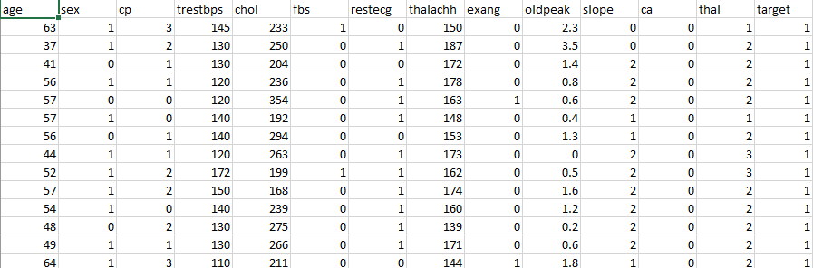
Fig 4.1: dataset visualization

4.2 Handling missing Data
Missing values were found in some features and there were placeholders - (?) on the missing entries. To combat this, placeholders -(?) were replaced with NaN. Finally, rows with missing data were dropped to ensure data consistency. This shrunk the size of the dataset from 2,182 records to 1,889.

4.3 Data Distribution
Below there is a graph of the distribution of Data for each of the features. Key insights we get are-
- age: Majority of the age of our patients ranges from 55-65.
- chol: Most patients have a Serum Cholesterol level (in mg/dl) between 220-270.
- sex: In our data the number of male patients is more than double that of female patients.
- cp: chest pain types for most patients were Typical angina and Non-anginal pain.
- thalachh: Most patient’s Maximum heart rate is between 155-170.
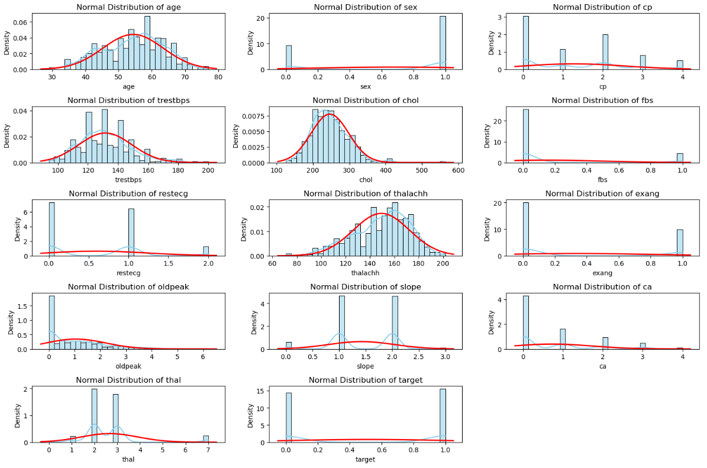
Fig 4.2: plot of normal distribution of features

4.4 Scatter Plot
This scatter plot illustrates the relationship between Resting Blood Pressure (trestbps) on the x-axis and Maximum Heart Rate Achieved (thalachh) on the y-axis, categorized by Heart Attack Risk (target). Looking at the scatter plot we don’t see any clear correlation. So, there isn't a strong linear relationship between the features trestbps and thalachh.
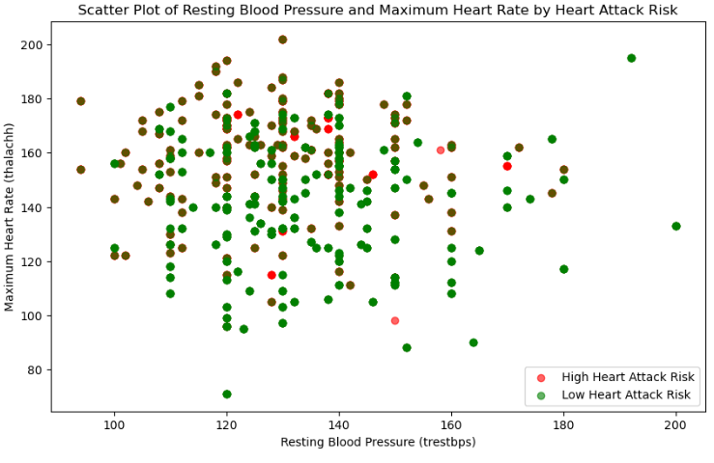
Fig 4.3: scatter plot

4.5 Box-plot
The following boxplot visualizes the distribution of Cholesterol Levels (chol) across different Chest Pain Types (cp). We observe, there is no significant distinction in cholesterol levels across chest pain types. The medians, ranges, and IQRs overlap substantially. Outliers (dots outside the whiskers) are present across all chest pain types.
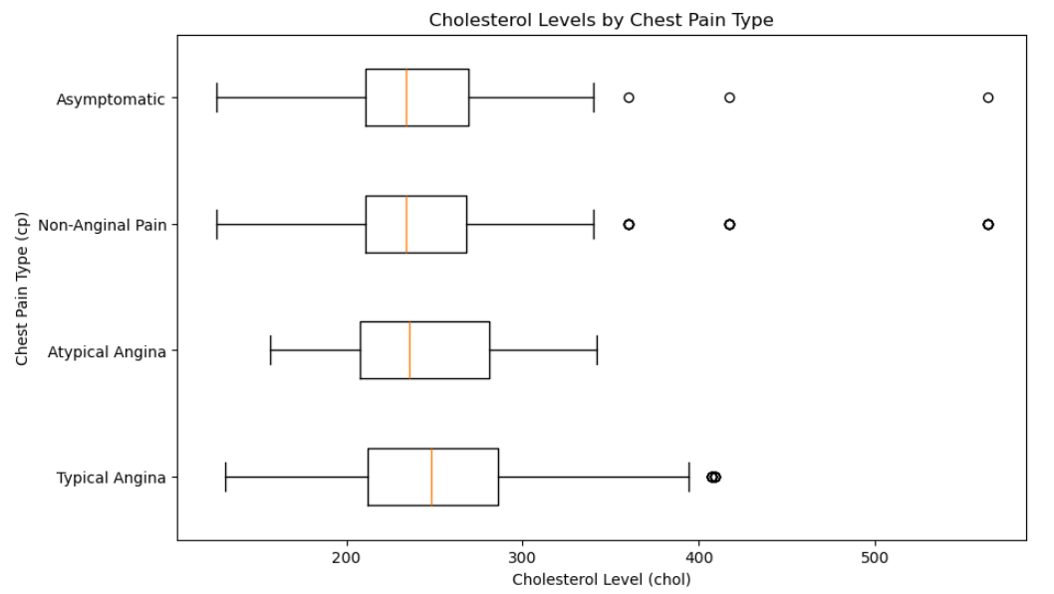
Fig 4.4: box-plot

4.6 Finding Outliers
Below is box plot we plotted from the features trestbps, chol, and thalachh all containing numeric values. From the plot we find outliers on the high end in trestbps, and chol, then in the lower end in thalachh. We combat this by capping the outliers by lower-upper bound limit of 5% and 95%.
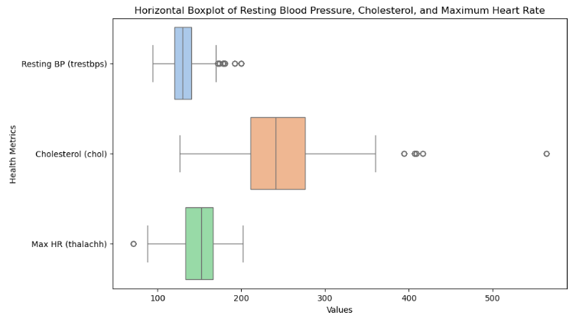
Fig 4.5: box-plot before capping outliers
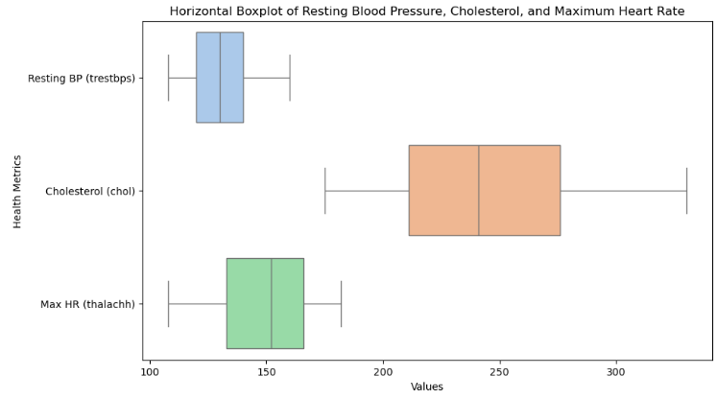
Fig 4.6: box-plot after capping outliers

4.7 Heatmap
The following heatmap represents the Pearson Correlation Coefficients between all the features in the dataset. The feature that will be predicted in my model is target. From the heatmap we can conclude that cp, thalachh, slope, exang, oldpeak, and ca should be prioritized as they exhibit moderate to strong correlations with target.
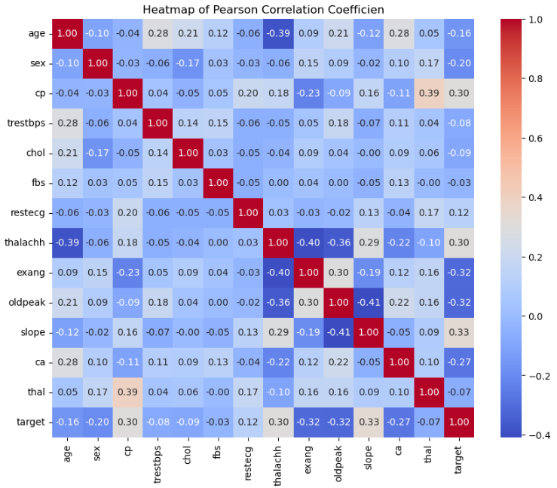
Fig 4.7: correlation heat-map

Data Modelling and Results

5.1 Choice of Models
To predict heart attack risk, we chose the following models for their complementary strengths:
- Naive Bayes: Efficient and interpretable, particularly for categorical and numerical features. Works well for smaller datasets with independent features.
- Decision Tree: Handles non-linear relationships effectively and provides insights into feature importance. Useful for interpretability.
- K-Nearest Neighbours: Non-parametric and capable of capturing local patterns in the data.
- Random Forest: An ensemble model that combines multiple decision trees to reduce overfitting and improve accuracy. Robust to noise and captures complex relationships.

5.2 Training and Testing Process
- Data Splitting:
- The dataset was split into 80% training data and 20% testing data.
- Target variable: target (1 = High Heart Attack Risk, 0 = Low Heart Attack Risk).
- Features: Selected based on correlation and importance (e.g., cp, thalachh, slope).
- Feature Scaling:
- For KNN, numerical features were normalized to ensure distance-based calculations were not biased.
- Model Training:
- Each model was trained using the training dataset.
- Evaluation Metrics:
- Accuracy
  - Definition: The proportion of correct predictions (both positive and negative) out of the total predictions.
  - Importance: Gives an overall measure of the model’s performance but may be misleading if classes are imbalanced.
  - Formula:
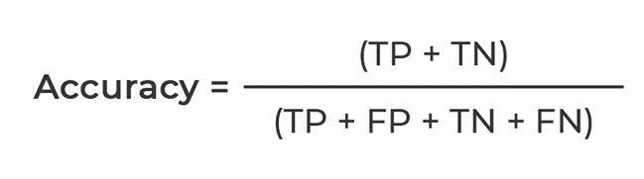
- Precision:
  - Definition: Out of all instances predicted as positive, how many were truly positive.
  - Importance: Useful when false positives are costly.
  - Formula:
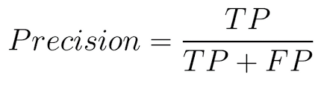
- Recall:
  - Definition: Out of all actual positive instances, how many were correctly predicted as positive.
  - Importance: Crucial when false negatives are costly (e.g., in medical diagnoses like heart attack prediction).
  - Formula:
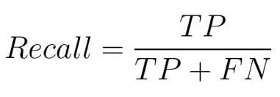
- F1-score:
  - Definition: The harmonic mean of precision and recall.
  - Importance: Useful when you need a single metric to evaluate overall performance.
  - Formula:
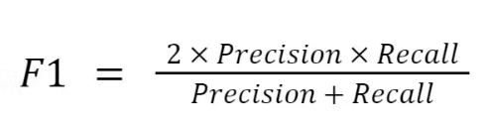
- ROC-AUC: Evaluates the trade-off between sensitivity and specificity across thresholds.
- Bar-plot: Compares accuracy of each plot.
- PR Curve: Analyses precision and recall balance, especially for imbalanced data.

5.3 Models and their performance
Gaussian Naive Bayes (Accuracy: 0.69)
- Precision: Moderate (0.70 on average).
- Recall: Performs slightly better on high-risk patients (recall = 0.78) but worse on low-risk patients (recall = 0.61).
- F1-Score: Balanced at 0.69.
Why It Performed Poorly:
- Assumes feature independence, which is unrealistic for this dataset (e.g., chol and thalachh are likely correlated).
- Performs poorly with complex relationships in data.
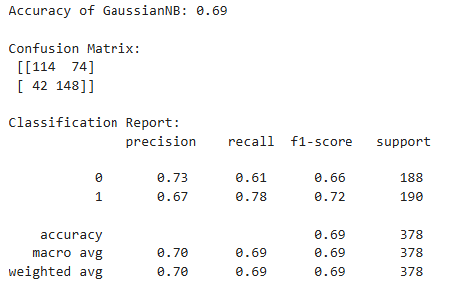
Fig 4.8: Naïve Bayes performance

Decision Tree Classifier (Accuracy: 0.94)
- Precision, Recall, and F1-Score: High (0.94 across all metrics).
- Balanced performance between classes (low-risk and high-risk).
Why It Performed Well:
- Handles non-linear relationships effectively.
- Captures complex interactions between features without assuming independence.
- Fits the training data well due to its flexibility, but care should be taken to prevent overfitting.
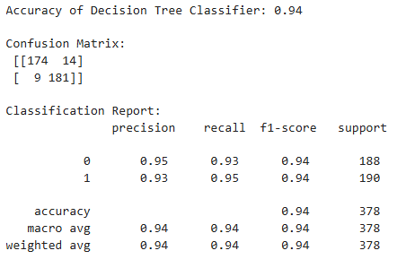
Fig 4.9: DT classifier performance
k-nearest neighbours (KNN) (Accuracy: 0.93)
- Precision: High (0.95 for low-risk, 0.92 for high-risk).
- Recall: High for high-risk cases (0.95), slightly lower for low-risk cases (0.92).
- F1-Score: Balanced at 0.94.
Why It Performed Well:
- KNN captures local patterns, which are important for datasets with overlapping classes.
- Sensitive to feature scaling; likely benefited from normalized numerical features.
Limitations:
- Computationally intensive for large datasets.
- Performance depends heavily on the choice of k (number of neighbours).
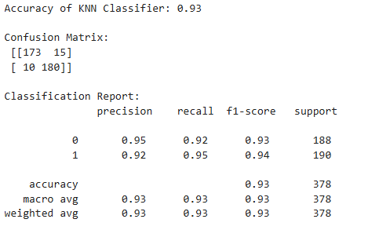
Fig 5.1: KNN performance
Random Forest Classifier (Accuracy: 0.95)
- Precision, Recall, and F1-Score: Consistently high (0.95 across all metrics).
- Best overall performance.
Why It Performed Best:
- Uses an ensemble of decision trees, reducing overfitting while maintaining flexibility.
- Captures complex, non-linear relationships in the data.
- Robust to noise and irrelevant features.
- Feature importance ranking helps optimize the model further.
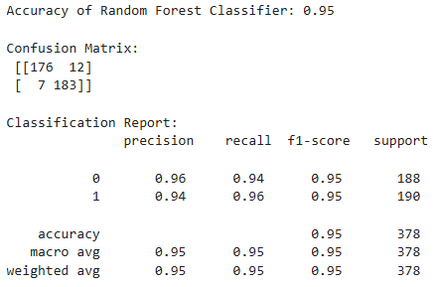
Fig 5.2: random forest performance

5.4 Precision-Recall Curve
The Precision-Recall (PR) curve evaluates the trade-off between Precision and Recall for different decision thresholds. Key Observations from the PR Curve-
- Naive Bayes (AP = 0.70):
- Precision drops sharply as Recall increases. This indicates the model sacrifices precision (more false positives) to improve recall (correctly identifying true positives).
- Performs moderately well, but its inability to capture complex feature interactions limits its effectiveness.
- Decision Tree (AP = 0.91):
- Maintains high precision across most recall levels, resulting in a strong PR curve.
- Balances both precision and recall effectively.
- Slight dip at the end indicates some loss in precision at very high recall levels.
- K-Nearest Neighbours (AP = 0.51):
- Performs poorly overall, with significant drops in precision as recall increases.
- The zigzag pattern reflects instability in its predictions, likely due to sensitivity to noisy data or poor feature scaling.
- The lowest AP score suggests this model struggles to generalize well for this dataset.
- Random Forest (AP = 0.97):
- Outperforms all other models, maintaining high precision across almost all recall levels.
- The curve is nearly flat at the top, indicating it handles the trade-off between precision and recall exceptionally well.
- High AP (0.97) suggests it is the most robust model for predicting high-risk patients in this dataset.
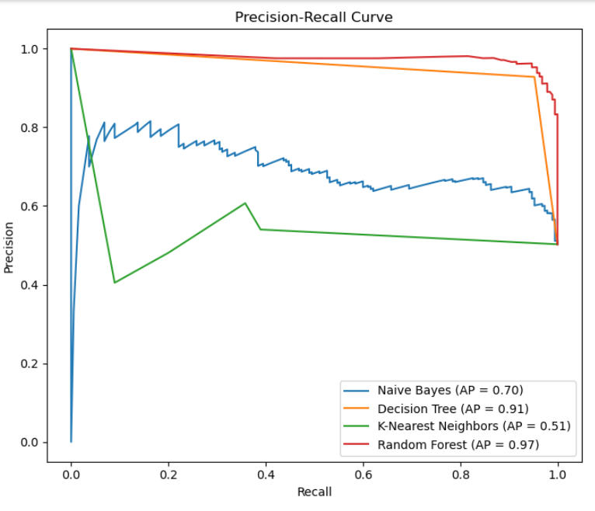
Fig 5.3: PR curve

5.5 ROC Curve
The Receiver Operating Characteristic (ROC) Curve is a graphical representation of a classification model's ability to distinguish between positive and negative classes at different threshold values. It plots:
- X-axis: False Positive Rate (FPR) – The proportion of negative cases incorrectly predicted as positive.
- Y-axis: True Positive Rate (TPR) (or Sensitivity) – The proportion of positive cases correctly predicted as positive.
The closer the curve is to the top-left corner, the better the model's performance.
Key Metric: AUC (Area Under the Curve)
- AUC quantifies the overall ability of the model to classify correctly across all thresholds.
- Ranges from 0.5 (random guessing) to 1.0 (perfect classification).
- Higher AUC values indicate better model performance.
From the graph we observe-
- Random Forest (AUC = 0.98):
  - The best-performing model.
  - The curve is very close to the top-left corner, meaning the model achieves a very high TPR while keeping the FPR low.
  - The almost perfect AUC value of 0.98 reflects its robustness and excellent predictive ability.
- Decision Tree (AUC = 0.94):
  - Also performs very well, with an AUC close to Random Forest.
  - Slightly less accurate than Random Forest but still demonstrates strong classification capability.
- Naive Bayes (AUC = 0.74):
  - Moderately effective.
  - The curve is farther from the top-left corner, indicating a trade-off between TPR and FPR.
  - The AUC of 0.74 shows that Naive Bayes struggles to balance precision and recall due to its simplistic assumptions (e.g., feature independence).
- K-Nearest Neighbours (AUC = 0.52):
  - The weakest model.
  - The curve is close to the diagonal line (random guessing).
  - The low AUC value reflects its poor ability to discriminate between positive and negative classes, likely due to insufficient feature scaling or inappropriate choice of k (number of neighbours).
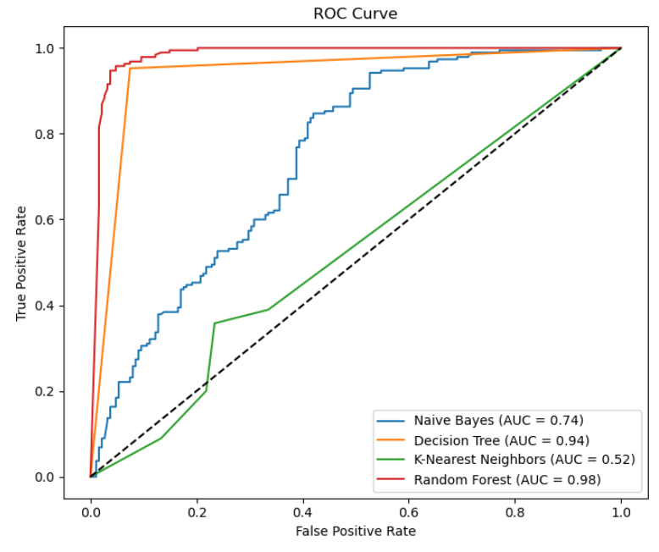
Fig 5.4: ROC curve

Discussion and Conclusion

6.1 Findings and Implications
- Model Performances:
- Random Forest emerged as the best-performing model with the highest AUC (0.98), accuracy (0.95), and balanced precision-recall metrics. Its ability to handle complex feature interactions made it suitable for this dataset.
- Decision Tree was a strong alternative with an AUC of 0.94. It is simpler and interpretable, making it a viable choice when understanding feature importance is crucial.
- Naive Bayes struggled with the dataset's complexity, achieving an AUC of 0.74, as it assumes feature independence, which is not valid here.
- KNN underperformed, with an AUC of 0.52, close to random guessing. The model's reliance on distance metrics likely failed due to sensitivity to noisy data.
- Key Findings:
- Models like Random Forest and Decision Tree provided robustness against noise and overfitting, ensuring better generalization on unseen data.
- Implications:
- These models can be instrumental in early heart disease detection, aiding healthcare professionals in identifying high-risk patients efficiently.
- High-performing models like Random Forest can minimize misclassification errors, potentially saving lives by ensuring timely medical intervention.

6.2 Future Applications
- Enhanced Predictive Tools:
- Deploying models like Random Forest in clinical settings.
- Integration with wearable devices (e.g., fitness trackers) to provide real-time risk predictions based on health data.
- Feature Engineering and Additional Data:
- Including more detailed health data, such as genetic information or lifestyle factors (diet, smoking, etc.), to improve model accuracy further.
- Real-Time Decision Systems:
- Using these models to flag high-risk patients during routine checkups.
- Extending the models for other related diseases to create comprehensive diagnostic tools.

6.3 Limitations
- Dataset Size:
- Dataset used in this analysis was relatively small, limiting the model's ability to generalize to broader populations.
- May not fully represent demographic or geographic variability (e.g., ethnicity, region.)
- Overfitting Risk:
- While Random Forest performed well, its ensemble nature may hide potential overfitting, requiring further testing on external datasets.
- Naive Bayes Assumptions:
- The poor performance of Naive Bayes highlights its limitations in handling non-linear relationships and correlated features.

6.4 Conclusion
This analysis demonstrated that Random Forest is the most effective model for heart disease prediction due to its robustness and accuracy. Decision Tree is a close second, offering simplicity and interpretability. The findings highlight the importance of feature selection, scaling, and proper model choice for healthcare data.
While these models show great promise, future work should focus on:
- Incorporating larger, more diverse datasets.
- Exploring advanced feature engineering techniques.
The results affirm the potential of machine learning to transform healthcare by enabling early diagnosis and personalized treatment, ultimately saving lives.

Reference

  - Takci, H. (2018). Improvement of heart attack prediction by the feature selection methods. Turkish Journal of Electrical Engineering and Computer Sciences, 26(1), 1-10.
  - Mall, S. (2024, May). Heart Attack Prediction using Machine Learning Techniques. In 2024 4th International Conference on Advance Computing and Innovative Technologies in Engineering (ICACITE) (pp. 1778-1783). IEEE.
  - Alshraideh, M., Alshraideh, N., Alshraideh, A., Alkayed, Y., Al Trabsheh, Y., & Alshraideh, B. (2024). Enhancing heart attack prediction with machine learning: A study at jordan university hospital. Applied Computational Intelligence and Soft Computing, 2024(1), 5080332.
  - Nandal, N., Goel, L., & TANWAR, R. (2022). Machine learning-based heart attack prediction: A symptomatic heart attack prediction method and exploratory analysis. F1000Research, 11, 1126.
  - Reddy, V. S. K., Meghana, P., Reddy, N. S., & Rao, B. A. (2022). Prediction on Cardiovascular disease using Decision tree and Naïve Bayes classifiers. In Journal of physics: conference series (Vol. 2161, No. 1, p. 012015). IOP Publishing.
  - Girish, R., Trevedi, D., & Navarathna, R. (2010). Title of the work in italics. Publisher/Journal, Volume (Issue).
  - World Health Organization. (2011).
  - Centre Cardiologique Laval. (2024).

