

**Unity 3D Asset**

**TerraHe**

Simple Terrain Heightmap Tool

**DOCUMENTATION**

**Contact : cartridgegamestudio@gmail.com**



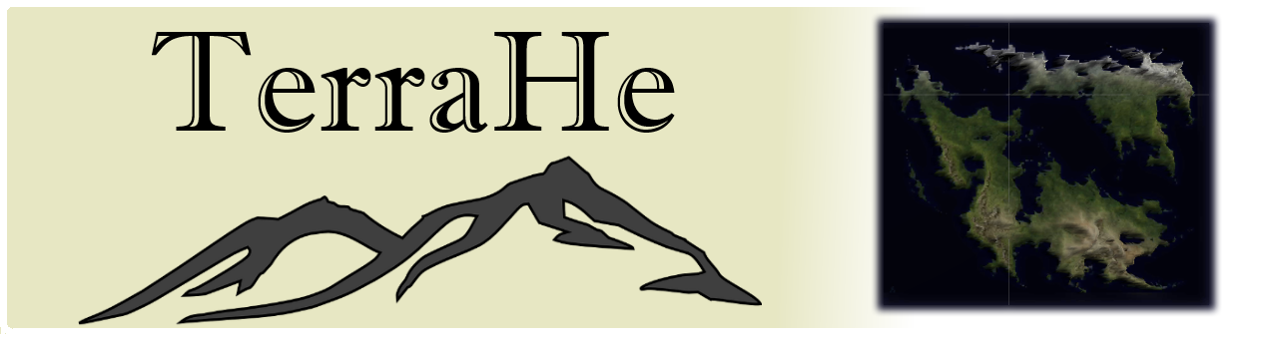

1. **What is TerraHE?**  
   TerraHE (TerrainHeightmapEditor) is a simple tool for terrain heightmaps. What it does is basically applies a heightmap texture from nearly all formats(.PNG , .JPG , .GIF etc) no need to be black&white , you can just use colored textures too , and It also lets you edit height according to your wish. Therefore , with that asset you no longer need .RAW files ,extra effort to change it's height tone and such. This was a problem for me while I first start to use heightmaps in Unity. Then I came across with heightmap's editing problem. And here , I made this asset for developers who suffer same.
2. **Why TerraHE?**  
   TerraHE is cool because as far as I can see there are no other asset that gives the same result. Since heightmap importing looks easy , most of the asset makers don't want to spend time on it. Also , TerraHE is cheap. Might be the cheapest. It's cheap because I'm a developer and I use assets too. So no one likes to pay a lot for a tiny bump on the road.
3. **How to use TerraHE?**

3.1 **About Terrain and Terrain Optimization**

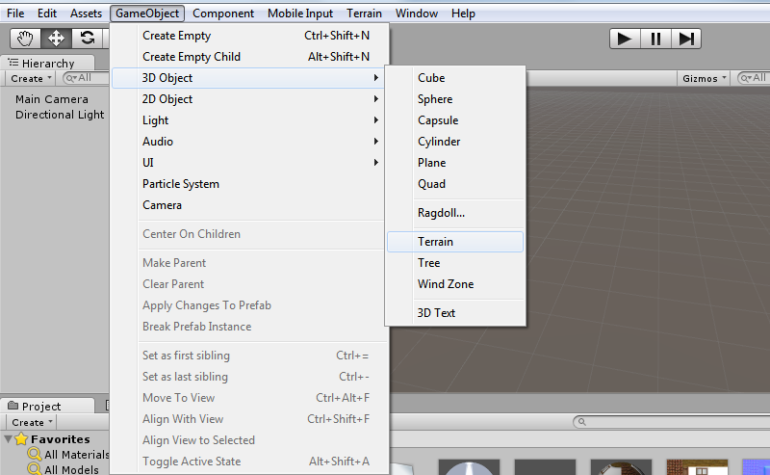Before using TerraHE you should optimize your terrain first. To do that first you need an active terrain. Go to

*Game Object*

*3D Object*

*Terrain*

This will create a new terrain for you. For a fresh start. You might want to use your old terrain too which is fine. Just be sure that its active on scene.

Now you have a terrain. But we are not finished yet.

Click on your terrain. From inspector , click Terrain Settings(Cog icon). Then you will see settings like this ;

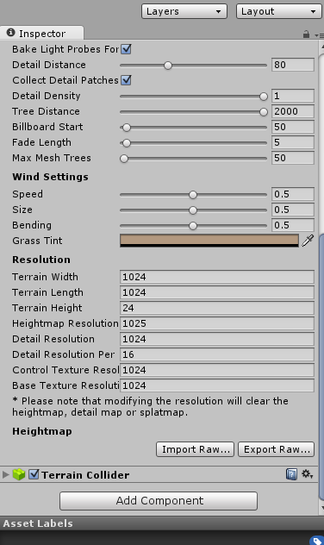

**This part is about your lightning and wind settings**

**This is NOT the default settings. But for TerraHE , this is the default settings.So before you use TerraHE , you should set this values.**

And you are done. You can now learn the basics of TerraHE.

**3.2 Using TerraHE**

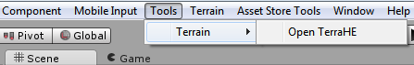​

TerraHE is really simple. Just select Tools from toolbar , select Terrain and select Open TerraHE and you are ready to go. It's a floating window , so you can put it anywhere. Now you can say to yourself "*There are some options , what are they?*". Let me talk about them more then.  
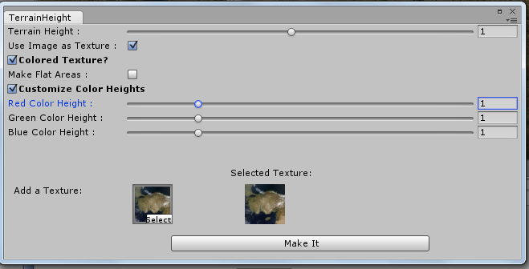

* ***Terrain Height :*** As you can understand from Its name , its a slider for adjusting the terrain height. It's mainly increase/decrease the height of mountains etc. For best value , you need to make some changes and experience yourself.
* ***Use Image as a Texture:*** If this option clicked , windows uses your heightmap resource as a texture for terrain
* ***Colored Texture :***You can check this option If you texture is colored. But you have to know this , If you don't check this , you can't check Flat Areas. Because for now , It's only working with Colored Textures

***-Make Flat Areas :*** By clicking this , you can make flatter areas. You can use this mainly for high detailed maps

* ***Customize Color Heights*** : You can check this option If you want to customize color heights. But I would recommend that If and only If you don’t have another option like making flat areas and modify total height etc.

**Support :**  
I would be really grateful If you share this asset with your friends and support it. I'm always open to hear new ideas , improvements or friendly talk. If you feel generous , you can also buy me a beer :)  
<https://www.paypal.com/cgi-bin/webscr?cmd=_s-xclick&hosted_button_id=H74HTU33A84LC>

**Contact:**

If you have problems or questions , do not hesitate to mail me

cartridgegamestudio@gmail.com