**TITLE : Smart Banking Chatfin**

**ABSTRACT**

The rapid advancement of financial technology has revolutionized banking services, creating a demand for smarter, more efficient systems. Chat-based financial systems (ChatFin) powered by Artificial Intelligence (AI) aim to enhance customer experience, streamline banking operations, and provide real-time financial assistance. This paper introduces a Smart Banking ChatFin model that integrates machine learning algorithms and natural language processing (NLP) for personalized and secure banking. The proposed system overcomes limitations of existing models by incorporating advanced AI capabilities such as predictive analytics and multilingual support. A comparative analysis of the existing and proposed models highlights significant improvements in efficiency, accuracy, and user satisfaction. The system also addresses security concerns through robust encryption and authentication mechanisms. This study provides a comprehensive framework for implementing a next-generation ChatFin solution, paving the way for innovative banking experiences.

**OBJECTIVE**

The objective of this study is to design and develop a Smart Banking ChatFin model that offers seamless, personalized, and secure interactions between users and banking services. By leveraging the capabilities of Artificial Intelligence (AI) and Natural Language Processing (NLP), the model aims to bridge the gap between traditional banking services and modern customer expectations. The proposed system seeks to overcome prevalent challenges, including limited language support that restricts accessibility for diverse user groups, poor response accuracy that impacts user trust, and inadequate security measures that leave sensitive data vulnerable to threats.

This model aspires to provide a holistic solution by incorporating features such as multilingual support to cater to a global user base, adaptive learning mechanisms for improved query resolution, and advanced encryption protocols for heightened data security. Moreover, the system is designed to enhance operational efficiency by automating routine banking processes and enabling real-time decision-making. By prioritizing customer satisfaction and accessibility, the Smart Banking ChatFin model aims to redefine the way users interact with banking services, ensuring a seamless, intuitive, and secure experience.

**EXISTING MODEL**

Current ChatFin solutions predominantly rely on rule-based algorithms or basic machine learning techniques, which often result in limited functionality and adaptability. These systems struggle with understanding complex user queries, providing accurate financial advice, and offering multilingual support. Furthermore, existing models are vulnerable to security threats due to inadequate encryption and authentication protocols. The lack of predictive analytics also limits their ability to proactively assist users in financial planning and decision-making.

**Algorithm:**

| **Step** | **Function Name** | **Description** |
| --- | --- | --- |
| Step 1 | initialize_system() | Initializes the system components such as models, encryption, authentication, fraud prevention, etc. |
| 1.1 | load_nlp_model() | Load the trained NLP model. |
| 1.2 | load_sentiment_analysis_model() | Load the trained sentiment analysis model. |
| 1.3 | load_predictive_analytics_model() | Load the predictive analytics model. |
| 1.4 | initialize_encryption_protocol() | Initialize encryption protocol for secure communication. |
| 1.5 | initialize_two_factor_authentication() | Initialize two-factor authentication system. |
| 1.6 | setup_anomaly_detection_system() | Set up fraud prevention and anomaly detection systems. |
| 1.7 | integrate_core_banking_system() | Integrate core banking systems for real-time transaction data and services. |
| 1.8 | integrate_third_party_apis() | Integrate external financial services APIs. |
| Step 2 | user_interaction() | Main loop for handling user interaction and response generation. |
| 2.1 | authenticate_user() | Authenticates the user based on their profile and two-factor authentication. |
| 2.2 | nlp_preprocessing() | Processes the user's query using NLP preprocessing techniques. |
| 2.3 | analyze_sentiment() | Analyzes sentiment of the processed query. |
| 2.4 | is_complex_query() | Checks if the query is complex or simple. |
| 2.5 | generate_complex_response() | Generates a tailored response for complex queries using predictive analytics. |
| 2.6 | generate_simple_response() | Generates a simple response based on predefined rules for simple queries. |
| 2.7 | provide_personalized_advice() | Provides personalized financial advice based on user profile. |
| 2.8 | integrate_financial_advice() | Combines the generated response with the personalized financial advice. |
| 2.9 | encrypt_response() | Encrypts the final response to ensure secure communication. |
| 2.10 | send_encrypted_response() | Sends the encrypted response to the user. |

**PROPOSED MODEL**

The proposed Smart Banking ChatFin model integrates advanced AI techniques such as deep learning, sentiment analysis, and predictive analytics. Utilizing NLP, the system can comprehend and respond to complex queries in multiple languages, enhancing user accessibility. Robust security measures, including two-factor authentication and end-to-end encryption, ensure data privacy and protection. Additionally, the model features a personalized financial advisor powered by machine learning algorithms, offering tailored insights and recommendations based on user behavior and financial history. The proposed solution significantly improves operational efficiency, user satisfaction, and security over existing models.

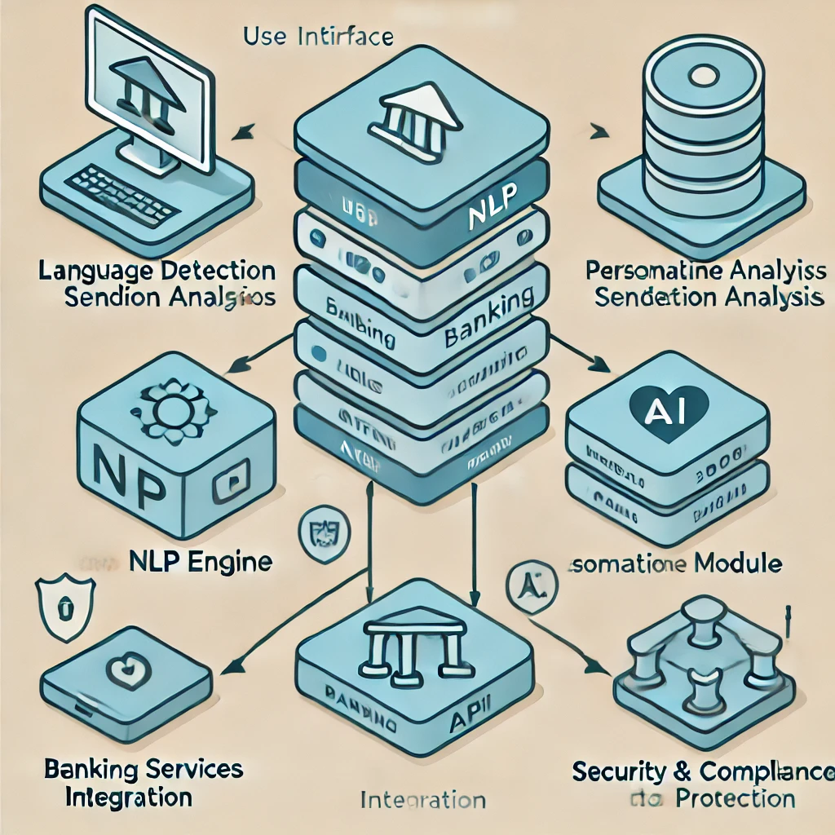

**LITERATURE SURVEY**

Several studies have explored the integration of AI in banking systems, focusing on automation, fraud detection, and customer engagement. Research highlights the potential of NLP for enhancing human-computer interactions in banking. However, many existing works emphasize the limitations of current models, particularly in handling complex queries and ensuring data security. Notable advancements include hybrid AI systems combining rule-based and machine learning approaches, but these still fall short in personalization and predictive capabilities. The literature underscores the need for a holistic ChatFin model addressing these gaps.

* *Cambria E and White B 2014 Jumping NLP curves: a review of natural language processing research J. IEEE Computational Intelligence Magazine****9****48-57*
* [2]*Tembhekar S and Kanojiya M 2017 A Survey Paper on Approaches of Natural Language Processing (NLP) J. International Journal of Advance Research, Ideas and Innovations in Technology****3****1496-98*
* [3]*Kamper H and Ruder 2018 October 1 A Review of the Neural History of Natural Language Processing Aylien Retrieved March 18, 2019, from recent-history-of-natural-language-processing/*
* [4]*Young T, Hazarika D, Poria S and Cambria E 2017 Recent Trends in Deep Learning Based Natural Language Processing arXiv: Computation and Language*
* [5]*Collobert R, Weston J, Bottou L, Karlen M, Kavukcuoglu K and Kuksa P P 2011 Natural Language Proc. (Almost) from Scratch J. Journal of Machine Learning Research 2493-2537*
* [6]*Bocklisch T, Faulkner J, Pawlowski N and Nichol A 2017 Rasa: Open Source Language Understanding and Dialogue Management arXiv: Computation and Language*
* [7]*Desot T, Raimondo S, Mishakova A, Portet F and Vacher M 2018 September Towards a French Smart-Home Voice Command Corpus: Design and NLU Experiments C. text speech and dialog*
* [8]*Honnibal M and Montani I 2017 spacy 2: Natural language understanding with bloom embeddings, convolutional neural networks and incremental parsing To appear*

**CONCLUSION**

The Smart Banking ChatFin model proposed in this paper represents a significant advancement in financial technology. By integrating cutting-edge AI techniques, the system overcomes the limitations of existing models, delivering a secure, efficient, and user-friendly banking experience. Its ability to handle complex queries, provide personalized financial advice, and ensure robust data protection positions it as a next-generation solution for the banking industry.

**FUTURE WORK**

Future enhancements to the Smart Banking ChatFin model include the integration of blockchain technology for improved transaction transparency and security. Additionally, expanding the model’s capabilities to support advanced financial analytics and real-time decision-making will further enhance its utility. Research into user-centric features, such as voice-based interactions and adaptive learning algorithms, will continue to refine the system’s performance and accessibility. Collaboration with financial institutions will be critical for deploying and validating the model in real-world scenarios.