Name: Shabana Ajamal Hannure
U-ID: U80532141

Rental Management Database
Version 1.0 Revision 1
Submittal Date: 9/25/2021

1
Table of Contents

Purpose……………………………………………………………………………………………3

Narrative………………………………………………………………………………………….3

Requirements (Actors/Roles)……………………………………………………………………4

Workflow Process Models……………………………………………………………………….4

Entities……………………………………………………………………………………………5

Entities (with Nested Attributes)………………………………………………………………..5

Business Rules……………………………………………………………………………………7

ERD……………………………………………………………………………………………….8

EERD……………………………………………………………………………………………..9

Relational Schema……………………………………………………………………………….8

2

Purpose

The purpose of this Database Design Document is to control the data on the rental management system. This manages business transactions between tenants, landlords and the properties themselves. Furthermore, it keeps track of the vendors with the repairs as well as the inspections conducted by the tenants.

Narrative

A rental management company manages business transactions consisting of tenants who rent the properties, landlords who own the properties, inspections of the properties conducted by the tenants, vendors who service and conduct maintenance or repairs at the properties, and the properties themselves.

Information collected about tenants and landlords are names, and contact details. Also, how many late payments a tenant has made.

Information collected about vendors are names, contact details, and services offered.

Information collected about the properties are the addresses and location information.

Information collected about the inspections are which tenant conducted the inspection, the type of inspection, and a photo image of the item inspected.

Information collected about rent payments are which tenant paid for which property and the date of payment.

Information collected about repairs are which vendor repaired which property, the type of repair and the date of repair.

3

Requirements (Actors/Roles)

Tenant: a tenant rents the properties, pays their rent, requests a type
Of maintenance and conduct an inspection.
Landlord: a landlord owns the properties and collects the rent payments.

Property: a property is owned a landlord and rented by a tenant.

Vendor: a vendor services and conducts a type of maintenance.

Inspection: an inspection is conducted by a tenant.

Repair: a repair is conducted by a vendor.

Workflow Process Model
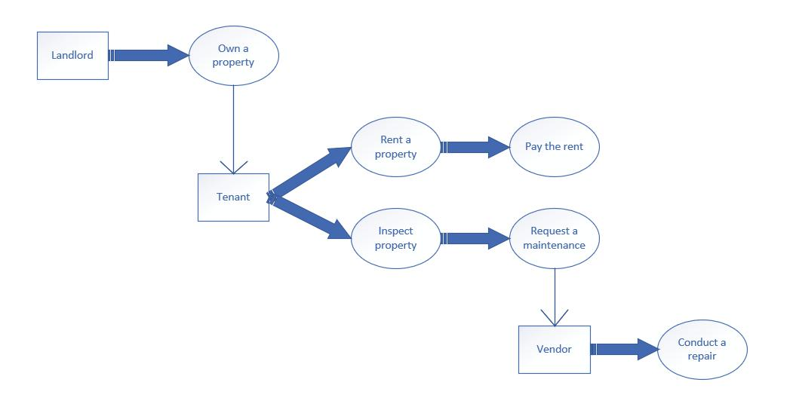

4

Entities

Tenants

Landlords Properties Rents

Vendors Repairs
Inspections

Entities with Nested Attributes

Tenants

  - Name

  - Tenant ID

  - Email

  - Phone number

  - Late payment

Landlords

  - Name

  - Landlord ID

  - Email

  - Phone number Properties

  - Property ID

  - Street

5

  - City

  - State

  - Zip code

  - Location information Rents
  - Tenant ID

  - Property ID

  - Date of payment Vendors
  - Name

  - Vendor ID

  - Email

  - Phone number

  - Service provided Repairs
  - Vendor ID

  - Property ID

  - Type of repair

  - Date of repair

Inspections

  - Inspection ID

  - Tenant ID

  - Date of inspection

6

- Type of inspection

- Photo of the item inspected

Business Rules

- A landlord owns at least one or more properties.

- A property is owned by only one landlord.

- A tenant rents only one property.

- A property has zero or one tenants, and no more than one tenant.

- Tenants conduct one or more inspections of a property.

- Tenants pay zero, one or more than one rent payment.

- A property is inspected zero, one or more than one times.

- A property received zero, one or more than one rent payment.

- A vendor conducts zero, one or more than one service on zero, one or more than one property.

ERD

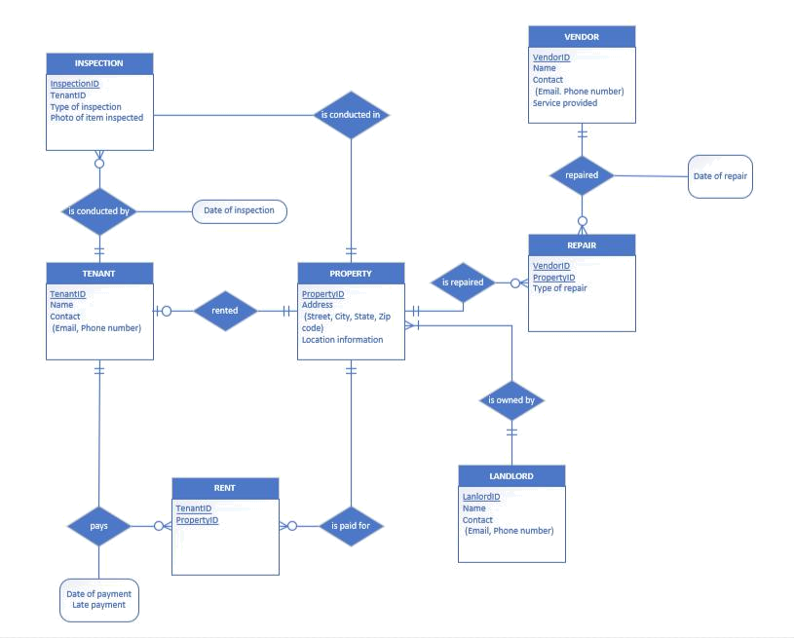

EERD

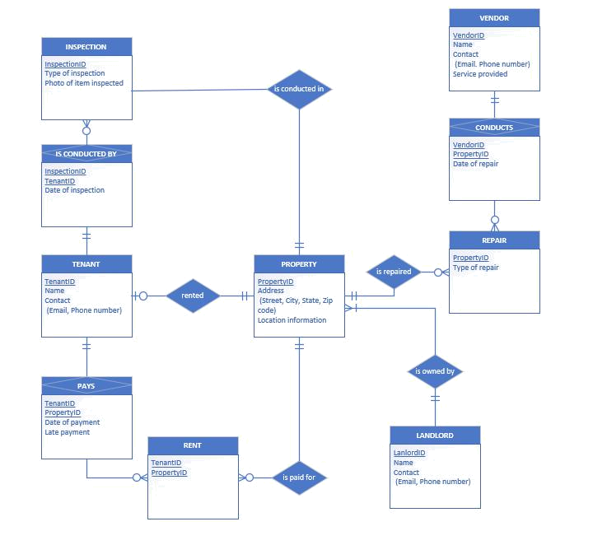

Relational Schema

