**Abstract:**

Emotion can be expressed in ways that can be seen such as facial expression and gestures. Emotion can also be heard by detecting prosody features and other vocal characteristics. However in this research, we

are interested to detect emotions from textual information. Our main objective is to predict the emotions from textual material.These solutions include extracting keywords with semantic analysis, and ontology design with emotion theory of appraisal.

**Table of contents:**

**Chapter 1: Introduction**

1. **Aim**
2. **Objective**
3. **Introduction to problem domain**
4. **Application**
5. **Existing solution methods**
6. **Proposed solution methods**
7. **Time schedule for completion of the project work**

**Chapter 2: Literature survey**

**Chapter 3: System Requirements and Analysis**

**Chapter 4: Tools and Technology used**

**Chapter 5:System Design**

**Chapter 6: System implementation**

**Chapter 7: System Testing and Result Analysis**

**Chapter 8: Conclusion and future work**

1. **Introduction**
2. **AIM**

This project is aimed to design a prototype which classifies different levels of emotions and detects emotions from text using NLP and ML.

1. **OBJECTIVE**

* To classify text as emotional or non emotional text.
* To compare Natural Language processing and Machine Learning based application.
* To develop a prototype for classifying and detection of emotions.

1. **INTRODUCTION TO THE PROBLEM DOMAIN**

An Emotion is a feeling such as happiness, [love](https://www.collinsdictionary.com/dictionary/english/love), fear, [anger](https://www.collinsdictionary.com/dictionary/english/anger), or [hatred](https://www.collinsdictionary.com/dictionary/english/hatred), which can be caused by the [situation](https://www.collinsdictionary.com/dictionary/english/situation) that you are in or the people you are with.

Emotion can be expressed in many ways that can be seen such as facial expression and gestures, speech and by written text. Emotion Detection in text documents is essentially a content – based classification problem involving concepts from the domains of Natural Language Processing as well as Machine Learning. In this paper emotion recognition based on textual data and the techniques used in emotion detection are discussed.The collection of dataset is the basic step, which is collected from the various sources like daily used sentences, user status from various social networking websites such as facebook and twitter. Using this data set we target only on the keywords that show human emotions. The targeted keywords are extracted from the dataset and translated into the format which can be processed by the classifier to finally generate the Predicting model which is further compared by the test dataset to give the emotions in the input sentences or documents.Recently much research is going on in emotion recognition domain. Recognition of emotions is very useful to human-machine communication. Many kinds of the communication system can react properly for the human’s emotional actions by applying emotion recognition techniques on them. These systems include dialogue system, automatic answering system and robot. The recognition of emotion has been implemented in many kinds of media, such as image, speech, facial expressions, signal, textual data, and so on. Text is the most popular and main tool for the human to convey messages,

By this we are able to depict writer’s feeling.

1. **Applications**

* Mainly used in detection of emotions from text.
* Used as an enhancement for grammar checking software.
* Natural Language processing helps machines “read” text and analyse the human language.

1. **Existing solution Methods**

We can detect emotion by reading and analyzing the text statement or document. In Existing solution method detection of emotions is limited to some short documents. They detect emotions by counting positive and negative documets.

1. **Proposed solution Methods**

We are trying to detect emotion from smaller statements to larger documents and detecting the different levels of emotions

1. **Literature Survey**

**MODEL 1:**

The concept of affective computing in 1997 by Since Picard [1] proposed that the role of emotions in human computer interaction. This domain attracted many researchers from computer science, biotechnology, psychology, and cognitive science and so on.

Following the trend, the research in the field of emotion detection from textual data emerged to determine human emotions from another point of view. Recently much research is going on in emotion recognition domain. Recognition of emotions is very useful to human-machine communication. Many kinds of the communication system can react properly for the human’s emotional actions by applying emotion recognition techniques on them. These systems include dialogue system, automatic answering system and robot. The recognition of emotion has been implemented in many kinds of media, such as image, speech, facial expressions, signal, textual data, and so on. Text is the most popular and main tool for the human to convey messages,

**Disadvantages**

* Ambiguity in Keyword Definitions
* Incapability of Recognizing Sentences without Keywords
* Lack of Linguistic Information
* Difficulties in Determining Emotion Indicators

**MODEL 2:**

firstly the assigned probabilities are biased toward corpus-specific genre of texts, secondly it misses out emotional content that resides deeper than the word-level on which this technique operates.

For example the word „accident‟, having been assigned a high probability of indicating a negative emotion, would not contribute correctly to the emotional assessment of phrases like “I avoided an accident‟ or “I met my girlfriend by accident”.

1. **System Requriments and Analysis**
2. **Tools and Technology used**

Minimum Hardware Requirements

Processor : Intel i5 2.53GHz

Hard Disk : 30GB

Ram : 4 GB or above

Software Requirements

Operating system : Windows 7 and above

Coding Language : Python

Version : 3.6 & above

IDE : Pycharm

1. **DESIGN**

**System design**



**Emotion Class**

**Identify emotion**

**Feauture extraction**

**Eliminationg Stop words**

**Tokenization**

**Text**

Fig:4.1 emotion classification

1. **System Implementation**
2. **Program to classify emotions into 5 basic emotion class**

import csv

import pandas as pd

data = pd.read_csv('EmotionWords.csv')

print(data)

print(len(data))

Joydataset=[]

Saddataset=[]

Angerdataset=[]

Disgustdataset=[]

Feardataset=[]

#for i in range(len(data)):

#print(data(0))

fn = 'EmotionWords.csv'

with open(fn, 'r') as csvfile:

# creating a csv reader object

csvreader = csv.reader(csvfile)

# extracting each data row one by one

for row in csvreader:

if row[1]=='sadness':

Saddataset.append(row[0])

if row[1]=='joy':

Joydataset.append(row[0])

if row[1]=='anger':

Angerdataset.append(row[0])

if row[1]=='fear':

Feardataset.append(row[0])

if row[1]=='disgust':

Disgustdataset.append(row[0])

csvfile.close()

f = open("SadData.txt", "a")

for i in range(len(Saddataset)):

f.write(Saddataset[i]+"\n")

f.close()

f = open("JoyData.txt", "a")

for i in range(len(Joydataset)):

f.write(Joydataset[i]+"\n")

f.close()

f = open("Angerdataset.txt", "a")

for i in range(len(Angerdataset)):

f.write(Angerdataset[i]+"\n")

f.close()

f = open("Feardataset.txt", "a")

for i in range(len(Feardataset)):

f.write(Feardataset[i]+"\n")

f.close()

f = open("Disgustdataset.txt", "a")

for i in range(len(Disgustdataset)):

f.write(Disgustdataset[i]+"\n")

f.close()

''' try:

#print(rows[1][1])

for row in rows[1:]:

# parsing each column of a row

if row[0][0]!="":

query="";

query="insert into staging_product_master values (";

for col in row:

query =query+"'"+col+"',"

query =query[:-1]

query=query+");"

print("query :"+str(query), flush=True)

cursor.execute(query)

connection.commit()

except:

print("An exception occurred")

csvfile.close()'''

**b) Baseline Program to identify emotions**

from nltk.tokenize import sent_tokenize, word_tokenize

import nltk

from nltk.corpus import stopwords

""" Reading Input """

'''val = input("Enter the text : ")

print ("Input given :"+ str(val))'''

happyset=['Satisfied','pleased','happy','glad']

val=open("positive.txt", "r")

flagindicator=''

with open("positive.txt") as f:

lineList = f.readlines()

print((lineList))

print(len(lineList))

for i in range(len(lineList)):

if(lineList[i]!='\n'):

comment=lineList[i]

commentval=comment.split(' ')

for ix in range(len(commentval)):

token=commentval[ix]

for j in range(len(happyset)):

if(happyset[j] in token):

flagindicator='Happy emotion'

break

print("Comment : "+lineList[i]+ " is - "+flagindicator)

1. **System Testing and Result Analysis**

a)

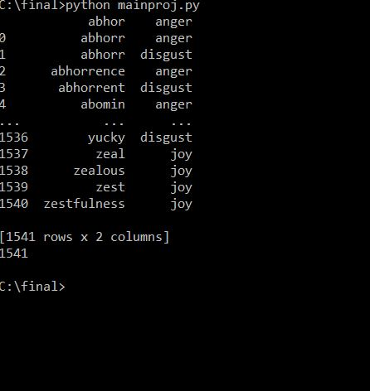

Classifies the dataset and produce 5 text files which contains happy,sad,fear,anger and disgust keywords

b)

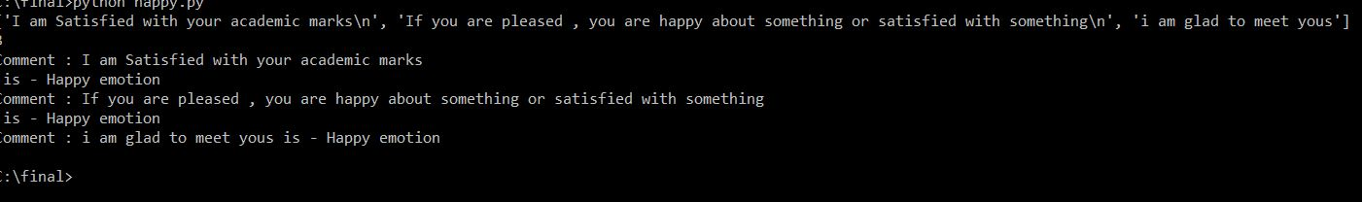

It identifies keywords satisfied, pleased and glad as happy keyword and yields output as happy emotion.

1. **Conclusion**

Emotion Detection can be seen as an important field of research in human-computer interaction. A sufficient amount of work has been done by researchers to detect emotion from facial and audio information whereas recognizing emotions from textual data is still a fresh and hot research area.

In this paper emotions are classified into 3 basic emotion classifiers,which can be used in future system architecture which would perform efficiently.