OOPS TEST

1

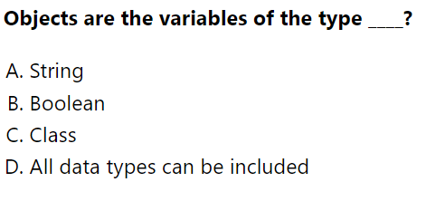

2

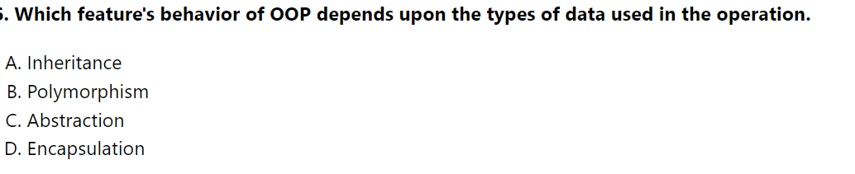

3

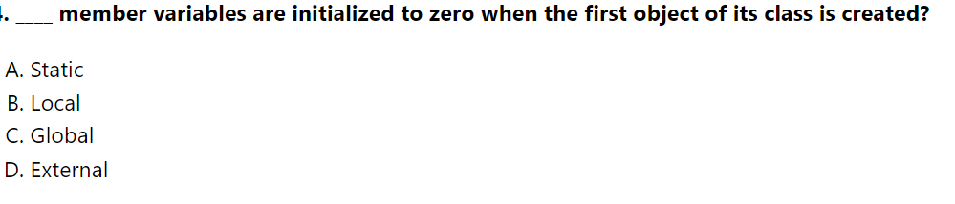

4

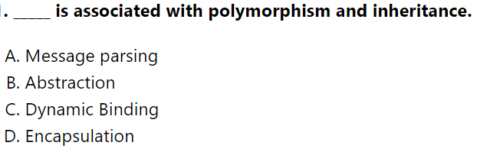

5

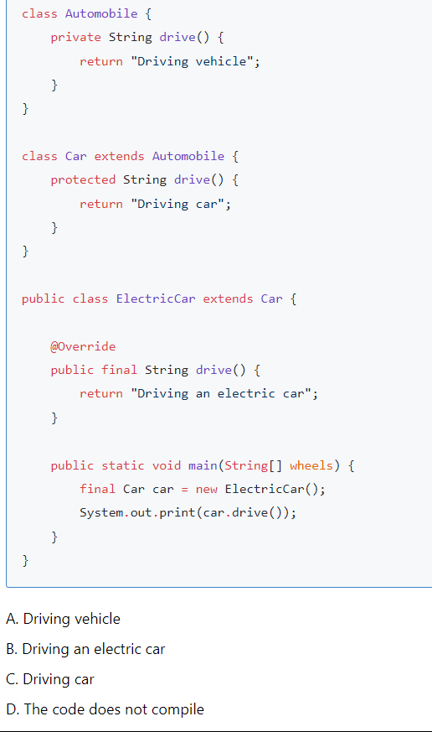

6

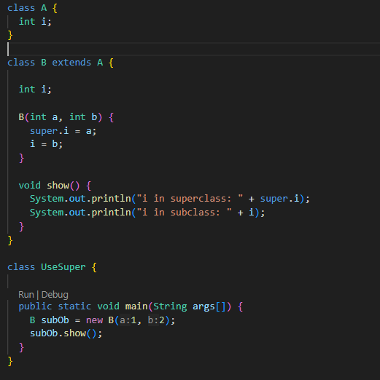

1. Compile Time Error
2. I in superclass:0

I in subclass:0

1. I in superclass:1

I in subclass:2

1. Run Time Error

7

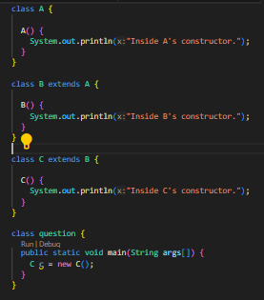

A)

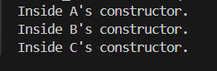

B)

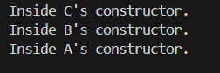

C)



8) 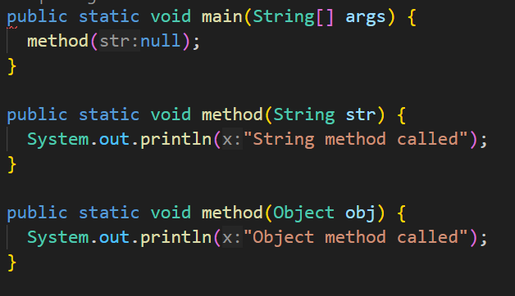

1. String method called
2. Object method called
3. Compile Time Error
4. Null

9)

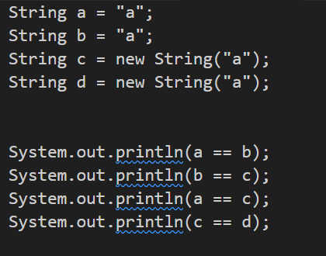

1. true false false true
2. true false false false
3. true true true false
4. false true true false

10)

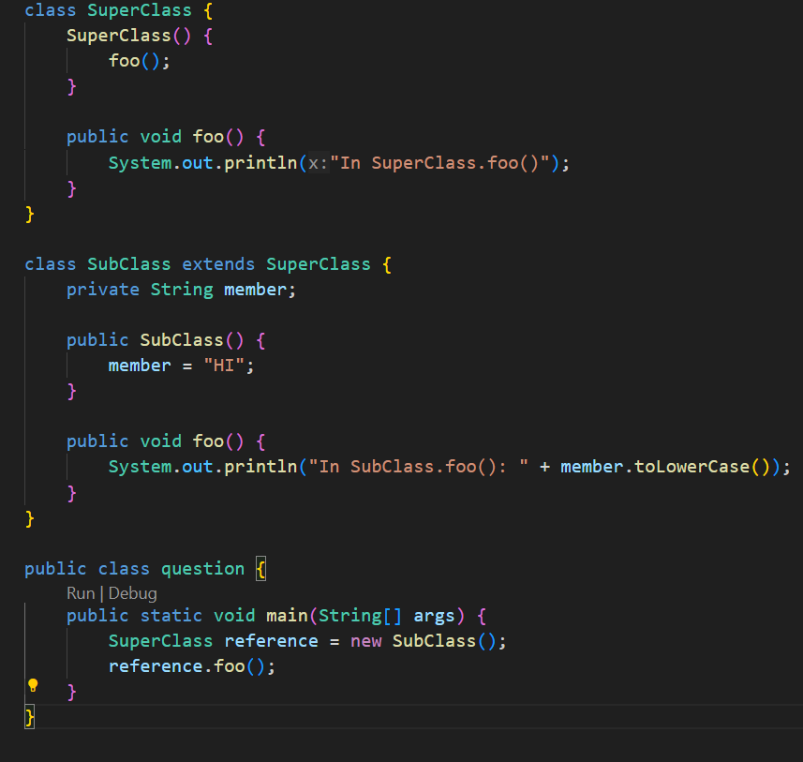

a) In SuperClass.foo()

b) In Derived.foo(): hi

c) In SuperClass.foo() In Derived.foo(): hi

d) This program throws a NullPointerException.

11)

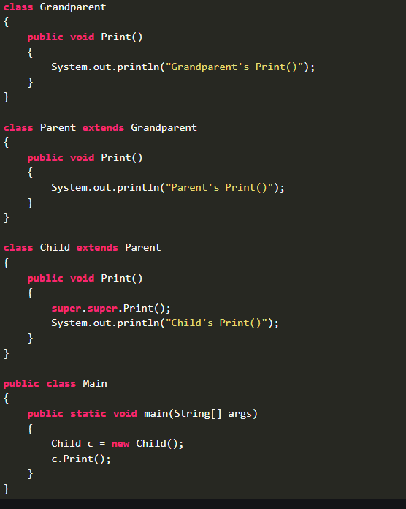

1. Grandparent's Print()

Parent's Print()

Child's Print()

1. Parent's Print()

Child's Print()

1. Compile Time Error
2. Run Time Error

12)

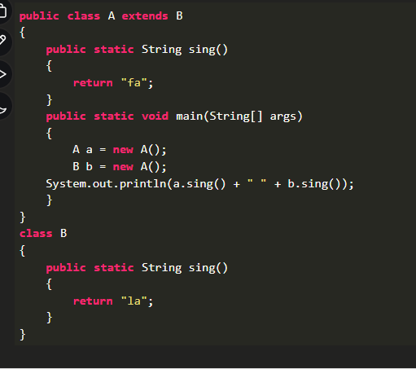

1. Fa la
2. La Fa
3. Fa fa
4. La la
5. Run Time Exception

0

13)

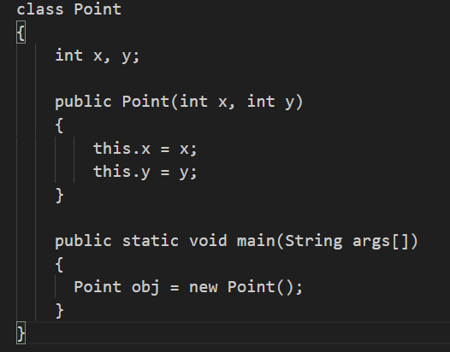

A) The code will be executed by calling default constructor of class Point

B) Compile Time Error

C) Run Time Error

14)

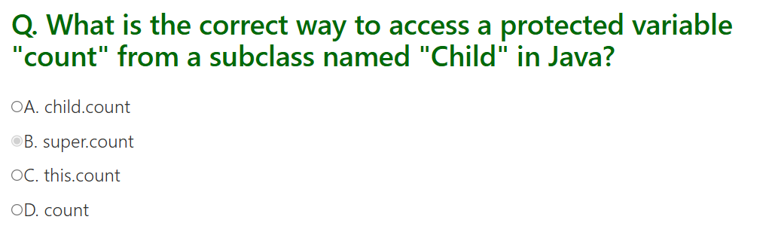

15

