Intelligent Agent based Job Search System
In this project we are providing flexibility to job seekers to search job based on their home and company area distance, weekly working days, shift type, preferred salary etc.
This project consists of two users
Employer: Employer can signup and login to application and then post jobs or activate or deactivate job
Applicant: Applicant can signup and login to application and then search job based on preferred distance, shift and working days and this search technique will use fuzzy search mechanism.
SCREEN SHOTS
To run project first create database in MYSQL by copying content from DB.txt file and then paste in MYSQL console
Now double click on ‘runServer.bat’ file to start python DJANGO server and get below screen
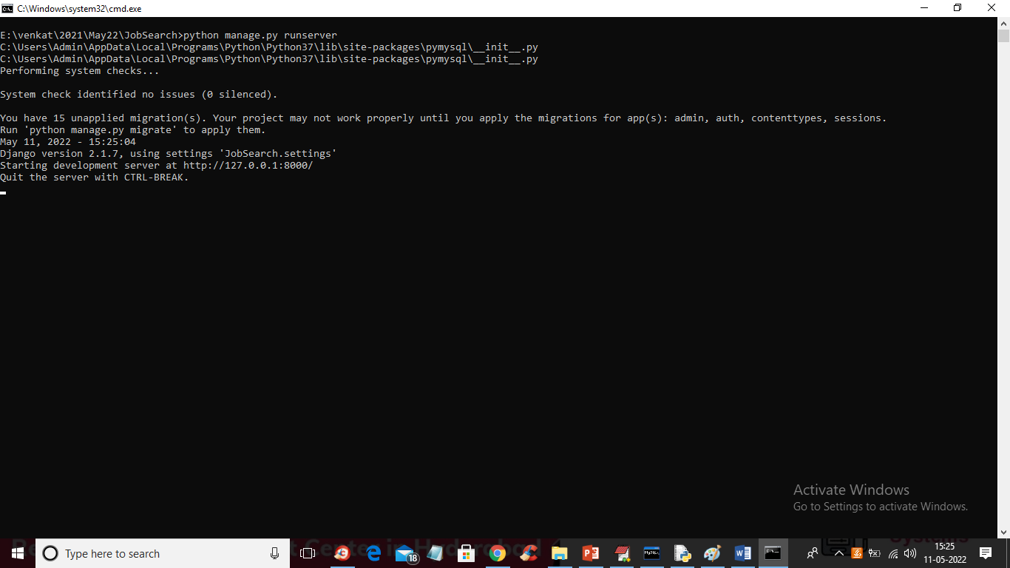
In above screen DJANGO server started and now open browser and enter URL as http://127.0.0.1:8000/index.html and press enter key to get below page
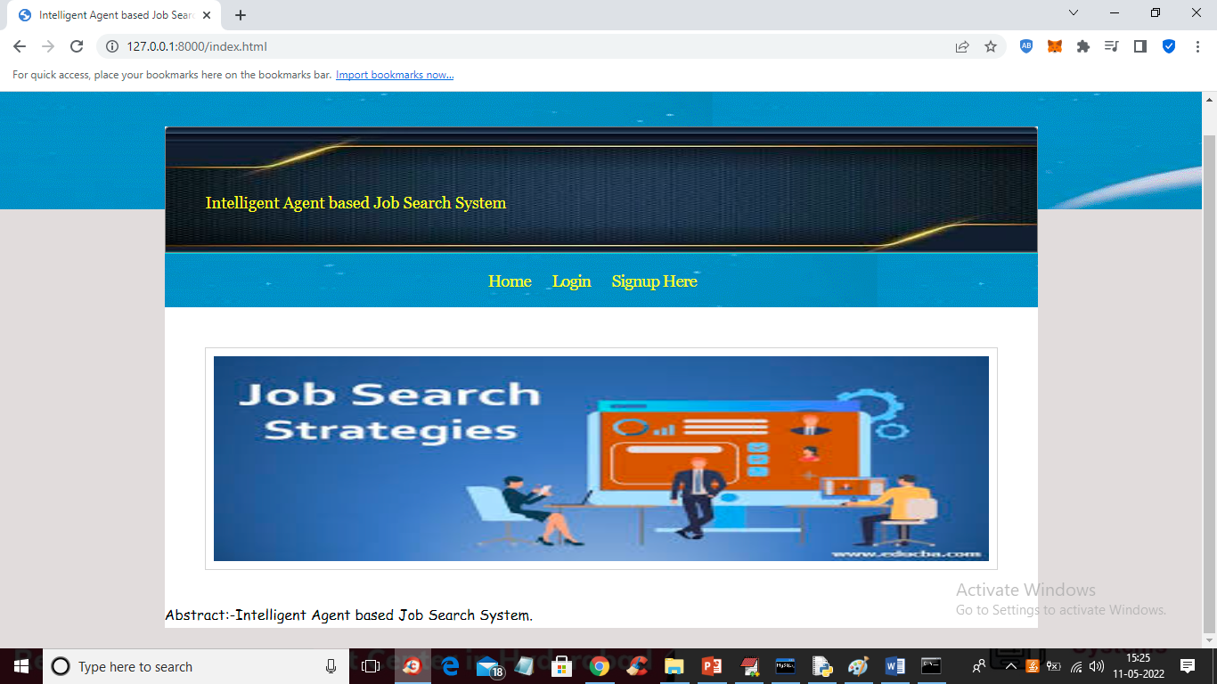
In above screen click on ‘Signup Here’ link to get below signup screen
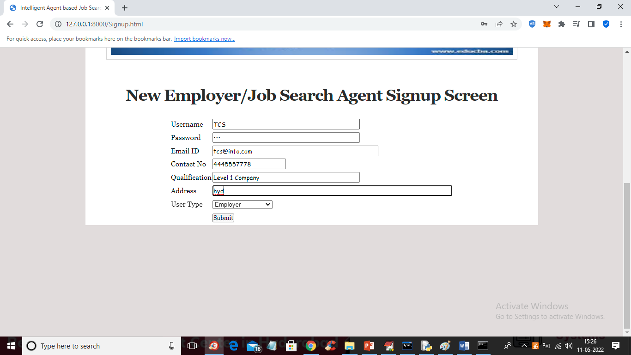
In above screen company is entering signup details and press button to get below screen
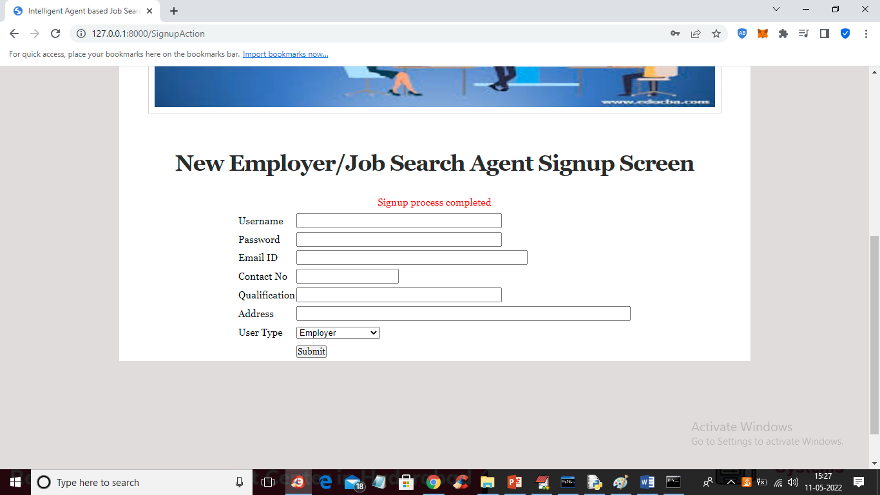
In above Screen Company signup process completed and now signup one application like below screen
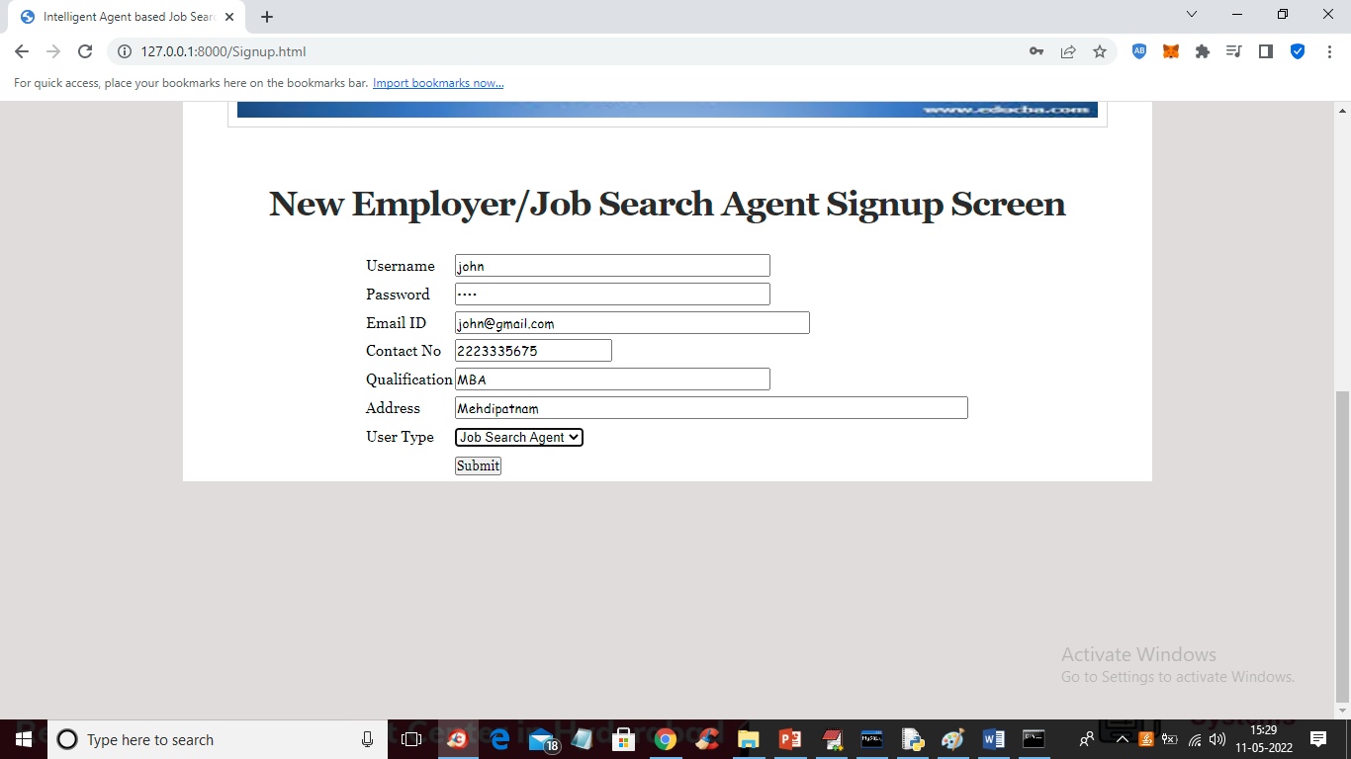
In above screen job applicant is signing up and then click on ‘Submit’ button to get below output
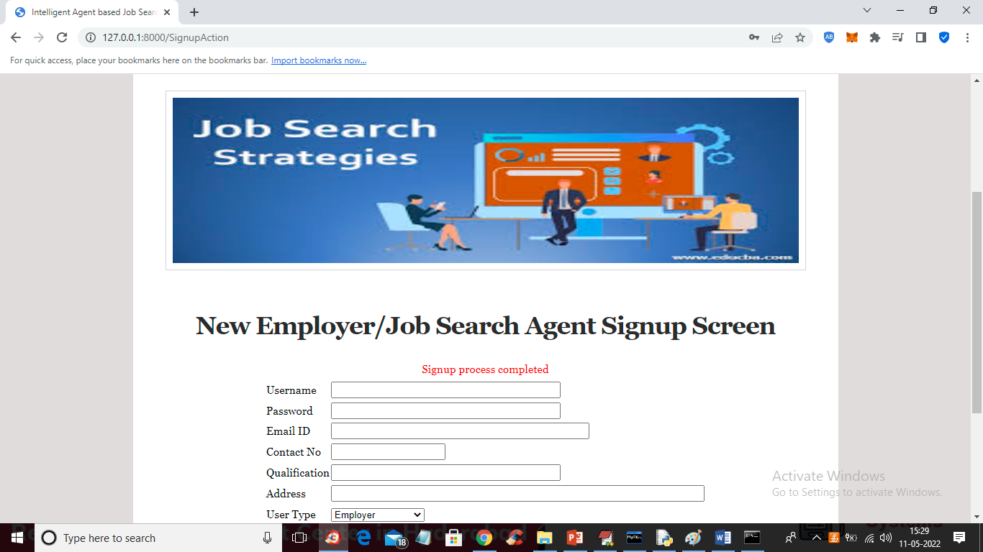
In above screen applicant signup completed and now click on ‘Login Here’ link to login as company
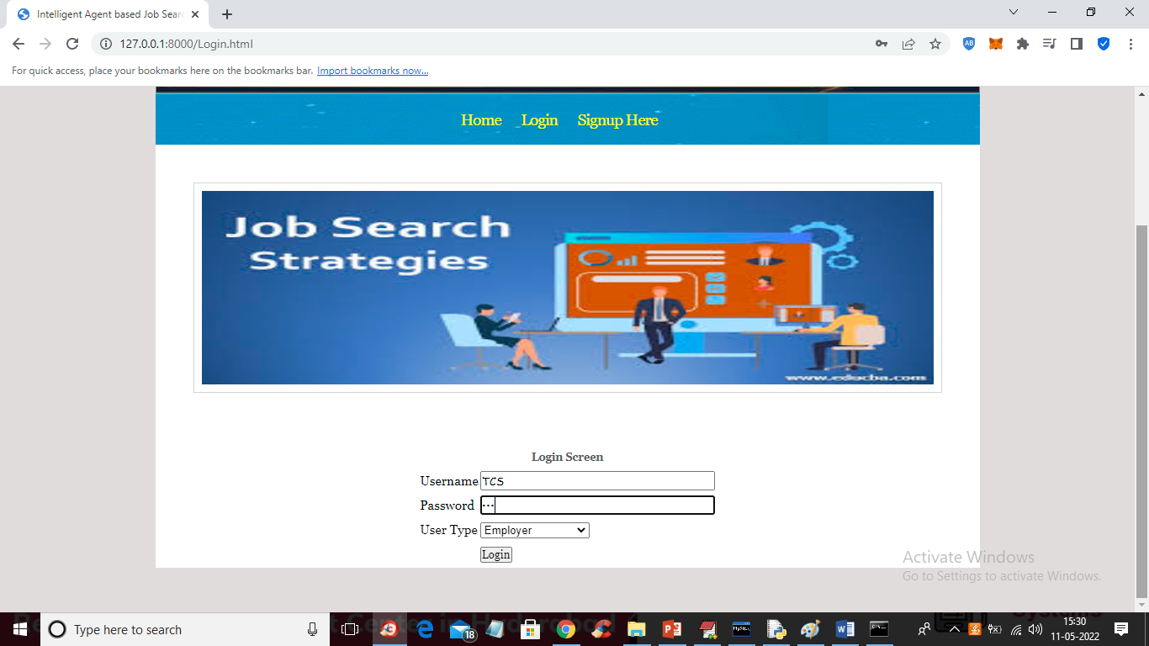
In above screen company is login and after login will get below screen

In above screen company can click on ‘Post Jobs’ link to post the new JOB
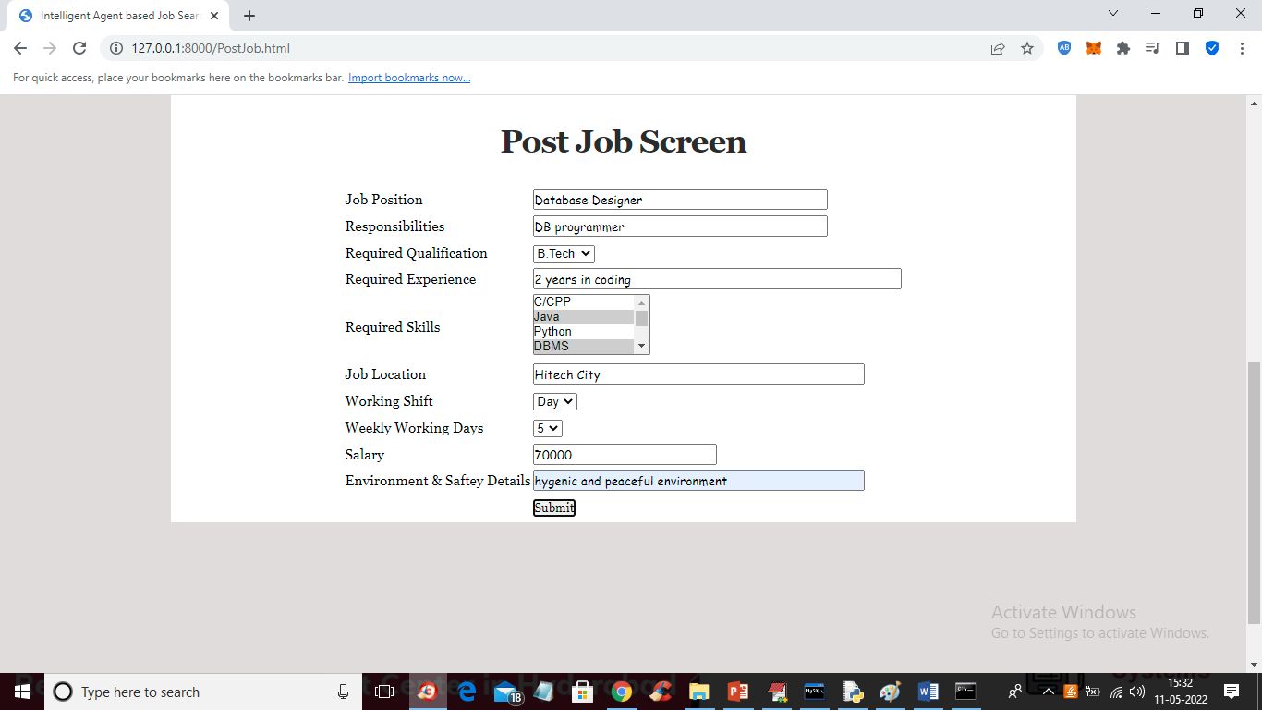
In above screen company is posting the job and now press button to get below output
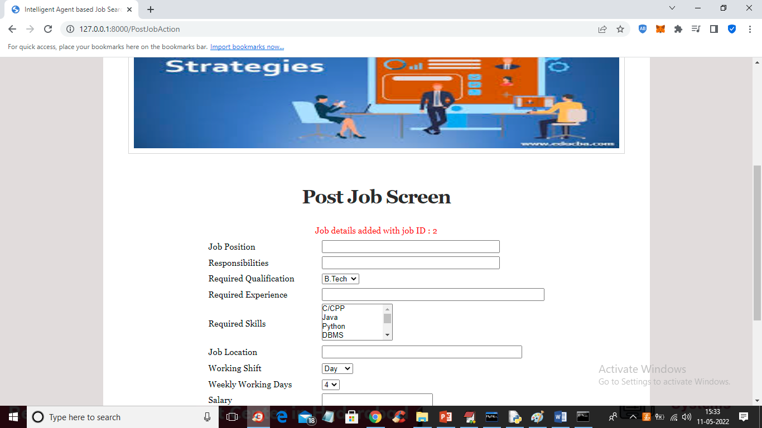
In above screen job details added and now click on ‘Activate/Deactivate Job’ link to get list of jobs posted by company and then activate or deactivate
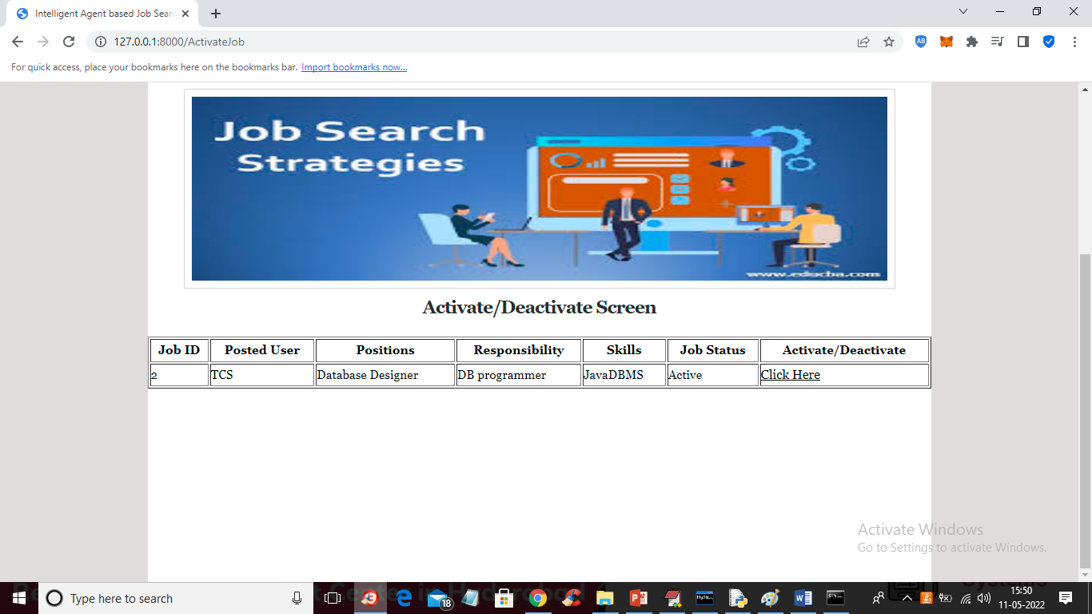
In above screen company can click on ‘Click Here’ link to either activate or deactivate JOB. Now logout and login as ‘job applicant’
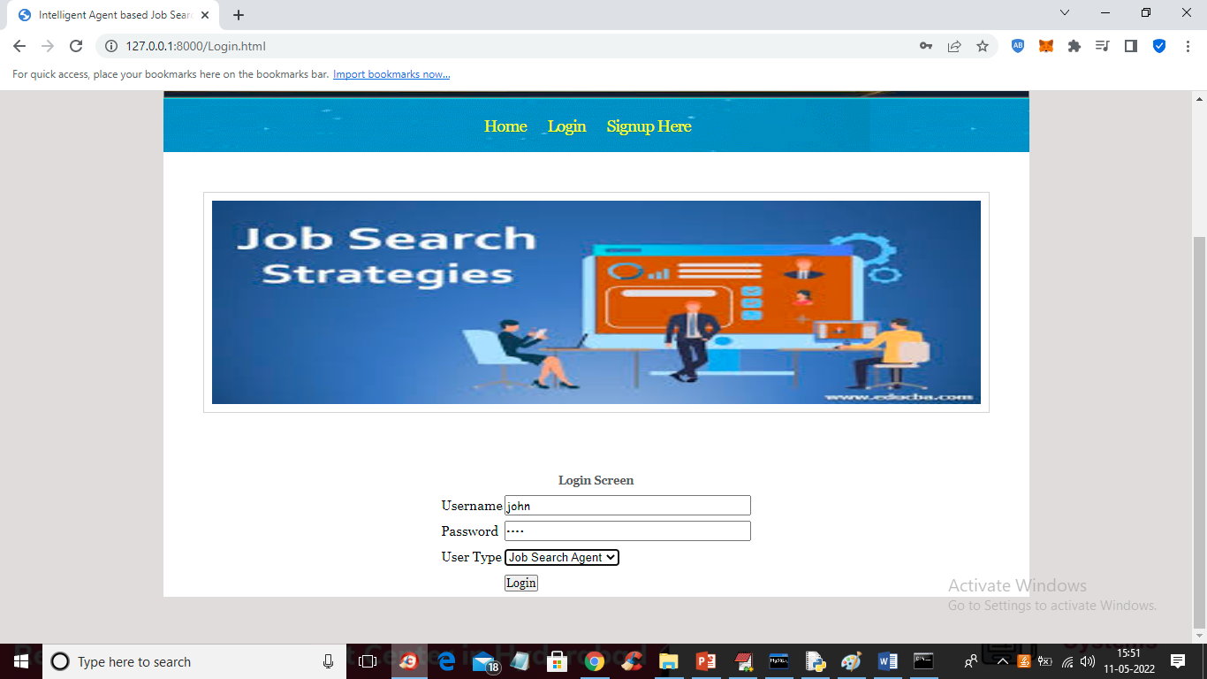
In above screen job applicant is login and after login will get below screen
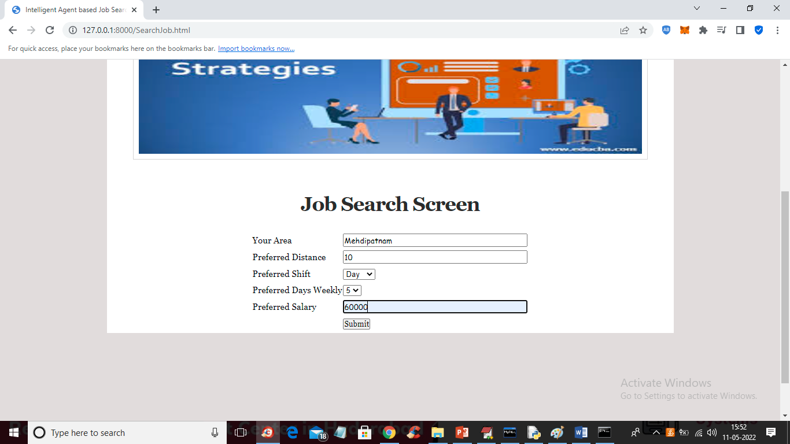
For above search we got below fuzzy search result
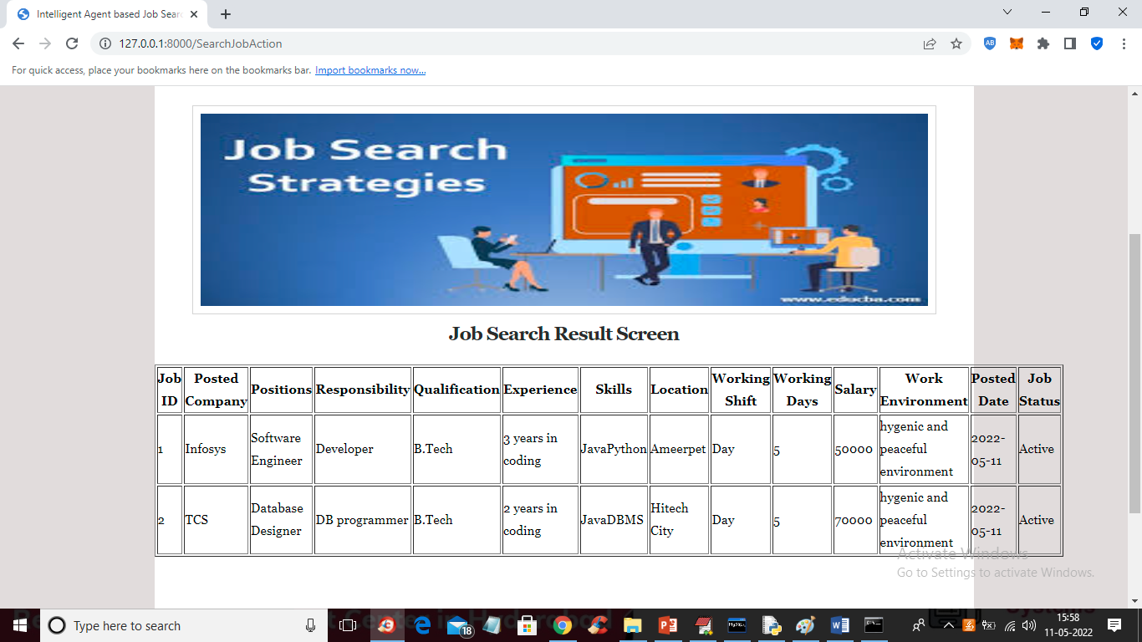
Similarly company will post JOBS and job seekers will search jobs

